    DEPARTMENT OF BIOENGINEERING, ROBOTICS, INFORMATICS AND SYSTEMS ENGINEERNIG (DIBRIS)  Via Opera Pia, 13  16145- Genova, ITALY  tel. +39 010 353-2310  https://www.dibris.unige.it/en/ |  | 
  Vinil Thekkedath Chackochan
  Development of Collaborative Strategies in Joint Action
  March 2018
Many tasks in daily life involve coordinating movements between two or more individuals. A couple of dancers, a team of players, two workers carrying a load or a therapist interacting with a patient are just a few examples. Acting in collaboration or joint action is a crucial human ability, and our sensorimotor system is shaped to support this capability efficiently. When two partners have different goals but may benefit from collaborating, they face the challenge of negotiating a joint strategy. To do this, first and foremost both subjects need to know their partner’s state and current strategy. It is unclear how the collaboration would be affected if information about the partner is unreliable or incomplete.  This work intends to investigate the development of collaborative strategies in joint action.  To this purpose, I developed a dedicated experimental apparatus and task. I also developed a general computational framework -- based on differential game theory -- for the description and implementation of interactive behaviours of two subjects performing a joint motor task. The model allows to simulate any joint sensorimotor action in which the joint dynamics can be represented as a linear dynamical system and each agent’s task is formulated in terms of a quadratic cost functional. The model also accounts for imperfect information about dyad dynamics and partner’s actions, and can predict the development of joint action through repeated performance.  A first experimental study, focused on how the development of joint action is affected by incomplete and unreliable information. We found that information about the partner not only affects the speed at which a collaborative strategy is achieved (less information, slower learning) but also optimality of the collaboration. In particular, when information about the partner is reduced, the learned strategy is characterised by the development of alternating patterns of leader-follower roles, whereas greater information leads to a more synchronous behaviour. Simulations with a computational model based on game theory suggest that synchronous behaviours are close to optimal in a game theoretic sense (Nash equilibrium). The emergence of roles is a compensation strategy which minimises the need to estimate partner’s intentions and is, therefore, more robust to incomplete information.  A second study addresses how physical interaction develops between adults with Autism spectrum disorder (ASD) and typically developing subjects. ASD remains mostly a mystery and has therefore generated some theories trying to explain their cognitive disabilities, which involve an impaired ability to interact with other human partners. Although preliminary due to the small number of subjects, our results suggest that ASD subjects display heterogeneity in establishing a collaboration, which can be only partly explained with their ability to perceive haptic force.  This work is a first attempt to establish a sensorimotor theory of joint action. It may provide new insights into the development of robots that are capable of establishing optimal collaborations with human partners, for instance in the context of robot-assisted rehabilitation..  Vinil Thekkedath Chackochan was born in India, in 1989. He obtained Bachelor degree (B.Tech) in Applied Electronics and Instrumentation in 2011 from Mahatma Gandhi University, India after which he obtained a Master degree (MS) in Bioengineering in 2014 from Christian Medical College – Vellore, India. |  | Department of Informatics, Bioengineering, Robotics and Systems Engineering  Ph.D. Program in Bioengineering and Robotics
 |  | 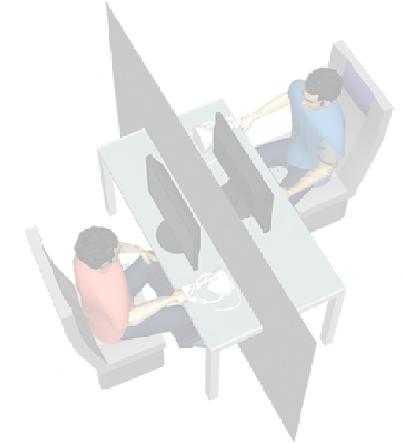  Development of collaborative strategies in joint action  Vinil Thekkedath Chackochan  Doctoral thesis in Bioengineering and Robotics  March 2018  Supervisor:  Prof. Vittorio Sanguineti  Please make sure you list the correct name of your faculty and PhD degree.  The background can be left blank or you can insert an image (mind author’s rights…).  Delete this textbox

