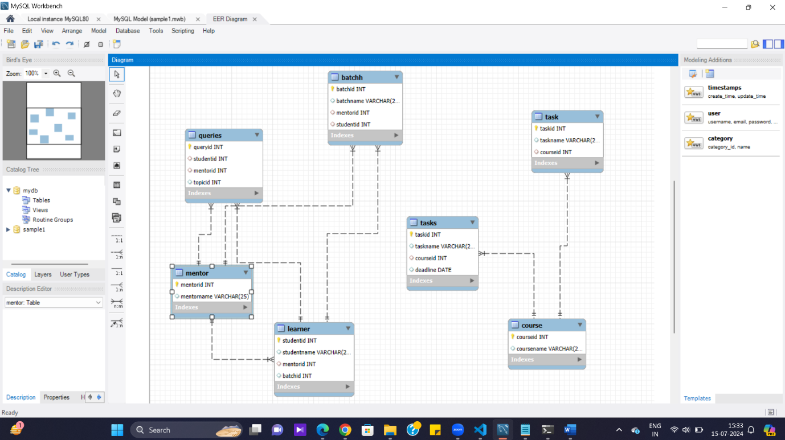

Code :

create table mentorss (mentorid int primary key, mentorname varchar(25));

describe mentorss;

insert into mentorss (mentorid, mentorname) values

(1001, 'lakshan') , (1002, 'surya');

create table batchhh (batchid int primary key, batchname varchar(25), mentorid int, studentid int,

foreign KEY (mentorid) REFERENCES mentor(mentorid),

foreign key (studentid) REFERENCES learner(studentid));

describe batchhh;

create table learners (studentid int primary key, studentname varchar(25), mentorid int, batchid int,

foreign KEY (mentorid) REFERENCES mentor(mentorid));

describe learners;

create table courses (courseid int primary key, coursename varchar(25));

describe courses;

create table tasks (taskid int primary key, taskname varchar(25), courseid int, deadline DATE,

foreign key (courseid) REFERENCES course (courseid));

describe tasks;

create table queries (queryid int primary key, studentid int, mentorid int, topicid int,

foreign KEY (mentorid) REFERENCES mentor(mentorid),foreign KEY (studentid) REFERENCES learner(studentid));

describe queries;