Article title
Abstract
Abstract text.
Keyword 1 ,Keyword 2 ,Keyword 3 ,Keyword 4 ,Keyword 5 ,Keyword 6

1 Introduction
Text with citations:
- textual citation where the author is part of the sentence (citet): [1]
- parenthetical citation (citep): [1]

2 Methodology
The Figure 1 was made using script ‘flowchart.py‘ ...
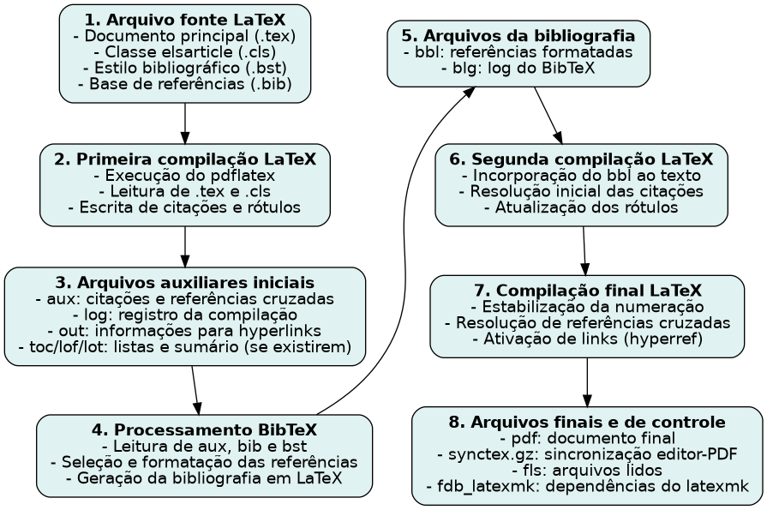
Figure 1: Flowchart of how LaTeX works to generate a PDF.

2.1 Subsection example
Example of equation (Equation [eq:example]):
DAOIRef=1Nst∈S​(GHIt−GHIRef,t)
where $S=\{t∣GHI_{t}>GHI_{Ref,t}\}$ and $N_{s}=|S|$.
Example of a table (Table 1):
Summary of the results.
Model | Var1 | Var2
model1 | 0.20342 | 0.14154
model2 | 0.21000 | 0.15000
model3 | 0.16708 | 0.12299
model4 | 0.16000 | 0.12000

3 Results and discussion
More text... See more at Section 2.1

4 Conclusions
More text... See more at Appendix 5

5 Appendix name section
Appendix informations ...
[1] V.R. da Rocha, G. Fisch, R.S. Costa, A. Ruano, Anomaly detection in all-sky images: An approach using robust ensemble modeling of cloud cover fraction and prediction bounds, Engineering Applications of Artificial Intelligence 143 (2025) 110003. https://doi.org/10.1016/j.engappai.2025.110003.

