Individual Weekly Report for Vinisha Bala Dhayanidhi
LLM Powered Interview Simulator, 26th October 2025

1. Key design/development/learning accomplishments
- Design:

- Development:

- Learning (e.g. new language, framework, tools)

2. Project Schedule Update

Week | Objectives Planned | Activities/Tasks | Deliverables (Quantified) | - What you could/should have done differently  - What went well  - Condensed Version Only
Week #1
Week #2
Week #3
Week #4
Week #5
Week #6
Week #7
Week #8
Week #9
Week #10

3. Reflection/Comments (Full Version of “What Went Well/What You could/should have done differently)

4. Evidence of Work

5. Next week’s plan

Individual Weekly Report for Vinisha Bala Dhayanidhi
LLM Powered Interview Simulator, 19th October 2025

1. Key design/development/learning accomplishments
- Design:
- Deployed the initial blank repository structure with clear separation for frontend and backend directories.
- Created a minimal README and environment setup to make future contributions easier.
- Planned out how to integrate user feedback into the project development cycle.

- Development:
- Deployed the blank repository on GitHub to share with peers and collect feedback from potential users.
- Tested initial environment setup to ensure everything runs smoothly on different systems.
- Drafted a short user feedback form to prioritize what features real users expect from the interview simulator.

- Learning (e.g. new language, framework, tools)
- Learned how to set up GitHub Pages and integrate deployment pipelines for future frontend updates.
- Explored Google Forms and Sheets integration for collecting and organizing user feedback.
- Reviewed examples of user research prioritization frameworks (MoSCoW, WSJF).

2. Project Schedule Update

Week | Objectives Planned | Activities/Tasks | Deliverables (Quantified) | - What you could/should have done differently  - What went well  - Condensed Version Only
Week #1
Week #2
Week #3
Week #4 | Deployed blank repo and collected user feedback | Deployed initial repo and shared with peers via form and presentation | Blank repo live, initial round of user feedback collected | N/A
Week #5
Week #6
Week #7
Week #8
Week #9
Week #10

3. Reflection/Comments (Full Version of “What Went Well/What You could/should have done differently)
This week went smoothly and productively. Deploying the blank repository gave the project a solid foundation and made it easier to share with others. Collecting early user feedback helped me better understand what students actually want in an interview simulator — for example, most preferred structured scoring and shorter sessions. I also participated in dub hacks and couldn’t work on this project Saturday and Sunday!

4. Evidence of Work
User feedback collection
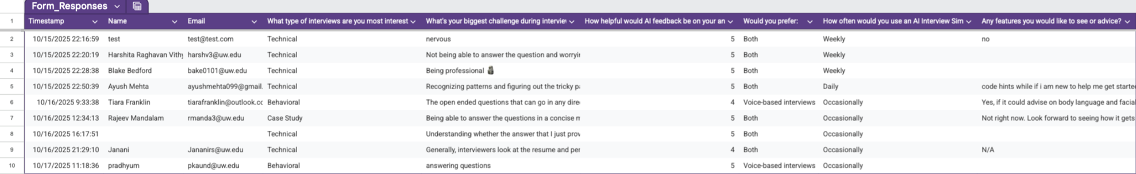

Blank repo deployment
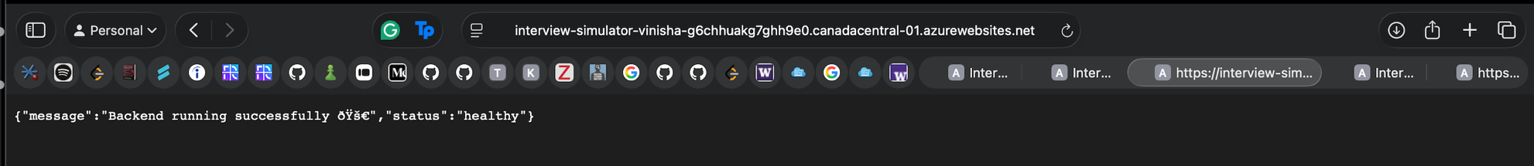

5. Next week’s plan
- Take user feedback seriously and begin drafting a plan to cater to their needs
- Begin implementing a simple frontend interface using React (home page + mock interview button).
- Create API endpoints in FastAPI to test frontend-backend connection.
- Analyze feedback results and prioritize top 3 user-requested features.
- Start drafting user journey flow for the interview session.

Individual Weekly Report for Vinisha Bala Dhayanidhi
LLM Powered Interview Simulator, 12th October 2025

1. Key design/development/learning accomplishments
- Design:
- Created a rough draft of the repository (separate directories for frontend and backend)
- decided which languages to use i.e., Python for backend, React for frontend, and OpenAI API for LLM integration.
- Development:
- Finalized on a project idea i.e., an AI driven interview practice simulator that allows users to practice behavioral and technical interview questions powered by GPT model.
- Set up initial environment files (.env)
- Learning (e.g. new language, framework, tools)
- Researched about how to integrate OpenAI GPT API with FastAPI endpoints
- Reviewed documentation on LangChain for potential conversation memory management.
- Researched very little about CORS setup between FastAPI and React frontend

2. Project Schedule Update

Week | Objectives Planned | Activities/Tasks | Deliverables (Quantified) | - What you could/should have done differently  - What went well  - Condensed Version Only
Week #1
Week #2
Week #3 | Set up repository and tech stack after splitting up from the group and doing solo project | Created Github repo and decided frameworks | Repo initialized with README and license | I really wish that I had chosen this project from the start and not wasted three weeks thinking about ideas. At the same time, I’m glad I chose this project now and not wasted my entire capstone.
Week #4
Week #5
Week #6
Week #7
Week #8
Week #9
Week #10

3. Reflection/Comments (Full Version of “What Went Well/What You could/should have done differently)
This week went well overall. I’m glad that Andriy and Justin agreed to split smoothly and the setup process for my project was smooth. I’m happy with the pace of my progress so far. If I could have done something differently, I’d have started with this idea and documented the setup steps more thoroughly. I also plan to explore modular API design early so future integration (like mock interviews or feedback scoring) will also be smoother.

4. Evidence of Work

https://www.youtube.com/watch?v=EtldFS3JbGs

Conversational Memory in LangChain for 2025 youtube video

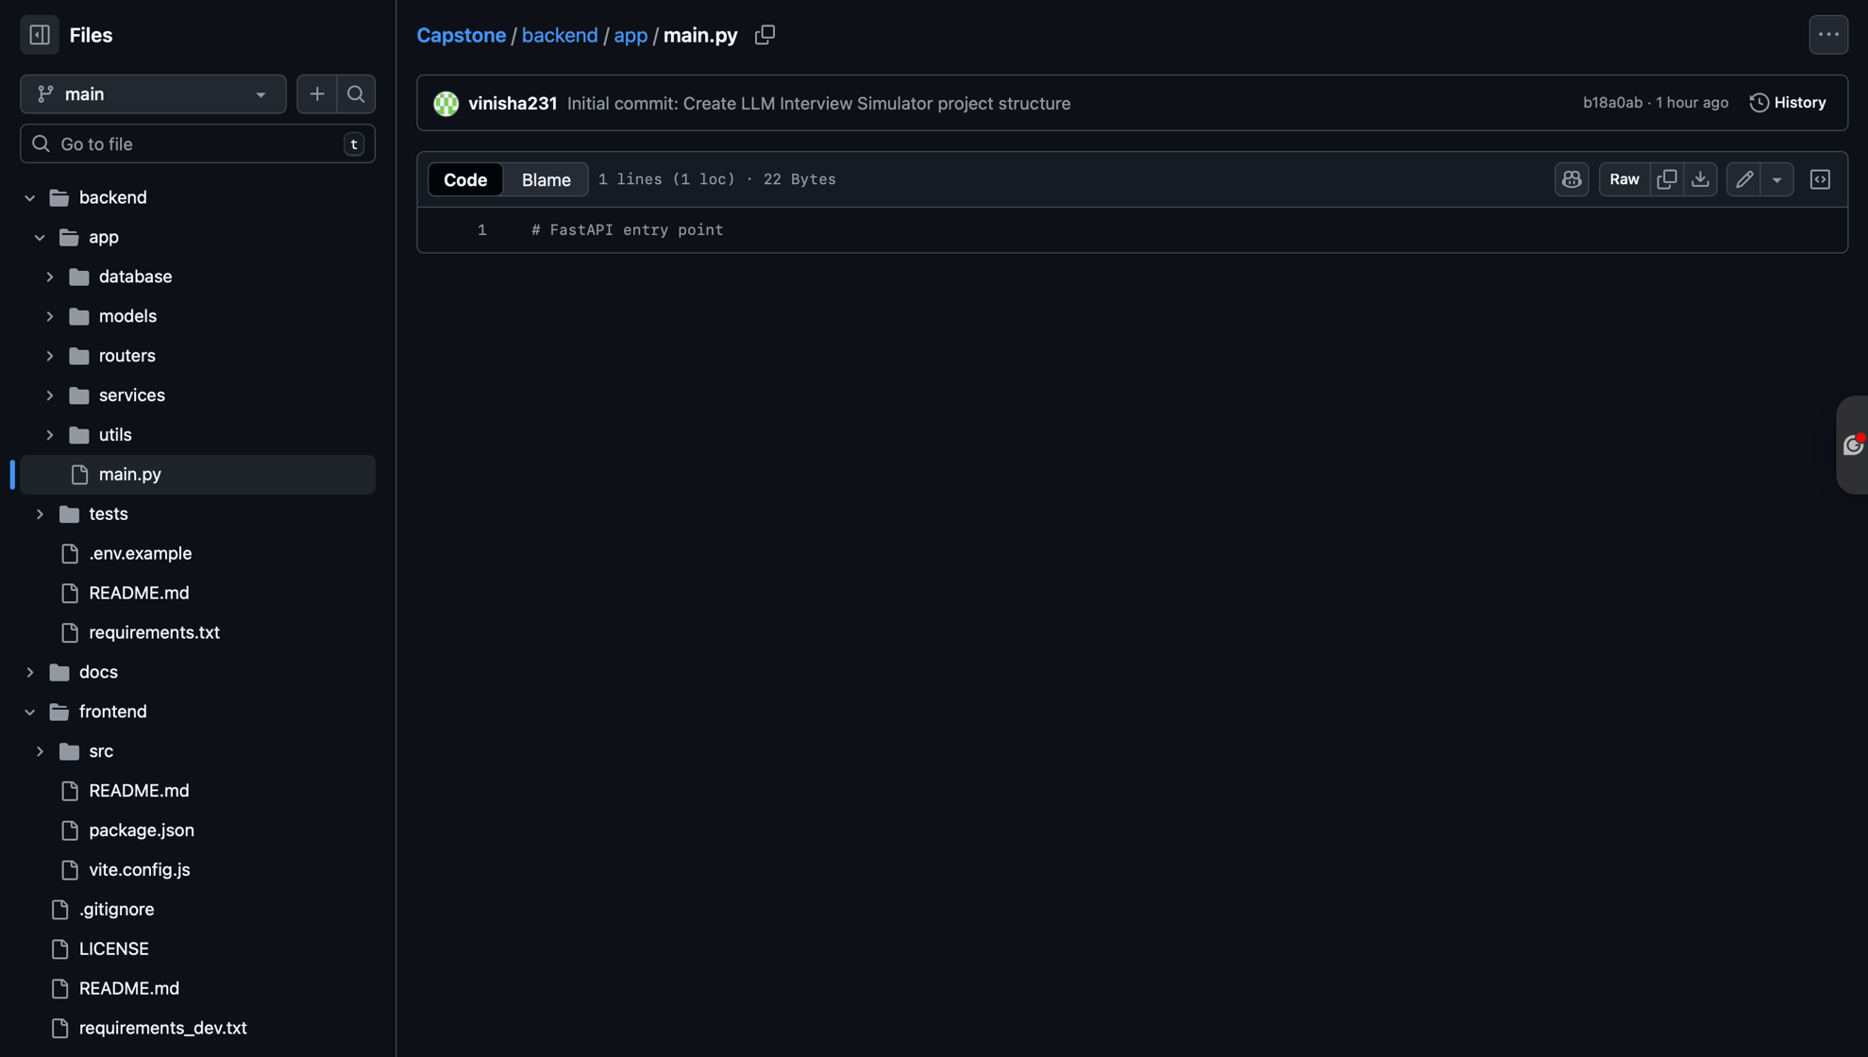
Github repo

https://www.youtube.com/watch?v=14102ccnZ48

FastAPI and React Full-stack Application: How to add COR to fastAPI youtube video

5. Next week’s plan
- Implement frontend skeleton using React.
- Connect frontend to backend using Axios and test API communication.
- Begin designing database schema for storing user sessions and interview history.
- Draft preliminary mock interview flowchart.

