Some Important Notes on Clustering

Ruhi Ghosh
Post Graduation Program in Data Science
Praxis Business School
Bangalore, Karnataka- 560102
ghoshruhi09@gmail.com

Vinisha
Post Graduation Program in Data Science
Praxis Business School
Bangalore, Karnataka- 560102
vinisha.maurya@gmail.com

Abstract— In this paper, various experiments on clustering is explained. Clustering is an unsupervised learning algorithm. It is an assignment of a set of observations into subsets (called clusters) so that observations in the same cluster are similar in some manner. Clustering is broadly explained in two types here: Hierarchical Clustering and K-Means Clustering along with their characteristics.
Keywords— Clustering, Hierarchical Clustering, K-Means Clustering, Linkage, Euclidean distance, Correlation distance

Introduction
Clustering is a machine learning technique which is used mainly to group data points. It segregates the population or the data points into a number of groups. Each data points inside each group are similar to each other and dissimilar to the data points in other groups. It mainly groups data on basis of similarity and dissimilarity. It is a common technique for statistical data analysis.

Figure A: Clustering

Classification of clustering

Hierarchical Clustering
Hierarchical Clustering is that approach of clustering which divide the similar pattern of data by constructing a hierarchy of clusters. It is also called as connectivity based clustering. It mainly clusters the data based on their distances. Few of the distance metrics used for hierarchical are: Euclidean distance, Squared Euclidean distance, Manhattan distance, Maximum distance, Mahalanobis distance. It gives a tree like visualization representation of data, known as dendogram. The number of clusters to form is not known in prior. Hierarchical Clustering is classified as
1. Agglomerative Hierarchical Clustering
2. Divisive Hierarchical Clustering.

Agglomerative Hierarchical Clustering
It is bottom-up approach. The criteria used in this method for clustering the data is min distance, max distance, average distance, centre distance. It is also called as AGNES. The steps involved in this method are:
Step 1: It Consider each of the observations as a single cluster.
Step 2: Group the most similar objects, using some similarity measures, e.g. Euclidean distance.
Step 3: Merge the similar groups into new cluster.
Step 4: Continue as the similarity decreases and all subgroups are fused into a single cluster.

Divisive Hierarchical Clustering
It is top-down approach. It is opposite of agglomerative method. It is also known as DIANA. The steps involved in this method are:
Step 1: Starts with a single cluster (with all observation in it)
Step 2: Divide the single cluster into two clusters so that the clusters are as much different as possible.
Step 3: Divide these two subgroups further into dissimilar subgroups.
Step 4: Continue the process until as many clusters as the number of observations are formed.
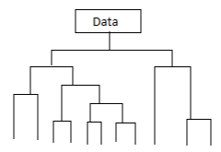
Figure B: Dendogram obtained for the data
Hierarchical Clustering determines the proximity matrix containing the distance between each data point using distance function before clustering the data. There are three measure of cluster proximity: single-link, complete-link and average link.
Table A: Types of linkages
Linkage | Description
Single | Minimal inter-cluster dissimilarity i.e. the distance between two clusters to be the smallest distance between two points such that one point is in each cluster
Complete | Maximal inter-cluster dissimilarity i.e. the distance between two clusters to be the largest distance between two points such that one point is in each cluster.
Average | Mean inter-cluster dissimilarity i.e. the distance between two clusters to be an average distance between two points such that one point is in each cluster.

K-Means Clustering
K-means clustering is a technique for partitioning a dataset into k distinct, non-overlapping cluster based on similar attributes or features. Here K is positive integer number defining the number of clusters. It is a centroid-based clustering method. The number of cluster i.e. k needs to be pre specified in advance, which is considered as a drawback at times. The main logic for K-Means clustering is that a good clustering is one for which the within-cluster variation is as small as possible, that means that each cluster should have similar type of data with minimum variation among each other.
Algorithm for K-Means:
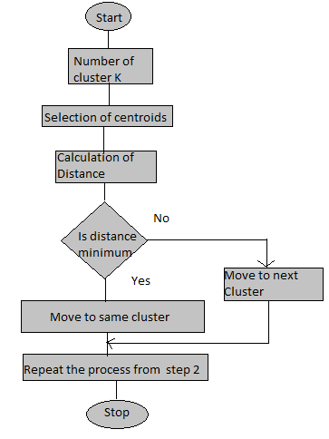

Experiments around clustering
Simulated experiments are performed to validate the concepts of clustering through various cases.

Case 1: Nested Cluster Limitation of Hierarchical clustering
In hierarchical clustering, clusters are obtained by cutting the dendogram at a given height are necessarily nested within the clusters obtained by cutting the dendogram at any greater height. This can be a limitation of hierarchical clustering. To understand this, an experiment has been conducted.
Related work: A simulated data- Data 1 with columns- avg_glucose_level, bmi, Gender, State used. Total observations: 12. Data 1 has ‘gender’ variable has 50-50 split of male and female, and this is evenly split between ‘states’- UP, Jharkhand, Karnataka.
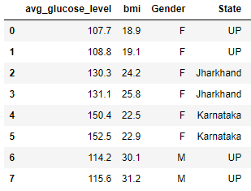
Figure 1.1: Data 1
In this scenario the best division into two groups might split Data 1 by gender, and the best division into three groups might split them by state.
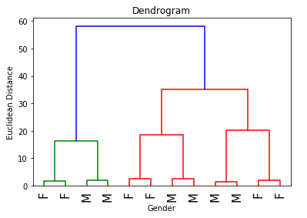
Figure 1.2: Dendogram
Here, the true clusters are not nested, i.e. the best division into three ‘state’ groups does not result from taking the best division into two ‘gender’ groups and splitting up one of those groups. This ends up as a limitation for hierarchical clustering.

Case 2: Dissimilarty metrics in Clustering
The choice of distance measures is a critical step in clustering. It defines how the similarity of two elements (x, y) is calculated and it will influence the shape of the clusters. Based on the business problem, different dissimilarity metrics are used.

- Euclidean distance:
Most common dissimilarity metric is Euclidean distance, which calculates the distance between two observations.
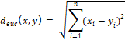

- Correlation distance:
The Pearson correlation measures the degree of a linear relationship between two profiles.

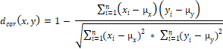
Both dissimilarity measures have their own benefits. To check this, following experiment has been perform considering retail business problem, where retailer wants to segment his customers.
In online retail business, the retailer’s area of interest would be mainly to classify his customers into segment as:

- Where customers are segmented based on their purchase behavior towards certain products. This can be achieved by checking the correlation between them.

- Which customers are buying less and who all are buying more? This can be obtained by calculating the Euclidean distance between observations.

Related work: A simulated online retail Data-2 used. It consists of 11 columns: Customer, product_1, product_2, product_3, product_4, product_5, product_6, product_7, product_8, product_9, and product_10. It contains the count of purchase of products for 5 customers, namely- cust_1, cust_2, cust_3, cust_4, cust_5.

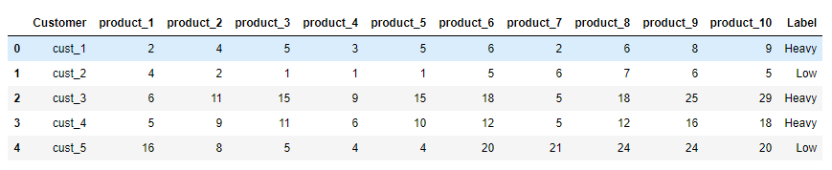
Figure 2.1: Data-2

To see the behavior of dissimilarity metrics in hierarchical clustering, the customers profile has already been created as ‘heavy’ and ‘low’ (by observing their buying behavior for certain products).

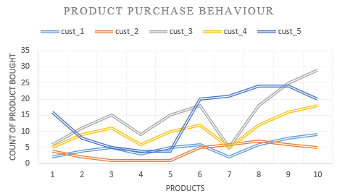
Figure 2.2: Customer behavior plot

From Fig.2.2, a pattern can be seen in customers 1,3 and 4 (labeled as heavy) and similary between 2 and 5 (labeled as low). So, as per correlation metrics should cluster them together. But customers 2 and 5 have quite different values for each variable, so, they have large Euclidean distance. Customers 1 and 2 have similar values for each variable and so there is a small Euclidean distance between them. But they are very weakly correlated, so they have a large correlation-based distance.

After performing hierarchical clustering, following results have been found:
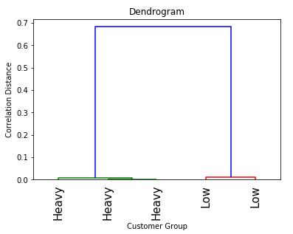
Figure 2.3: Dendogram from correlation distance

With correlation distance metric, the cluster of ‘heavy’ and ‘low’ are clearly visible. Both ‘Heavy’ and ‘low’ cluster customers show similar purchase behavior towards certain products repectively. Heavy buyers and clustered in one group and Low buyers are clustered in another group. Thus correlation profiled the clusters based on cutsemers buying habits.
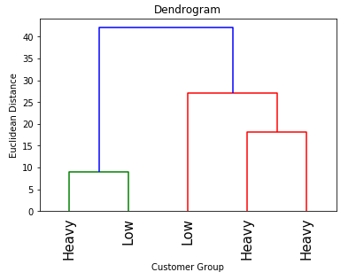
Figure 2.4: Dendogram using euclidean distance

Here, with euclidean distance, the customers are clustered on the basis how much noumber of each product every customer is purchasing. So, customer 1 and 2 are grouped together and customers 3,4, and 5 are grouped together.

Case 3: Importance of Scaling in Clustering
In clustering along with dissimilarity measures, scaling also plays an important role. In scaling, the variables are scaled to have one standard deviation before the inter-observation dissimilarities are computed, and then each variable will in effect be given equal importance in the hierarchical clustering. Scaling can also be done when the variables present are on different scales. To illustrate this theory, continuing with the below experiment:
Related Work: Dataset Used: USArrest, dataset consist of 50 states and 4 different types of crime rate in each state

- Before scaling the data
Performed hierarchal clustering with complete linkage and Euclidean distance on the dataset to form clusters of similar states.
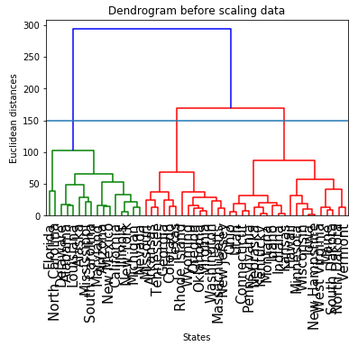
Figure 3.1 : Dendoram obtained before scaling the data
- After scaling the data
After scaling the data, performed Hierarchal Clustering with complete linkage and Euclidean distance on data to form clusters of similar states.
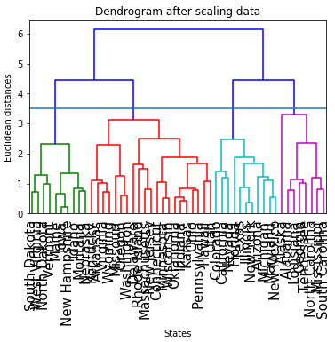
Figure 3.2 : Dendogram obtained after scaling the data
Thus scaling plays an important role, as it’s seen in the above experiment that without scaling, clustering yields a 3 cluster based solution(by cutting dendogram at certain height) i.e. it grouped similar states into 3 groups whereas after scaling the same data 4 cluster based solution is obtained i.e. it grouped similar states into 4 groups. The groups are formed based on the crime rates and states with similar crime rates are grouped under same cluster. Hence, without scaling, groups might be miss-leading here as there is a loss of information for one extra group which is obtained when clustering performed with scaling as it clubs more accurate data point into similar groups.
Table 3.1: Comparison Table
Groups formed | Number of States (Before Scaling) | Number of States (After Scaling)
0 | 17 | 9
1 | 21 | 22
2 | 15 | 12
4 | No Values | 10

Thus scaling the data yields more accurate results in clustering when the data is mixed numerical i.e. the values are not really comparable. But if the data is well defined and are in same scale, then without scaling the data will generate a better result in clustering.

Case 4: Choice of Linkage
In hierarchical clustering linkage mainly defines the dissimilarity between groups. The three common types of linkages used are-single, complete and average. Illustrating the three different linkages by an experiment below:
Related Work: Dataset used: NC160, data consist of 6,830 gene expression measurements on 64 cancer cell lines.
- Single Linkage: Using hierarchical clustering of cell lines on scaled data obtained single linkage. [Fig 4.1]
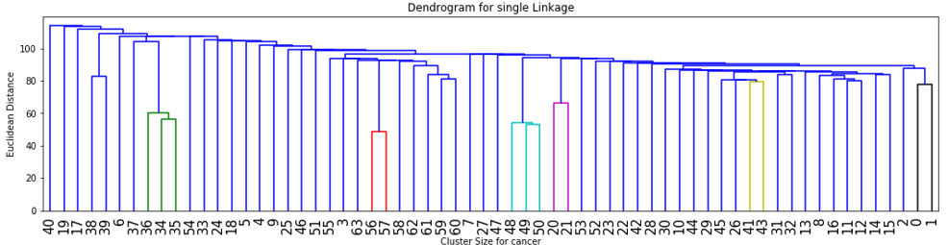
Figure 4.1: Dendogram of Single Linkage
- Complete Linkage: Using hierarchical clustering of cell lines on scaled data obtained complete linkage. [Fig 4.2]
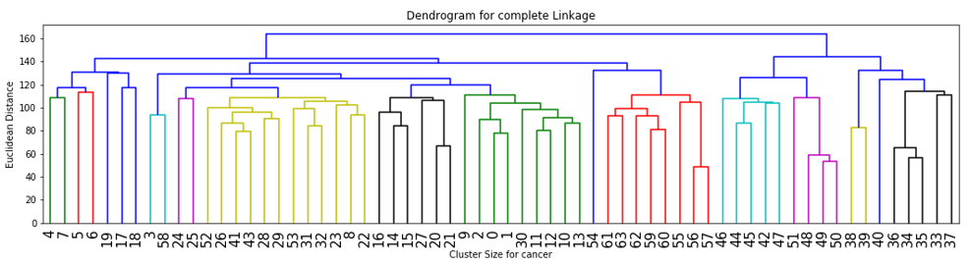
Figure 4.2: Dendogram of complete linkage
- Average Linkage: Using hierarchical clustering of cell lines on scaled data obtained average linkage. [Fig 4.3]
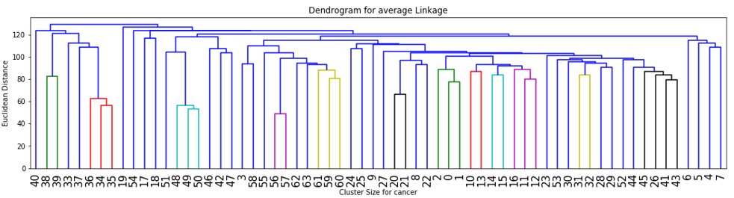
Figure 4.3: Dendogram of average linkage
From the experiments conducted above, it is seen that complete and average linkage gives more balanced and attractive cluster whereas single linkage produces straggling clusters by attaching individual observations one by one. The merging of observations in single linkage is completely local, thus a chain of points is extended for long distance. This effect is also known as chaining. Hence, complete and average linkage is most preferred for hierarchical clustering.

Case 5: Effect of Outlier in Clustering
Outliers are the observations that are far away from the rest of the observations of the dataset. Like every other statistical method, clustering also gets affected by the presence of the outlier observation.
One of the drawback of the clustering algorithm is that both K-Means and hierarchical clustering force every observation into a cluster, the clusters found may be heavily distorted due to the presence of outliers that do not belong to any cluster. This is not an appropriate way of grouping observations. To illustrate this, following experiment has been conducted with simulated data.
Related work: simulated Data-3 used. It consists of 3 variable (namely: a, b, and c) and 24 observations. In observations 6 and 21, outlier has been deliberately inserted as 1000 in variable ‘c’ and 900 in variable ‘b’ respectively.
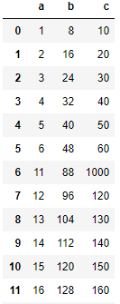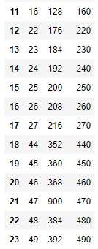
Figure 5.1: Data-3
For Data-3, ideally obersevations 6 and 21 should not be grouped into any cluster with other observation, but due to their tendency to assign every observation to some cluster, they try to cluster these outliers into other clusters.
a) Output From Hierarchical Clustering

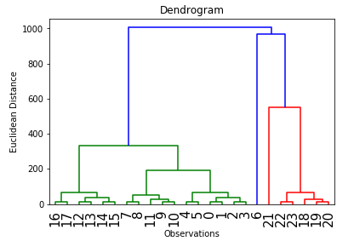
Figure 5.2: Dendogram of Data-3
From Fig.5.2, it is clearly visible that observation 21 has been clustered with observations-22,23,18,19,20. Also if 2-cluster solution is taken, then observation 6 is also clustered in same gorup. This output is subjected to large amount of within cluster variance, which results in high error.

b) Output from K-Means Clustering
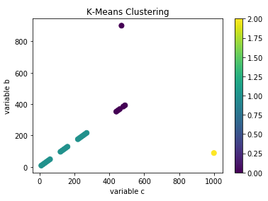
Figure 5.3: Scatter plot for 3-clusters formed by k-means
From k-means clustering, when k is 3, the observation 21 is clustered (showed in voilet color).
The above experiment clearly depict the drawback of clustering algorithm, that they fail to identify outliers.
One of the solution to handle this situation is to use mixture-models. In Guassian mixture model, data points are assinged to clusters with certain probabilities. Here rather than identifying clusters by “nearest” centroids, a set of k gaussian’s is fitted to the data. Then, the gaussian distribution parameters are estimated such as mean and Variance for each cluster and weight of a cluster. After learning the parameters for each data point, the probabilities of it belonging to each of the clusters can be calculated.

F. Case 6: Advantages and Drawbacks of Clustering

a) Issues in Clustering
Clustering comes with its own advantages and disadvantages. The few of the issues in clustering are:
- The identification of distance metrics
- Structure of data
- The number of cluster
1. As, it was illustrated above in case 2 in the paper clustering can be done with different types of distance metrics but to identify the exact distance metrics for a business problem is challenging. Until the exact distance metrics used the clustering may not yields the perfect results.
2. The structure of data plays a vital role, as seen in case 4, results obtained with and without scaling of the data were very different.
3. Clustering cannot handle missing values on its own. If a missing value is present in the data, it has to be properly imputed before applying the techniques of clustering.
4. Outliers present in data are another challenge for clustering as it’s seen in case 5. The number of clusters to obtain is again a challenging task, as it mainly depends on the business problem and the intuition behind it.
The types of clustering i.e. Hierarchical Clustering and K-Means Clustering have their own merits and demerits.

b ) Advantages of K-Means Clustering
- Time Complexity: In Hierarchical and K-Means Clustering
Related Work: Both Hierarchical and Clustering techniques are applied on the same data set one at a time. And it is observed that the time taken by K-Means is comparatively lesser than time take by hierarchical to form clusters. This is because K-Means algorithm is more efficient for a large dataset and takes less time to compute than Hierarchical algorithm.
Time take by Hierarchical Clustering:
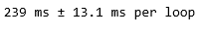
Time take by K-Means Clustering:
- Elbow Plot: In K-Means Clustering
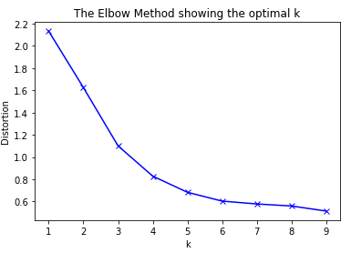
Figure 6.1: Elbow plot
Elbow plot method to determine the optimal number of clusters for k-means clustering.
Related Work: Applied k-means clustering on a dataset and ran the model for a range of values of (here it is 1 to 10) and for each k calculated the sum squared errors (SSE). Then plotted a line chart of SSE for each value of k. The goal is to choose a small value of k that has a low SSE i.e. to choose that value of k where SSE abruptly decreases (for example here appropriate value of k would be 5). This method only works well when the data is clearly clustered. This is one of the advantages which K-Means has. Elbow method could be also used as validate the number of clusters.
This could not be implemented for hierarchical model as we do not need to pre-specify the number of clusters

c) Disadvantages of K-Means Clustering
- Selection of initial centroid
As, all the experiments conducted in above in the paper suggests to pre-specify the value of k for k-means clustering, this is not a optimal approach, as, the number of clusters are assigned even before visualizing the clusters i.e. forcefully setting the number of clusters which might even be wrong as the inital cluster assignement is at random.

c ) Advantages of Hierarchical Clustering
- Visualisation:
Hierarchical Clustering gives tree like visual represntation of observation, called Dendogram.
- Choice of Dissimalirity Measures:
Hierarchical Clustering is based on distance metrics and it gives an ease to choose the distance metric to be applied on data depending on the problem (Case 2)

. d ) Disadvantages of Hierarchical Clustering
- Time Complexity:
As seen before the time taken by Hierarchical Clustering for a large dataset is high.

- Misinterpretation of Dendogram:
Dendrograms are provided as an output to hierarchical clustering. Many users believe that such dendrograms can be used to select the number of clusters. However, this is true only when the ultrametric distance matrix (without errors) tree inequality holds, which is rare, if ever, the case in practice.

Conclusion
This paper presented some important concepts of clustering explained via various experiments conducted. Clustering is a broad set of techniques for finding subgroups or clusters in a data set. Clustering techniques can be used for data mining, market segmentation, image analysis, information retrieval, data compression, computer graphics and bioinformatics

Acknowledgment
The authors would like to thank Praxis Business School’s Asst. Professor Gourab Nath-Data Science.

References
- An Intorduction to Statistical Learning (ISLR)
- https://jakevdp.github.io/PythonDataScienceHandbook/05.11-k-means.html
- https://journals.plos.org/plosone/article?id=10.1371/journal.pone.0144059
- https://medium.com/clustering-with-gaussian-mixture-model/clustering-with-gaussian-mixture-model-c695b6cd60da
- https://link.springer.com/chapter/10.1007/978-81-322-2731-1_3
- M. Young, The Technical Writer’s Handbook. Mill Valley, CA: University Science, 1989.
- https://en.wikipedia.org/wiki/Cluster_analysis
- https://www.displayr.com/strengths-weaknesses-hierarchical-clustering/
- https://www.analyticsvidhya.com/blog/2016/11/an-introduction-to-clustering-and-different-methods-of-clustering/
- https://nlp.stanford.edu/IR-book/html/htmledition/single-link-and-complete-link-clustering-1.html
- https://medium.com/datadriveninvestor/k-means-clustering-b89d349e98e6
- https://towardsdatascience.com/the-5-clustering-algorithms-data-scientists-need-to-know-a36d136ef68
- https://pdfs.semanticscholar.org/12f4/a1852e95939080b695edbb7d23183918689e.pdf

