**QUESTIONNAIRE:**

This questionnaire will help me make improvements to help suit your preference. Therefore I would love if you answer honestly and truthfully to help me succeed in my project.

Name: ______________________________________________________

1ai) What gaming console do you use frequently? _____________________________

aii) Do you prefer gaming on a pc such as a laptop and computer or your phone and tablet? __________________________________________________________________________________

2) How would you prefer my gaming software to be operated? ______________________________ _________________________________________________________________________________

3) What buttons should I have on my main menu? ________________________________________ _________________________________________________________________________________

4) How long should the timer be for each round a player receives? ____________________________ __________________________________________________________________________________

5) What colour should I do for each of the following?

i) The background: __________________________________________________________________

ii) The sovrano board: _______________________________________________________________

iii) The game pieces for each player: ____________________________________________________

6) Would you compete to be on the leader board or does that not matter to you? _______________ __________________________________________________________________________________

Thank you for completing this questionnaire, if possible could I receive this form back as soon as possible so I’m able to make some adjustments to my game.

**Results :**

(Response from 10 people)

1ai) Play station [x6]

Nintendo switch[x1]

Xbox [x2]

Don’t game [x1]

aii) Computer [x6]

Laptop [x1]

Phone [x3]

2) Computer[x6]

Laptop[x2]

Phone [x2]

3) start game [x10]

Quit game [x9]

Pause [x10]

Resume [x10]

Settings [x3]

4) 40 seconds [x1]

1 minute [x1]

1 minute 30 seconds [x7]

2 minutes [x1]

5i) Ancient/Rustic [x8]

ii) Brown[x9]

iii) Blue and Red [x5]

6) Yes [x6]

No [x4]

**Interview**

1. Would an instruction menu help users understand the games main goal?
2. How many points should you receive for a win, draw or a loss?
3. How long do you think it will take you to make the best possible move?
4. What options should there be on the main menu?
5. Is the layout of the sovrano board suitable for you?
6. Would you play to get onto the leader board or is that not important to you?
7. Would you prefer to use your keyboard to move the pieces into the new position or your mouse?
8. Would you like to play with other players or just against the computer?
9. Would you like to collect the gems to get onto a new level or just use the gems to calculate a win in the one game?

10) How would you want this game to work for you?

11) Should the game have sound effects?

12) Does the look of the game determined if you want to play the game or not?

13) Which background aesthetic do you prefer?

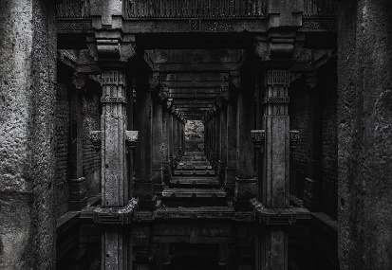A. 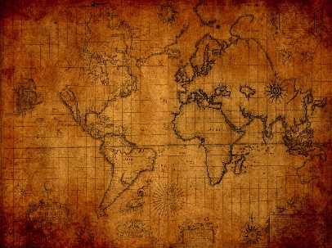 B. 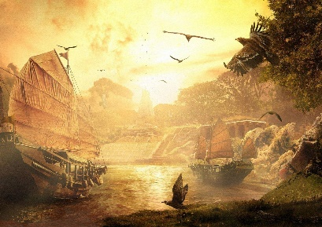 C.

**Interview Results:**

I interviewed 10 people from an age range of 8 to 65 who have played many ancient board games as well as the modern games which have a very similar game layout as sovrano. Through this interview I was able to gather up information and opinions on my game which differed such as question number 2 which had a varied range of results. Whereas for question number 4 the options for my menu buttons were very similar. This feedback helped me understand which features I should keep from my game.

MENU

LEAVE GAME

RESUME

PAUSE

QUIT

LEADERBOARD

INSTRUCTIONS

START