TESTING
TESTCASE #1:
Purpose:
-allow new users to register.
Steps:
- choose register option.
- fill the form with valid details.
-successful if user is created.
Expected Results: New User profile created.
Output and attached ScreenShots:
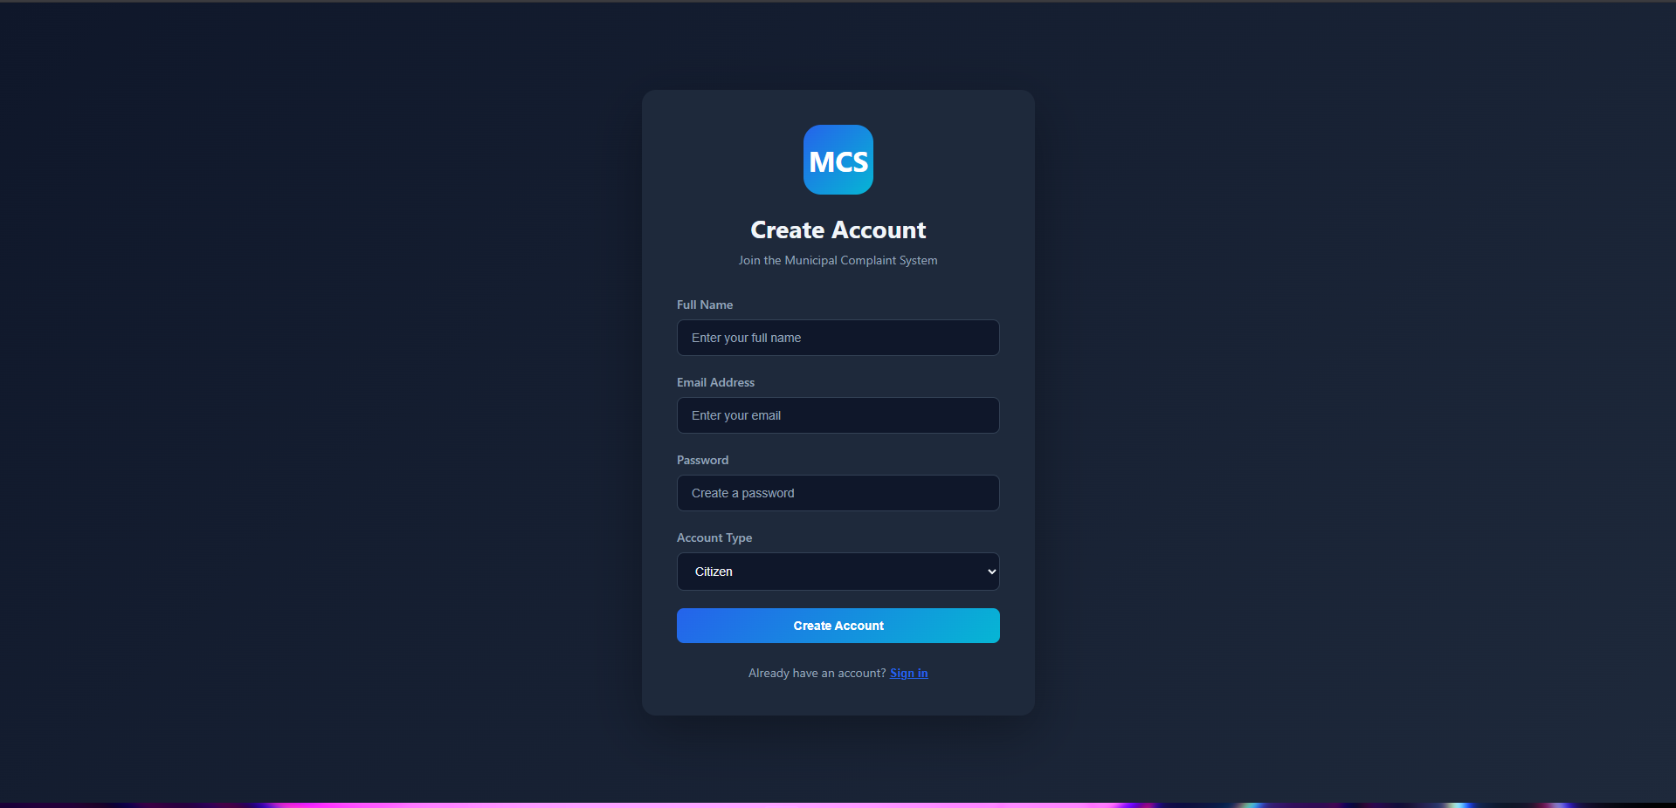
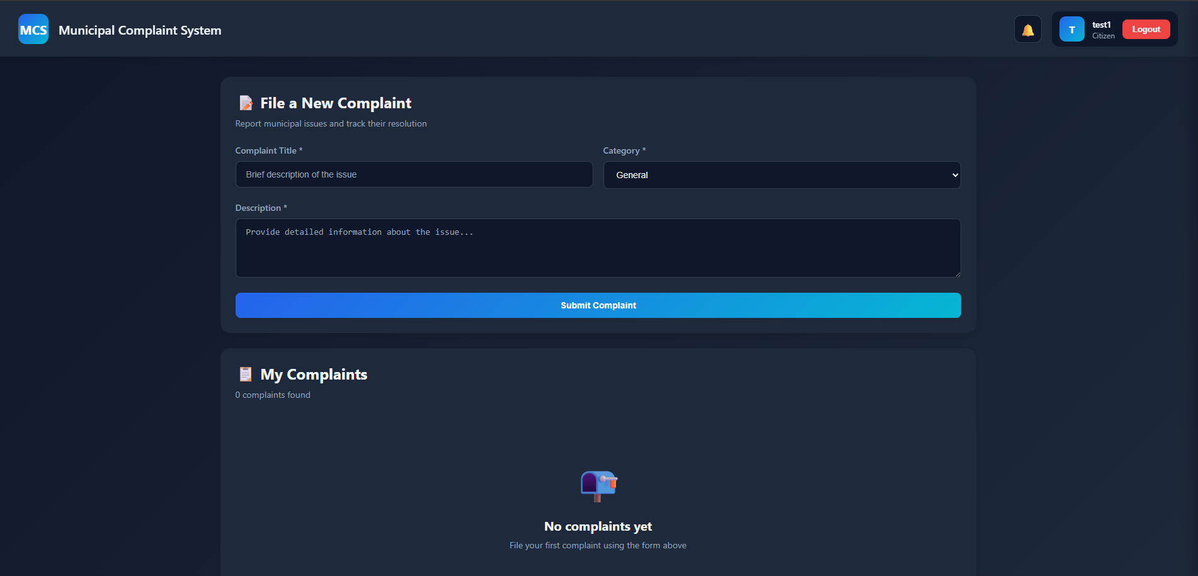
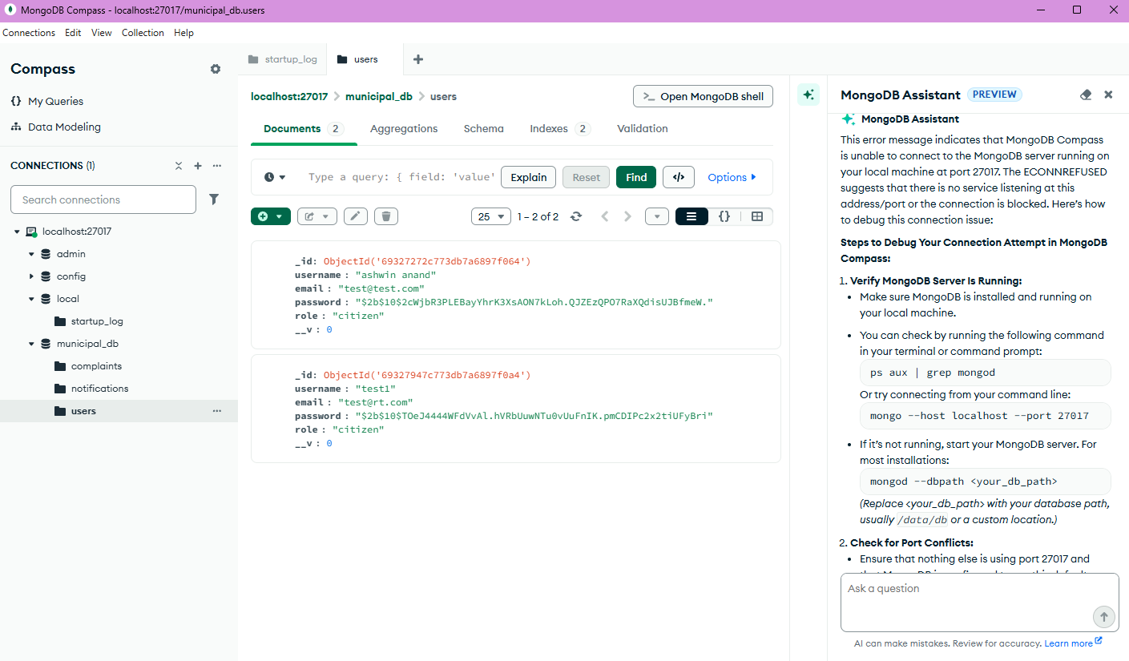
Output: New user Successfully created on registration.
Result: Passed.

TestCase#2:
Purpose:
- Allow existing users to Login.
Steps:
- Use the login page.
- Fill details of an existing user.
- Passed if successful login.
Output and ScreenShots:
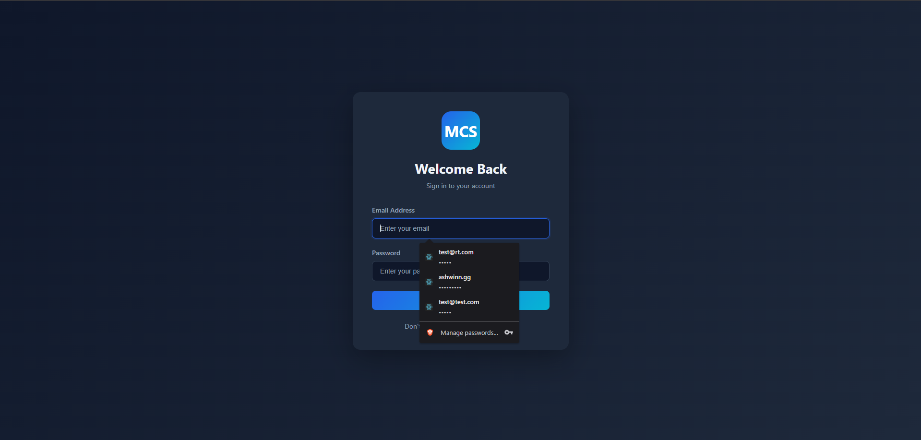
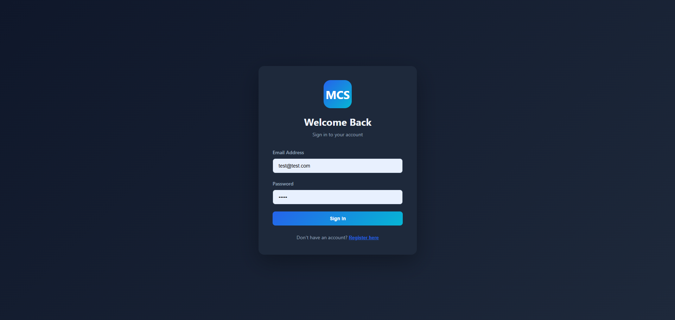
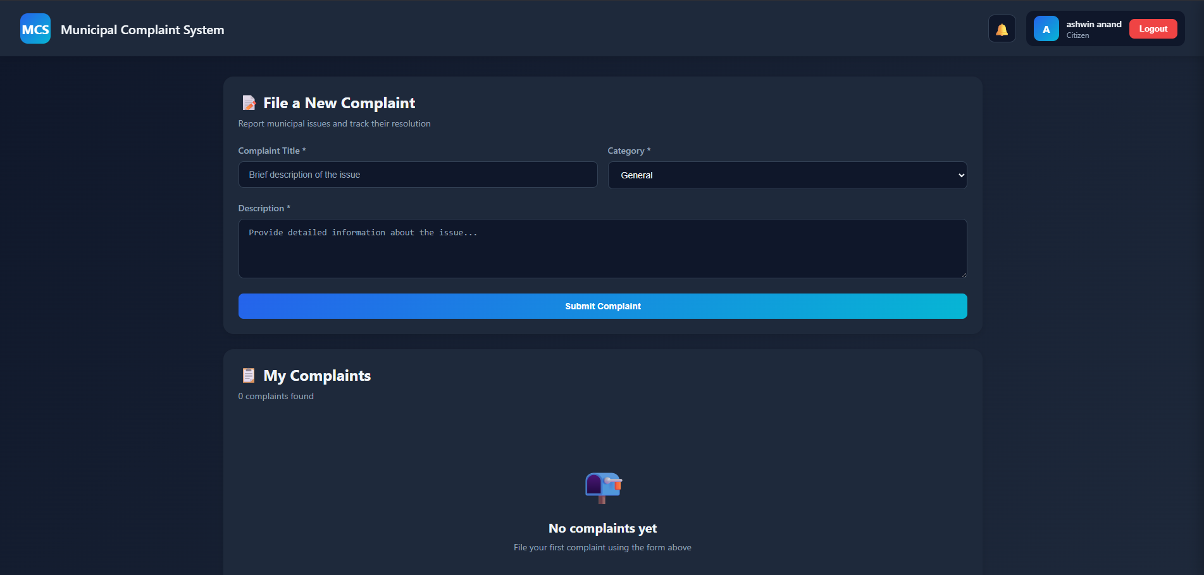
Output: Logged in Successfully.
Result: Passed.

TestCase#3:
Purpose: Authenticated Users Shall be able to file complaints.
Steps:
- Use a logged in session.
- Fill the details on the home page to file a complaint.
- Successful if the complaint is filed.

Output and Screenshots:
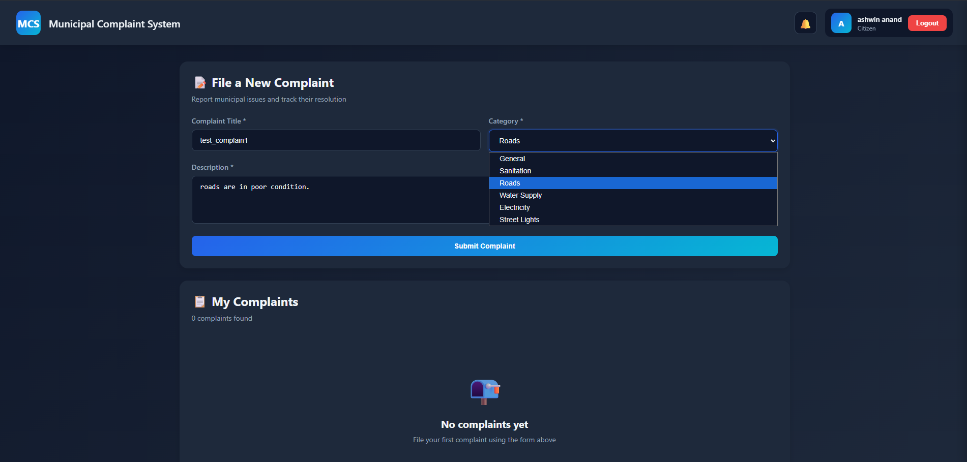
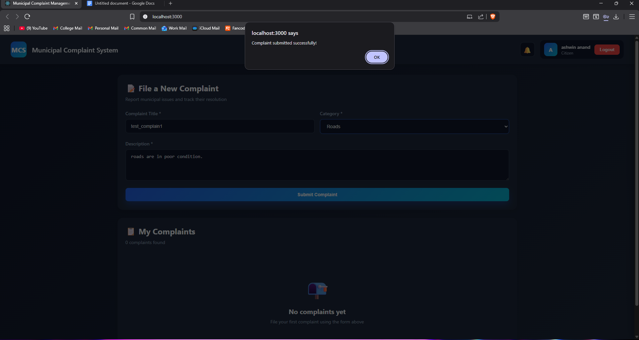
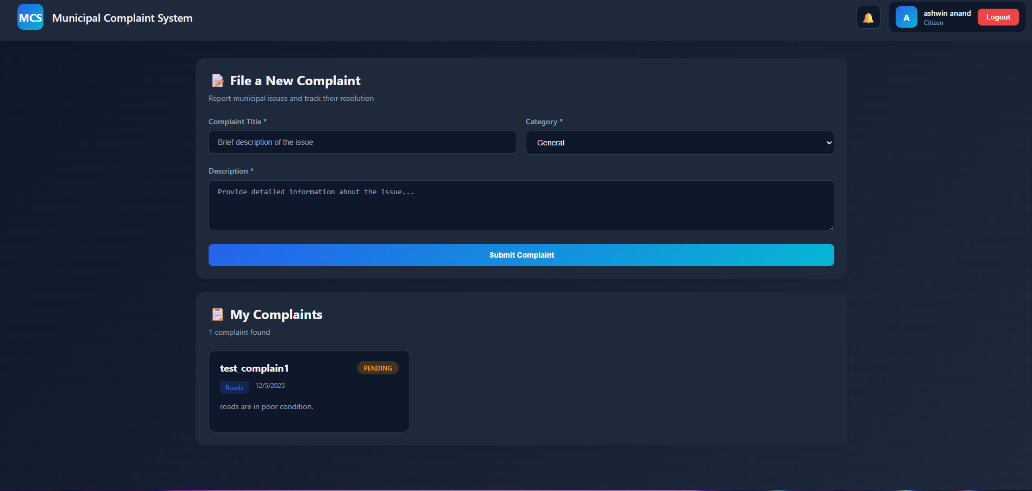
Output: The Complaint is successfully filed.
Result: Passed.

TestCase #4:
Purpose: Users shall be able to view their complaints and Admins can see those complaints along with user details.
Steps:
- Use a logged in session as a user.
- View a complaint which is already made.
- Logout.
- Sign in using an admin account.
- View complaints made by the user.
Output and screenshots:
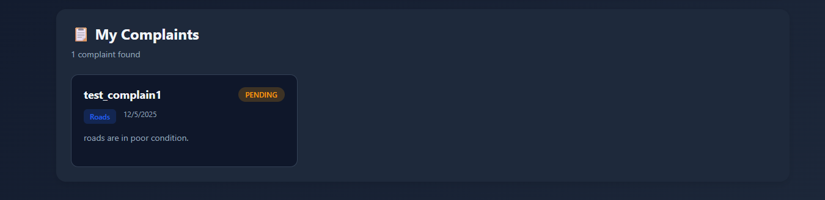
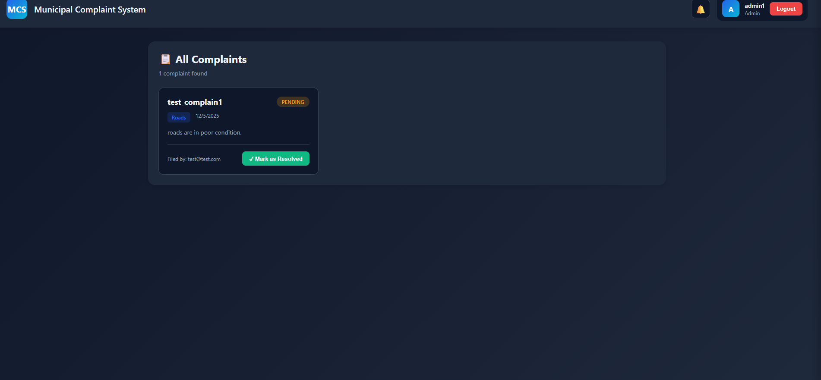
Output: users can see their complaint and admins can see the complaints made by users along with user id.
Result: Passed.

TestCase #5:
Propose: Admins should be able to view the complaints and resolve them
Steps:
- Log in as an Admin.
- From the list of requests mark one as resolved.
Output and ScreeShots:
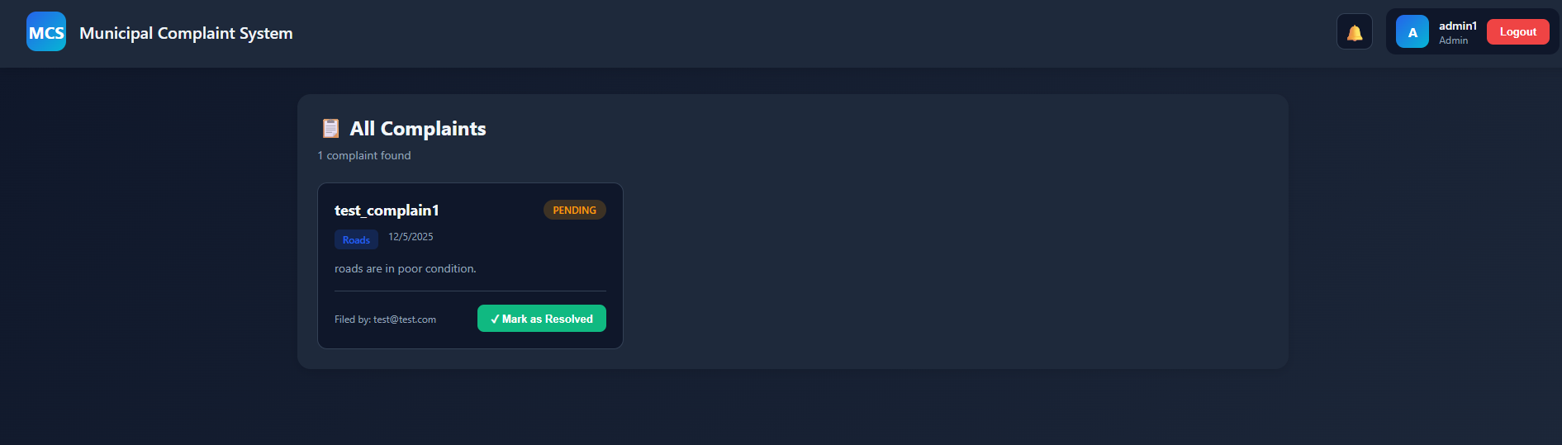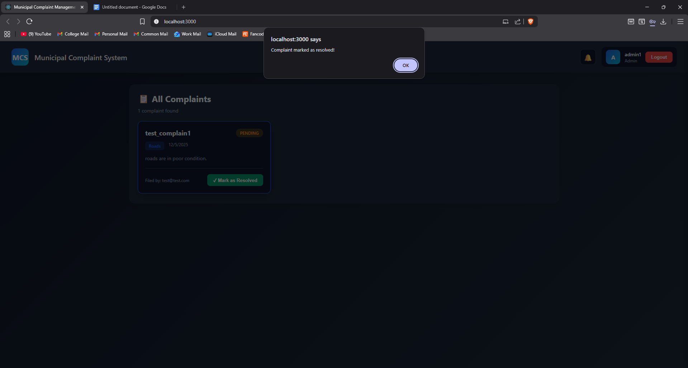
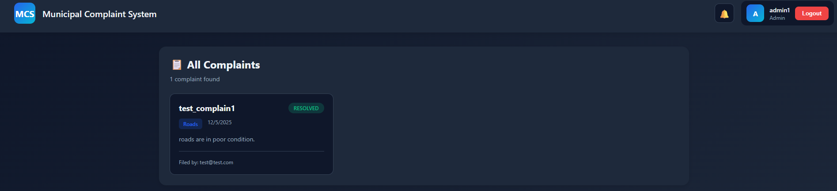
Output: Complaint marked as resolved.
Result: Passed.

Negative TestCase #1:
-Login using invalid credentials.
Steps:
- From the login page enter wrong credentials to check if we get access.
Outcome and ScreenShots:
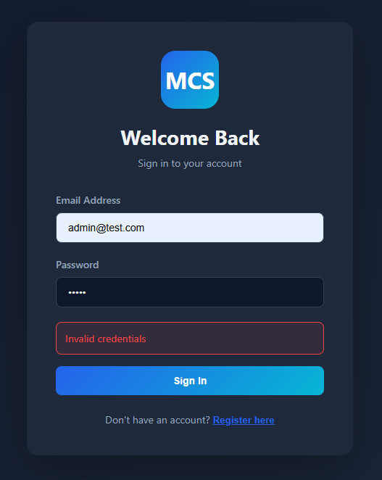
Outcome: Access Denied when credentials are incorrect.
Result: Negative, No error.

Negative TestCase#2:

-Users shall only see their own Complaints.
Steps:
-Login using a user session.
-Check if we can see other User’s complaints or modify them.
Outcome and ScreenShots:
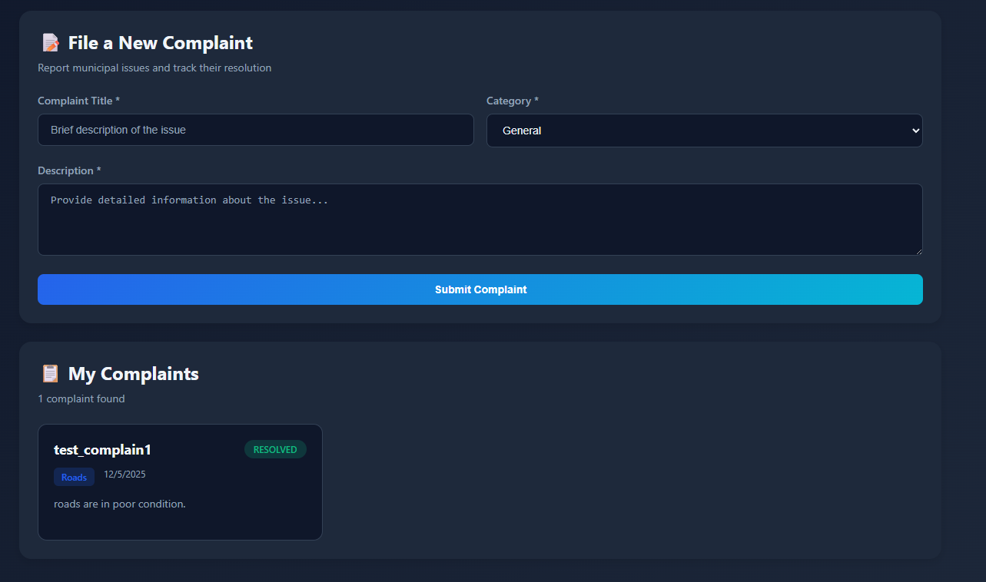
Outcome: A user can only see complaints made by their own.
Result: Negative, No error.

