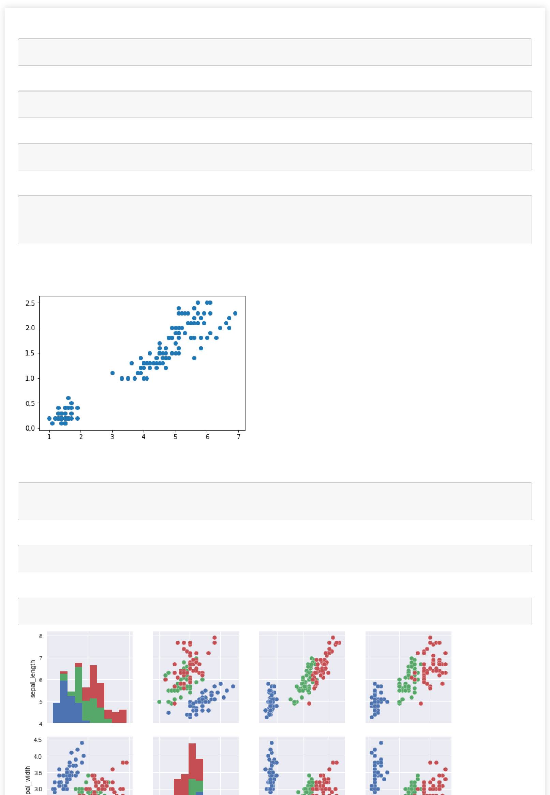In [2]:

**import pandas as pd**

In [3]:

**import matplotlib.pyplot as plt**

In [5]:

data = pd.read_csv('C:/Users/XYZ/Desktop/iris.csv')

In [6]:

fig = plt.figure()

ax = fig.add_subplot(1,1,1)

ax.scatter(data['petal_length'],data['petal_width'])

Out[6]:

<matplotlib.collections.PathCollection at 0x2121d747898>

In [8]:

**import seaborn as sns**

sns.set()

In [9]:

data = pd.read_csv('C:/Users/XYZ/Desktop/iris.csv')

In [10]:

x=sns.pairplot(data, hue='species', size=2.5)



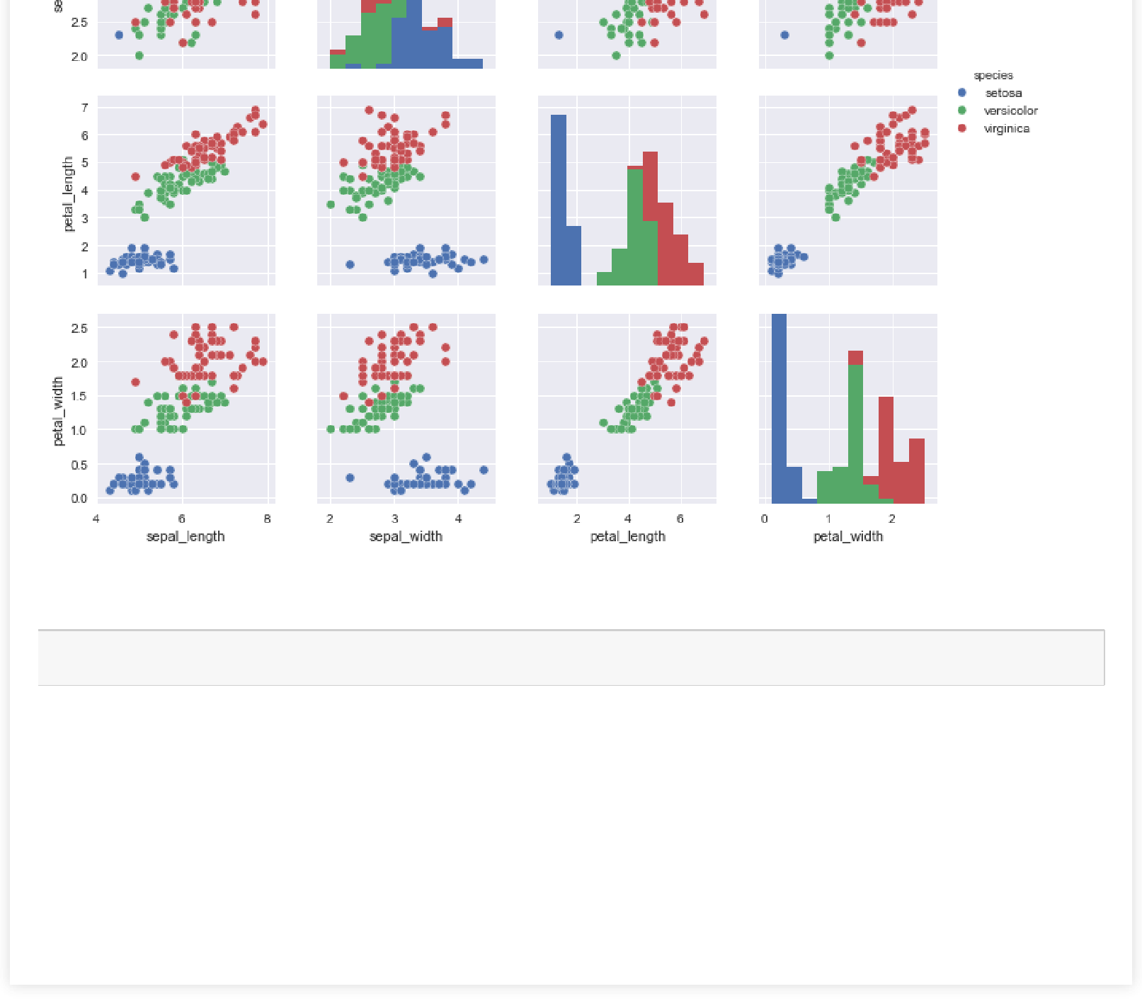

In [11]:

data.corr(method='spearman')

Out[11]:

|  |  |  |  |  |
| --- | --- | --- | --- | --- |
|  | **sepal_length** | **sepal_width** | **petal_length** | **petal_width** |
|  |  |  |  |  |
| **sepal_length** | 1.000000 | -0.159457 | 0.881386 | 0.834421 |
|  |  |  |  |  |
| **sepal_width** | -0.159457 | 1.000000 | -0.303421 | -0.277511 |
|  |  |  |  |  |
| **petal_length** | 0.881386 | -0.303421 | 1.000000 | 0.936003 |
|  |  |  |  |  |
| **petal_width** | 0.834421 | -0.277511 | 0.936003 | 1.000000 |
|  |  |  |  |  |