In [1]:

**import pandas as pd**

**from sklearn.model_selection import** train_test_split

In [2]:

**from sklearn.linear_model import** LinearRegression **import matplotlib.pyplot as plt**

**from sklearn.metrics import** r2_score

In [3]:

filename='C:/Users/Sneha/Desktop/iris.csv'

ds=pd.read_csv(filename)

X=ds['petal_length']

Y=ds['petal_width']

In [4]:

len(X)

Out[4]:

150

In [5]:

X_train, X_test, Y_train, Y_test = train_test_split(X,Y,test_size=0.3)

In [6]:

len(X_train)

Out[6]:

105

In [7]:

len(X_test)

Out[7]:

45

In [8]:

model=LinearRegression()

In [9]:

model.fit(X_train.values.reshape(-1,1),Y_train.values.reshape(-1,1))

Out[9]:

LinearRegression(copy_X=True, fit_intercept=True, n_jobs=1, normalize=False)

In [10]:

* = model.intercept_[0]

In [11]:

* 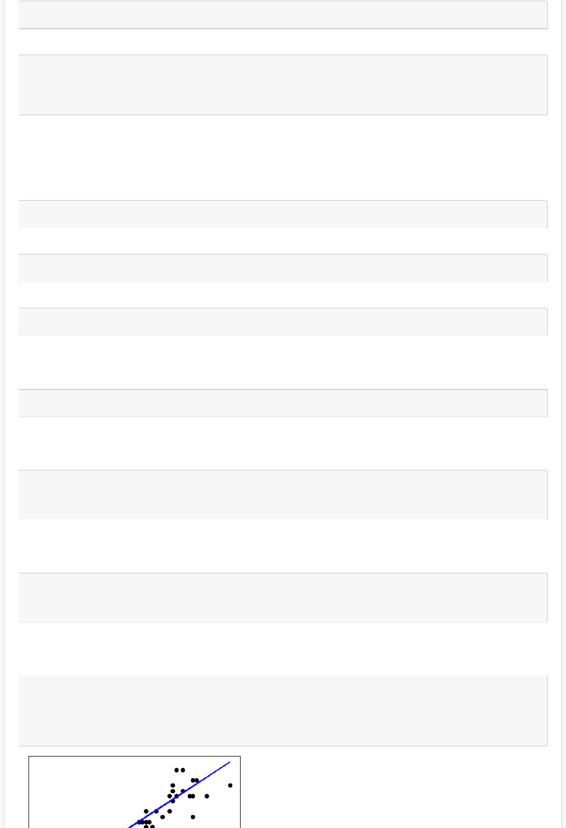= model.coef_[0,0]

In [12]:

print('Intercept is')

print(c)

print('Slope is')

print(m)

Intercept is

-0.38089127699654446

Slope is

0.421757807883999

In [13]:

y_pred=model.predict(X_test.values.reshape(-1,1))

In [14]:

**from sklearn.metrics import** mean_squared_error

In [15]:

print("Mean_Squared_Error: **%.2f**" % mean_squared_error(Y_test,y_pred))

Mean_Squared_Error: 0.04

In [16]:

print("R2_Score: **%.2f**" %**r2_score**(Y_test,y_pred))

R2_Score: 0.92

In [18]:

**from scipy.stats import** pearsonr

r,p = pearsonr(X_test,Y_test)

print (r)

0.9628654686561594

In [19]:

**from scipy.stats import** pearsonr

r,p = pearsonr(X,Y)

print (r)

0.9627570970509662

In [20]:

plt.scatter(X_test,Y_test,color='black')

plt.plot(X_test,y_pred,color='blue')

plt.xticks(())

plt.yticks(())

plt.show()

