1. CREATE DATABASE
MongoDB Query:
use Students
Explanation: Creates or switches to the Student database.
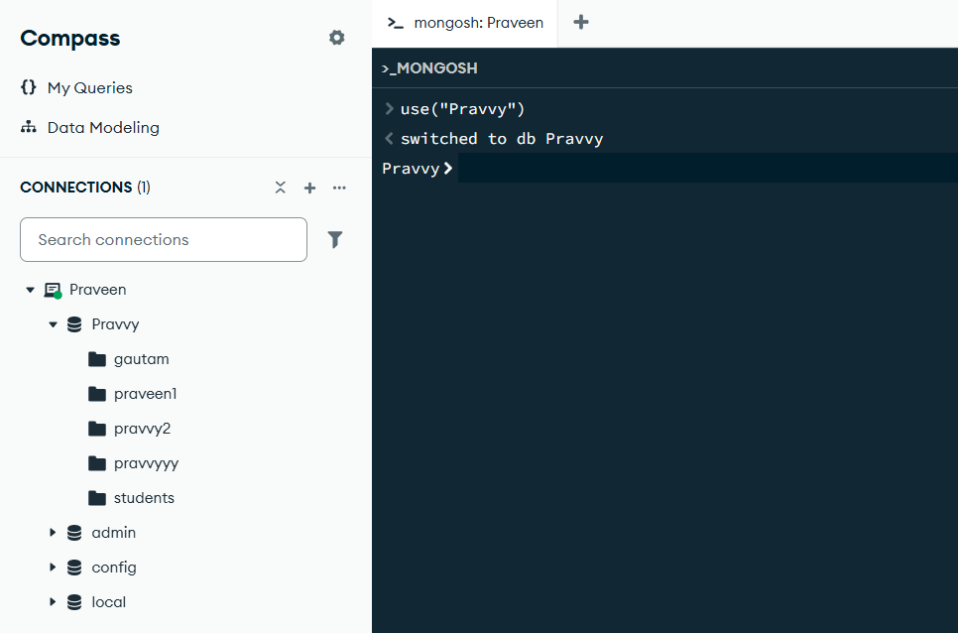

2. CREATE COLLECTION
MongoDB Query:
db. create Collection("students")
Explanation: Creates a collection named students.
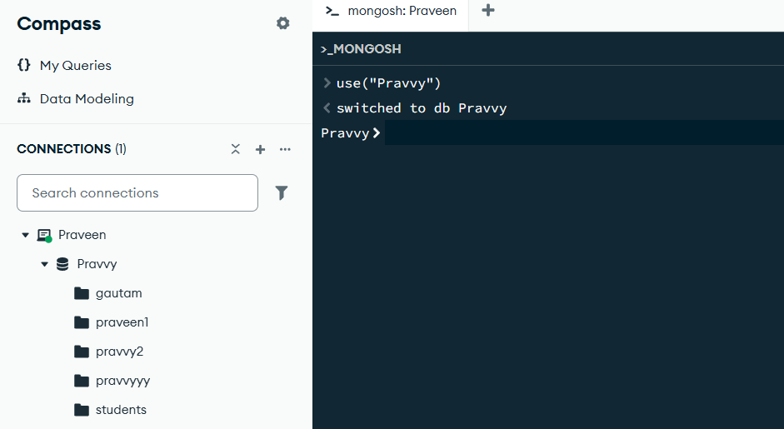

3. INSERT 50 STUDENTS
MongoDB Query:
db.Students.insertMany([
{roll:101,name:"Rahul",age:20,marks:85,city:"Lucknow"},
{roll:102,name:"Priya",age:21,marks:90,city:"Kanpur"},
{roll:103,name:"Amit",age:19,marks:75,city:"Varanasi"},
{roll:104,name:"Neha",age:22,marks:88,city:"Prayagraj"},
{roll:105,name:"Rohan",age:20,marks:92,city:"Agra"},
{roll:106,name:"Anjali",age:21,marks:81,city:"Lucknow"},
{roll:107,name:"Vivek",age:23,marks:69,city:"Ayodhya"},
{roll:108,name:"Sneha",age:20,marks:95,city:"Varanasi"},
{roll:109,name:"Karan",age:22,marks:78,city:"Kanpur"},
{roll:110,name:"Pooja",age:19,marks:87,city:"Lucknow"},
{roll:111,name:"Arjun",age:21,marks:91,city:"Agra"},
{roll:112,name:"Simran",age:20,marks:73,city:"Varanasi"},
{roll:113,name:"Aditya",age:22,marks:84,city:"Prayagraj"},
{roll:114,name:"Kavya",age:21,marks:89,city:"Lucknow"},
{roll:115,name:"Ravi",age:23,marks:76,city:"Kanpur"},
{roll:116,name:"Nisha",age:20,marks:93,city:"Agra"},
{roll:117,name:"Sahil",age:19,marks:68,city:"Ayodhya"},
{roll:118,name:"Isha",age:22,marks:96,city:"Varanasi"},
{roll:119,name:"Varun",age:21,marks:82,city:"Lucknow"},
{roll:120,name:"Riya",age:20,marks:86,city:"Kanpur"},
{roll:121,name:"Manish",age:22,marks:74,city:"Agra"},
{roll:122,name:"Ayesha",age:21,marks:90,city:"Varanasi"},
{roll:123,name:"Deepak",age:23,marks:79,city:"Prayagraj"},
{roll:124,name:"Shreya",age:19,marks:94,city:"Lucknow"},
{roll:125,name:"Mohit",age:20,marks:83,city:"Kanpur"},
{roll:126,name:"Tanvi",age:21,marks:77,city:"Agra"},
{roll:127,name:"Akash",age:22,marks:85,city:"Varanasi"},
{roll:128,name:"Muskan",age:20,marks:98,city:"Lucknow"},
{roll:129,name:"Yash",age:19,marks:72,city:"Ayodhya"},
{roll:130,name:"Divya",age:23,marks:89,city:"Prayagraj"},
{roll:131,name:"Raj",age:20,marks:45,city:"Lucknow"},
{roll:132,name:"Komal",age:21,marks:62,city:"Kanpur"},
{roll:133,name:"Suresh",age:19,marks:38,city:"Varanasi"},
{roll:134,name:"Payal",age:22,marks:71,city:"Prayagraj"},
{roll:135,name:"Nitin",age:20,marks:55,city:"Agra"},
{roll:136,name:"Shalini",age:21,marks:48,city:"Lucknow"},
{roll:137,name:"Gaurav",age:23,marks:66,city:"Ayodhya"},
{roll:138,name:"Ritika",age:20,marks:35,city:"Varanasi"},
{roll:139,name:"Harsh",age:22,marks:59,city:"Kanpur"},
{roll:140,name:"Mansi",age:19,marks:43,city:"Lucknow"},
{roll:141,name:"Abhishek",age:21,marks:81,city:"Agra"},
{roll:142,name:"Sakshi",age:20,marks:52,city:"Varanasi"},
{roll:143,name:"Rohit",age:22,marks:68,city:"Prayagraj"},
{roll:144,name:"Pallavi",age:21,marks:47,city:"Lucknow"},
{roll:145,name:"Kunal",age:23,marks:73,city:"Kanpur"},
{roll:146,name:"Rashmi",age:20,marks:29,city:"Agra"},
{roll:147,name:"Dev",age:19,marks:57,city:"Ayodhya"},
{roll:148,name:"Megha",age:22,marks:64,city:"Varanasi"},
{roll:149,name:"Varsha",age:21,marks:41,city:"Lucknow"},
{roll:150,name:"Sameer",age:20,marks:76,city:"Prayagraj"} ])

Explanation: Inserts multiple student documents into the collection.

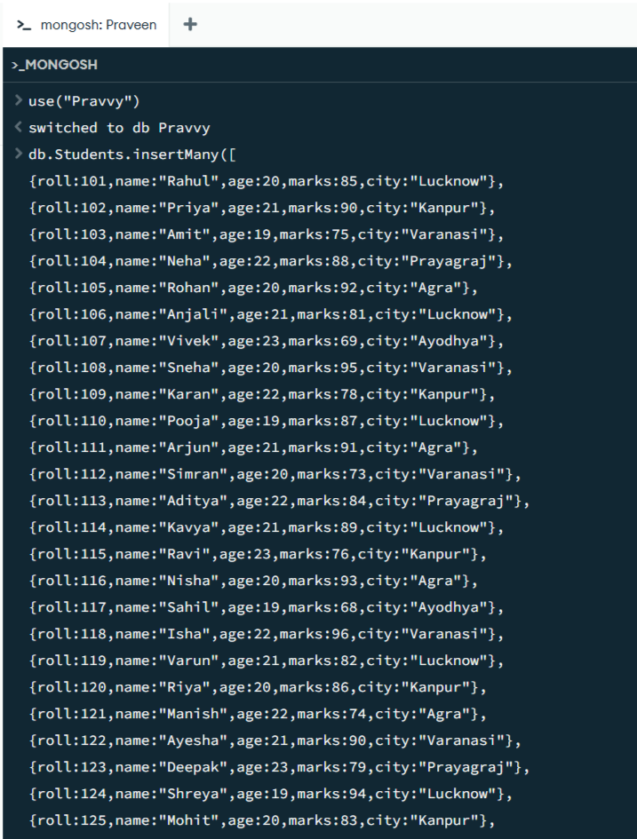

4. DISPLAY ALL STUDENTS
MongoDB Query:
db. students. Find ()
Explanation: Retrieves documents from the students collection.
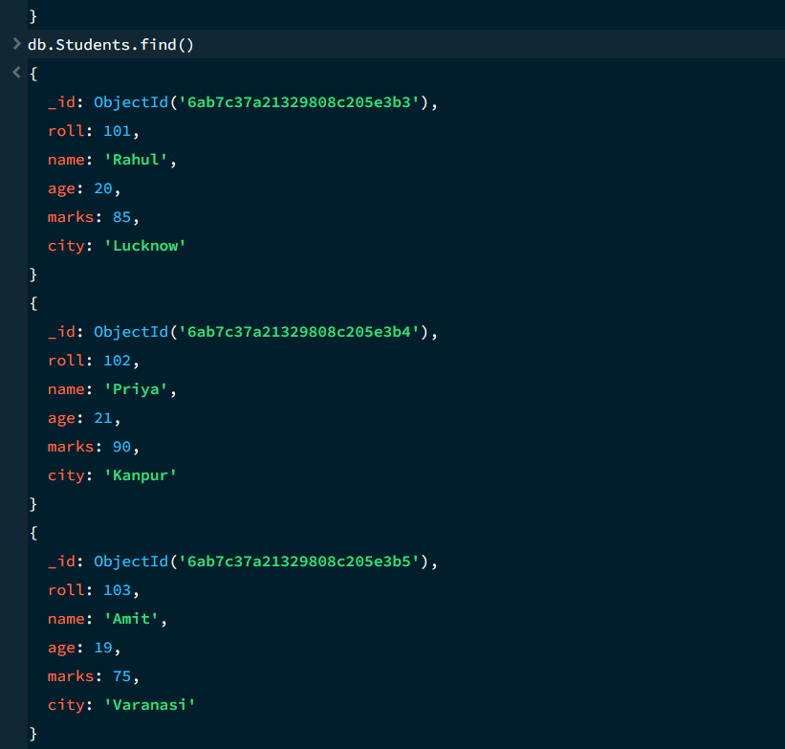

5. EQUAL TO — $eq
MongoDB Query:
db. students. Find ({marks: {$eq: 85}})
Explanation: Finds students whose marks are exactly 85.

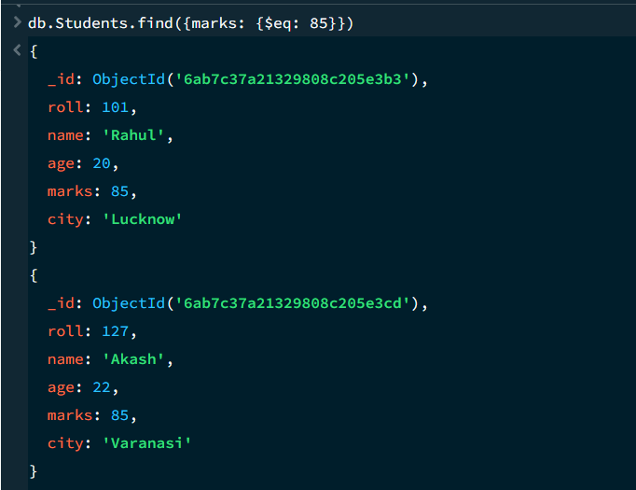
6. GREATER THAN — $gt
MongoDB Query:
db.students.find({marks: {$gt: 85}})
Explanation: Finds students whose marks are greater than 85.

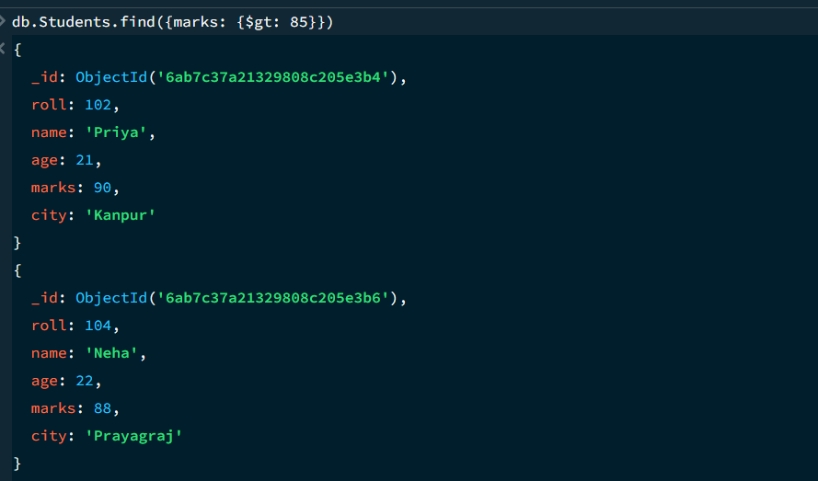

7. LESS THAN — $lt
MongoDB Query:
db. students. find ({marks: {$lt: 70}})
Explanation: Finds students whose marks are less than 70.

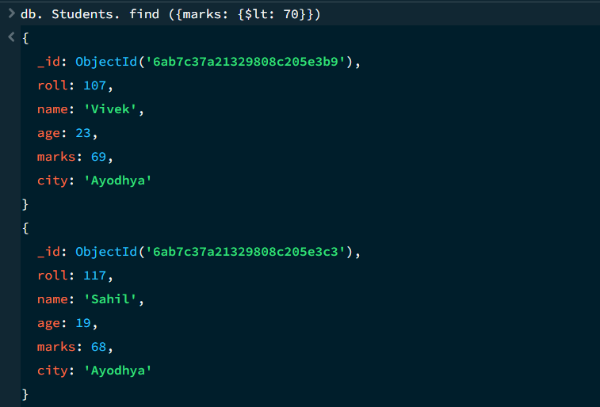
8. GREATER THAN OR EQUAL TO — $gte
MongoDB Query:
db. students. find({marks: {$gte: 90}})
Explanation: Finds students whose marks are 90 or above.
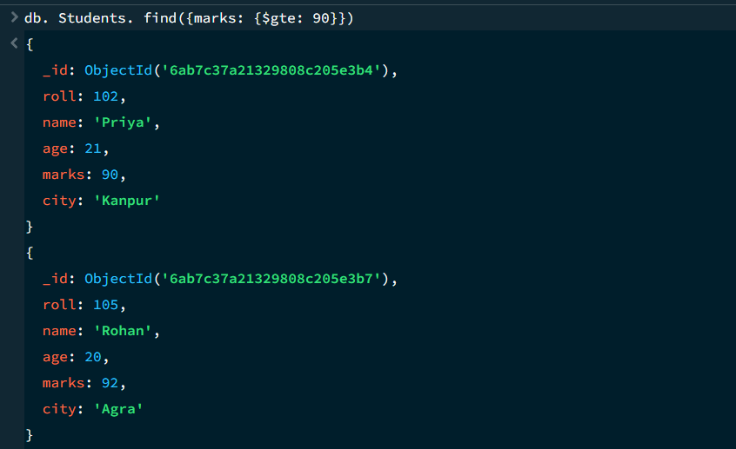

9. LESS THAN OR EQUAL TO — $lte
MongoDB Query:
db. students. find({marks: {$lte: 60}})
Explanation: Finds students whose marks are 60 or below.
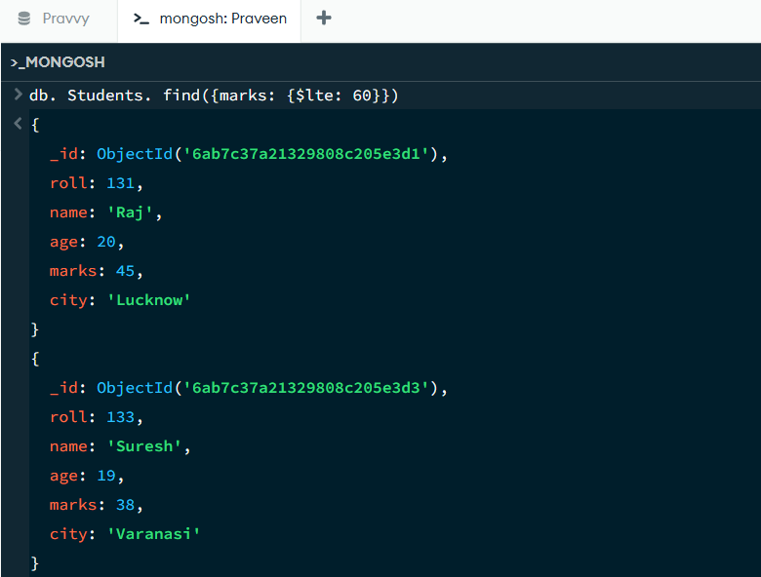

10. UPDATE OPERATION
MongoDB Query:
db.students.updateOne(
{roll:105},
{$set:{marks:95}}
)
Explanation: Updates the marks to 95 of the student with roll number 105.

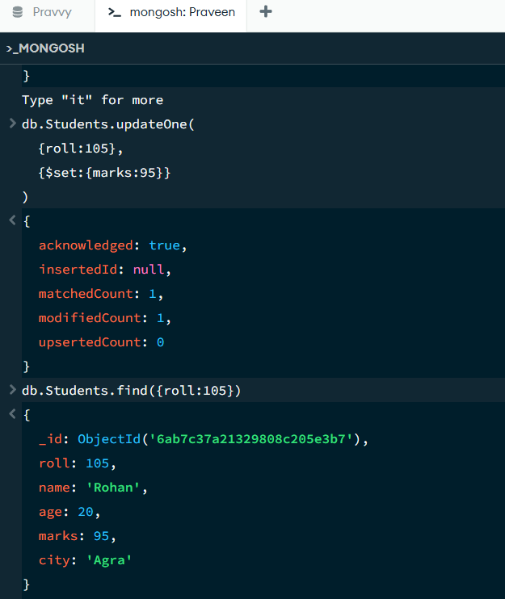

11. DELETE ONE OPERATION
MongoDB Query:
db.students.deleteOne({roll:10})
Explanation: Deletes one document matching roll number 10.
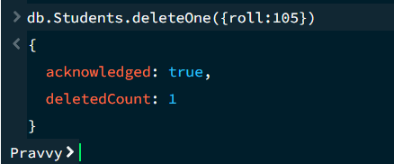

12. DELETE MANY OPERATION
MongoDB Query:
db.students.deleteMany({
marks: {$lt:40}
})
Explanation: Deletes all students having marks below 40.

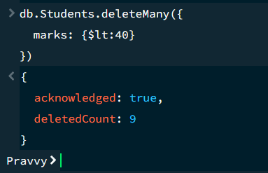

13. AND OPERATION — $and
MongoDB Query:
db. students. find({
$and:[
{marks:{$gt:80}},
{age:19}
]
})
Explanation: Finds students satisfying both conditions.
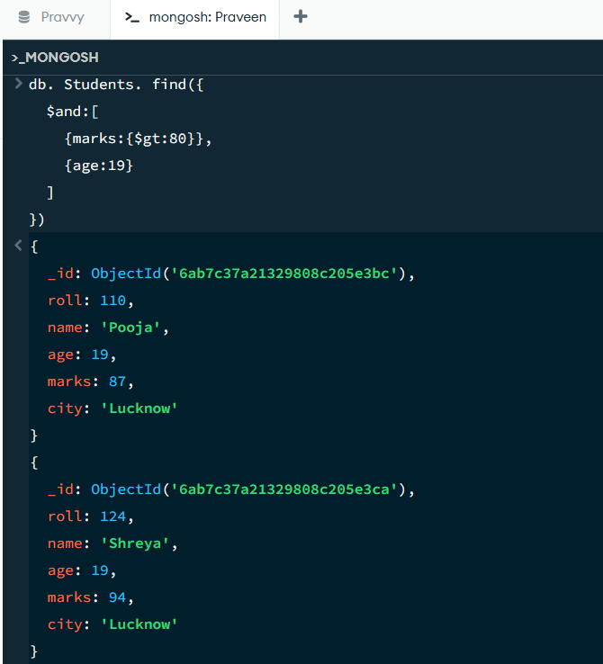

14. OR OPERATION — $or
MongoDB Query:
db.students.find({
$or:[
{city:"Lucknow"},
{city:"Kanpur"}
]
})
Explanation: Finds students from Lucknow or Kanpur.
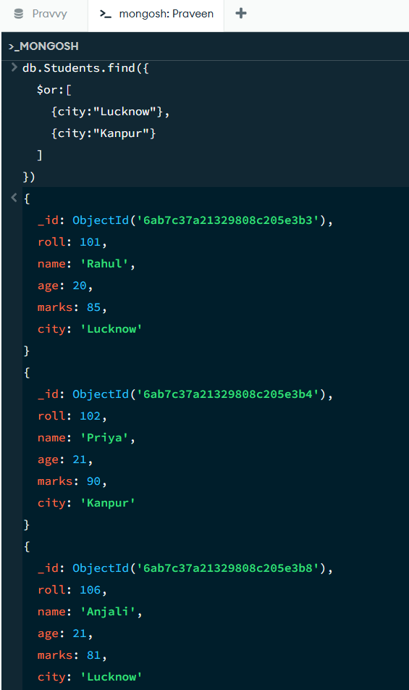

15. SORT OPERATION
A.MongoDB Query:
db. students. find (). sort({marks : 1})
Explanation: Sorts students by marks from lowest to highest. Use 1 for ascending order.
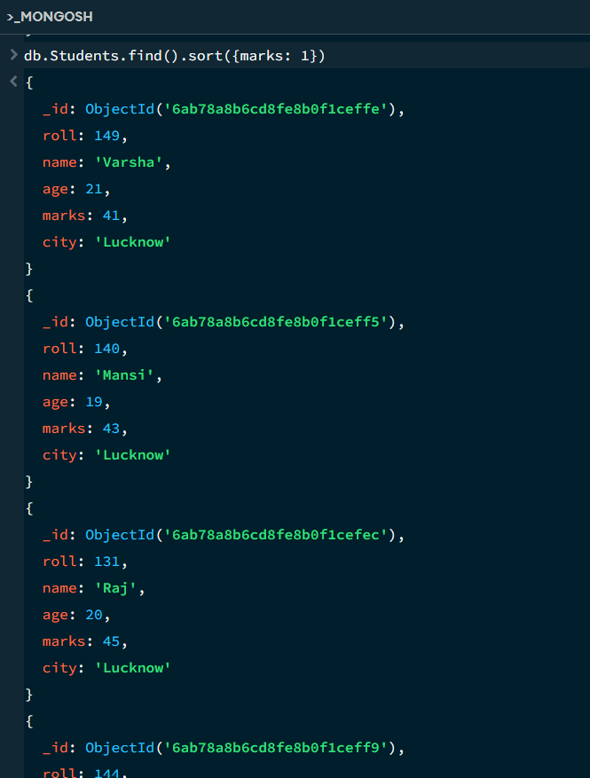

B. MongoDB Query:
db. students. find (). Sort ({marks: -1})
Explanation: Sorts students by marks from highest to lowest. Use -1 for descending order.
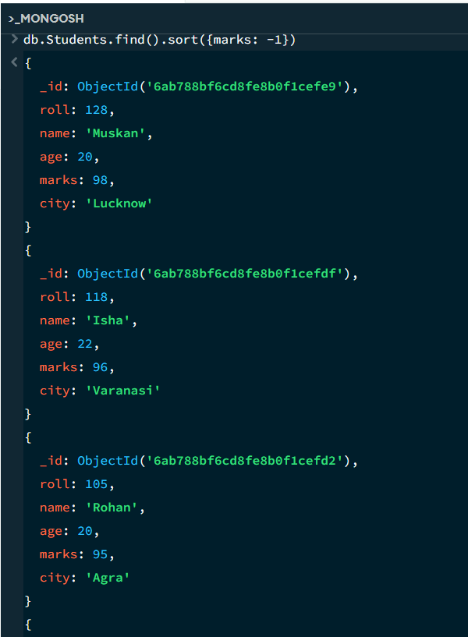
16. LIMIT OPERATION
MongoDB Query:
db. students. find (). limit (5)
Explanation: Displays only the first five documents.
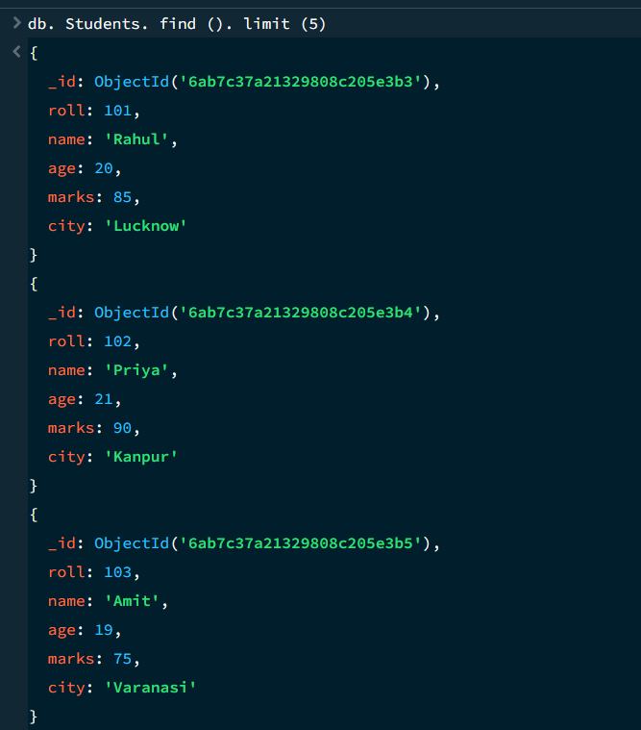

17. SEARCH BY CITY
MongoDB Query:
db.students.find({city:"Lucknow"})
Explanation: Finds all students whose city is Lucknow.
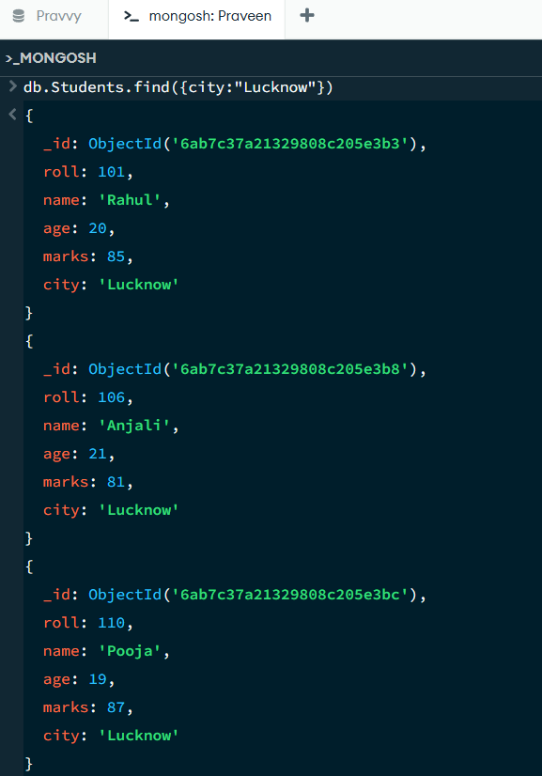

18. COUNT DOCUMENTS
MongoDB Query:
db. students. count Documents ()
Explanation: Counts documents currently present in the collection (performing after the delete function).
