Unit 05 Problem Set Submission Form

# Overview

|  |  |
| --- | --- |
| Your Name | Vinit Horakeri |
| Your SU Email | vhoraker@syr.edu |

# Instructions

Put your name and SU email at the top. Answer these questions all from the lab. When asked to include screenshots, please follow the screen shot guidelines from the first lab.

Remember as you complete the problem sets it is not only about getting it right / correct. We will discuss the answers in class so it’s important to articulate anything you would like to contribute to the discussion in your answer:

* If you feel the question is vague, include any assumptions you've made.
* If you feel the answer requires interpretation or justification provide it.
* If you do not know the answer to the question, articulate what you tried and how you are stuck.

This how you receive credit for answering questions which might not be correct.

# Questions

**Questions 8,9,10 are extra credit questions. If you choose to answer any of them and answer them correctly, you’ll receive 1 point for each correct answer.**

Answer these questions using the **VBAY database** and problem set submission template. You will need to consult the logical model in the overview section for details. For any screenshots provided, please follow the guidelines for submitting a screenshot.

Write the following as SQL queries. If the query is ambiguous, fill in the gaps yourself and justify your reasoning. For each, include the SQL as a screenshot with the output of the query.

1. How many item types are there? Perform an analysis of each item type. For each item type, provide the count of items in that type, the minimum, average, and maximum item reserve prices for that type. Sort the output by item type.

1. Perform an analysis of each item in the “Antiques” and “Collectables” item types. For each item display the name, item type and item reserve. Include the min, max and average item reserve over each item type so that the current item reserve can be compared to these values.

1. Write a query to include the names, counts (number of ratings) and average seller ratings (as a decimal) of users. For reference, User Carrie Dababbbi has 4 seller ratings and an average rating of 4.75.

1. Create a list of “Collectable” item types with more than 1 bid. Include the name of the item and the number of bids making sure the item with the most bids appear first.

1. Generate a valid bidding history for any given item of your choice. Display the item id, item name a number representing the order the bid was placed, the bid amount and the bidder’s name. Here’s an example showing the first 3 bids on item 11.   
   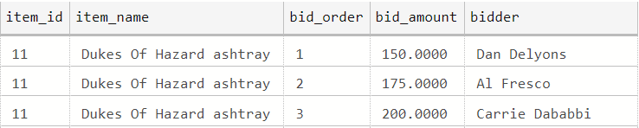

1. Re-Write your query in the previous question to include the names of the next and previous bidders, like this example again showing the first 3 bids for item 11.  
   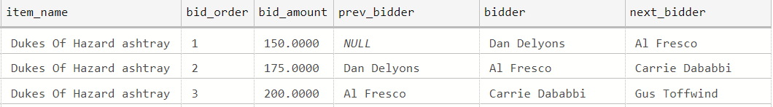

1. Among items not sold, show highest bidder name and the highest bid for each item. Make sure to include only valid bids.

**Questions 8 -10 are extra credit and are worth 1 point each.**

1. Find the names and emails of the users who give out the worst ratings (lower than the overall average rating) to either buyers or sellers (no need to differentiate whether the user rated a buyer or seller), and only include those users who have submitted more than 1 rating.
2. Produce a report of the KPI (key performance indicator) user bids per item. Show the user’s name and email total number of valid bids, total count of items bid upon and then the ratio of bids to items. As a check, Anne Dewey’s bids per item ratio is 1.666666

1. Write a query with output similar to question 3, but also includes the overall average seller rating, and the difference between each user’s average rating and the overall average. For reference, the overall average seller rating should be 3.2.

# Reflection

Use this section to reflect on your learning. To achieve the highest grade on the assignment you must be as descriptive and personal as possible with your reflection.

1. What are the key things you learned through the process of completing this assignment?  
   window functions, having, group by
2. What were the challenges or roadblocks (if any) you encountered on the way to completing it?  
     
   window function 9,10 question
3. Now that you have completed the assignment rate your comfort level with this week’s material. This should be an honest assessment: (choose one)  
     
   4 ==> I understand this material and can explain it to others.