Department of Artificial Intelligence – Data Science and Machine Learning
Program name :- Artificial Intelligence – Data Science and Machine Learning Class: S.Y. B. Tech Div:- B
Name of Student: Vinit Thokale Batch:- B3 Course Name:- Digital Finance
PRN No :- 251121118 Roll No:- 22258 Sem :- 3rd Course :- AI Specialist - BFSI

 | 
SMARTBRIDGE | SKILLWALLET
Personal Finance Advisor: AI-Powered Financial Management and Insights
Project Description :-
Personal Finance Advisor is an AI-powered web application designed to help users manage their personal finances in one place. It allows users to record income and expenses, review recent transactions, understand spending by category, monitor savings, and set a savings goal through a simple dashboard.
The dashboard calculates total recorded income, expenses, net savings, and savings rate from the user's transaction records. The application is built with Python and Flask, and uses Flask-SQLAlchemy with an SQLite database to store transactions. Its AI Advisor sends relevant financial summaries to Google Gemini to generate plain-language observations and practical budgeting suggestions.
The application is maintained in a public GitHub repository and deployed as a web service on Render. The Gemini API key is configured as a server-side environment variable rather than being placed in the frontend or committed to the repository. The project includes a Reset Demo Data control for clearing recorded transactions when preparing a demonstration.
Technology & AI :-
Frontend: HTML5 / CSS3 / JavaScript
Backend: Python / Flask
AI: Google Gemini API using the Google GenAI Python SDK
Data Storage: SQLite with Flask-SQLAlchemy
Deployment: Render
Source Control: GitHub; API key configured through environment variables
Key Features :-
- Financial dashboard showing recorded income, expenses, net savings, and savings rate
- Transaction management for adding income and expenses with category and description
- Spending breakdown that groups recorded expenses by category
- AI Advisor that summarizes financial activity and generates budgeting suggestions
- Savings Goal feature for entering a target amount and tracking progress
- Transaction history showing recorded financial activity and dates
- Reset Demo Data control to clear transactions after user confirmation
- Responsive light-theme interface with navigation for Overview, Transactions, Insights, and Savings Goal
Scenarios :-
Scenario 1: A user records monthly income and expenses using the transaction form. The dashboard updates the recorded totals and calculates net savings and savings rate.
Scenario 2: A user records expenses in categories such as rent or food. The spending section groups the recorded expenses to help the user see which category accounts for the spending shown.
Scenario 3: A user opens the Insights section and selects Generate Insights. The backend prepares a summary of the recorded financial activity and requests a plain-language analysis from Google Gemini.
Scenario 4: A user creates a savings goal, such as purchasing a laptop, enters the target and current savings, and reviews the displayed completion percentage. Before a demonstration, the user can use Reset Demo Data to clear the transaction records.
Milestones :-
Milestone 1 – Project Planning & UI/UX Design
Define the purpose of the application, identify the main financial tracking requirements, and design a clear dashboard with Overview, Transactions, Insights, and Savings Goal sections.
Milestone 2 – Flask Backend & Transaction Management
Develop the Flask application, transaction data model, database setup, and API routes for retrieving and adding transaction records.
Milestone 3 – Dashboard, Spending Analysis & Savings Goals
Implement the dashboard calculations, category-based spending display, transaction history, savings goal progress, and the reset-demo-data endpoint and button.
Milestone 4 – Google Gemini AI Integration
Connect the backend to Google Gemini for financial insights, configure the API key through an environment variable, and provide a local fallback when AI analysis is unavailable.
Milestone 5 – Testing, Documentation & Deployment
Test the core transaction and insight workflows, publish the source code to GitHub, prepare project documentation, and deploy the web application using Render.
Conclusion :-
Personal Finance Advisor brings income tracking, expense management, spending analysis, savings goals, and AI-generated insights together in one web application. By combining calculated financial summaries with plain-language AI explanations, it helps users understand their recorded activity and consider practical budgeting improvements. The project demonstrates the use of web development, database management, API integration, and cloud deployment to address a common personal-finance need.
Expected Outcome :-
The expected outcome is a working web application where users can record transactions, review financial totals, inspect category-based spending, track a savings goal, and request AI-generated financial insights. The deployed demo makes the application accessible through a public link. Financial results depend on the completeness and accuracy of the data entered by the user.

Detailed Technical Documentation
This appendix expands the original Personal Finance Advisor Bot report using the project repository and the supplied interface screenshots. The original report pages, college branding, header/footer, student-information block, and existing content have been retained as the starting document. New appendix text is black. The figures shown in screenshots are example inputs and outputs, not verified personal financial records.

1. Detailed User Scenarios

Scenario 1: Enter financial information
The user enters monthly net income and adds expense categories with their amounts. The interface provides a live preview of income, expenses, remaining balance, potential savings, and expense-to-income ratio before the information is submitted for analysis.

Scenario 2: Review the 50/30/20 framework
After analysis, the user reviews the allocation of income into essential needs, discretionary wants, and savings/reserves. The displayed amounts and progress indicators help compare entered expenses with the framework targets.

Scenario 3: Review recommended budget allocations
The application presents a category-level table containing current spending, a recommended target, a suggested action, and the reasoning behind the recommendation. The suggested action can include maintaining or adjusting a category.

Scenario 4: Identify spending patterns
The spending-analysis section highlights spending concentrations, key observations, and possible efficiency opportunities based on the submitted expense categories. Any rendered output should be checked for valid labels and readable values before relying on it.

Scenario 5: Create a goal-oriented savings roadmap
The user can optionally enter a financial goal description, target amount, and timeframe. The system evaluates the goal against the available monthly surplus and returns practical saving steps or a roadmap.

Scenario 6: Read financial health notes and disclaimers
The result includes risk-related observations and a clear educational disclaimer. The application states that AI-generated guidance is for financial-planning education and is not certified financial, investment, legal, or tax advice.

2. Technical Architecture
The project uses a browser-based frontend, a Flask backend, a deterministic financial calculation service, a Google Gemini advisory service, and SQLite persistence managed through SQLAlchemy. The calculation layer computes financial figures before the AI service generates qualitative guidance, reducing reliance on the language model for arithmetic.
User Browser (HTML5 / CSS3 / Vanilla JavaScript)
│ JSON request to POST /api/analyze
▼
Flask Controller (app.py)
▼
Deterministic Finance Calculator
• Income, expense and balance calculations
• Expense ratios and 50/30/20 classification
• Goal feasibility and shortfall calculations
▼
Gemini Advisory Service (structured prompt / JSON response)
▼
SQLite + SQLAlchemy persistence
▼
Results dashboard: summary, budget table, spending analysis,
saving suggestions, goal roadmap and disclaimer
The repository describes Google Gemini 3.8 Flash through the Google GenAI Python SDK. The API key is configured on the server through the GEMINI_API_KEY environment variable and should not be exposed in browser code or committed to source control.

3. Prerequisites and Environment Setup
The repository documentation specifies Python 3.10 or later, pip, the project dependencies in requirements.txt, and a Google Gemini API key for AI-generated recommendations. A code editor such as Visual Studio Code can be used for local development.

Activity 3.1: Obtain the source code
git clone https://github.com/vinit1659/personal-finance-advisor-bot
cd personal-finance-advisor-bot

Activity 3.2: Create and activate a virtual environment
python -m venv venv
# Windows PowerShell
.\venv\Scripts\Activate.ps1

Activity 3.3: Install dependencies
python -m pip install -r requirements.txt

Activity 3.4: Configure environment variables
Create a local .env file using .env.example as a guide. Add the required configuration values locally. Never include a real API key in the report, frontend code, screenshots, or public repository.
GEMINI_API_KEY=your_gemini_api_key_here
FLASK_APP=app.py
FLASK_DEBUG=0
SECRET_KEY=replace-with-a-random-secret-key
DATABASE_URL=sqlite:///database/finance.db
PORT=5000

Activity 3.5: Run the application
python app.py
The repository documentation states that database tables initialize on startup. Open http://127.0.0.1:5000 in a browser after the Flask server starts.

4. Backend Implementation and API Workflow

Activity 4.1: Request validation
The Flask backend validates incoming analysis requests and handles malformed requests and invalid financial inputs. Income must be greater than zero, while expense values must be non-negative. The backend maps validation and service errors to appropriate HTTP responses.

Activity 4.2: Deterministic financial calculations
The finance-calculation service calculates total expenses, remaining balance, expense ratio, savings ratio, category allocations under the 50/30/20 framework, and feasibility gaps for optional savings goals. These calculated metrics are supplied to the AI advisory service as established figures.

Activity 4.3: Gemini advisory generation
The Gemini service uses a unified structured prompt to generate an executive summary, budget recommendations, spending observations, saving suggestions, goal milestones, and financial-health notes. The repository documents JSON response formatting and response validation, including checks for the required educational disclaimer.

Activity 4.4: Main API endpoints
Endpoint | Method | Purpose
/ | GET | Render the main financial-advisor interface.
/api/health | GET | Return health/configuration information.
/api/analyze | POST | Validate financial inputs, calculate metrics, request AI guidance, and return the analysis.
/api/history | GET | Return the most recent assessment sessions.

Activity 4.5: Database persistence
The repository documents two main SQLAlchemy models: FinancialReport, which stores assessment-level metrics and the AI response, and ExpenseItem, which stores category-level expense records linked to a report. The database is SQLite, with its path configured through DATABASE_URL.

5. Frontend Implementation and Page Walkthrough

Activity 5.1: Financial information form
The user enters monthly net income and expense categories. Categories can be added or removed, and optional goal details can be supplied.

Activity 5.2: Live financial preview
Client-side JavaScript updates totals and derived values as the user changes income or expense amounts. This preview is intended to help users review their inputs before requesting AI analysis.

Activity 5.3: Financial advisory report
The results dashboard presents an executive summary and key financial indicators, including income, expenses, remaining balance, and savings capacity.

Activity 5.4: Budget and spending analysis
The interface includes the 50/30/20 framework, a category-allocation table, spending-pattern observations, and efficiency opportunities.

Activity 5.5: Savings roadmap and risk notes
The results include suggested savings actions, optional goal-related guidance, and educational risk/disclaimer notes.

6. Testing Plan and Evidence
The repository includes unit, integration, and end-to-end test files. Its README reports 23 automated tests covering calculations, validation, routes, persistence, error handling, and realistic Indian Rupee scenarios. This report does not independently rerun those tests; the results below are a practical test checklist for a reviewer.
Test ID | Test action | Expected result
TC-01 | Open the home page. | The financial-information form and live preview render.
TC-02 | Enter positive income and valid expense amounts. | The preview shows totals and remaining balance consistently.
TC-03 | Submit zero or negative income. | Validation rejects the input and displays a clear error.
TC-04 | Submit negative expense values or malformed JSON. | The request is rejected safely.
TC-05 | Submit a valid financial assessment with AI available. | The response includes financial metrics and structured advisory sections.
TC-06 | Simulate Gemini rate limiting or timeout. | The API returns a handled error response without exposing secrets.
TC-07 | Request assessment history. | Recent assessment sessions are returned.
TC-08 | Inspect the response and page for API-key leakage. | No secret key is included in client-visible content.
TC-09 | Enter an optional goal and timeframe. | The result reports goal feasibility or the estimated shortfall/timeline.

The supplied screenshot of the Spending Analysis section visibly contains '[object Object]' placeholders in the High Spending Areas area. This should be treated as a UI rendering issue to investigate, not as a successful display of category labels. A recommended regression check is to confirm that the frontend renders the expected text property from each returned spending-area object.

7. Security, Limitations, and Future Enhancements

7.1 Security practices
Keep GEMINI_API_KEY and SECRET_KEY in server-side environment variables. Exclude .env files and local database files from version control. Return sanitized error messages to the client rather than stack traces or configuration values.

7.2 Current limitations documented by the repository
The repository describes a single-user SQLite setup without multi-tenant authentication, manually entered expense categories rather than automatic bank-statement ingestion, and assessment sessions that evaluate the submitted snapshot rather than automatically analyzing multi-month trends.

7.3 Possible future enhancements
Possible future work documented in the repository includes multi-user authentication, CSV/OFX bank-statement parsing, retirement or investment scenario simulations, and localized Indian tax-deduction guidance. These are future possibilities and should not be described as currently implemented features.

8. Deployment and Source Control

Activity 8.1: Source control
The source code is maintained in the public GitHub repository. The repository includes the Flask app, configuration, models, calculation and Gemini services, HTML/CSS/JavaScript assets, dependency files, and automated test files.

Activity 8.2: Public demonstration using ngrok
The repository documents using ngrok to expose a locally running Flask server for demonstration. Start the app locally, then open a second terminal and run the tunnel command shown below. The public tunnel URL may change after restarting a free tunnel.
python app.py
# In a second terminal:
ngrok http 5000
Do not hardcode a temporary tunnel URL into the application, and never publish the Gemini API key or the .env file. The README describes this as a public demo tunnel, not a permanent production deployment.

9. Application Screenshots
The following supplied screenshots document the input form, live preview, advisory results, budget allocations, spending analysis, saving suggestions, and financial health notes. Figures are included as interface evidence; their displayed financial values are illustrative inputs.
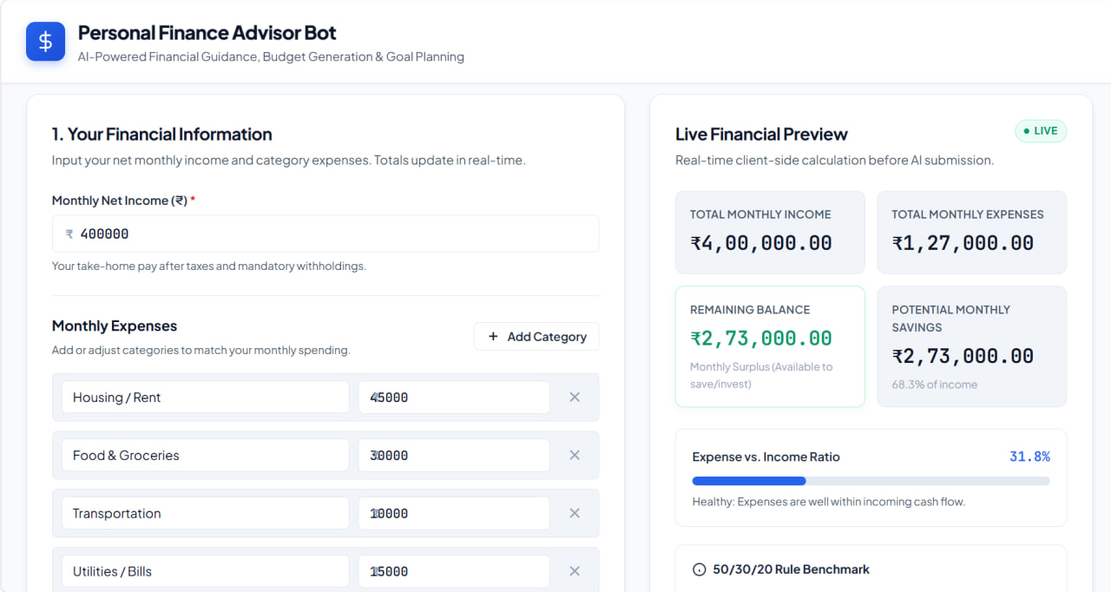
Figure 1. Financial information form and live financial preview.
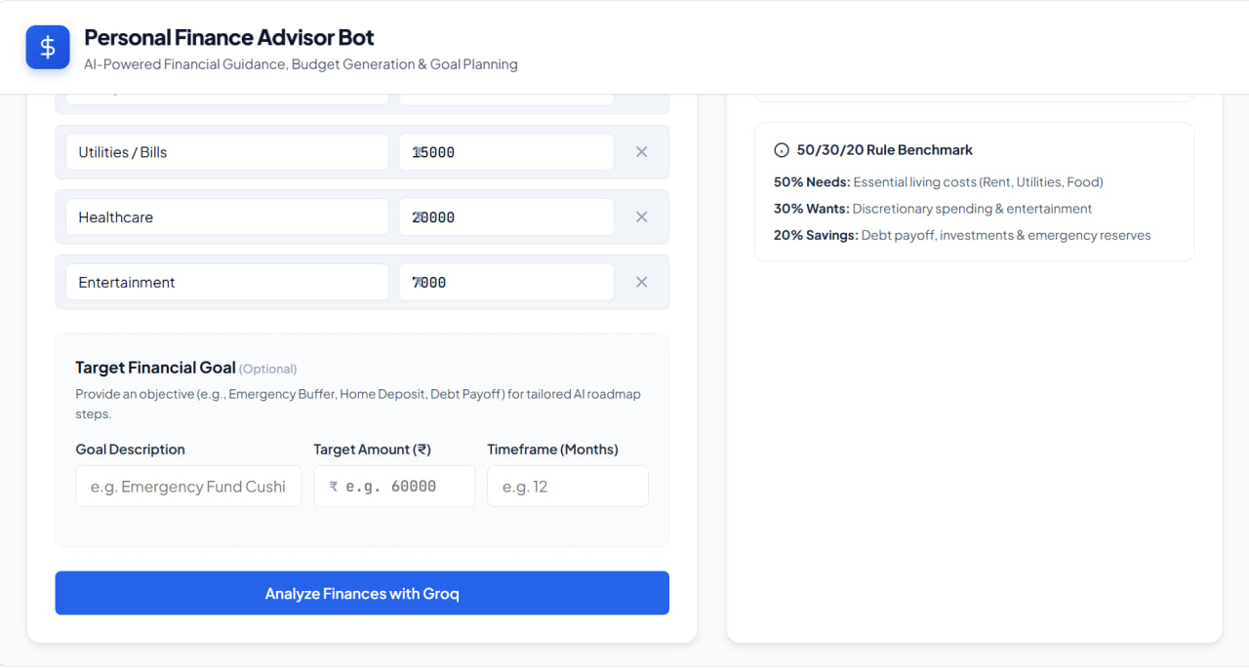
Figure 2. Live financial preview with entered monthly income and expenses.
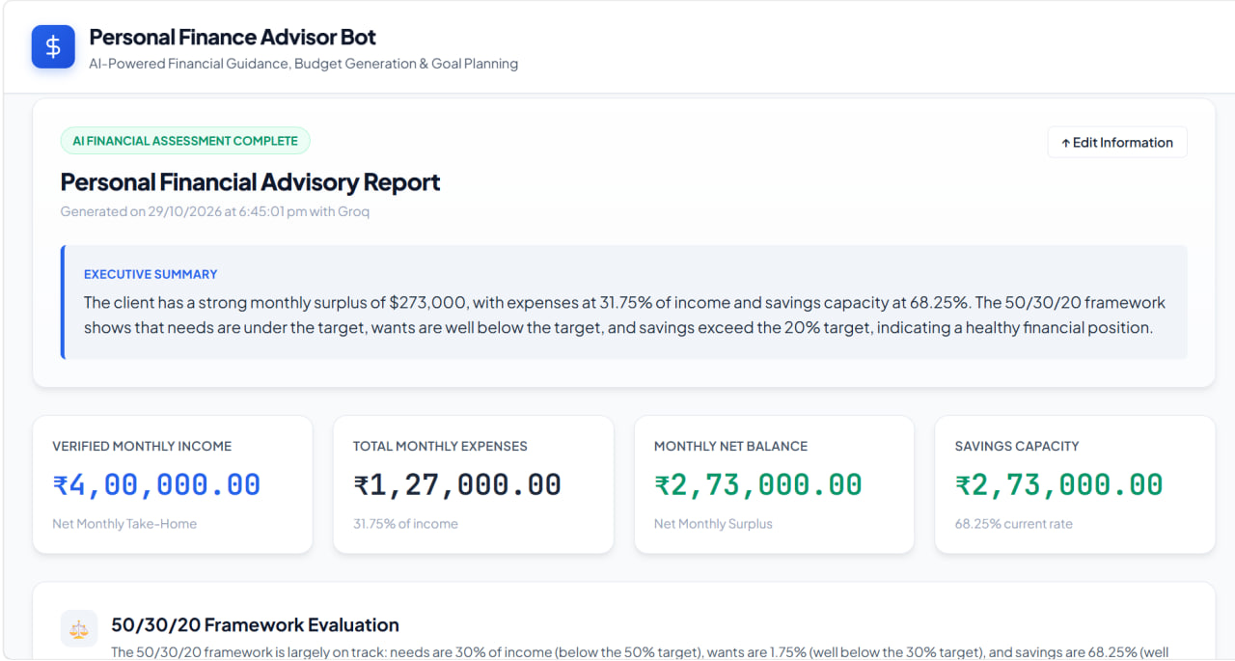
Figure 3. Personal Financial Advisory Report and executive summary.
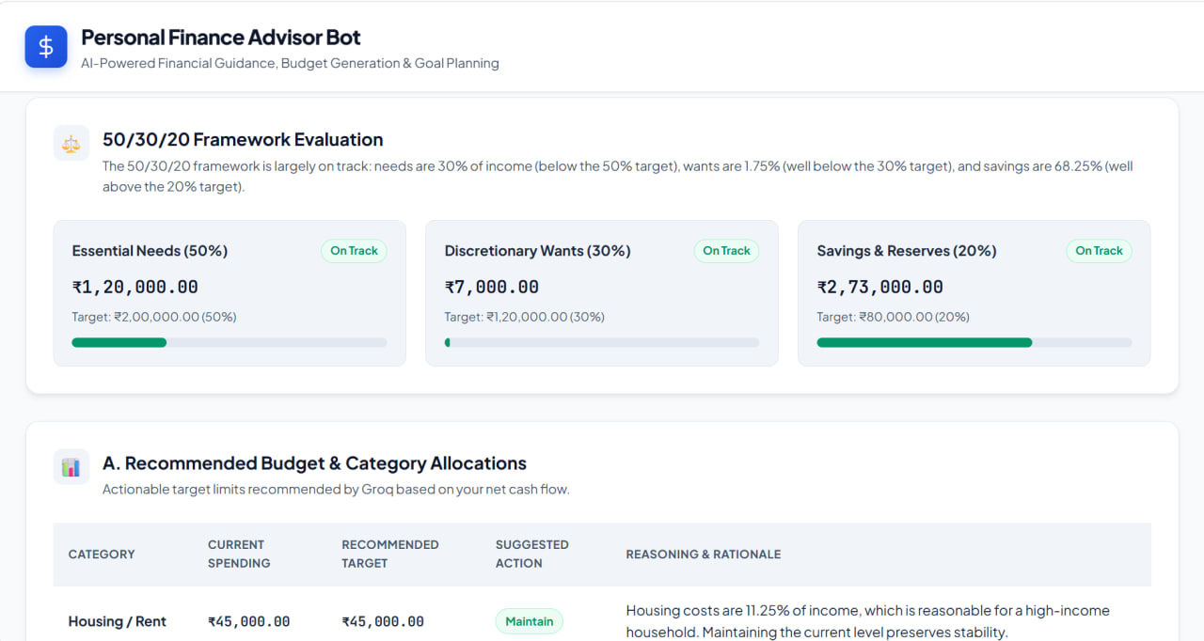
Figure 4. 50/30/20 framework evaluation and recommended budget allocations.
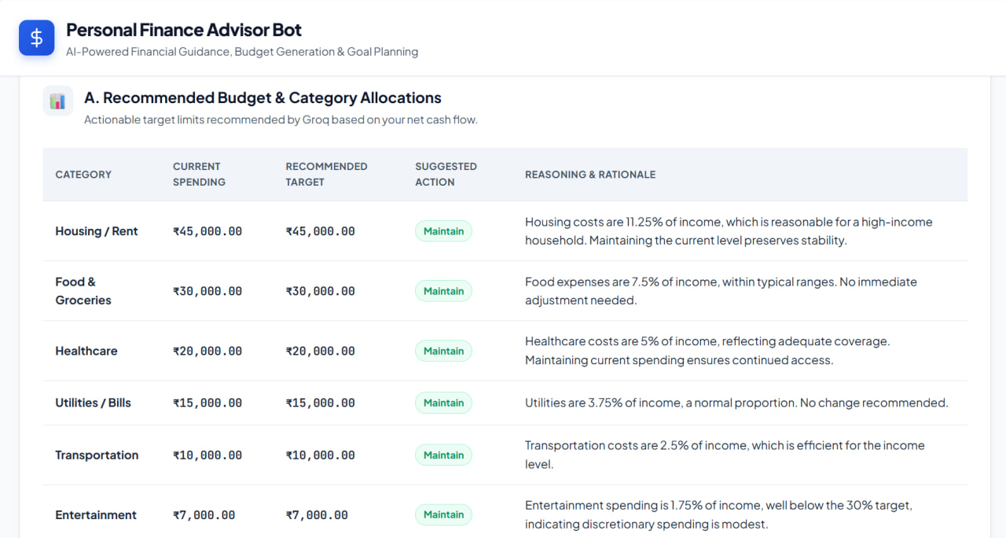
Figure 5. Spending analysis, high-spending-area display, and key observations.
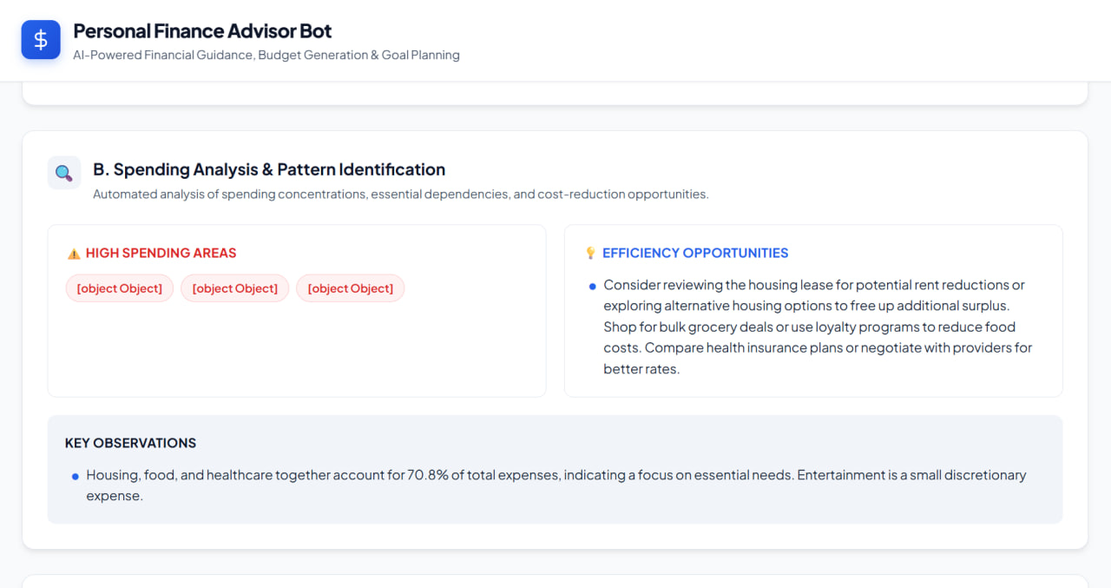
Figure 6. Practical saving suggestions and financial-health risk guidelines.
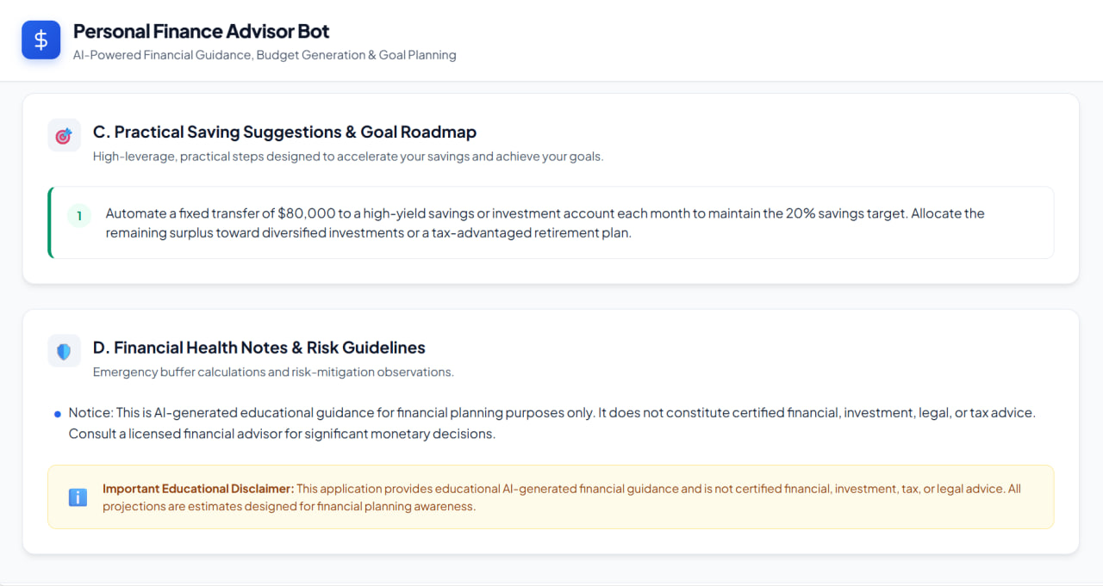
Figure 7. Goal-related inputs and financial planning form.

10. Conclusion and Expected Outcome
The Personal Finance Advisor Bot combines deterministic financial calculations with AI-generated qualitative guidance. It is designed to help users understand their cash flow, compare category spending with a budgeting framework, review possible savings actions, and consider optional financial goals. Its usefulness depends on accurate user inputs, validated calculations, and successful AI service responses. The application is an educational planning aid and not a substitute for certified financial advice.

