Experiment-1

INSTALLATION OF GIMP:

Step:1
Download the GIMP installer.​ You can download this for free from gimp.org/downloads.
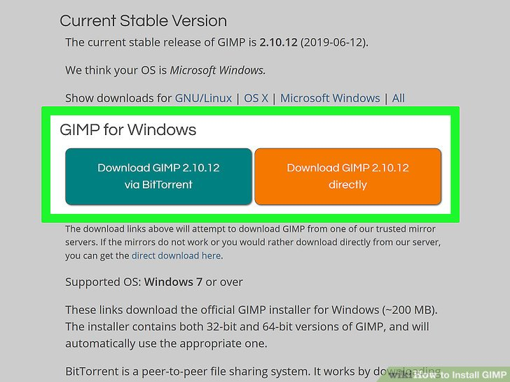

Step:2
Run the GIMP installer.​ You can find this at the default download location. Download folder by default.

Step:3
Follow the prompts to install GIMP.​ Most of the settings can be left default.
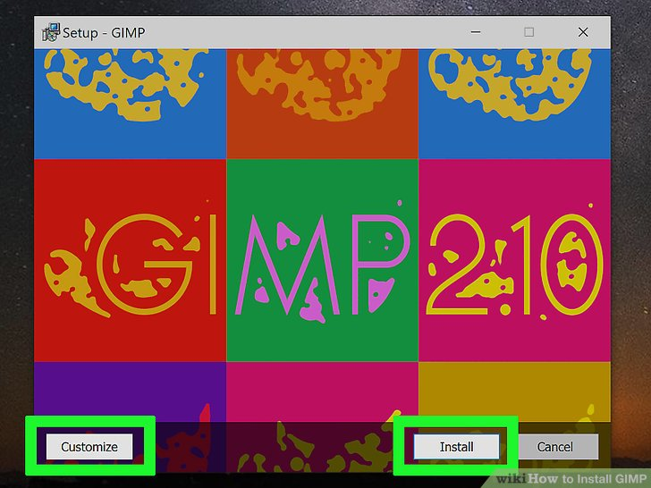

Step:4
Finish the installation. ​After selecting the file formats, GIMP will install. This may take a few minutes.

Step:5
Start using GIMP. ​Once GIMP has finished installing, you can start using it.
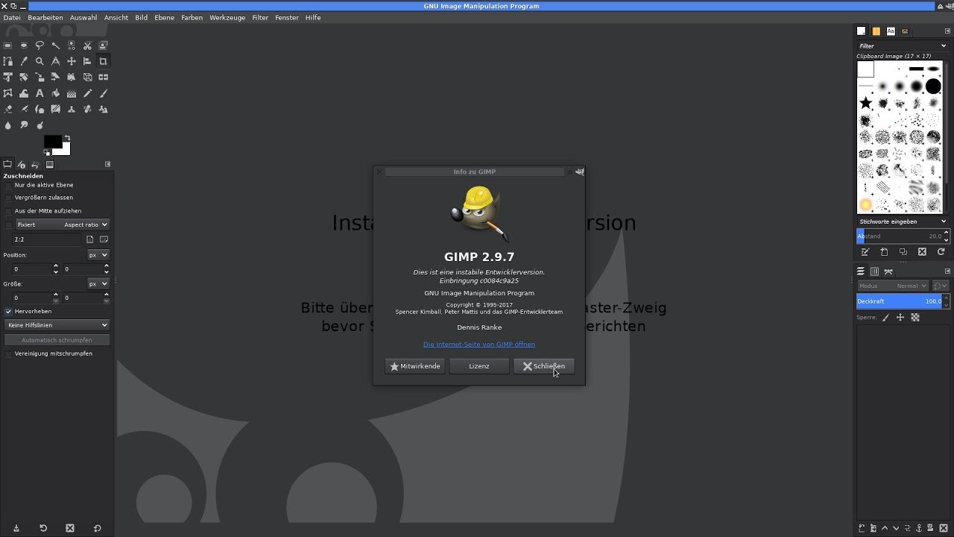

Installation of BLENDER:

Step – 1:
Visit the Blender Website
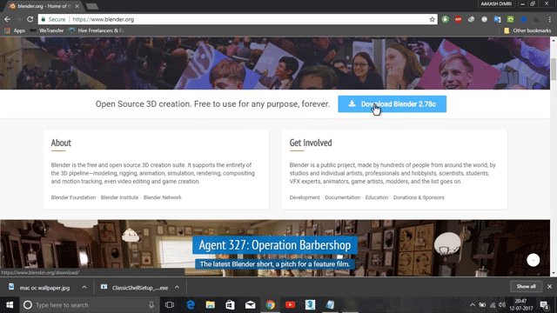

Step – 2:
Click on the link to access the Download page. Also, select the operating system to install the program.

Step – 3:
Now, run the downloaded Installer which will probably be available in the download folder

Step – 5:
Click on the Next Button, when asked to move ahead in the process.
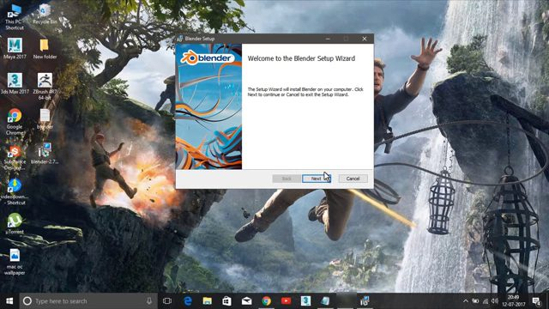

Step – 6:
In this step, the user can change the default location of the program. Click Install to move ahead.

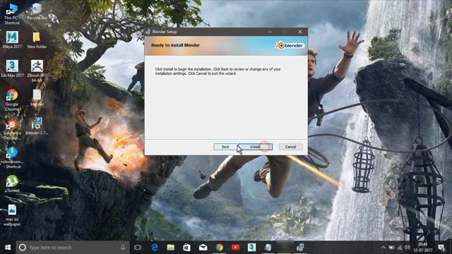

Step-7:
Wait for the installer to complete installation and then launch the blender application.

