1. Min-Max

function min_max(A)
n=length(A);
max=A(1);
min=A(1);
for i=2:n
if A(i)>max
max=A(i);
end
if A(i)<min
min=A(i);
end
end
fprintf('Max: %d\nMin: %d\n',max,min);
end

Result:
>> min_max([-21, -4, -742, -1556, -77, -367, -63])
Max: -4
Min: -1556

2. Fibonacci

a=0;
b=1;
fprintf('%d ',a);
while b<2000
temp=a;
a=b;
b=b+temp;
fprintf('%d ',a)
end
fprintf('\n');

Result:
0 1 1 2 3 5 8 13 21 34 55 89 144 233 377 610 987 1597

3. Gaussian

clc;
clear;
n=1e5;
r1=rand(1,n);
r2=rand(1,n);
r=sin(2*pi*r2).*(-2*log(r1)).^0.5;

d=0.25; %bin size
k=30; % Number of bins

bin=zeros(1,k+1);

for j=1:n
for i=1:k+1
if r(j)>(i-k/2)*d && r(j)<(i-k/2+1)*d
bin(i)=bin(i)+1;
end
end
end

hold on
scatter(-d*k/2:d:d*k/2, bin)

%Genrating Histogram without using histogram function
bin2=zeros(1,10*k+1);
for i=1:10*k+1
bin2(i)=bin(int8(i/10)+1);
end
plot (-d*k/2:d/10:d*k/2,bin2,'r')

Result: binsize = 0.25

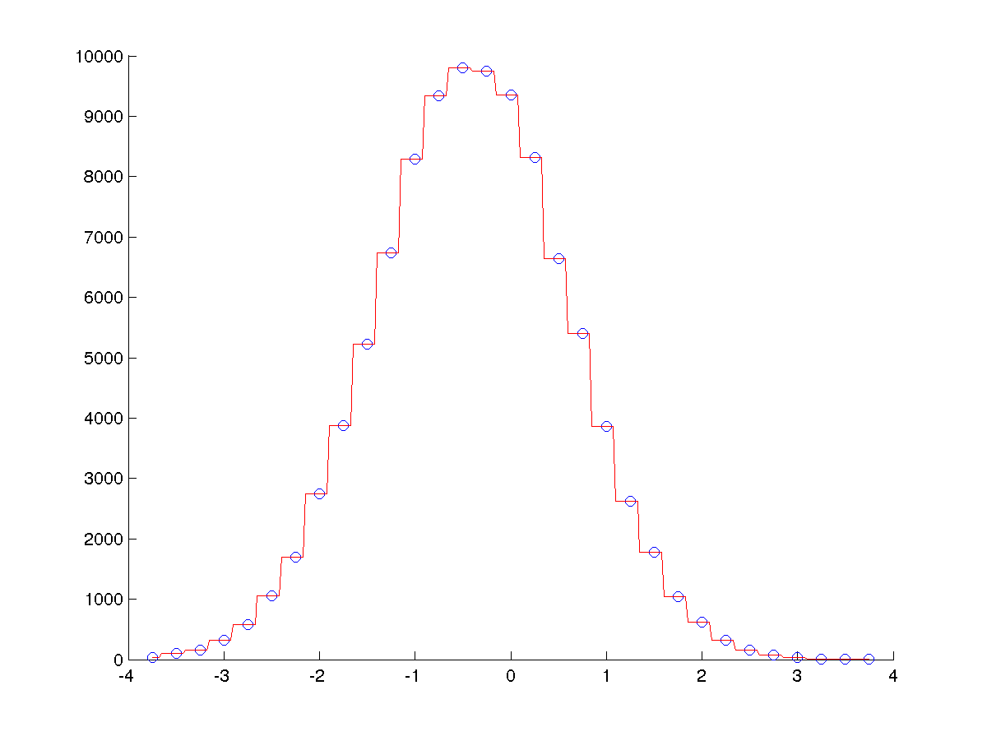

Result: binsize = 0.1

