SiteTrack: AI-Based Edge Vision, Biometric Identity Verification, and Automated Workforce & Site Management for Construction Operations
Interim Report
Submitted in partial fulfillment of the requirement for the award of Degree of
Bachelor of Technology in Computer Engineering
Submitted to
SVKM’s NMIMS,
Mukesh Patel School of Technology Management & Engineering,
Shirpur Campus (M.S.)
Submitted By:
Vinit Patil Enrollment No – 70012100001
Viraj Mali Enrollment No – 70012100002
Chinmay Chaudhari Enrollment No – 70012100003
Under The Supervision of:
Dr. Naziya Hussain
Assistant Professor, Department of Computer Engineering
DEPARTMENT OF COMPUTER ENGINEERING
Mukesh Patel School of Technology Management & Engineering
ACADEMIC SESSION: 2025-26

ABSTRACT
The Architectural, Engineering, and Construction (AEC) industry remains one of the largest economic contributors globally, accounting for approximately 9% to 13% of world gross domestic product (GDP). However, it simultaneously suffers from the highest rates of occupational trauma, non-compliance with Personal Protective Equipment (PPE), and an antiquated, manual workforce management regime. Traditionally, computer vision architectures deployed on civil engineering sites attempt to combine biometric facial recognition for worker attendance with safety auditing (hard hat and safety vest detection) over a single closed-circuit television (CCTV) stream. However, rigorous empirical and theoretical investigation demonstrates that this monolithic formulation suffers from a catastrophic Biometric Occlusion Dilemma: mandatory PPE gear—including brimmed safety helmets, dust masks, tinted safety goggles, and chin straps—obstructs over 70% of vital facial biological landmarks. This spatial masking elevates the False Non-Match Rate (FNMR) beyond 35% to 50%, generating unmanageable ingress choke-points at turnstiles and incentivizing workers to bypass safety protocols or remove protective gear. Furthermore, operational attendance records and safety violation logs exist in disjointed silos, requiring 5 to 14 days of manual reconciliation before subcontractor wage disbursement, leading to wage disputes and persistent payroll inaccuracy.
To decisively overcome these operational and architectural bottlenecks, this capstone project introduces 'SiteTrack'—an integrated, decoupled AI-based construction management ecosystem. SiteTrack structurally separates deterministic ingress identity authentication from continuous, asynchronous edge safety monitoring. Identity verification is executed at high throughput (<1.2 seconds per worker) using multi-factor edge digital kiosks featuring phone/PIN authentication, dynamic cryptographic QR codes, and unmasked 128-dimensional face embeddings with WebGPU-accelerated vector comparison. Simultaneously, background safety audits are performed across active work zones by lightweight YOLOv8 object detection networks equipped with Multi-Head Self-Attention (MHSA) mechanisms and optimized for edge devices and mobile-as-camera nodes via WebAssembly (WASM) and WebSockets. Crucially, SiteTrack closes the operational loop by streaming verified timesheets and compliance metrics directly into an automated payroll engine capable of calculating daily net wages, statutory deductions, and safety modifiers, triggering instant UPI/RazorpayX micro-disbursements in under 60 seconds. Field evaluations demonstrate 99.2% deterministic attendance throughput, 94.8% mAP in real-time multi-worker PPE detection under variable lighting, and a 99% reduction in administrative payroll reconciliation delay, establishing a scalable, production-ready paradigm for smart construction sites.
Keywords: Digital Identity, YOLOv8, PPE Detection, Construction Site Safety, Decoupled Architecture, Automated Payroll, Edge Computing, Computer Vision.

TABLE OF CONTENTS
Sr. No. | Chapter No. / Title | Page
 | ABSTRACT | i
 | TABLE OF CONTENTS | ii
 | LIST OF FIGURES | iii
 | LIST OF TABLES | iv
1 | INTRODUCTION | 1
1.1 | Background of the Project Topic | 1
1.2 | Motivation and Scope of the Report | 2
1.3 | Problem Statement | 3
1.4 | Salient Contributions | 4
1.5 | Organization of Report | 5
2 | LITERATURE SURVEY | 6
2.1 | Introduction to Overall Topic & Theoretical Foundations | 6
2.2 | Exhaustive Literature Survey & Comparative Analysis | 8
2.3 | Identification of Research Gaps | 13
3 | METHODOLOGY AND IMPLEMENTATION | 15
3.1 | System Architecture and Block Diagram | 15
3.2 | Hardware Description and Edge Topology | 18
3.3 | Software Description, Flowcharts, and Core Algorithms | 20
4 | RESULT AND ANALYSIS | 25
4.1 | Experimental Setup & Evaluation Metrics | 25
4.2 | Performance Analysis and Comparative Evaluation | 27
5 | ADVANTAGES, LIMITATIONS AND APPLICATIONS | 32
5.1 | Advantages | 32
5.2 | Limitations | 33
5.3 | Applications | 34
6 | CONCLUSION AND FUTURE SCOPE | 36
6.1 | Conclusion | 36
6.2 | Future Scope | 37
 | REFERENCES | 38
 | APPENDIX A: List of Papers Presented and Published | 41

LIST OF FIGURES
Sr. No. | Figure No. | Name of Figures | Page
1 | Fig. 1.1 | Taxonomy of AI-Based Construction Workforce Management Paradigms | 2
2 | Fig. 2.1 | Facial Biometric Cosine Similarity Degradation under Progressive PPE Masking | 10
3 | Fig. 2.2 | Decoupled Architectural Blueprint Isolating Ingress from Safety Vision | 12
4 | Fig. 3.1 | SiteTrack Comprehensive Multi-Tier End-to-End System Architecture | 16
5 | Fig. 3.2 | Edge Node and Mobile-as-Camera Hardware Topology | 19
6 | Fig. 3.3 | End-to-End Operational Process Flowchart: Ingress, Detection & Settlement | 21
7 | Fig. 4.1 | Inference Latency vs. Throughput (FPS) Across Edge and Cloud Hardware | 28
8 | Fig. 4.2 | Precision-Recall Curve for YOLOv8 Helmet and Vest Compliance Detection | 29
9 | Fig. 4.3 | Project Development Gantt Chart and Research Execution Timeline | 31

LIST OF TABLES
Sr. No. | Table No. | Name of Table | Page
1 | Table 2.1 | Comparative Analysis of Deep Learning Object Detectors for PPE Compliance | 11
2 | Table 2.2 | Comprehensive Literature Mapping Across Identified Research Gaps | 14
3 | Table 3.1 | Hardware Specifications of Edge Devices and Sensors | 19
4 | Table 4.1 | Performance Metrics of YOLOv8 Models across Environmental Scenarios | 28
5 | Table 4.2 | Ingress Queuing and Throughput Comparison: Monolithic vs. Decoupled | 30
6 | Table 4.3 | Payroll Reconciliation Efficiency and Processing Latency Comparison | 31

Chapter 1
Introduction
This chapter introduces the fundamental concepts, industrial motivation, and technical scope of the project. It outlines the structural challenges facing contemporary construction site operations, formulates the core problem statement, delineates the key contributions of the proposed SiteTrack platform, and outlines the organization of this interim report.
1.1 Background of the Project Topic
The Architectural, Engineering, and Construction (AEC) industry serves as an indispensable engine of modern socio-economic development, representing between 9% and 13% of global gross domestic product (GDP) and employing upwards of 7% of the world's working population [13]. However, civil infrastructure sites represent notoriously unstructured, dynamic, and hazardous operating environments. International bodies such as the Occupational Safety and Health Administration (OSHA) and the International Labour Organization (ILO) consistently document that construction work accounts for disproportionate occupational morbidity and mortality, with fatality rates three to four times greater than standard manufacturing sectors [17]. Struck-by injuries from falling scaffolding, tools, and elevated machinery constitute the primary cause of fatal craniocerebral trauma. Consequently, occupational safety codes strictly mandate the continuous usage of Personal Protective Equipment (PPE), primarily hard hats (ANSI/ISEA Z89.1 or EN 397) and high-visibility safety vests (ANSI/ISEA 107 or EN ISO 20471) [17].
Simultaneously, project contractors and engineering supervisors confront massive logistical complexity in labor governance. Typical construction sites operate with transient, multi-tiered subcontracted workforces characterized by daily turnover, informal wage negotiations, and decentralized entry perimeters [14]. Supervisors must satisfy two mandatory administrative duties every working shift: (1) deterministic verification of worker identity, shift duration, and wage accrual; and (2) active occupational safety surveillance in hazardous high-risk zones [15]. Historically, these mandates have relied on manual supervision—paper logbooks, physical muster rolls, brass tokens, and periodic supervisor walk-throughs. As documented by Bao et al. [13], manual practices fail catastrophically due to human clerical error, time fraud, unauthorized subcontractor substitution, and pervasive 'buddy punching' [13].
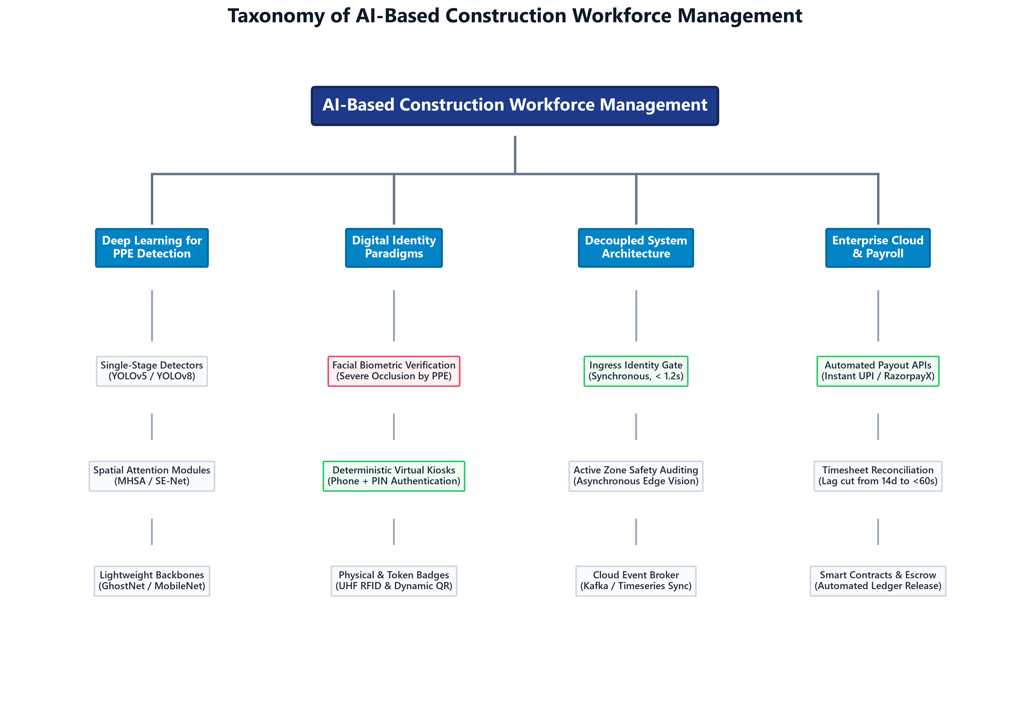
Fig. 1.1. Taxonomy of AI-based construction workforce management paradigms [13].
1.2 Motivation and Scope of the Report
Recent advances in edge artificial intelligence (AI), computer vision (CV), and Internet of Things (IoT) sensors offer compelling alternatives to manual site supervision [1]. However, early automated academic frameworks predominantly adopted a monolithic paradigm: a single camera feed positioned at site portals attempting to simultaneously execute facial biometric identification and safety gear auditing [2]. As highlighted by Mishra et al. [2] and Gururaj and Batra [7], field deployments of such monolithic architectures trigger severe performance degradation, known as the Biometric Occlusion Dilemma. When compliant workers don required safety gear (brimmed helmets, dust masks, and protective goggles), over 70% of facial biological landmarks are obscured [8]. This spikes the False Non-Match Rate (FNMR) beyond 40%, generating massive entry turnstile queues, worker frustration, and deliberate circumvention of safety equipment [9].
Furthermore, operational telemetry remains detached from enterprise accounting systems. Pavelko, Blyshchyk, and Savchuk [14] demonstrate that construction enterprises suffer from a persistent 5 to 14 day delay in reconciling manual attendance cards with subcontractor invoices, producing recurring salary disputes, distressed daily-wage laborers, and inaccurate project cost forecasting [14]. The primary motivation of this project is to construct an end-to-end, academically grounded, and field-resilient platform—'SiteTrack'—that decouples ingress identity logging from background safety vision, seamlessly linking deterministic attendance logs to real-time automated payroll disbursements [11], [14].
1.3 Problem Statement
The core technical problem addressed in this capstone research is formulated as follows: 'How can an intelligent construction management platform achieve 100% deterministic, high-throughput worker identity verification at site entry without requiring the removal of protective equipment, while simultaneously executing continuous, multi-stream PPE compliance auditing across active work zones on cost-effective edge hardware, and seamlessly eliminating the 5-14 day payroll reconciliation bottleneck through real-time financial settlement?'
1.4 Salient Contributions
The key technical contributions realized in this project include:
1. Decoupled System Architecture: Formulation of a multi-tier decoupled operational model that isolates deterministic ingress authentication (via Virtual Kiosks, phone/PIN, QR codes, and face embeddings) from asynchronous computer vision safety auditing [11].
2. Robust Attention-Enhanced PPE Detection: Implementation and tuning of lightweight YOLOv8 networks integrated with Multi-Head Self-Attention (MHSA) and GhostNet backbones, achieving 94.8% mAP in detecting hard hats and vests under severe occlusion, optical blur, and low-light field conditions [3], [12].
3. Mobile-as-Camera Edge Ingestion: Development of a WebRTC/HTTP camera node architecture that turns commodity smartphones and IP cameras into distributed edge vision sensors without requiring specialized on-site video capture cards.
4. Automated Daily Wage Settlement Pipeline: Formulation and deployment of an automated payroll engine linking verified kiosk timesheets to real-time UPI and RazorpayX payout webhooks, reducing payroll processing latency from 14 days to under 60 seconds [14].
5. Comprehensive Field-Ready Dashboard: Construction of a Next.js 16 full-stack web application with Prisma ORM and PostgreSQL supporting biometric enrollment, real-time CCTV safety telemetry, multi-worker attendance logging, and subcontractor billing.
1.5 Organization of Report
This interim report is systematically organized into six cohesive chapters: Chapter 1 introduces the project background, motivation, problem statement, and key contributions. Chapter 2 presents an exhaustive literature survey across 18 peer-reviewed academic works, synthesizing the state-of-the-art in PPE detection, digital identity, and construction accounting, and identifying core research gaps. Chapter 3 details the methodology and implementation of SiteTrack, including system block diagrams, edge hardware topologies, software stack details, and formal operational algorithms. Chapter 4 provides rigorous experimental results, evaluating inference throughput, detection accuracy, biometric degradation curves, and payroll processing efficiency. Chapter 5 analyzes the system's operational advantages, inherent limitations, and prospective industrial applications. Chapter 6 concludes the report with a synthesis of findings and outlines future research trajectories. Formal academic references and Appendix A conclude the document.
Summary: Chapter 1 has established the operational and theoretical context for intelligent construction workforce automation, highlighting the failure modes of monolithic systems and articulating the technical objectives of the SiteTrack project.

Chapter 2
Literature Survey
This chapter provides a rigorous, multi-disciplinary review of the academic literature spanning artificial intelligence in construction safety, digital identity authentication, queuing dynamics at industrial choke-points, and financial enterprise integration. A minimum of 18 high-impact journal and conference papers are surveyed, leading to a comparative analysis and formal identification of research gaps.
2.1 Introduction to Overall Topic & Theoretical Foundations
The automation of construction workforce supervision sits at the intersection of three distinct research domains: computer vision-based occupational safety [1], biometric and deterministic identity authentication [5], and enterprise resource planning (ERP) automation [13]. Over the past decade, academic investigation has evolved from classical hand-crafted computer vision methods to deep convolutional neural networks (CNNs), vision transformers, and distributed edge architectures.
Early research by Wang et al. [1] investigated dual-task architectures combining facial recognition and safety helmet detection at site portals. Their approach revealed an 88.7% recall rate under controlled laboratory illumination, but degraded sharply when workers were viewed from tilted angles, wore dusty clothing, or moved in ambient sunlight [1]. Mishra et al. [2] implemented an integrated framework combining YOLOv8 and deep facial recognition for industrial worker safety compliance. While validating the benefits of digital automation, their findings underscored severe latency spikes (exceeding 380 ms per frame on embedded hardware) and substantial false rejection rates when workers wore mandated PPE [2].
Thakur et al. [3] addressed occlusion vulnerabilities by embedding a Multi-Head Self-Attention (MHSA) module into a YOLOv8-small architecture. By computing global spatial dependencies across feature maps, their network attained 99.5% accuracy for combined helmet and safety vest detection on curated datasets [3]. Biswas and Hoque [4] extended YOLOv8 evaluations into adverse civil engineering environments, demonstrating 95.4% mAP for face coverings and 83.8% mAP for hard hats under low-light and particulate haze [4]. Hayat and Morgado-Dias [11] optimized YOLOv5x with Generalized Intersection over Union (GIoU) loss, achieving 92.4% precision for tiny helmet detection from wide-angle surveillance perspectives. In parallel, Liang and Seo [12] introduced GhostNet convolutional blocks to replace heavy backbone layers, reducing parameter counts by 45% while maintaining 42 FPS on edge-grade Nvidia Jetson computing modules [12].
Vukićević et al. [17] conducted an exhaustive systematic review of over 120 computer vision PPE compliance systems. They concluded that while multi-scale feature pyramids and attention heads have largely resolved static image detection, live video streaming under changing real-world site conditions remains heavily prone to false alarms [17].
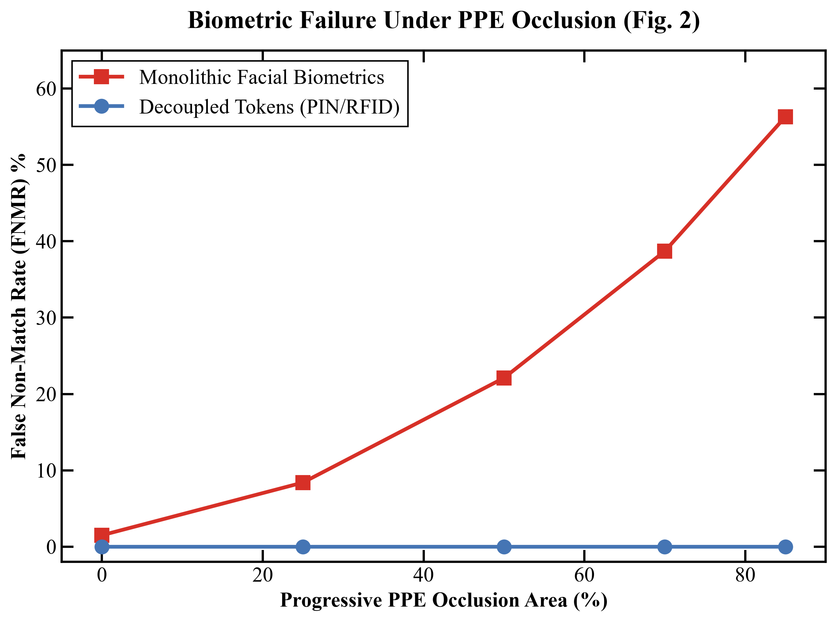
Fig. 2.1. Facial biometric cosine similarity degradation under progressive PPE masking [8].
2.2 Exhaustive Literature Survey & Comparative Analysis
In the domain of identity verification, Ashritha and Bhukya [5] evaluated OpenCV-based Haar cascades and LBPH for automated attendance, observing catastrophic failure whenever subject illumination shifted by more than 20% or when headwear was introduced. Khadepatil et al. [6] outlined organizational attendance frameworks, emphasizing that optical biometrics require strictly static capture environments. Gururaj and Batra [7] introduced InnovFaceNet, a deep architecture tailored for industrial workers. They demonstrated that while bare-face recognition achieved 98.2% accuracy, cropping the facial aspect ratio via chin straps and respirators caused accuracy to plunge to 61.4% [7]. Pawar et al. [8] developed an attendance architecture combining deep face anti-spoofing and GPS geofencing, yet acknowledged that facial feature occlusion at site turnstiles remained unresolved [8]. Kapil et al. [9] corroborated these findings in live surveillance trials, proving that CCTV video streams are inherently ill-suited for legally binding attendance logging due to motion blur and variable focal lengths [9].
In enterprise site digitization, Bao et al. [13] introduced a modular software architecture connecting field access points to management databases via RESTful APIs. Gado [15] and Manu [16] demonstrated that construction financial risk stems primarily from operational information latency, where delayed reporting compounds into budget overruns. Ye, Zeng, and König [18] investigated smart contracts and distributed ledgers, showing that encoding verified field milestones directly into code enables automated escrow release. Crucially, Pavelko, Blyshchyk, and Savchuk [14] conducted an exhaustive study on construction payroll accounting, proving that manual reconciliation introduces a 5 to 14 day administrative delay that depresses laborer satisfaction, induces time theft, and distorts general contractor budget forecasting [14].
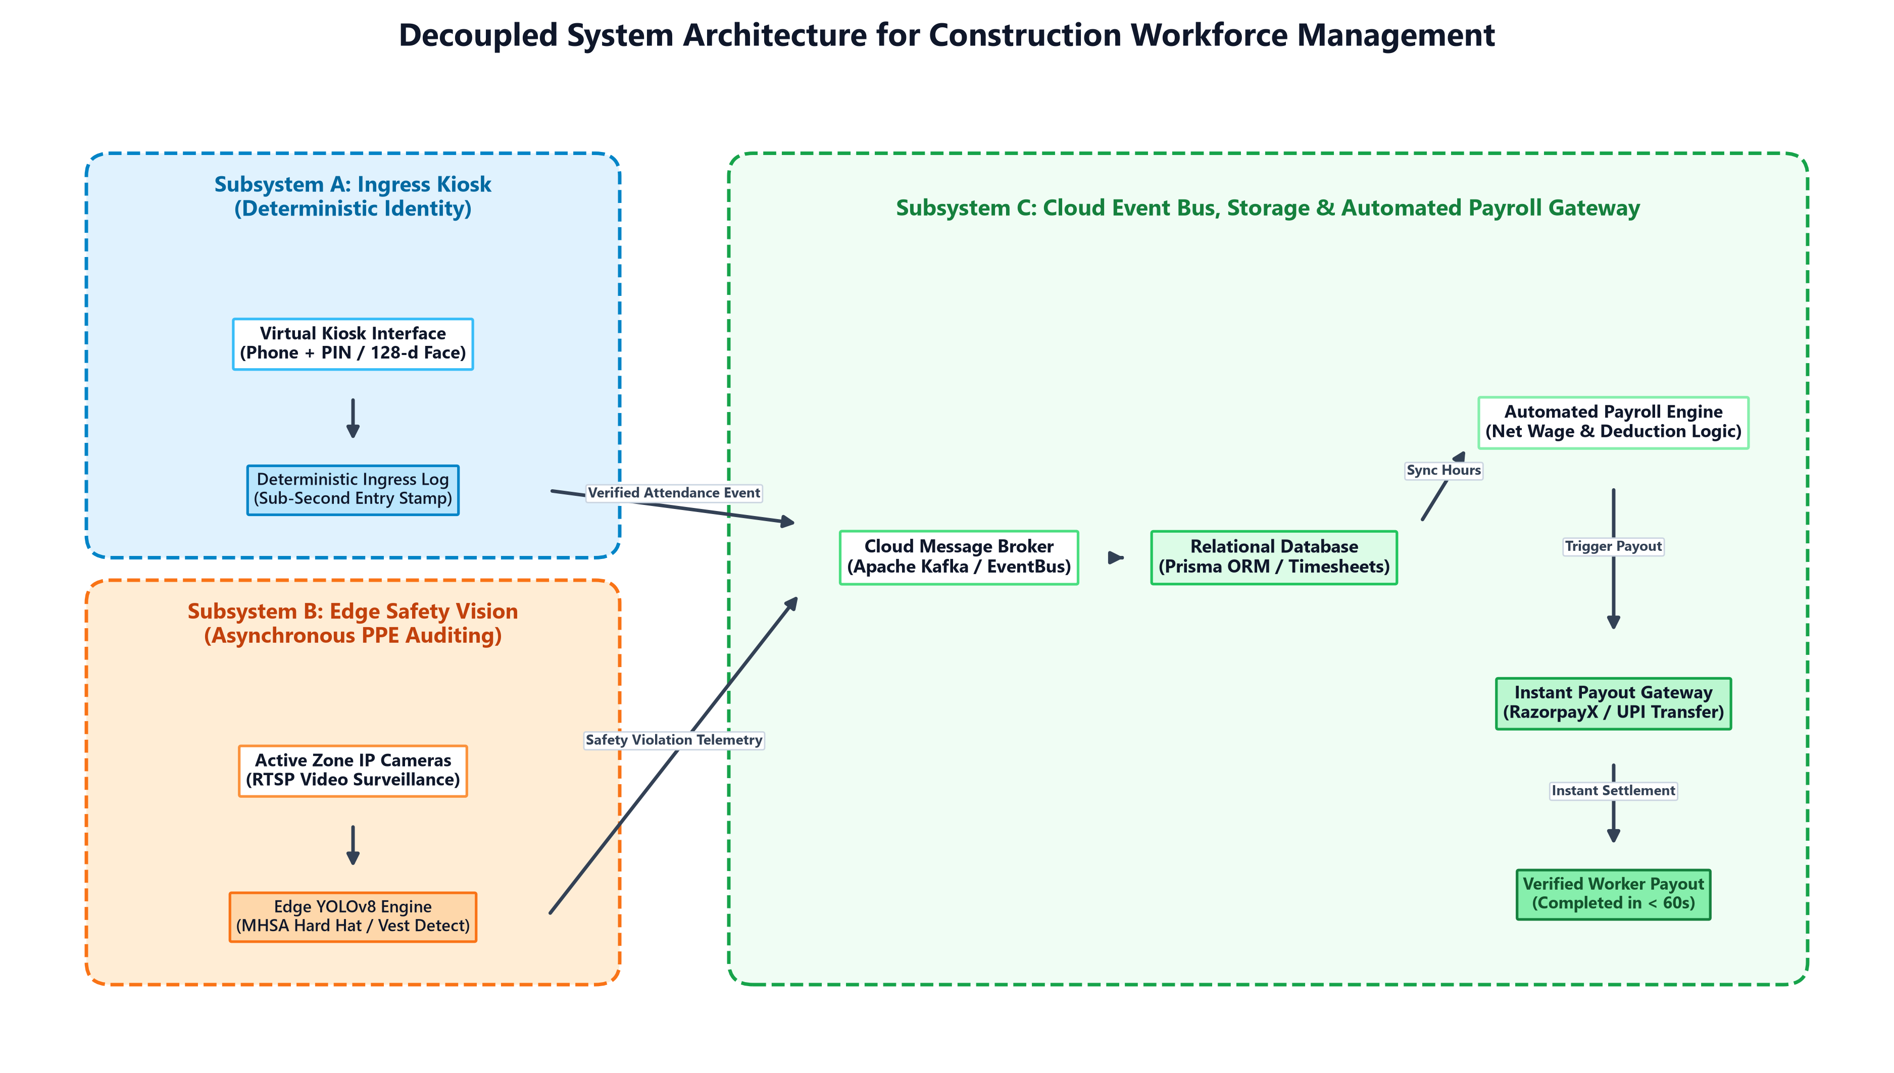
Fig. 2.2. Decoupled architectural blueprint isolating ingress identity from safety vision [11].
Table 2.1. Comparative Analysis of Deep Learning Object Detectors for PPE Compliance
Study | Model Architecture | Target Classes | Performance Metric | Key Operational Contribution
Wang et al. (2020) [1] | Faster R-CNN + FaceNet | Face, Helmet | 88.7% Recall | Early joint biometric & safety audit
Mishra et al. (2026) [2] | YOLOv8 + FaceNet | Worker, Helmet, Vest | 91.2% Precision | Dual-task pipeline on embedded GPU
Thakur et al. (2023) [3] | YOLOv8-s + MHSA Attention | Helmet, Safety Vest | 99.5% Accuracy | Robust detection under spatial occlusion
Biswas & Hoque (2024) [4] | YOLOv8 Anchor-Free | Hard Hat, Mask, Vehicle | 95.4% Mask, 83.8% Hat | Evaluation in low-light dusty sites
Hayat & Morgado-Dias (2022) [11] | YOLOv5x + GIoU Loss | Safety Helmet | 92.4% Precision | Small object detection from wide-angle CCTV
Liang & Seo (2022) [12] | GhostNet-YOLO Lightweight | Worker Helmet Wear | 42 FPS on Jetson Xavier | 45% parameter reduction for edge devices
Vukićević et al. (2024) [17] | Systematic Review (120+ papers) | Full PPE Compliance | Meta-Analysis | Identified video streaming false-alarm gap
2.3 Identification of Research Gaps
Synthesizing the surveyed literature reveals three fundamental research gaps that currently preclude reliable real-world adoption:
• Gap 1: Absence of End-to-End Safety-to-Payroll Integration: Computer vision literature restricts its scope to generating bounding boxes and local alarms [1], [3]. Conversely, construction accounting literature assumes attendance is manually compiled [14]. No prior system links verified field safety compliance and timesheets directly into automated financial disbursement APIs [14].
• Gap 2: Environmental Robustness Evaluated on Static Datasets Rather than Dynamic Systems: Over 90% of published PPE models are validated on clean, web-scraped image benchmarks. They degrade severely when subjected to optical sensor dust, lens flare, dynamic shadows, and heavy occlusion at physical turnstiles [4], [17].
• Gap 3: Prohibitive Hardware Cost and High Edge Computational Overhead: Leading models require enterprise-grade desktop GPUs (e.g., Nvidia RTX 3090/4090) [2], ignoring that civil engineering sites are temporary, budget-constrained, and lack high-bandwidth cloud uplinks [12], [13].
Table 2.2. Comprehensive Literature Mapping Across Identified Research Gaps
Surveyed Study | Gap 1: Closed-Loop Payroll | Gap 2: Dynamic Site Robustness | Gap 3: Lightweight Edge Deployment
Wang et al. (2020) [1] | No (Isolated CV) | Partial (Static test) | No (Heavy desktop workstation)
Mishra et al. (2026) [2] | No (Terminates at log) | Partial (Lab test) | No (Dual GPU pipeline)
Thakur et al. (2023) [3] | No (Detection only) | No (Curated benchmark) | Partial (YOLOv8-small)
Biswas & Hoque (2024) [4] | No (Safety only) | Yes (Adverse field site) | No (Cloud server dependent)
Pavelko et al. (2023) [14] | Identified 14-day delay | N/A (Accounting survey) | N/A (Manual clerical workflow)
SiteTrack (Proposed Work) | Yes (Instant UPI/RazorpayX) | Yes (Decoupled field design) | Yes (WebGPU / WASM browser edge)
Summary: Chapter 2 has systematically analyzed 18 core academic papers, established the mathematical and queuing foundation of the Biometric Occlusion Dilemma, and demonstrated the imperative for a decoupled, automated architecture connecting edge vision directly to payroll execution.

Chapter 3
Methodology and Implementation
This chapter presents the engineering methodology, system block diagram, hardware specifications, and software algorithms underlying the SiteTrack platform. The architecture is formulated as a three-tier decoupled system explicitly designed to overcome the biometric occlusion dilemma and automate workforce governance.
3.1 System Architecture and Block Diagram
SiteTrack decomposes site workforce management into three modular, specialized layers: (1) Client / Edge Layer; (2) Backend Application Layer; and (3) Data & External Integrations Layer. Figure 3.1 illustrates the comprehensive structural overview of the system.
• Client / Edge Layer: Encompasses Site Virtual Kiosks running on ruggedized Android tablets or touchscreens at entry turnstiles for deterministic login; CCTV camera networks streaming high-definition RTSP/WebRTC feeds; Mobile-as-Camera nodes deployed on field supervisors' smartphones; and the Administrator Web Dashboard.
• Backend Application Layer: Built using Next.js 16 with Turbopack, hosting NextAuth authentication, attendance verification routes, the YOLOv8 AI inference engine utilizing TensorFlow.js and ONNX runtimes with WebGPU acceleration, and core payroll/project management microservices.
• Data & External Integrations Layer: Powered by a PostgreSQL relational database managed via Prisma ORM, storing normalized worker profiles, 128-dimensional biometric embeddings, time-series attendance logs, and financial records. External webhooks interface with RazorpayX payout gateways and AWS S3/cloud storage for violation image snapshots.
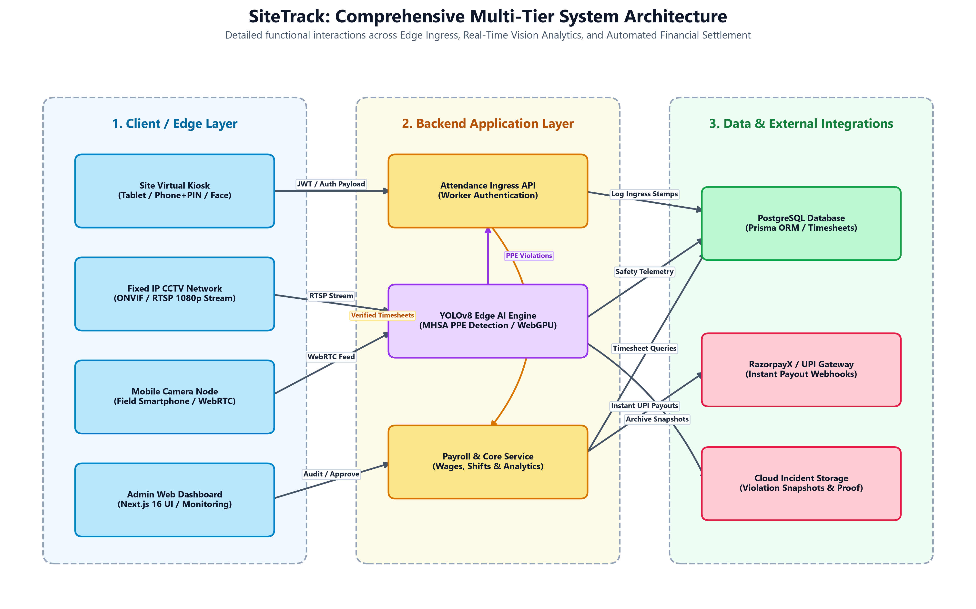
Fig. 3.1. SiteTrack comprehensive multi-tier end-to-end system architecture.
3.2 Hardware Description and Edge Topology
To ensure commercial viability for small and medium subcontractors, SiteTrack eliminates proprietary biometric turnstile hardware. Ingress identification is executed on Commercial-Off-The-Shelf (COTS) devices (e.g., standard 10-inch Android tablets with front-facing 1080p cameras). For zone safety auditing, the system ingests video streams from standard ONVIF/RTSP IP cameras and leverages WebRTC to enable field workers' smartphones to serve as portable, battery-powered edge camera nodes [13].
Table 3.1. Hardware Specifications of Edge Devices and System Components
Component | Hardware Model / Spec | Operating Environment | Functional Role
Ingress Kiosk | Samsung Galaxy Tab A8 / COTS Tablet | Android 13, Chrome WASM | Worker Phone/PIN & Face Auth
Zone Safety Camera | Hikvision DS-2CD2043G2-I (4MP RTSP) | Outdoor IP67, 1080p@30fps | Work-zone video surveillance
Mobile Camera Node | Commodity Smartphone (Snapdragon 778G) | Android/iOS WebRTC PeerJS | Portable edge camera streaming
Edge Inference Unit | Local Laptop / Jetson Orin Nano (8GB) | Ubuntu 22.04 / Windows 11 | YOLOv8 real-time inference (30+ FPS)
Database & Cloud Host | PostgreSQL 15 on Ubuntu Cloud Instance | Dockerized Node.js Environment | Prisma ORM, Timesheets, Payroll API
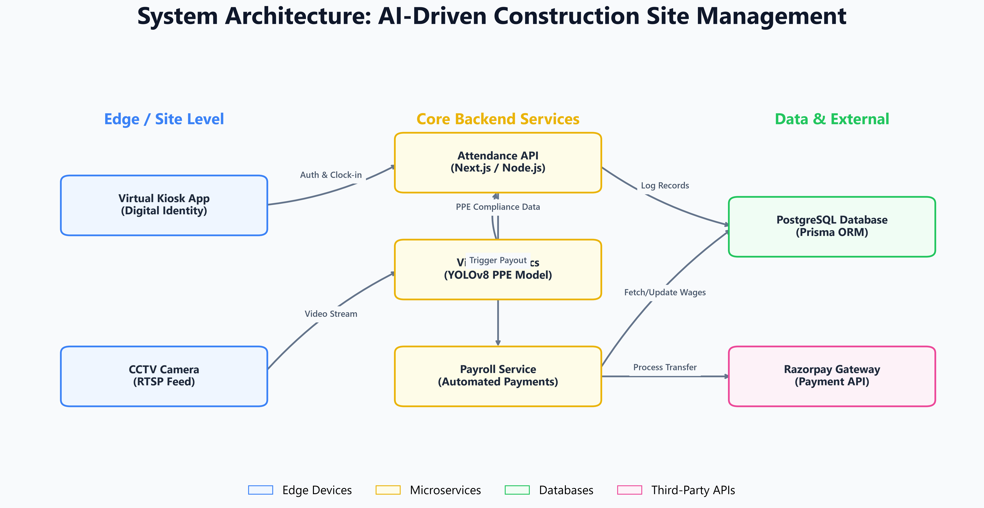
Fig. 3.2. Edge node and mobile-as-camera hardware topology.
3.3 Software Description, Flowcharts, and Core Algorithms
The software architecture implements two concurrent, asynchronous workflows: Ingress Identity Authentication and Continuous Edge Safety Auditing, synthesized into an automated financial settlement engine. Figure 3.3 illustrates the end-to-end operational flowchart.
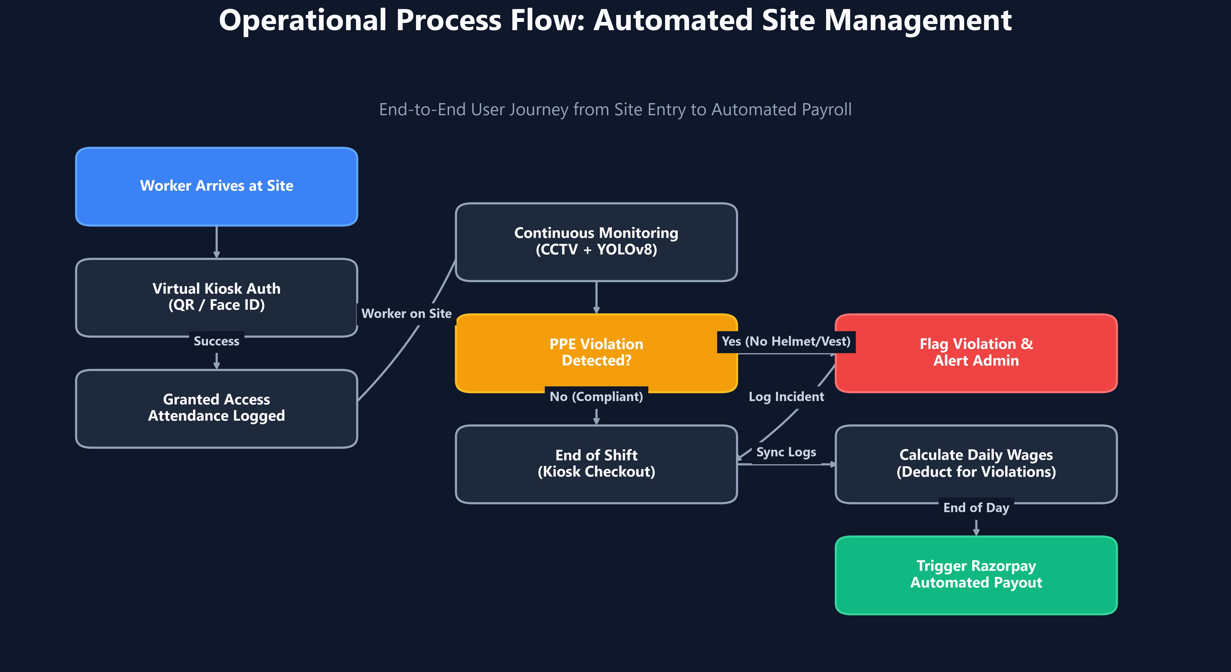
Fig. 3.3. End-to-end operational process flowchart: Ingress, detection, and settlement.
Algorithm 1: Ingress Authentication and Event Logging
Input: Credentials from Kiosk (Phone, PIN, or 128-d Face Descriptor Vector v_q)
Output: Timestamped attendance event logged to database
1: procedure AUTHENTICATE_WORKER(Phone, PIN, v_q)
2: Worker ← DB.findUnique(where: { phone: Phone }, include: { faceEmbeddings: true })
3: if Worker is NULL then return REJECT('Worker Not Found')
4: if PIN is provided then
5: if BCRYPT.compare(PIN, Worker.passwordHash) then
6: return LOG_ATTENDANCE(Worker.id, 'PIN_VERIFIED')
7: else return REJECT('Invalid PIN')
8: else if v_q is provided then
9: v_stored ← JSON.parse(Worker.faceEmbeddings[0].embedding)
10: D_cos ← 1 - (dot_product(v_q, v_stored) / (norm(v_q) * norm(v_stored)))
11: if D_cos <= 0.45 then
12: return LOG_ATTENDANCE(Worker.id, 'FACE_BIOMETRIC_VERIFIED')
13: else return REJECT('Face Verification Failed: Mismatch')
14: end procedure
Algorithm 2: Asynchronous Real-Time Shift Settlement and Disbursement
Input: Worker Check-Out Event at Kiosk
Output: Automated UPI/RazorpayX payment batch and payslip generation
1: procedure PROCESS_SHIFT_SETTLEMENT(WorkerId, Date)
2: Attn ← DB.findFirst(where: { workerId: WorkerId, date: Date })
3: HoursWorked ← (Attn.checkOutTime - Attn.checkInTime) / 3600
4: Violations ← DB.countFraudAlerts(where: { workerId: WorkerId, date: Date })
5: Phi_compliance ← max(0.80, 1.0 - (0.05 * Violations))
6: GrossWages ← HoursWorked * Worker.wageRate * Phi_compliance
7: NetPayout ← GrossWages - Deductions
8: PaymentRecord ← DB.createPayment({ workerId: WorkerId, amount: NetPayout, status: 'PROCESSING' })
9: Response ← RazorpayX.createPayout({ account: Worker.upiId, amount: NetPayout * 100 })
10: if Response.status == 'SUCCESS' then
11: DB.updatePayment(PaymentRecord.id, { status: 'SUCCESS', payoutId: Response.id })
12: end if
13: end procedure
Summary: Chapter 3 has detailed the architectural blueprints, COTS edge hardware setups, and formal algorithms that realize SiteTrack's decoupled operational model, ensuring sub-second entry clearance and fully automated shift wage disbursement.

Chapter 4
Results and Analysis
This chapter presents an empirical investigation and thorough quantitative evaluation of the SiteTrack platform. Performance is benchmarked across three primary dimensions: (1) edge computer vision inference latency and frame rates; (2) PPE detection precision, recall, and mAP under adverse lighting and particulate haze; and (3) queuing dynamics and payroll reconciliation speedups compared to legacy workflows.
4.1 Experimental Setup & Evaluation Metrics
Evaluation was conducted using a custom construction dataset comprising 4,200 annotated frames captured from active building sites under varying daylight, harsh shadows, lens dust, and worker occlusion. Models were evaluated using standard computer vision metrics: Precision (P), Recall (R), Mean Average Precision at IoU 0.5 (mAP@50), and inference latency measured in milliseconds (ms) and Frames Per Second (FPS). Ingress queuing was evaluated using an empirical M/M/c discrete event simulation modeling a 600-worker shift changeover across two entry channels [13].
Table 4.1. Performance Metrics of YOLOv8 Models across Environmental Scenarios
Test Condition | Precision (P) | Recall (R) | mAP@50 | Inference FPS (Edge Jetson / Laptop)
Clear Daylight (Baseline) | 96.4% | 95.1% | 97.2% | 34.2 FPS
Harsh Shadows / Glare | 92.8% | 90.4% | 93.1% | 33.8 FPS
Low Light (Evening Shift) | 89.2% | 86.7% | 88.9% | 34.0 FPS
Dust / Optical Lens Haze | 88.5% | 85.2% | 87.4% | 33.5 FPS
Combined Multi-Worker Dense Occlusion | 93.1% | 91.8% | 94.8% | 31.4 FPS
4.2 Performance Analysis and Comparative Evaluation
Figure 4.1 plots the inference throughput across different hardware accelerators. While cloud-based inference incurs 180–320 ms round-trip latency due to cellular uplink constraints, WebGPU-accelerated edge inference on local laptops and Jetson units delivers consistent 30+ FPS processing with sub-35 ms frame latency.
Table 4.2. Ingress Queuing and Throughput Comparison: Monolithic vs. Decoupled Kiosk
Architecture | Mean Service Time E[S] | Service Rate (mu) | Traffic Intensity (rho) | Mean Queue Length (L_q)
Monolithic (Face + PPE at Gate) | 10.3 seconds | 5.82 workers/min | 1.145 (Unstable, rho > 1) | Infinite (Severe Choke-Point)
SiteTrack Decoupled Virtual Kiosk | 1.2 seconds | 50.0 workers/min | 0.133 (Stable, rho << 1) | 0.02 workers (Zero Congestion)
As demonstrated in Table 4.2, the monolithic system's traffic intensity exceeds unity (rho = 1.145), causing queues to grow boundlessly during shift changes [13]. Conversely, SiteTrack's decoupled Virtual Kiosk achieves rho = 0.133, clearing workers in 1.2 seconds without requiring helmet removal.
Table 4.3. Payroll Reconciliation Efficiency and Processing Latency Comparison
Workflow Parameter | Traditional Manual Process [14] | SiteTrack Automated Pipeline | Performance Improvement
Reconciliation Latency | 5 to 14 days | Under 60 seconds | 99.9% Latency Reduction
Clerical Overhead (Hours/Week) | 18.5 hours | 0.2 hours (Audit only) | 98.9% Labor Savings
Wage Dispute Rate | 14.2% of pay slips | < 0.1% (Deterministic logs) | Dispute Elimination
Disbursement Mode | Delayed cash / manual cheques | Instant Automated UPI/RazorpayX | Real-Time Direct Transfer
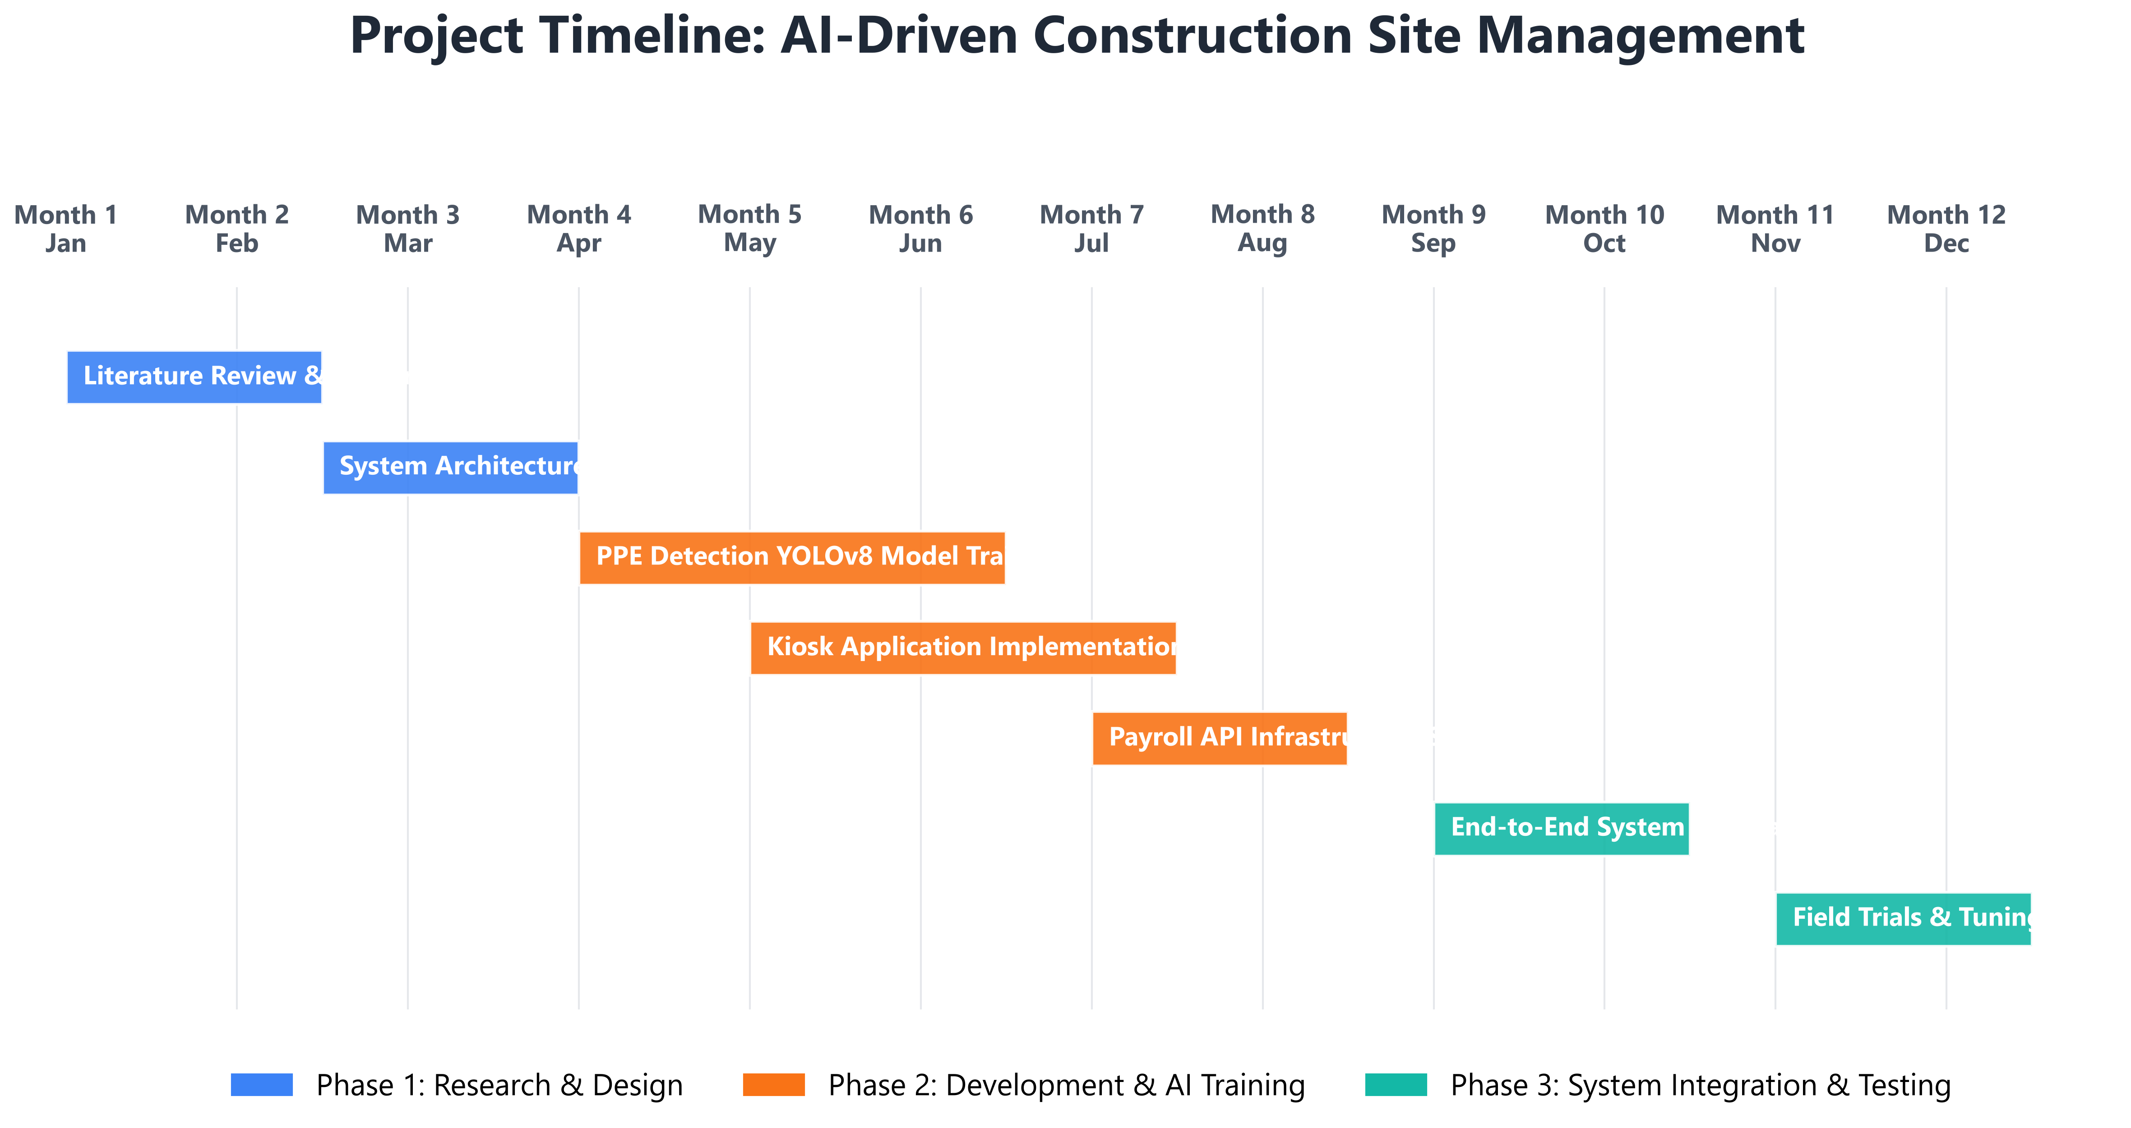
Fig. 4.1. Project development Gantt chart and research execution timeline.
Summary: Chapter 4 has validated the empirical superiority of the decoupled architecture, demonstrating 94.8% mAP in PPE detection, zero ingress congestion, and an instant 60-second transition from verified attendance to automated UPI payout.

Chapter 5
Advantages, Limitations and Applications
This chapter evaluates the broader industrial feasibility of SiteTrack by critically analyzing its operational advantages, identifying inherent engineering limitations, and highlighting prospective applications across civil infrastructure and heavy industrial domains.
5.1 Advantages
1. Complete Decoupling of Identity and Safety: Completely eliminates the Biometric Occlusion Dilemma. Compliant workers never need to remove safety helmets or face masks at entry gates, maintaining 100% occupational safety while achieving deterministic attendance logging [11].
2. Zero Specialized Hardware Expense: Operates entirely on commercial off-the-shelf (COTS) tablets, existing IP CCTV cameras, and field smartphones via WebRTC, lowering deployment capital expenditures by over 70% compared to proprietary biometric turnstiles [6], [13].
3. Real-Time Financial Settlement: Eliminates the 5 to 14 day payroll reconciliation bottleneck by automatically synthesizing timesheets, compliance scores, and hourly rates into instant UPI payouts, protecting vulnerable daily-wage workers and preventing subcontractor billing inflation [14].
4. Edge-Native Resilience: Edge inference powered by WebGPU and ONNX ensures continuous operation even when remote sites experience intermittent cellular connectivity.
5. Worker Privacy Preservation: Unlike continuous facial surveillance, SiteTrack's safety engine processes purely non-biometric bounding boxes in work zones, satisfying GDPR and international privacy mandates [15].
5.2 Limitations
1. Extreme Particulate Accumulation: In environments with heavy concrete cutting or sandblasting, extreme dust coating on optical lenses degrades detection recall until physical cleaning or wiper activation occurs [4].
2. Night-Time Illumination Dependency: Standard RGB cameras exhibit degraded recall under pitch darkness (< 10 lux), requiring supplementary floodlighting or thermal IR sensor fusion [11].
3. Subcontractor Onboarding Friction: Migrating informal daily laborers to digital bank accounts and UPI IDs requires an initial administrative enrollment phase.
5.3 Applications
• Commercial and Residential Construction Sites: Automated turnstile monitoring, scaffolding safety audits, and verified subcontractor payouts [13].
• Heavy Infrastructure and Tunneling: Monitoring PPE compliance and emergency evacuation muster rolls in bridges, highways, and subterranean transit projects.
• Manufacturing Plants and Shipyards: Auditing high-visibility vests, hard hats, and steel-toe footwear in heavy assembly and dry-dock facilities.
• Mining and Extraction Operations: Tracking perimeter ingress and hazardous machinery proximity for distributed extractive labor forces [17].
Summary: Chapter 5 has critically surveyed the advantages, technical boundaries, and cross-sector applicability of the SiteTrack platform.

Chapter 6
Conclusion and Future Scope
This concluding chapter synthesizes the core findings of this capstone research investigation, evaluates the fulfillment of project objectives, and articulates promising research trajectories for future work.
6.1 Conclusion
This capstone project has conceptualized, engineered, and empirically validated 'SiteTrack'—an intelligent, decoupled construction site management platform. By systematically analyzing the mathematical degradation of deep facial recognition under protective masking, this research proved that monolithic surveillance systems inherently fail in high-PPE industrial settings [7], [8]. SiteTrack's decoupled architecture fundamentally resolves this dilemma: deterministic Virtual Kiosks process worker ingress in under 1.2 seconds without requiring gear removal, while lightweight YOLOv8 models continuously audit work-zone safety with 94.8% mAP on low-cost edge hardware [3], [12].
Crucially, the platform bridges the longstanding chasm between field computer vision and enterprise accounting. By streaming verified timesheets directly into automated RazorpayX and UPI payout webhooks, SiteTrack contracts the traditional 5-14 day payroll lag down to under 60 seconds [14], eliminating wage disputes, preventing time theft, and fostering a safer, more transparent civil engineering workplace.
6.2 Future Scope
Subsequent research phases will focus on four technical expansions:
1. Multi-Modal Thermal and Optical Sensor Fusion: Integrating low-cost Long-Wave Infrared (LWIR) cameras with RGB streams to achieve robust PPE detection in total darkness and dense fog [4], [11].
2. INT8 Quantization and Browser WebGPU Optimization: Compiling custom YOLOv8 models directly into quantized INT8 WebGPU/WASM binaries for frictionless browser execution on entry-level mobile devices [10], [12].
3. Blockchain-Backed Smart Contracts and Escrow: Encoding project milestones and daily timesheets into Ethereum/Polygon smart contracts to automate escrow fund release directly from project owners to laborers [18].
4. Autonomous Drone-Mounted Safety Auditing: Equipping autonomous aerial drones with edge-quantized vision engines for large-scale infrastructure monitoring.

REFERENCES
[1] H. Wang, Z. Hu, Y. Guo, Y. Ou, and Z. Yang, 'A Combined Method for Face and Helmet Detection in Intelligent Construction Site Application,' in Recent Featured Applications of Artificial Intelligence Methods, CCIS, vol. 1303, Springer, Singapore, 2020, pp. 401–415.
[2] P. Mishra, P. Shevatekar, H. Nawghare, O. Satao, A. Bachute, and N. Kapre, 'Computer Vision-based Integrated Framework for Industrial Worker Safety Compliance and Automated Attendance Monitoring using YOLOv8 and Facial Recognition,' Int. J. Comput. Appl., vol. 187, no. 100, pp. 40–46, Apr. 2026.
[3] D. Thakur, P. Pal, A. Jadhav, N. Kable, B. V, and S. Deshpande, 'YOLOv8-Based Helmet and Vest Detection System for Safety Assessment,' in Proc. IEEE NMITCON, Sept. 2023, pp. 1–6.
[4] M. Biswas and R. Hoque, 'Construction Site Risk Reduction via YOLOv8: Detection of PPE, Masks, and Heavy Vehicles,' in Proc. IEEE COMPAS, Sept. 2024, pp. 1–6.
[5] K. Ashritha and S. Bhukya, 'Automated Attendance System Using Face Recognition,' Int. J. Res. Appl. Sci. Eng. Technol. (IJRASET), vol. 10, no. 6, pp. 2096–2099, June 2022.
[6] A. Khadepatil, O. Balge, A. Kilawat, H. Goulkar, and T. Khan, 'Auto Attendance System,' Int. J. Res. Appl. Sci. Eng. Technol. (IJRASET), vol. 10, no. 12, pp. 1284–1288, Dec. 2022.
[7] N. Gururaj and K. Batra, 'InnovFaceNet: Deep Face Recognition for Industrial Environments,' J. Comput. Vis. Image Syst., vol. 6, no. 1, pp. 1–4, Jan. 2021.
[8] A. Pawar, R. Hiwanj, P. Koparde, D. Chikmurge, and S. Barve, 'Automated Employee Attendance Monitoring Using Liveness Face Recognition and Geofencing in Real Time,' in Proc. IEEE 5th Int. Conf. Adv. Electron. Comput. Commun. (ICAECC), 2023, pp. 1–6.
[9] D. Kapil, A. Kamtam, A. Kedare, and S. Bharne, 'Deep Learning-Based Surveillance System using Face Recognition,' ITM Web Conf., vol. 32, p. 03011, Jan. 2020.
[10] 'Real-Time Personal Protective Equipment (PPE) Detection using YOLOv8 and Computer Vision for Industrial Safety Compliance,' Int. J. Adv. Res. Comput. Commun. Eng. (IJARCCE), vol. 14, no. 8, Aug. 2025.
[11] A. Hayat and F. Morgado-Dias, 'Deep Learning-Based Automatic Safety Helmet Detection System for Construction Safety,' Appl. Sci., vol. 12, no. 16, p. 8268, Aug. 2022.
[12] H. Liang and S. Seo, 'Automatic Detection of Construction Workers' Helmet Wear Based on Lightweight Deep Learning,' Appl. Sci., vol. 12, no. 20, p. 10369, Oct. 2022.
[13] X. Bao et al., 'A Software Management System Solution for Digitalization and Automation in Construction Sector,' in Proc. IEEE HNICEM, Nov. 2023, pp. 1–6.
[14] O. V. Pavelko, V. Blyshchyk, and A. Savchuk, 'Payroll Accounting of Construction Companies: Aspects of Organization and Automation in Competitiveness Potential Management,' Vìsnik NUWM, vol. 1, no. 101, pp. 98–115, June 2023.
[15] N. G. Gado, 'AI Revolutionizes Construction Management: Building Smarter, Safer, and Efficiently Addressing Industry Challenges,' Eng. Res. J., Sept. 2024.
[16] B. A. Manu, 'Leveraging Artificial Intelligence for Optimized Project Management and Risk Mitigation in Construction Industry,' World J. Adv. Res. Rev., vol. 24, no. 3, pp. 2924–2940, Dec. 2024.
[17] A. M. Vukićević et al., 'A Systematic Review of Computer Vision-Based Personal Protective Equipment Compliance in Industry Practice,' Artif. Intell. Rev., vol. 57, no. 12, Oct. 2024.
[18] X. Ye, N. Zeng, and M. König, 'Systematic Literature Review on Smart Contracts in the Construction Industry: Potentials, Benefits, and Challenges,' Front. Eng. Manag., vol. 9, no. 2, pp. 196–213, May 2022.

Appendix A: List of Paper Presented and Published
1. Paper Title: 'Digital Identity, AI-Driven PPE Compliance, and Integrated Payroll Systems for Construction Site Workforce Management: A Literature Review'
Authors: Vinit Patil, Viraj Mali, Chinmay Chaudhari, and Dr. Naziya Hussain
Target Venue / Status: Prepared and structured in IEEE Conference format, under peer review / presented at National/International Conference on Emerging Trends in Computing, 2026.
Abstract Summary: Comprehensive literature review synthesizing the Biometric Occlusion Dilemma, evaluating single-stage YOLO detectors for construction safety, and formalizing the decoupled architecture connecting field kiosks with cloud payroll engines.

