# Subscriber

## Create Subscriber

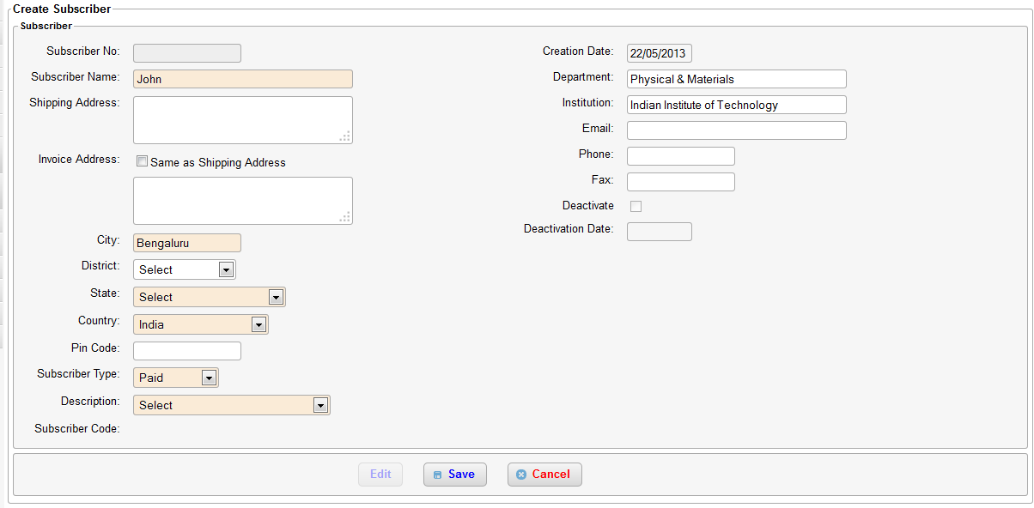

The create subscriber screen is displayed when a new subscriber is registered in the system and the inward type is selected as “New subscription” or “Request for Invoice” and the subscriber id is left blank. All fields on this screen which are also present in the inward are populated with data that was entered in the inward. For e.g. City, State, Country, Email. The subscriber number field is read only and need not be filled by the user, a unique system generated id is used as subscriber number.

## Edit Subscriber

To modify any subscriber information like address, email, phone, address follow the below steps. It is always recommended that user always create an inward of type “Address Change” before making an changes to subscriber address.

* Navigate to subscriber/subscription on the left menu and click on “Search Subscriber”

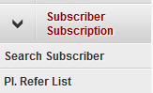

* Enter any of the search criteria like city, subscriber number, name, email, pin code. More the number of fields are filled better the search results, otherwise a large number of subscribers may get displayed after the search

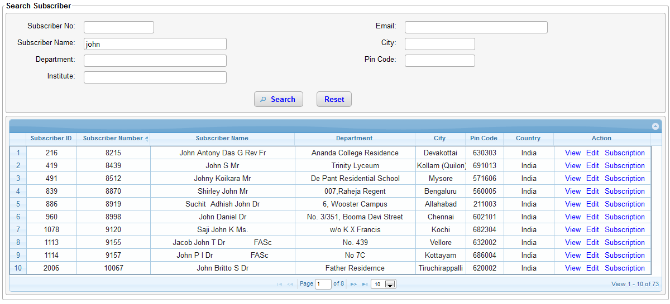

* Click on “Edit” link under the Action column.
* Now the subscriber screen is displayed in edit mode. Make changes to fields are required.
* If the deactivate checkbox is selected the subscriber is marked “inactive” and all his/her subscription will be marked inactive.
* Click on Save to submit the changes
* Click Cancel to revert any changes that were made.

## View Subscriber Details

To view detailed information like address, subscriptions, invoices, cheque returns, reminders, missing issue claims and inwards about a subscriber follow the below steps.

* Navigate to subscriber/subscription on the left menu and click on “Search Subscriber”



* Enter any of the search criteria like city, subscriber number, name, email, pin code. More the number of fields are filled better the search results, otherwise a large number of subscribers may get displayed after the search



* Click on a row or “view” link

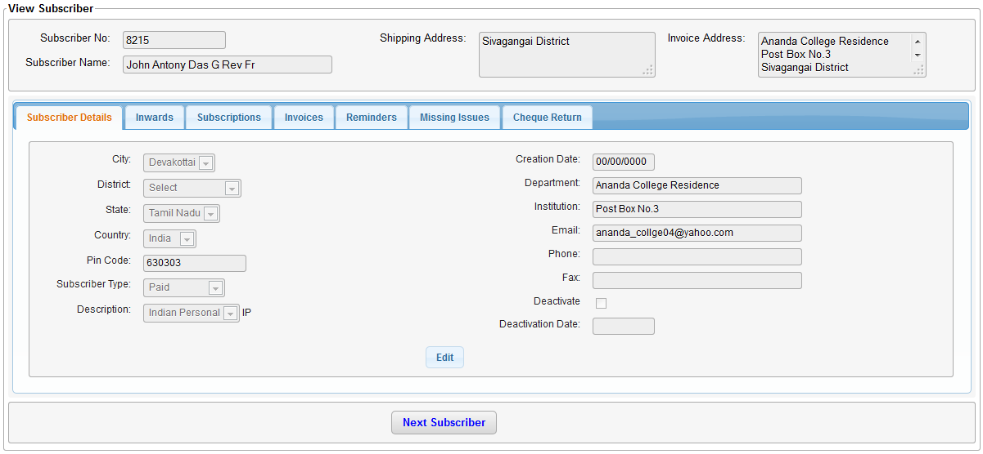

* Different tabs are displayed for each type of information about the subscriber. Click on any tab to view further details.
* Under the subscriber details tab, click on “Edit” button to modify subscriber address, state, city, country etc.
* Clicking on “Next Subscriber” will display the next subscriber details, this helps to traverse through the subscribers database.

# Subscription

## Create subscription

A Subscription can be created only by processing an inward of type Renew subscription/New subscription/Request for Invoice. To add a subscription follow the below steps.

* Create an inward with purpose Renew subscription, New subscription or Request for Invoice
* Navigate to Inward->Pending Inwards from the left menu
* Select the inward that for which a subscription needs to be created and click “Next”.
* If a subscriber is already selected (though for new subscription the subscriber should not exist) the create subscription will be directly displayed, else the create subscriber screen is displayed. Refer to Create subscriber section for further details.

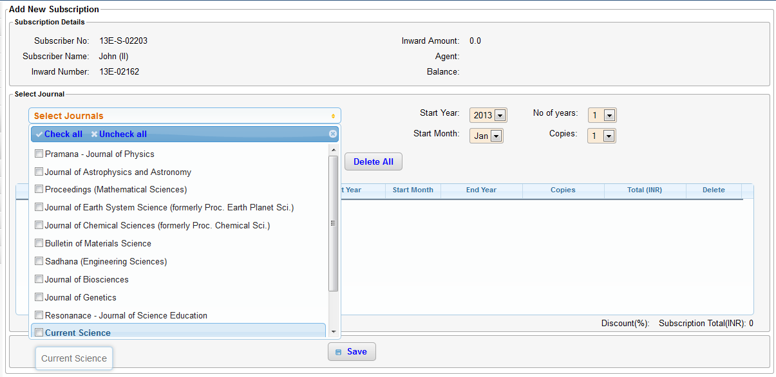

* From the “Select Journals” drop down select the journals the subscriber wishes to subscribe. Multiple journals can be selected at the same time by selecting the check box next to the journal name
* Select the start year, start month, number of years and copies
* Click on “Add”.
* If the subscriber has requested for multiple journals each having different number of copies or different start year then each such journal should be added individually
* Any discounts that are applicable for the subscriber are displayed at the bottom of the table
* The total subscription value (sum of all journal prices) is displayed at the bottom
* The balance and any amount already paid, agent name is displayed on top right side of the page
* Click on “Save” to create the subscription. If the balance is not zero then an invoice is created and displayed on saving. The invoice can be printed or emailed immediately. The invoice is also present under the invoices tab. To know how to navigate to invoice tab refer to section view subscriber details

## View subscription

All subscription information for a subscriber is available under the subscription tab. To know how to navigate to subscription tab refer to view subscriber details section

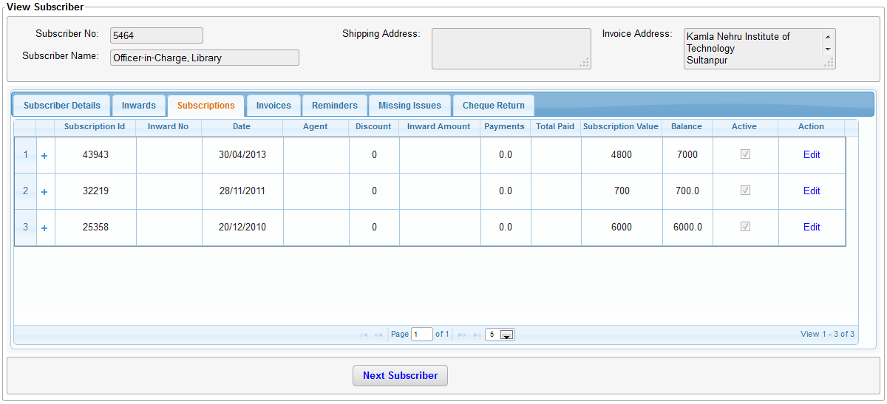

## Edit subscription

Click on “Edit” link on the subscriptions tab as shown above for the edit subscription page to be displayed.

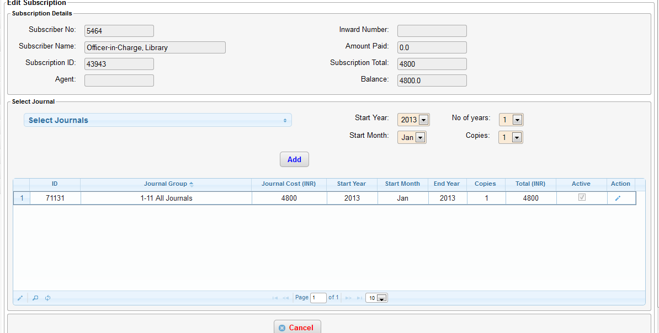

* Click on the pencil icon under the action column to edit each journal information (shown below).

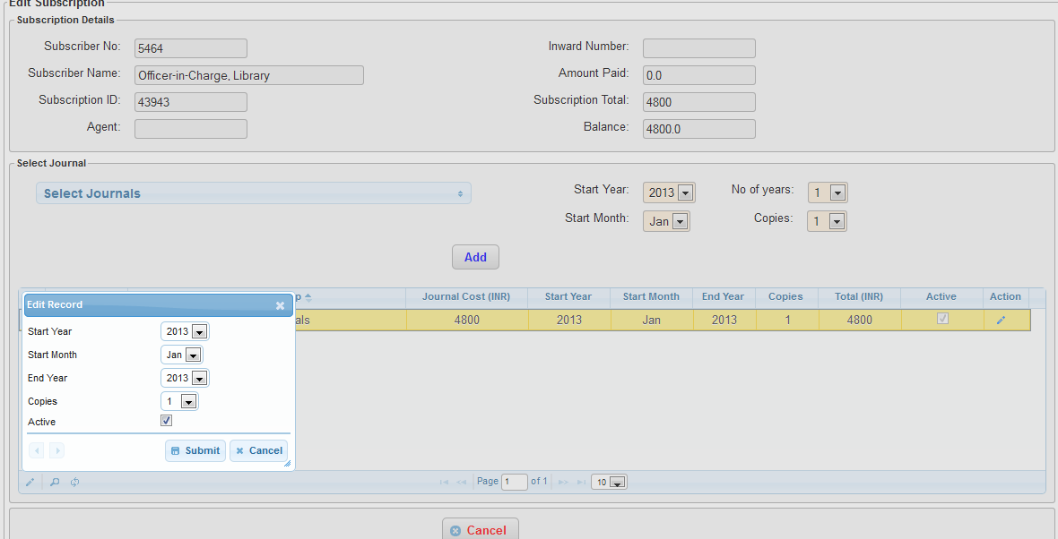

* Any changes made on the window gets saved immediately to the database. Please be sure before making any changes here.
* To add a journal that does not already exist, select the journal from the drop down, select start year, start month, number of years and copies. Click on Add. The new journal will get added to the back issue list
* Clicking on Cancel will only navigate away from this page. Any changes that were made will not be cancelled/reverted.

# Invoice Payment

If a subscription is created with a non-zero balance an invoice is generated automatically by the system. To view the list of invoices for a subscriber refer view subscriber details.

The subscriber on receiving the invoice may wish to send a payment via cheque/demand draft/bank transfer or money order. To add a payment to an existing invoice follow these steps:

* Create an inward purpose “Payment” and fill in all the mandatory fields that are marked in red. Payment information like cheque number, date and amount are mandatory fields for payment inward. Enter the subscriber number is known. Save the inward.

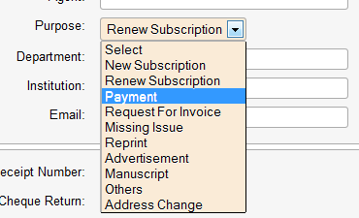

* Navigate to pending inwards and select this inward, press “Next”. The payment screen as shown below will be displayed. If the subscriber number fields is blank you will be prompted to select an existing subscriber.

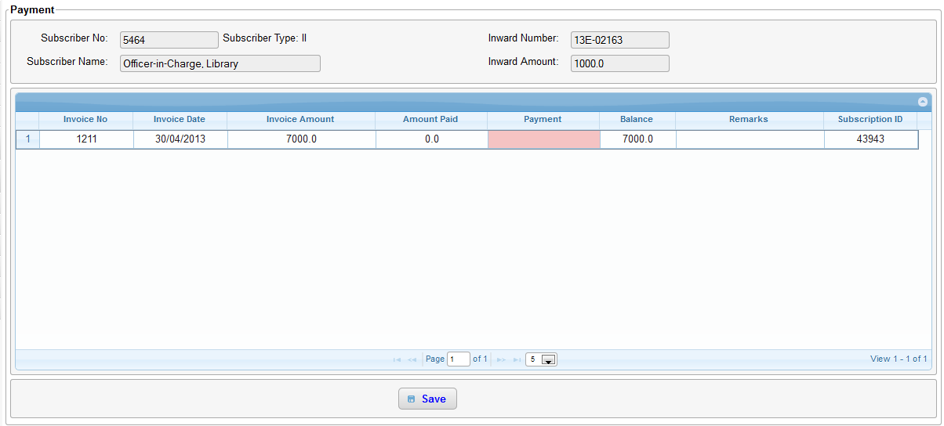

* Click on the red text box under the payment column. Now enter the amount you wish to pay towards the invoice. Now press enter again. The amount entered cannot exceed the inward amount as shown on top of the page. The user has an option to split the inward amount among multiple invoices and again the sum of all these payments cannot exceed the inward amount.
* No payments can be made against invoices which has a zero balance.
* If the entire balance amount is paid the payment is marked as “Full Payment” else “Partial Payment”
* All payments are considered in INR.
* Click on “Save” when all payments are added. A confirmation message as shown below is displayed.

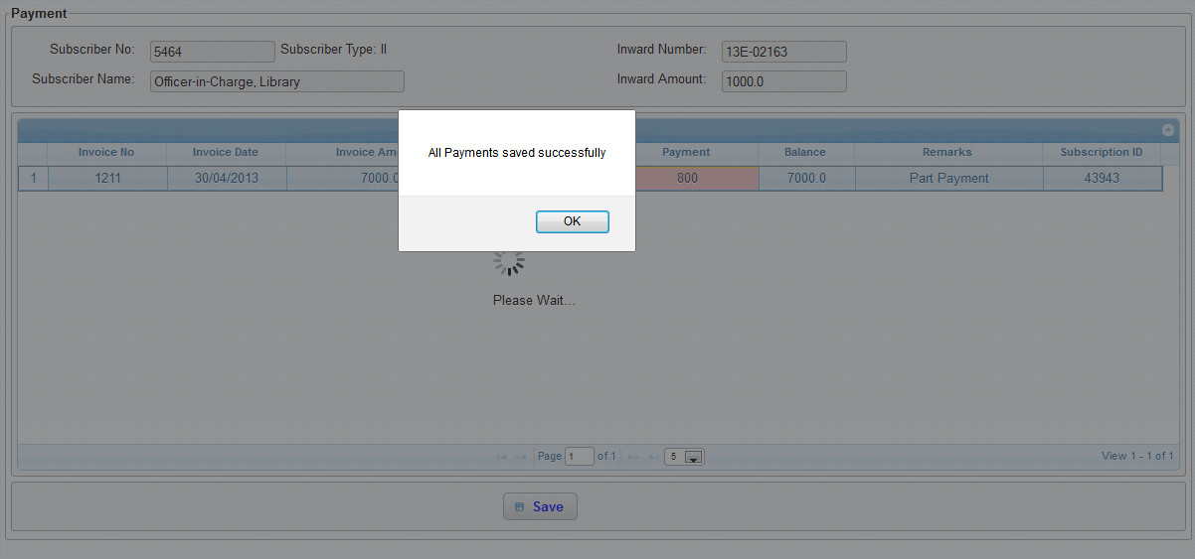

* To view the list of invoices and payments made (shown below) for a subscriber refer view subscriber details.

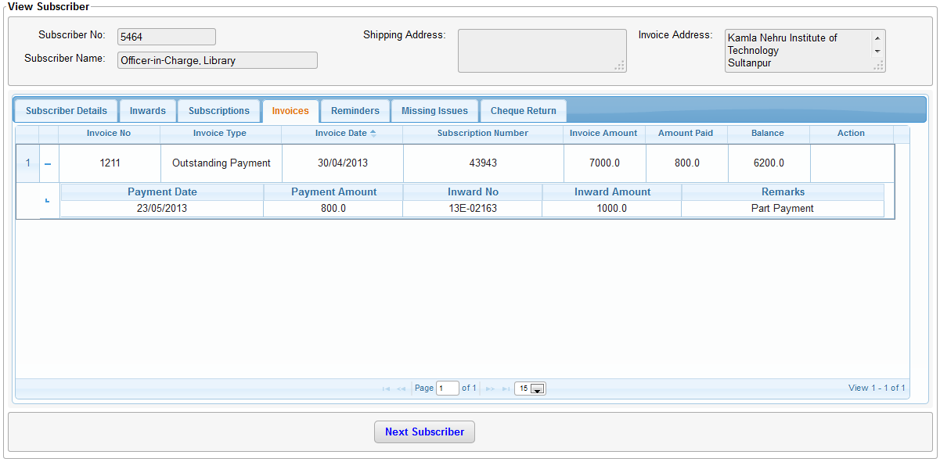

# Please Refer List

Please refer list creates invoices for the upcoming year for subscribers having a valid subscription. These invoices can be then sent to the subscriber via email of post. This feature is generally used to remind subscribers to renew their subscription for the upcoming year. To generate this list follow these steps.

* Click on subscriber/subscription on the left menu. Then click on “Pl. Refer list” as shown in the below picture.

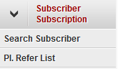

* Now select the medium through which the invoice should be sent.
  + Email Only: The invoice will be sent to all subscribers that have an email id in the system
  + Print Only: The invoice for all subscribers that do not have an email id in the system will be printed.
  + Print All: The invoice for all subscribers get printed even though they may have a valid email id.

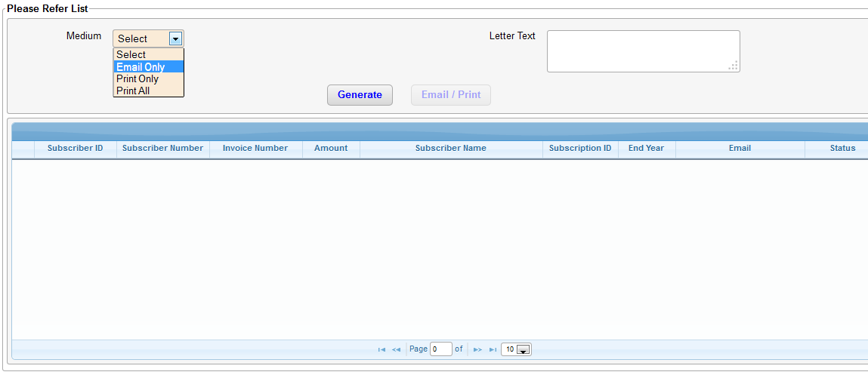

* Enter any custom text that you wish to convey to the subscribers in the “Letter text” field.
* Click on “Generate”
* The list is now generated for all valid subscribers.
* Click on “Email/Print” to either start sending emails or print each invoice in the list.