**Use Case Name :** Distribution System

**Team Name :** Courier Connect

**Team Members:**

1. Vinitha Sri Prathipati
2. Harsha Vardhan

**Abstract:**

This project designs a **Courier Booking Platform** on **Pega 24.2 Constellation**, enabling customers to sign up or log in and request parcel deliveries by entering details such as destination (national or international), package weight, and preferred logistics partner (Bluedart or FedEx). The application computes delivery charges based on the inputs and forwards the request to an administrator for review and decision. If approved, the task is handed over to a pickup agent, who validates the shipment, manages payment, and confirms collection, providing a smooth and structured courier service workflow.

**Scope (Requirements) :**

**For customer :**

* Register by providing the information and create login credentials.
* Enter shipment details including the destination (national or international) and preferred courier vendor (Bluedart or FedEx).
* Receive the automate caluclated delivery price based on shipment parameters.
* Receive confirmation or cancellation Mails after the booking is done.

**For Delivery Assistant :**

* Access assigned deliveries with details of the customer and the shipment.
* Pick up the items from the pickup assistant or warehouse and ensure timely delivery.
* Update delivery status and confirm completion in the system.
* Notify the customers upon successful delivery.

**For Admin :**

* Receive and review booking requests from the customers.
* Approve or reject bookings based on the package details, vendor, or other considerations.
* Assign approved bookings to pickup assistants for further process.
* Trigger notifications and confirmation documents to customer’s post-approval.

**For Pickup Assistant :**

* View bookings assigned by the admin.
* Visit the customer to verify package details and condition.
* Update case status to indicate completion of the pickup process

**Design**

**Application Name :** DistributionSystem

**Application Structure :** CourierRequest

**Case Design**

**Case Type : Courier Track**

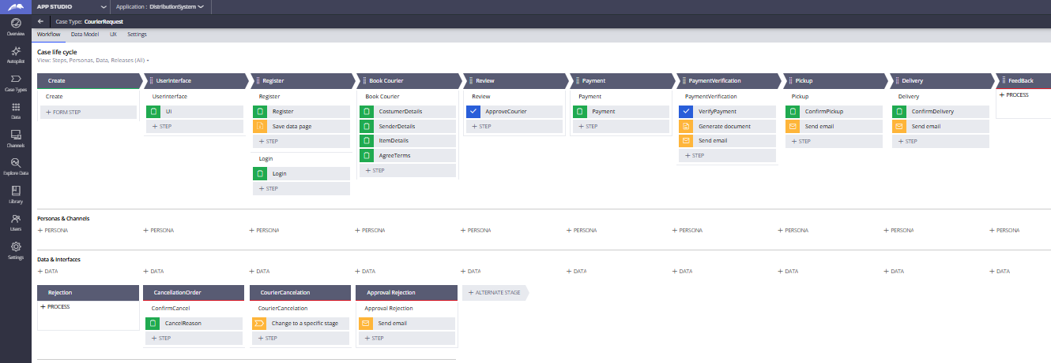

**Personas :** User, Admin, Pickup Assistant, Delivery Assistant

**Channel :** Web, Mobile

**Data & Interfaces :**

**Data :**

* Customer
* Item

**Interfaces :**

**Data Model Design**

**Data Objects and Attributes (All Pega SOR):**

* **Customer :** Name, Email, PhoneNo
* **Item :** Item Name, Description, Price, Quantity, Type, ServiceNeeded, Vendor

**Enterprise Class Structure Diagram**

**Org Layer (Org class) :** MyOrg

* **Integration Layer :** MyOrg-Int-*
* **Data Layer :** MyOrg-Data-*

**App Layer (Application class) :**   
 MyOrg-Distribu

* **Data Layer :**   
  MyOrg-Distribu-Data-*
* **Integration Layer :**   
  MyOrg-Distribu-Int-*
* **Work Layer :**   
  MyOrg-Distribu-Work-CourierRequest

**Portal Design**

**Customer Portal :**

* Login or Register
* Book an Order
* Mobile and Desktop responsive
* Mail confirmation on booking

**Admin Portal :**

* Dashboard with worklist
* Quick action : Accept / Reject

**Delivery Assistant Portal:**

* Dashboard with worklist
* Assigns work to the PickUp Assistant

**PickUp Assistant Portal:**

* Dashboard with worklist
* Check the items and pickup them

**Report Design (Insights) :**

* No of bookings based on Nationality
* Number of bookings based on Vendor
* Appointment Status (Pending / Accepted / Rejected)
* Daily / Weekly / Monthly Booking Trends

**User Details**

|  |  |  |  |  |  |  |  |  |  |  |  |  |  |  |  |  |  |  |  |  |  |  |  |  |  |
| --- | --- | --- | --- | --- | --- | --- | --- | --- | --- | --- | --- | --- | --- | --- | --- | --- | --- | --- | --- | --- | --- | --- | --- | --- | --- |
| |  |  |  |  |  | | --- | --- | --- | --- | --- | | **Role** | **Access Group** | **WorkGroup** | **Work Queue** | **Sample Operator ID** | | Customer | N/A | N/A | N/A | Guest (no login) | | Admin |  | Admin | Admin | admin@courierconnect | | PickUp Assistant |  | PickupAssist | PickupAssist | pickupassist@courierconnect | | Delivery Assistant |  | Delivery Assist | Delivery Assist | deliveryassist@courierconnect | |