Step:1:- Enable New Ec2 Experience Next Go To Ec2 Dashboard And Click Instances Hyperlink

Step : 2 :- Give Name As Linux And For Application Select Amazon Machine Image (Ami) Al2023-Ami2023.2.20230920.1-Kernel-6.1-X86_64

Step : 3 :- For Instance Type Select T2.Micro Free Tier Eligible

Step: 4 :- For Key Pair With Name Lokesh_Key .In Network Settings Security Group Name 1 Security Name And Description Is Changed To Vs7 Next Lauch Instance And Security Group Name 2 Select Http And Continue

Step : 5 :- Reload Status Type Until It Get 2/2 Check And Click The Option Connect

Step : 6 :- Install Puttygen And Click Load And Keep The File To All Files And Click Lokesh.Pem File And Click Save Private Way And Give File Name As Aws

Step : 7 Go To Putty And Give Host Name As Dns Address And Go To Ssh And Click Auth And Browse Aws.Ppk

Step : 8:- Click Open And Type Login As Ec2-User You Can Observe A Bird Like Symbol

Step : 9 :- Type The Given Information

sudo su

yum update –y

yum install httpd –y

cd /var/www/html

echo “ whatsapp friends “ > index.html

cat index.html

service httpd start

chkconfig httpd on

Step : 10 :- Go To The Instance And Copy The Pubic Address

Paste In New Tab And You Are observe whatsapp friends on newtab

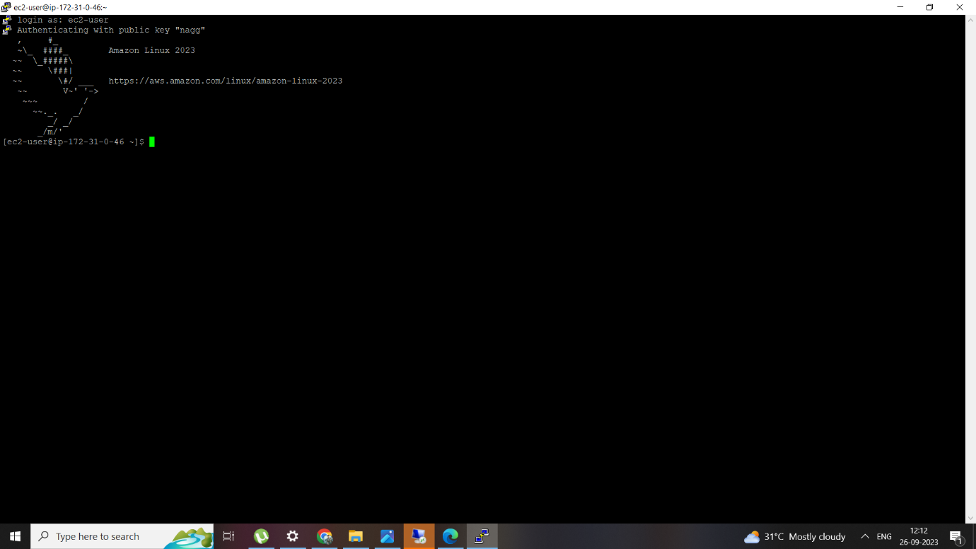

q