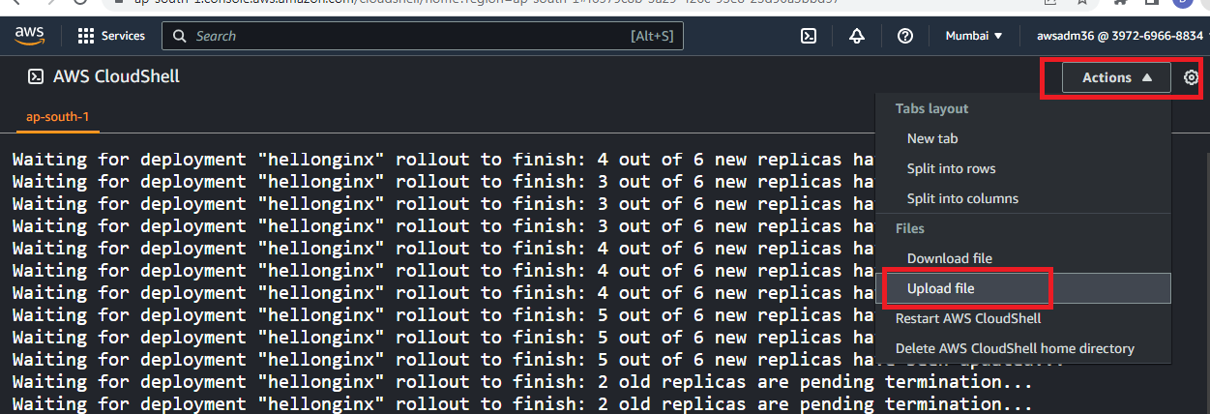

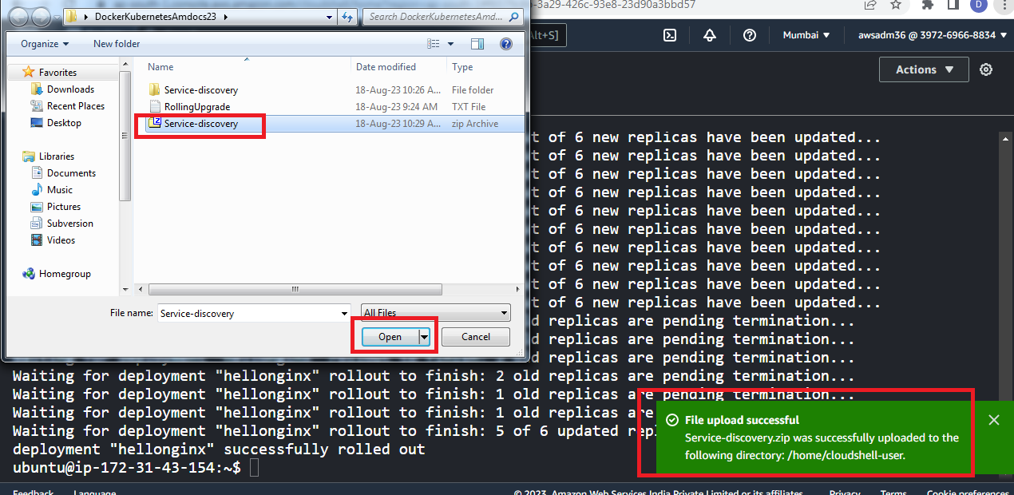

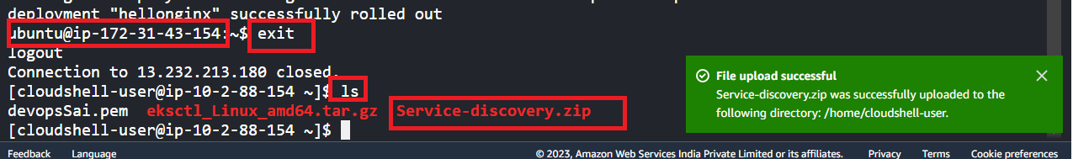

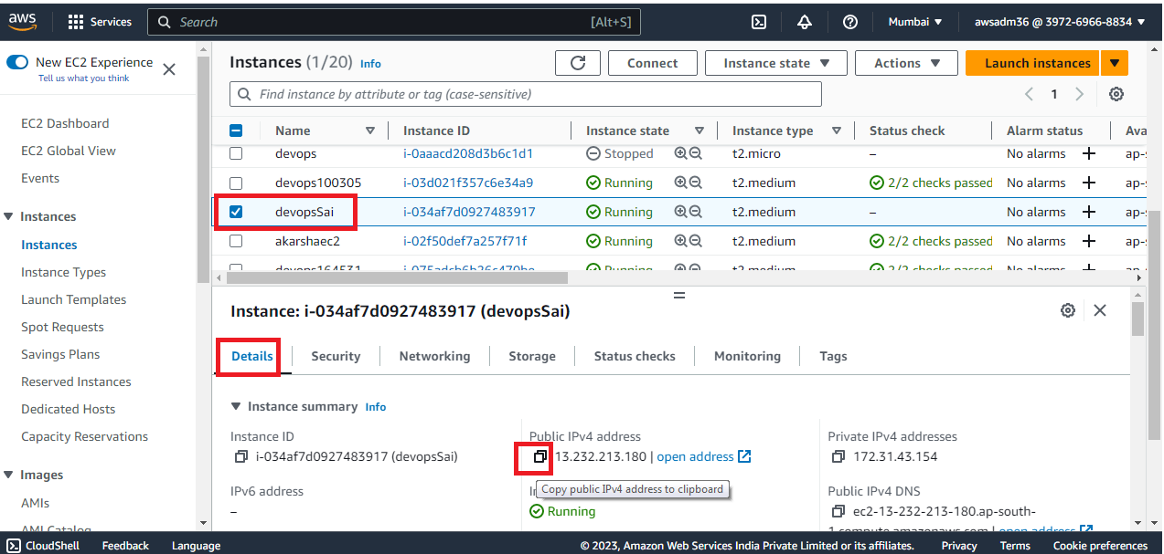

# replace the keyname and the VmIP

scp -i **KeyName**.pem Service-discovery.zip ubuntu@**VmIP**:/home/ubuntu/

# sample -> scp -i **devopsSai**.pem Service-discovery.zip ubuntu@**13.232.213.180**:/home/ubuntu/



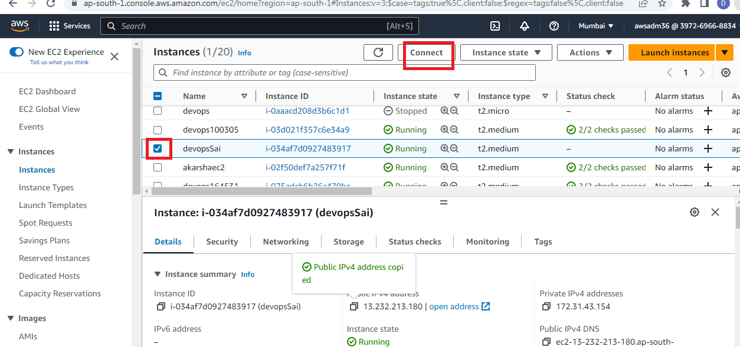

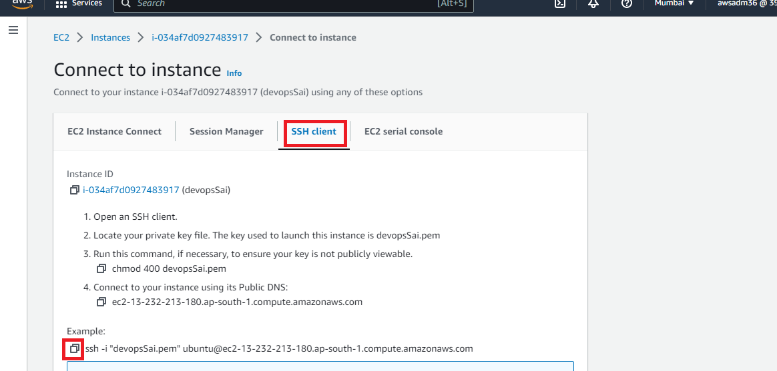

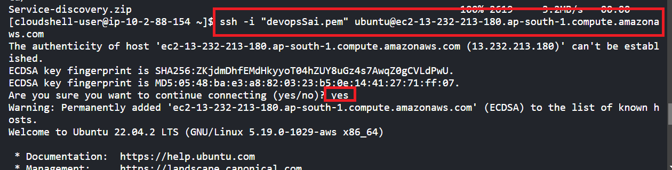

sudo apt update && sudo apt install unzip –y

unzip Service-discovery.zip

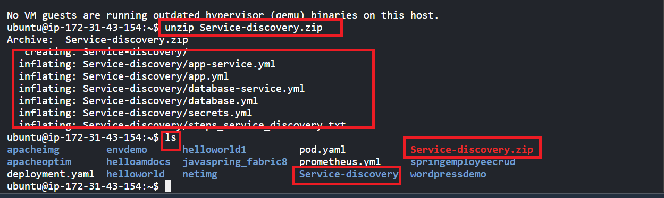

cd Service-discovery

kubectl apply -f secrets.yml

kubectl apply -f database.yml

kubectl apply -f database-service.yml

kubectl apply -f app.yml

kubectl apply -f app-service.yml

kubectl get pods

kubectl get svc

kubectl run -it busy --image busybox -- sh

cat /etc/resolv.conf

# The below command will give header error

wget database-service:3306

wget database-service.default.svc.cluster.local:3306

# Below command will time out

wget database-service:3307

Ctrl+C

exit

kubectl get svc

minikube service helloworld-db-service --url

curl $(minikube service helloworld-db-service --url)

curl $(minikube service helloworld-db-service --url)

curl $(minikube service helloworld-db-service --url)

curl $(minikube service helloworld-db-service --url)

curl $(minikube service helloworld-db-service --url)

kubectl delete -f secrets.yml -f database.yml -f database-service.yml -f app.yml -f app-service.yml

kubectl get pods

kubectl delete pod busy

kubectl get pods