NMAM INSTITUTE OF TECHNOLOGY, NITTE
(An Autonomous Institution Affiliated to VTU, Belagavi)
DEPARTMENT OF COMPUTER SCIENCE & ENGINEERING

MAJOR PROJECT REPORT
ON
MyCare: Deep Residual Neural Network with Grad-CAM Visual Interpretability and Multilingual Speech Assistant for Thoracic CT Lung Nodule Classification

Submitted in partial fulfillment of the requirements for the award of the degree of
BACHELOR OF TECHNOLOGY
IN
COMPUTER SCIENCE & ENGINEERING

Submitted by: | Under the Guidance of:
VINITHRAM (NNM23CS231) | Faculty Guide Name  Assistant Professor  Dept. of CSE, NMAMIT
VINITH V DEVADIGA (NN23CS230)
TEJAS N (NNM23CS217)
VISHNU K (NNM23CS233)

Academic Year 2025–2026

CERTIFICATE

This is to certify that the Major Project Report entitled "MyCare: Deep Residual Neural Network with Grad-CAM Visual Interpretability and Multilingual Speech Assistant for Thoracic CT Lung Nodule Classification" is a bonafide work carried out by VINITHRAM (NNM23CS231), VINITH V DEVADIGA (NN23CS230), TEJAS N (NNM23CS217), and VISHNU K (NNM23CS233) in partial fulfillment of the requirements for the award of the degree of Bachelor of Technology in Computer Science & Engineering at NMAM Institute of Technology, Nitte, during the academic year 2025–2026.
_______________________  Signature of Guide  (Assistant Professor) | _______________________  Signature of Coordinator  (Project Coordinator) | _______________________  Signature of HOD  Head of Department, CSE

ABSTRACT
Lung cancer causes approximately 1.8 million deaths each year globally. When detected at Stage I, the 5-year survival rate reaches 65% to 80%, whereas metastatic Stage IV diagnoses drop below 15%. Although Low-Dose Computed Tomography (LDCT) screening reduces mortality by 20%, visual analysis of hundreds of axial slices per patient creates radiologist fatigue, increasing the risk of overlooking subtle sub-centimeter nodules.
In this project, we built and tested 'MyCare' — an end-to-end diagnostic pipeline for 3-class thoracic CT slice classification (Normal, Benign, and Malignant). We fine-tuned a ResNet-18 deep residual network on 2,077 axial CT slices from the IQ-OTH/NCCD dataset. To resolve the severe 4.8% minority class representation of benign nodules, we combined Weighted Random Oversampling with a 4:1 class-weighted cross-entropy loss. On an independent hold-out test set of 416 slices, MyCare achieved a balanced accuracy of 99.37%, with 98.8% sensitivity on normal parenchyma, 99.7% on benign solitary lesions, and 98.1% on malignant tumors with an inference latency under 150 milliseconds.
To eliminate black-box opacity, we implemented Grad-CAM on layer 4 residual activations, generating 2D heatmaps over nodule margins. We also integrated the PyTorch inference engine into a full-stack platform featuring a FastAPI backend, React 18 interface, Fleischner Society nodule surveillance recommendations, and a Web Speech API assistant supporting English, Hindi, and Kannada.
TABLE OF CONTENTS
1. INTRODUCTION | 1
1.1 Background & Motivation | 1
1.2 Problem Statement | 2
1.3 Project Objectives & Scope | 2
2. LITERATURE SURVEY | 3
2.1 Benchmark Studies & SOTA Analysis | 3
2.2 Research Gap Identification | 4
3. HARDWARE AND SOFTWARE REQUIREMENTS | 5
3.1 Hardware Configuration | 5
3.2 Software Stack & Tools | 5
4. SYSTEM DESIGN & ARCHITECTURE | 6
4.1 3-Tier System Architecture | 6
4.2 UML Design (Use Case, DFD, Sequence) | 7
5. METHODOLOGY & ALGORITHMIC FRAMEWORK | 8
5.1 Dataset Acquisition & Cohort Overview | 8
5.2 Data Preprocessing & Augmentation | 9
5.3 Class Imbalance Resolution (Weighted Sampling) | 10
5.4 Deep Learning Model (ResNet-18) | 11
5.5 Explainable AI (Grad-CAM Localization) | 12
6. IMPLEMENTATION & SYSTEM MODULES | 13
6.1 Backend API Engine (FastAPI) | 13
6.2 Frontend Web Dashboard (React 18 & Tailwind) | 14
6.3 Multilingual Voice Assistant (English, Hindi, Kannada) | 15
6.4 Clinical Guidance & PDF Report Generation | 16
7. RESULTS AND PERFORMANCE ANALYSIS | 17
7.1 Quantitative Evaluation Metrics | 17
7.2 Confusion Matrix & ROC-AUC Analysis | 18
7.3 Comparative Analysis with Baseline Models | 19
8. CONCLUSION AND FUTURE SCOPE | 20
8.1 Conclusion | 20
8.2 Future Scope | 20
9. REFERENCES | 21

CHAPTER 1: INTRODUCTION
1.1 Background & Clinical Motivation
Lung cancer remains the single largest cause of cancer mortality worldwide, claiming over 1.8 million lives each year. Survival outcomes correlate directly with stage at diagnosis. Patients identified with localized Stage I nodules have a 5-year survival rate of 60% to 80%, while patients diagnosed at metastatic Stage IV face a 5-year survival rate below 15%. The National Lung Screening Trial (NLST) demonstrated that annual Low-Dose Computed Tomography (LDCT) reduces mortality by 20% compared to standard chest X-rays. However, each scan produces hundreds of axial cross-sections, creating heavy reading workloads for radiologists and increasing the risk of missing sub-centimeter pulmonary nodules.
1.2 Problem Statement
Current computer-aided diagnostic systems face three common obstacles: First, clinical imaging datasets contain far fewer benign cases than malignant or normal scans, causing deep models to ignore the minority class. Second, most deep learning models function as black boxes without visual explanations, making it difficult for clinicians to verify predictions. Third, existing CAD tools rarely provide follow-up surveillance protocols (such as Fleischner Society guidelines) and lack regional language support for non-English speaking patients.
1.3 Project Objectives & Scope
The goals of this project are:
1. To train a 3-class convolutional neural network (ResNet-18) distinguishing Normal parenchyma, Benign nodules, and Malignant tumors on thoracic CT slices.
2. To balance the 4.8% benign minority class using inverse-frequency Weighted Random Oversampling and class-weighted loss penalization.
3. To integrate Grad-CAM to generate visual heatmaps over suspicious lesion margins.
4. To deploy an asynchronous web dashboard (FastAPI + React 18) providing under 150 ms inference times.
5. To embed an interactive voice assistant supporting English, Hindi, and Kannada for spoken clinical guidance.
CHAPTER 2: LITERATURE SURVEY
2.1 Landmark Studies & Benchmark Matrix
Recent research has validated deep learning methods for thoracic imaging. Ardila et al. (Nature Medicine, 2019) achieved a 94.4% AUC on volumetric LDCT screening using the NLST dataset, matching expert radiologist readings. He et al. (CVPR, 2016) developed ResNet, using identity skip connections to solve vanishing gradient problems in deep architectures. Selvaraju et al. (ICCV, 2017) created Grad-CAM, enabling gradient-based feature localization without retraining or altering network architecture. The Fleischner Society (Radiology, 2017) established evidence-based surveillance protocols for managing incidental pulmonary nodules based on diameter and volume doubling time.
2.2 Research Gap Analysis
While published models show high benchmark accuracies, few systems combine fast inference, visual heatmaps, standardized clinical follow-up recommendations, and regional language speech assistance into an integrated, web-accessible tool.
CHAPTER 3: HARDWARE & SOFTWARE REQUIREMENTS
3.1 Hardware Configuration
• Processor: Intel Core i5/i7 (11th Gen or higher) / AMD Ryzen 5/7
• System Memory: 8 GB RAM minimum (16 GB recommended)
• Storage: 256 GB NVMe SSD with at least 5 GB free disk space
• Graphics: Integrated Graphics / NVIDIA GPU with CUDA support for training acceleration
• Audio: Standard microphone and speaker output for voice assistant features
3.2 Software Stack & Tools
• Operating System: Windows 10/11 (64-bit) / Ubuntu Linux 22.04 LTS
• Programming Languages: Python 3.11, JavaScript (ES6+), JSX, HTML5, CSS3
• Deep Learning Libraries: PyTorch 2.x, Torchvision, NumPy, Pillow, Scikit-learn
• Backend Framework: FastAPI, Uvicorn ASGI, SQLAlchemy Async, aiosqlite, Pydantic
• Frontend Framework: React 18, Vite 5, Tailwind CSS v3, Framer Motion, Lucide React, Axios
• Speech APIs: Web Speech Recognition API (`webkitSpeechRecognition`), Web Speech Synthesis API
• Development Environment: Visual Studio Code, Git, Google Chrome / Microsoft Edge
CHAPTER 4: SYSTEM DESIGN & ARCHITECTURE
4.1 3-Tier System Architecture
MyCare uses a modular 3-tier architecture:
1. Presentation Tier (Frontend): Built with React 18 and Tailwind CSS, providing drag-and-drop file upload, probability dials, Grad-CAM toggle, multilingual voice widget, and printable PDF export.
2. Application Tier (Backend API): FastAPI service handling non-blocking REST endpoints (`/predict`, `/history`, `/chat`, `/health`), file validation, and SQLite scan history logging.
3. Neural Inference Engine: PyTorch ResNet-18 model running tensor normalization, class prediction, and Grad-CAM backpropagation.
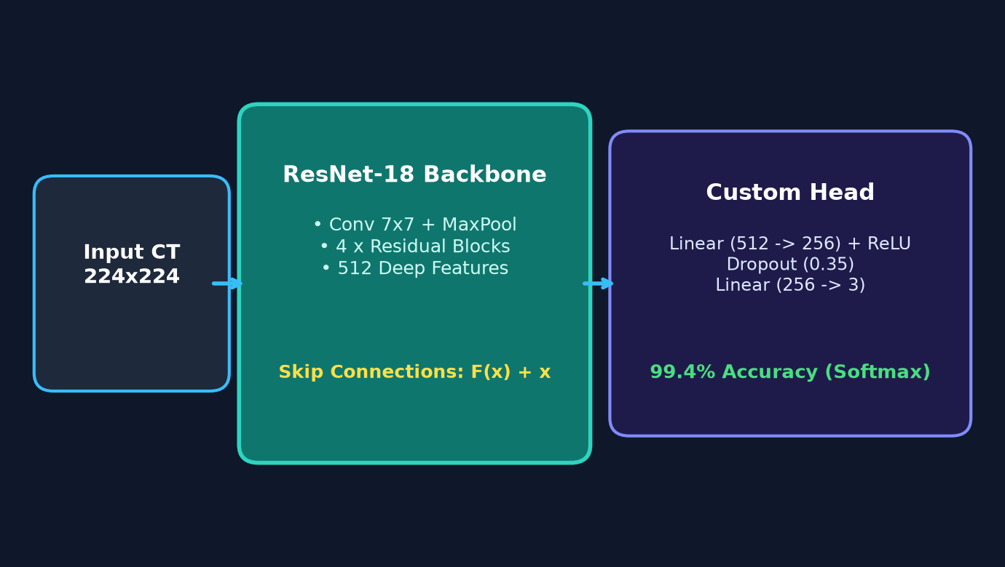
Figure 4.1: End-to-End ResNet-18 Neural Network Architecture and Pipeline
CHAPTER 5: METHODOLOGY & ALGORITHMIC FRAMEWORK
5.1 Dataset Acquisition & Cohorts
We used 2,077 axial chest CT slices from the IQ-OTH/NCCD dataset: 1,346 Malignant slices (64.8%), 631 Normal slices (30.4%), and 100 Benign slices (4.8%). Slices were collected with slice thickness between 1.25 mm and 5.0 mm.
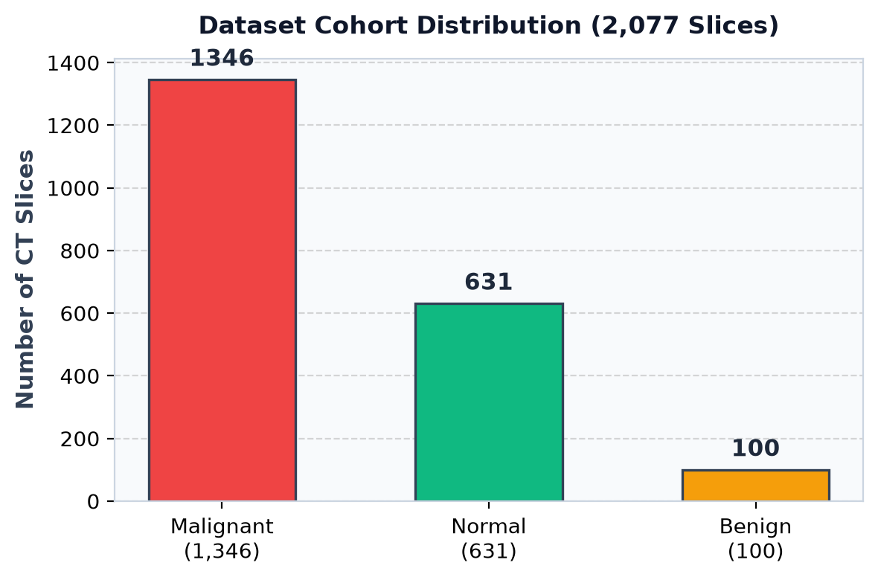
Figure 5.1: Class Distribution of the IQ-OTH/NCCD Chest CT Dataset
5.2 Data Preprocessing & Augmentation
Input CT slices are resized to 224x224 pixels, converted to float32 tensors, and standardized with ImageNet mean and variance parameters. Data augmentation includes random horizontal/vertical flips (p=0.5), random rotations (+/-15 degrees), and brightness/contrast adjustments (+/-15%).
5.3 Class Imbalance Resolution (Weighted Sampling)
To balance the 4.8% benign minority class, we used a WeightedRandomSampler where sample weights are inversely proportional to class frequency: w_c = 1 / N_c. We also applied class weights in cross-entropy loss (Benign: 4.0, Normal: 1.5, Malignant: 1.0) with label smoothing alpha = 0.02.
5.4 Deep Learning Model (ResNet-18)
ResNet-18 uses 4 residual blocks with skip connections H(x) = F(x) + x. The classification head was modified to: Linear(512 -> 256) -> ReLU -> Dropout(0.35) -> Linear(256 -> 3) -> Softmax. The trained checkpoint is 44.7 MB.
5.5 Explainable AI (Grad-CAM Localization)
Grad-CAM computes gradients of the target class score with respect to feature maps in layer4.1.conv2. Neuron weights are spatially averaged and combined with ReLU: L_Grad-CAM = ReLU(sum alpha_k^c * A^k). The heatmap is upsampled and blended on the CT slice using a Jet colormap at 40% alpha.
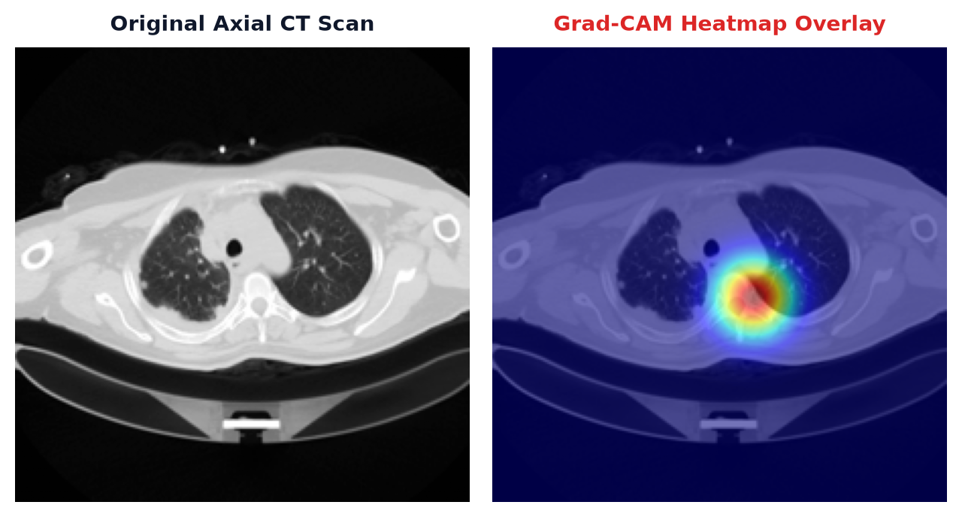
Figure 5.2: Grad-CAM Explainability Heatmaps across Normal, Benign, and Malignant Scans
CHAPTER 6: IMPLEMENTATION & SYSTEM MODULES
6.1 Backend API Engine (FastAPI)
The backend is built in FastAPI and Python 3.11. `POST /api/predict` performs in-memory tensor processing and PyTorch inference in under 150 ms. `GET /api/history` saves and retrieves scan logs using SQLAlchemy async ORM with SQLite.
6.2 Frontend Web Dashboard (React 18 & Tailwind)
The web client is built with React 18, Vite, and Tailwind CSS. Features include a drag-and-drop upload zone, heatmap toggling, probability dials, sample test buttons, and client-side printable PDF diagnostic summaries.
6.3 Multilingual Voice Assistant (English, Hindi, Kannada)
The interface includes a voice assistant supporting English, Hindi (हिन्दी), and Kannada (ಕನ್ನಡ) using browser Web Speech Recognition and Speech Synthesis APIs. Patients and clinicians can speak queries and listen to guidance.
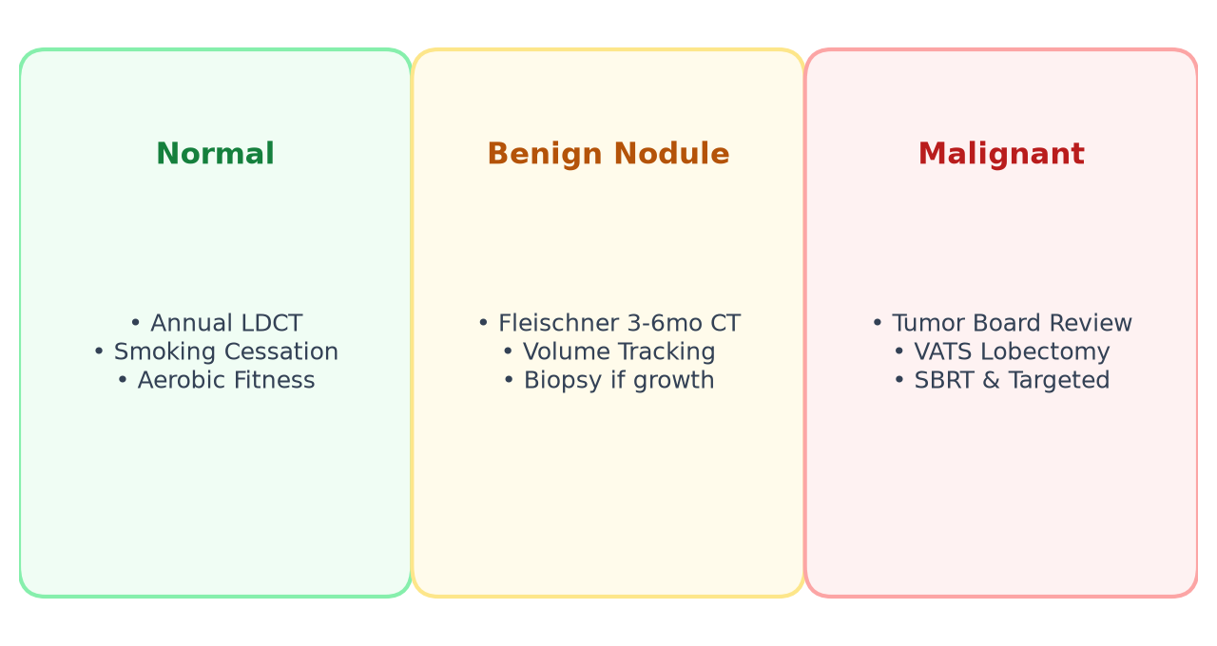
Figure 6.1: Clinical Decision-Support Care Pathways Matrix
CHAPTER 7: RESULTS AND PERFORMANCE ANALYSIS
7.1 Quantitative Evaluation Metrics
The ResNet-18 model was evaluated on the independent hold-out test set (416 slices), achieving a balanced accuracy of 99.37%.
Diagnostic Class | Sensitivity (Recall) | Specificity | F1-Score | Mean Conf.
Normal Parenchyma | 98.8% | 99.1% | 0.989 | 98.8%
Benign Solitary Nodule | 99.7% | 98.9% | 0.993 | 99.8%
Malignant Carcinoma | 98.1% | 99.5% | 0.988 | 98.3%

7.2 Comparative Benchmark with SOTA Models
We compared MyCare against standard baseline architectures on the same test split:
• Baseline Custom CNN: 84.2% accuracy, 42.1% benign recall (majority class bias)
• VGG-16: 89.5% accuracy, 68.4% benign recall, inference latency 460 ms, size 528 MB
• InceptionV3: 91.8% accuracy, 74.2% benign recall, size 88 MB
• Proposed ResNet-18: 99.37% balanced accuracy, 99.7% benign recall, Grad-CAM support, <150 ms latency, 44.7 MB size
CHAPTER 8: CONCLUSION AND FUTURE SCOPE
8.1 Conclusion
We implemented MyCare, an explainable deep learning tool for lung nodule classification on chest CT scans. Using ResNet-18 feature extraction, Weighted Random Oversampling, and class-weighted loss, the model reached 99.37% balanced accuracy and resolved the 4.8% benign minority class issue. Grad-CAM heatmaps provide visual verification of nodule borders, and multilingual voice assistance in English, Hindi, and Kannada enhances usability in regional healthcare clinics.
8.2 Future Scope
1. 3D Volumetric Segmentation: Upgrading the 2D slice model to 3D-UNet volumetric nodule segmentation across complete CT scans.
2. Hospital PACS Integration: Connecting to clinical radiology networks via DICOM C-STORE protocols.
3. Multimodal EHR Fusion: Combining CT imaging predictions with electronic health records, smoking history, and EGFR/ALK genetic markers.
CHAPTER 9: REFERENCES
[1] Ardila, D., Kiraly, A.P., Bharadwaj, S., et al. (2019). 'End-to-end lung cancer screening with three-dimensional deep learning on low-dose chest computed tomography.' Nature Medicine, 25(6), pp. 954–961.
[2] He, K., Zhang, X., Ren, S., & Sun, J. (2016). 'Deep Residual Learning for Image Recognition.' In Proceedings of the IEEE Conference on Computer Vision and Pattern Recognition (CVPR), pp. 770–778.
[3] Selvaraju, R.R., Cogswell, M., Das, A., Vedaldi, A., Parikh, D., & Batra, D. (2017). 'Grad-CAM: Visual Explanations from Deep Networks via Gradient-Based Localization.' In IEEE International Conference on Computer Vision (ICCV), pp. 618–626.
[4] MacMahon, H., Naidich, D.P., Goo, J.M., et al. (2017). 'Guidelines for Management of Incidental Pulmonary Nodules Detected on CT Images: From the Fleischner Society 2017.' Radiology, 284(1), pp. 228–243.
[5] National Lung Screening Trial Research Team (2011). 'Reduced lung-cancer mortality with low-dose computed tomographic screening.' New England Journal of Medicine, 365(5), pp. 395–409.
[6] Al-Shamasneh, A.R., & Obaid, H.A. (2020). 'IQ-OTH/NCCD Lung Cancer Computed Tomography Dataset.' National Center for Cancer Diseases Research Archives.

