AI and HCI Interactions and Synergies
A Report on the Pervasiveness of Computing and the Rise of Multimodal AI Interfaces

Vinit Parakh
University of the Cumberlands
MSAI-631-M90: Artificial Intelligence for Human-Computer Interaction
Summer 2026, Full Term

AI and HCI Interactions and Synergies
Computers are no longer confined to desks. From the moment a person silences a smartphone alarm to the moment they ask a voice assistant to turn off the lights at night, daily life is a near-continuous dialogue with computing devices and the embedded microcontrollers that animate them. Human-computer interaction (HCI), the field concerned with the design, evaluation, and implementation of interactive computing systems and the major phenomena surrounding them, has therefore moved from a specialty discipline to an infrastructure layer of modern society (Hewett et al., 1992; Card et al., 1983). The rapid maturation of artificial intelligence (AI), and in particular the public availability of large language models (LLMs) such as ChatGPT and Google Gemini, has further reshaped that dialogue, expanding it from clicks and taps into natural-language conversation, voice, gaze, gesture, and other modalities operating in concert (Liu, 2024; Oviatt, 2003). This report examines computers and microcontrollers in everyday life, surveys the field of HCI and its synergy with AI, and discusses multimodal interfaces as the emerging norm of human-computer communication. Per course policy, the use of an AI assistant (Claude, developed by Anthropic) to support drafting and source identification is disclosed at the end of this paper.
Computers and Microcontrollers in Daily Life
A useful way to appreciate the pervasiveness of computing is to inventory the devices a single person comes into contact with in a single day. The author’s own morning begins on a smartphone, a touchscreen-driven, multi-sensor pocket computer that, by 2024, more than five billion people carried (International Telecommunication Union, 2024). Within minutes that same person may interact with an Amazon Alexa smart speaker that answers spoken questions and controls the lights, a MacBook used for coursework and video conferencing, a smart thermostat that learns occupancy patterns, a microwave whose front panel is governed by an 8-bit microcontroller, a Bluetooth-enabled coffee machine, a smartwatch tracking heart rate, an electric or internal combustion vehicle in which dozens of embedded electronic control units coordinate braking and infotainment, and a checkout kiosk at a grocery store. Figure 1 presents one of the most familiar of these touchpoints, the touchscreen smartphone, and Figure 2 documents a broader ecosystem of devices the author engages with on an average weekday.
Figure 1
Touch-Based Mobile Human-Computer Interaction
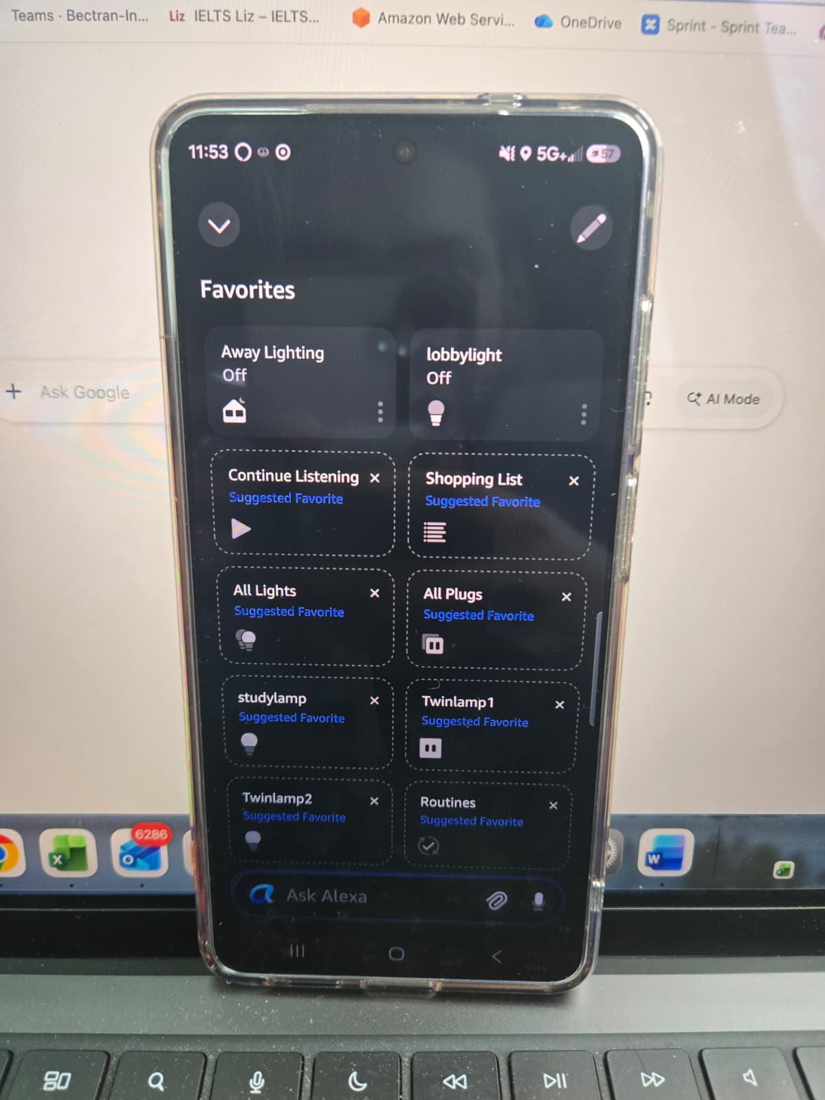

Many of these devices are not what most consumers would consider “computers.” A microwave oven, a washing machine, an LED light bulb, or a $2 toy contains a microcontroller, a single integrated circuit combining a processor core, memory, and input/output peripherals on one chip running firmware that interprets button presses, drives a small display, and triggers physical actuators. Microcontrollers vastly outnumber general-purpose computers: industry analysts estimate that more than 30 billion units shipped in 2023 alone (Statista, 2024). Each one represents an HCI moment: someone designed the affordances of its buttons, the legibility of its display, and the feedback it gives when an action succeeds or fails. Even a humble kitchen timer is, in HCI terms, an interface.
Figure 2
Pervasive Computing Touchpoints in a Typical Day

Human-Computer 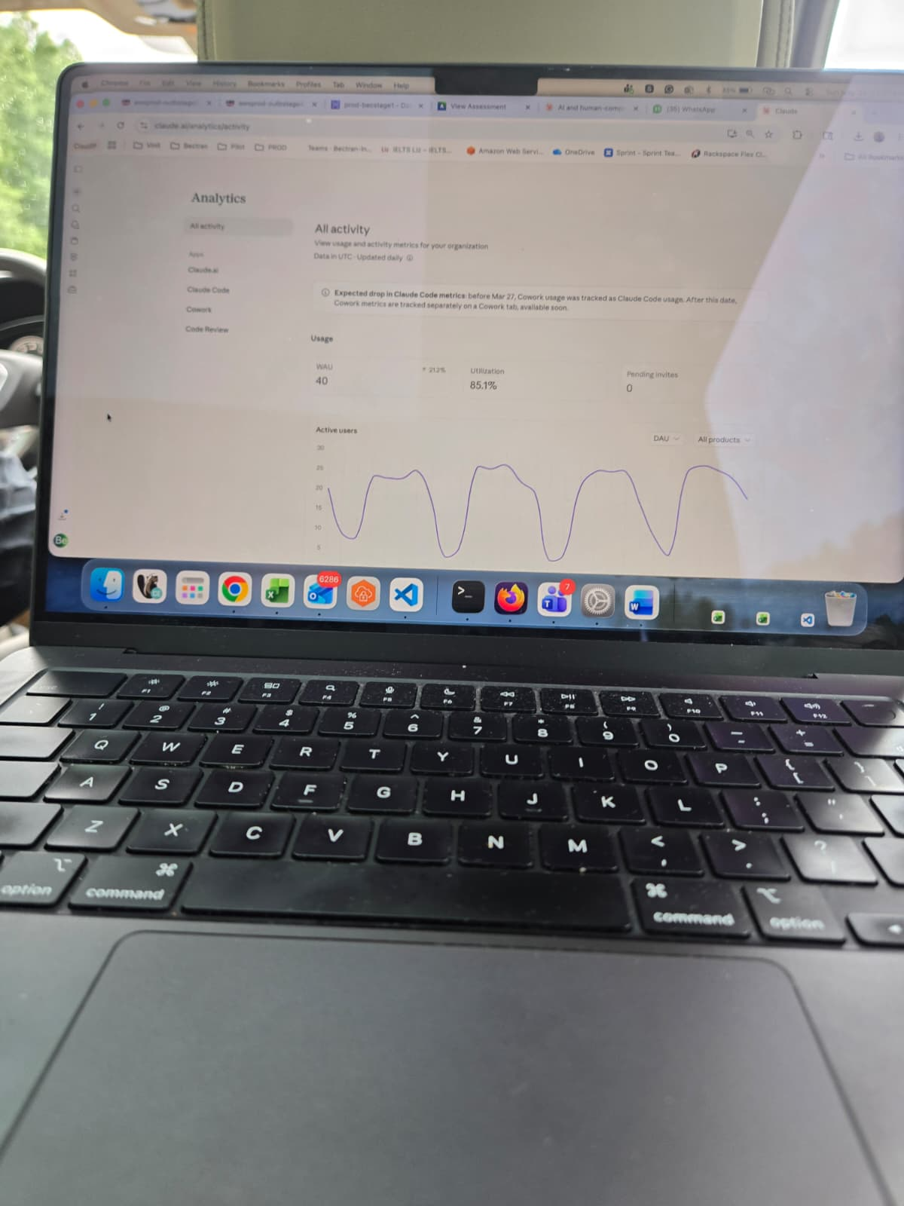Interaction as a Field
HCI is an interdisciplinary field that draws on computer science, cognitive psychology, design, ergonomics, and the social sciences to study how people use interactive computing systems and how those systems should be designed (Hewett et al., 1992). The term was popularized by Card, Moran, and Newell (1983) in The Psychology of Human-Computer Interaction, which framed the user not as an operator of a machine but as a cognitive agent whose perception, memory, and motor performance could be modeled and predicted. The Association for Computing Machinery’s Special Interest Group on Computer-Human Interaction (ACM SIGCHI) subsequently defined HCI as “a discipline concerned with the design, evaluation, and implementation of interactive computing systems for human use and with the study of major phenomena surrounding them” (Hewett et al., 1992, p. 5). Two implications of that definition are worth highlighting. First, HCI is concerned with the phenomena of social, organizational, and emotional use, not only with the artifact. Second, it is iterative: design produces a system, the system is evaluated with users, and evidence feeds back into design.
Three principles recur across the modern HCI literature. The principle of usability holds that systems should support effective, efficient, and satisfying completion of tasks in a given context (Nielsen, 1993). The principle of user-centered design places empirical knowledge of users at the center of design decisions rather than at their margins (Norman & Draper, 1986). The principle of affordance, introduced into design discourse from ecological psychology, holds that a well-designed object signals its possible uses through its perceptible properties: a button looks pressable; a slider looks slidable (Norman, 1988). When these principles fail, the consequences range from minor frustration to serious harm; aviation disasters and medical-device errors have been traced to poorly designed interfaces (Sharp et al., 2019).
The Synergy Between Artificial Intelligence and HCI
AI and HCI have long been intertwined. Early HCI research drew on AI’s cognitive science roots, and AI systems have always required interfaces through which humans supply data, inspect outputs, and correct errors (Card et al., 1983). What changed with the public release of ChatGPT in November 2022 and the subsequent emergence of Google Gemini (formerly Bard), Anthropic’s Claude, and others is that a powerful AI capability became directly accessible to non-experts through a familiar chat window, reaching one million users within five days (Hofmann et al., 2024). Generative AI does not merely sit behind an interface; it is becoming the interface. Figure 3 illustrates the canonical conversational pattern: the user types or speaks a question in natural language, the model returns a fluent natural-language response, and the conversation continues across multiple turns with context preserved (Liu, 2024).
Figure 3
Conversational AI as a Natural-Language Interface
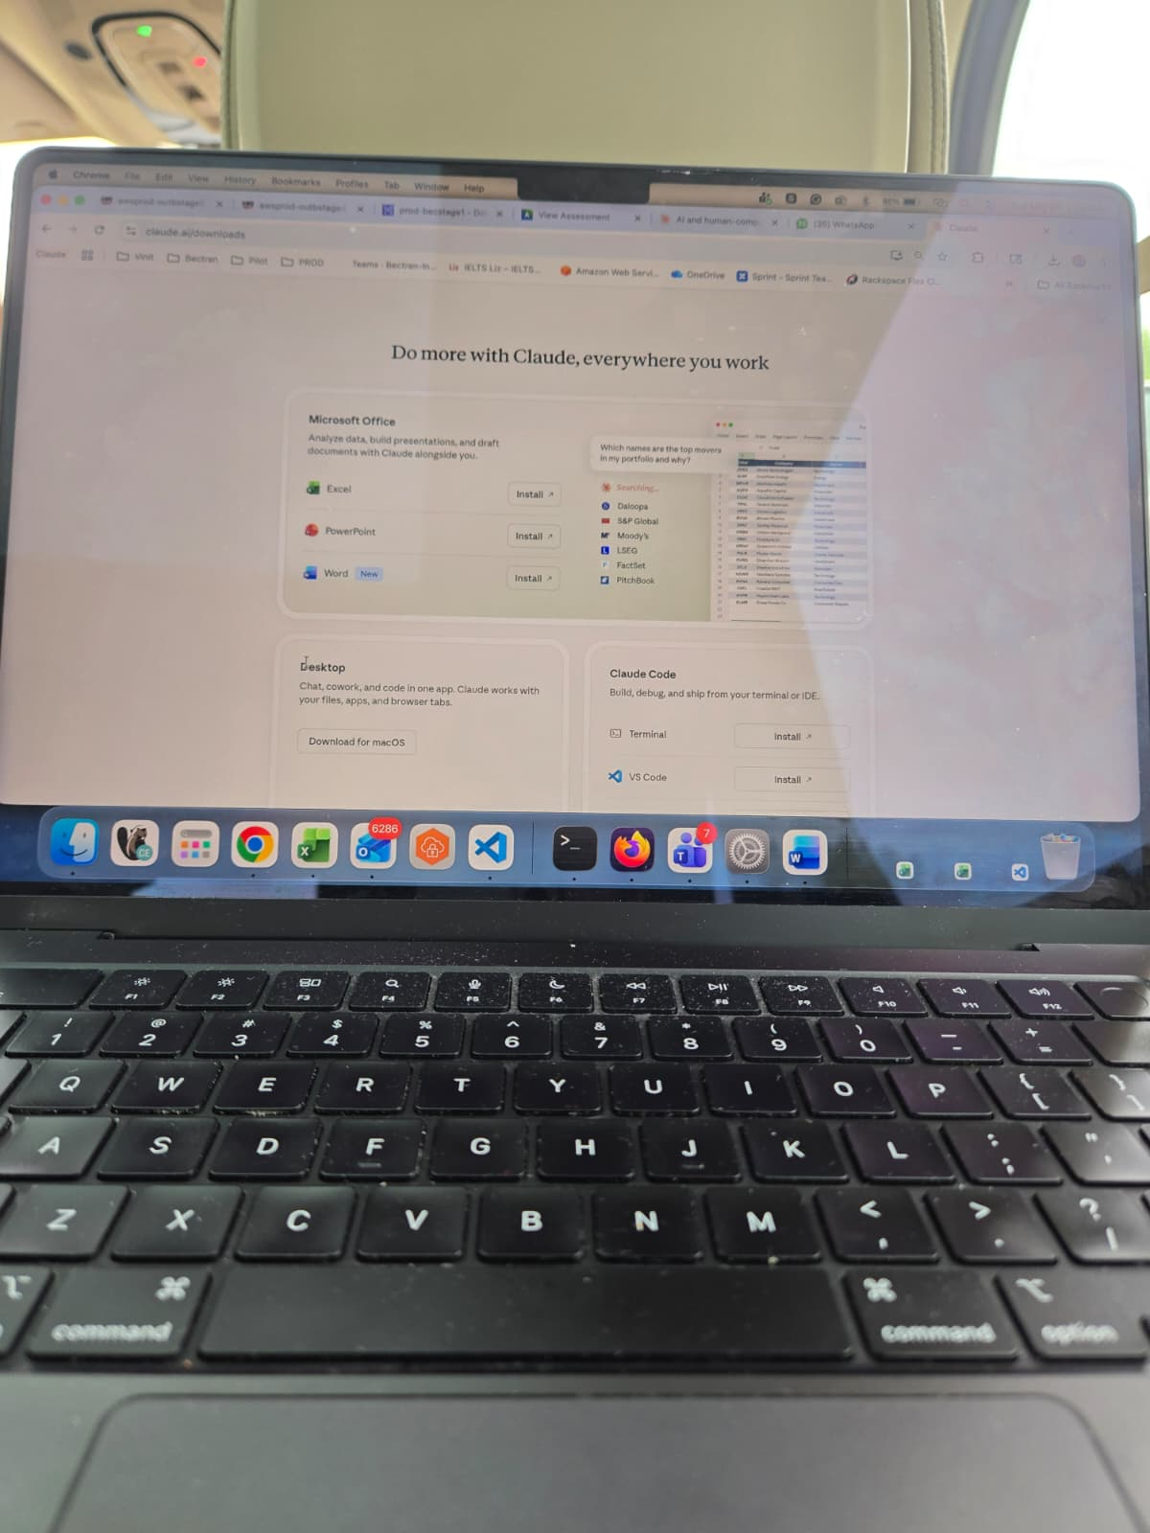
The synergy runs in both directions. AI provides HCI with new capabilities, such as speech recognition, image understanding, recommendations, intent detection, and the generation of plausible language, enabling interfaces previously confined to research labs to be shipped at consumer scale (Oviatt, 2003; Liu, 2024). HCI, in turn, provides AI with the design discipline required to make probabilistic, often-wrong systems usable and trustworthy. Concerns such as how to communicate model uncertainty, how to make AI behavior predictable across sessions, how to support graceful error recovery when the model hallucinates, and how to preserve user agency in the face of persuasive generative content are fundamentally HCI questions (Amershi et al., 2019; Hofmann et al., 2024). Microsoft’s Guidelines for Human-AI Interaction synthesize 18 such design rules from more than two decades of prior work, ranging from “make clear what the system can do” to “support efficient correction” (Amershi et al., 2019).
Multimodal Interfaces in the Context of HCI
Historically, HCI was dominated by unimodal interaction: a single primary input channel (the keyboard) paired with a single primary output channel (a text or graphical display) (Turk, 2014). Multimodal interfaces, by contrast, are “interactive systems that process two or more combined user input modes such as speech, pen, gaze, manual gestures, and body movements in a coordinated manner with multimedia system output, representing a paradigm shift away from conventional windows-icons-menus-pointing device (WIMP) interfaces” (Oviatt, 2003, p. 286). Mahmood et al. (2025) further characterize multimodal interaction as a “transformative human-computer interaction approach that allows users to interact with systems through various communication channels such as speech, gesture, touch, and gaze,” enabled by advances in sensors and machine learning (p. 1).
Figure 4
A Voice Assistant as a Multimodal AI Interface
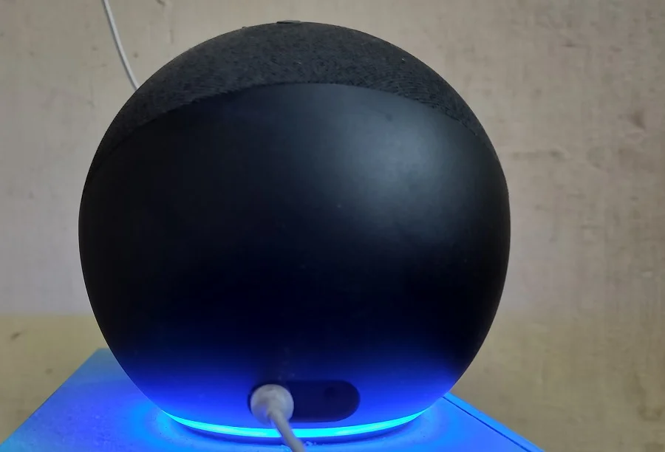
Three properties make multimodal interfaces important for the AI era. First, they exploit complementarity: the weaknesses of one modality are offset by the strengths of another, so dictating a long passage by voice while pointing on a touchscreen is faster and more accurate than either alone (Oviatt, 2003). Second, they increase accessibility, allowing users who cannot easily type, see, or hear to interact through the modalities that remain available to them (Mahmood et al., 2025). Third, they support naturalness: humans communicate with one another through interleaved speech, gesture, gaze, and facial expression, and multimodal interfaces aim to recover that richness in human-machine dialogue (Turk, 2014). Smart speakers (Figure 4) are the most familiar consumer example, combining a microphone array, automatic speech recognition, an LLM-backed dialogue manager, text-to-speech synthesis, and, in models with screens, a coordinated graphical display. Modern smartphone assistants extend this further by accepting camera input (a photograph of a document) alongside voice (“summarize this”) and producing both spoken and on-screen output. The emergence of multimodal foundation models such as GPT-4o and Gemini, which natively process text, audio, and images in a unified architecture, is rapidly closing the gap between research prototypes and shipping products (Mahmood et al., 2025).
Conclusion
Computing is no longer a discrete activity that begins when a user sits down at a desk; it is a continuous medium, woven through homes, vehicles, appliances, and pockets by general-purpose computers and the embedded microcontrollers that vastly outnumber them. HCI is the discipline that decides whether that medium serves people well. The current generation of AI systems, particularly large language models accessed through conversational interfaces, has not displaced HCI but rather amplified its stakes: a poorly designed AI interface can scale its problems to billions of users and generate persuasive but incorrect content. At the same time, a well-designed one extends what humans can do. Multimodal interfaces, fusing speech, gesture, touch, gaze, and vision into a single coordinated dialogue, represent the most active research frontier of HCI and the most visible product frontier of consumer AI. Designing them well will require the same patient, evidence-based, user-centered methods that have defined HCI since Card, Moran, and Newell first named the field.
Disclosure of AI Use
In accordance with the course policy and the assignment instructions, the author discloses that Claude, an AI assistant developed by Anthropic (Anthropic, 2024), was used to` support the drafting of this report. Specifically, Claude was used to (a) help locate and confirm scholarly definitions of HCI and multimodal interfaces, (b) suggest organizational structure, and (c) produce the original explanatory figures embedded in this paper. All claims attributable to a source are cited; the author reviewed, verified, and revised all AI-generated text and retains full responsibility for the content.

References
Amershi, S., Weld, D., Vorvoreanu, M., Fourney, A., Nushi, B., Collisson, P., Suh, J., Iqbal, S., Bennett, P. N., Inkpen, K., Teevan, J., Kikin-Gil, R., & Horvitz, E. (2019). Guidelines for human-AI interaction. In Proceedings of the 2019 CHI Conference on Human Factors in Computing Systems (Paper No. 3). Association for Computing Machinery. https://doi.org/10.1145/3290605.3300233
Anthropic. (2024). Claude (Large language model). https://claude.ai
Card, S. K., Moran, T. P., & Newell, A. (1983). The psychology of human-computer interaction. Lawrence Erlbaum Associates.
Hewett, T. T., Baecker, R., Card, S., Carey, T., Gasen, J., Mantei, M., Perlman, G., Strong, G., & Verplank, W. (1992). ACM SIGCHI curricula for human-computer interaction. Association for Computing Machinery. https://doi.org/10.1145/2594128
Hofmann, V., Mauerer, W., & Buschek, D. (2024). Risk or chance? Large language models and reproducibility in HCI research. arXiv. https://doi.org/10.48550/arXiv.2404.15782
International Telecommunication Union. (2024). Measuring digital development: Facts and figures 2024. ITU Publications. https://www.itu.int/itu-d/reports/statistics/
Liu, J. (2024). ChatGPT: Perspectives from human-computer interaction and psychology. Frontiers in Artificial Intelligence, 7, Article 1418869. https://doi.org/10.3389/frai.2024.1418869
Mahmood, A., Wang, J., & Yao, B. (2025). Multimodal interaction, interfaces, and communication: A survey. Multimodal Technologies and Interaction, 9(1), Article 6. https://doi.org/10.3390/mti9010006
Nielsen, J. (1993). Usability engineering. Academic Press.
Norman, D. A. (1988). The psychology of everyday things. Basic Books.
Norman, D. A., & Draper, S. W. (Eds.). (1986). User-centered system design: New perspectives on human-computer interaction. Lawrence Erlbaum Associates.
Oviatt, S. (2003). Multimodal interfaces. In J. A. Jacko & A. Sears (Eds.), The human-computer interaction handbook: Fundamentals, evolving technologies and emerging applications (pp. 286–304). Lawrence Erlbaum Associates.
Sharp, H., Preece, J., & Rogers, Y. (2019). Interaction design: Beyond human-computer interaction (5th ed.). Wiley.
Statista. (2024). Microcontroller unit (MCU) shipments worldwide from 2015 to 2027. https://www.statista.com/statistics/935382/worldwide-microcontroller-unit-shipments/
Turk, M. (2014). Multimodal interaction: A review. Pattern Recognition Letters, 36, 189–195. https://doi.org/10.1016/j.patrec.2013.07.003

