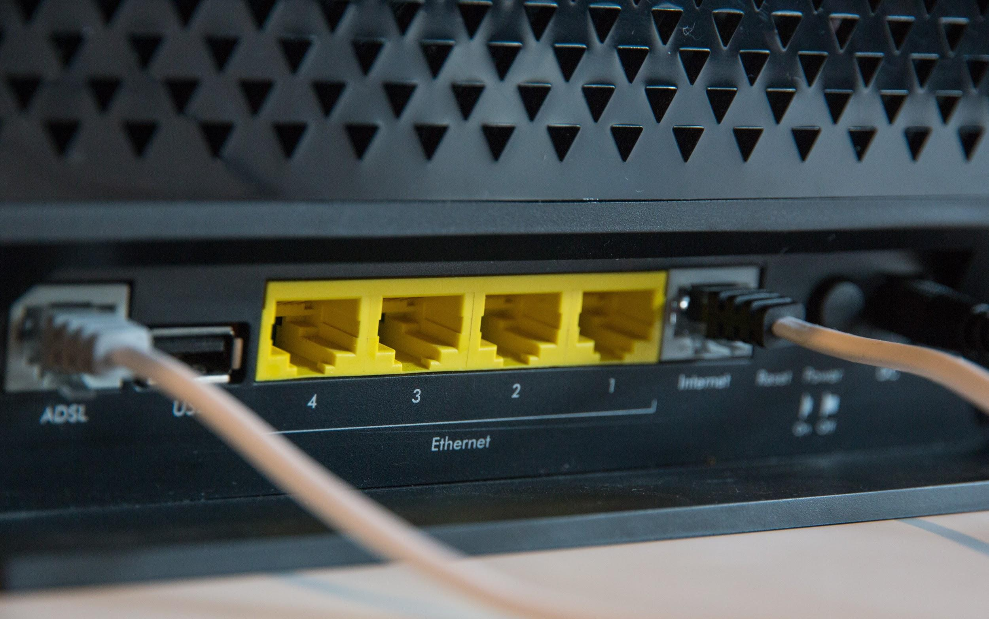

**Port Scanner in Software Defined Networking**

Contributors -[Vinit Shahdeo](https://github.com/vinitshahdeo/) -[Kashish](https://github.com/Kashish121) -[Ishika Dubey](https://github.com/ishika1727/)

## horizontal line

# **Overview**

The Port Scanner application is made to test a server or host for open ports. The application attempts to connect at various ports. If it is able to connect to open ports, then It is established that the ports with which the scanner connected are open and vulnerable to cyberattacks. The code is written in python and the server is built using express.js.

# **Disclaimer**

It ought to be noticed that port scanning can be viewed as, or interpreted as, a wrongdoing. One ought to never execute a port scanner against any site or IP address without unequivocal, composed, authorization from the proprietor of the server or PC that you are focusing on. Port scanning resembles going into somebody's home and looking at all of their entryways and windows. There is extremely just motivation behind why anybody would do this, and it is to survey protections and vulnerabilities. In this way, on the off chance that you have no rhyme or reason to test these things, it tends to be expected you are a criminal.

# 

# **Terminologies**

A **Port Scanner** is an application intended to test a server or host for open ports. Such an application might be utilized by managers to check security approaches of their systems and by assailants to recognize arrange administrations running on a host and adventure vulnerabilities.

**Software-defined networking technology** is an approach to network management that enables dynamic, programmatically efficient network configuration in order to improve network performance and monitoring, making it more like cloud computing than traditional network management.Software-Defined Networking (SDN) technology is being used for efficient and real-time defense against cyberattacks.

# 

# **Working**

The server code is executed first where it opens 10 random ports (random numbers generated by randomNum.js) and the index.js starts on ten servers. Then the scanner.py searches for all the open ports on the remote server using sockets (socket library of python). The index.js is coded in express which is a server side scripting language and creates and starts servers. The scanning code for open ports is built using the python programming language. The scanner.py code imports and uses several python libraries like socket, subprocess and sys.

**index.js** imports **randNum.js** to generate random numbers and open ports at those localhosts. It also imports **config.json** which stores values of low and high i.e. values within whose range the ports will open. In this code, it is set from 1 (inclusive) to 80 (exclusive). The code generates 10 random numbers from 1 to 80 i.e low to high and starts servers at those ports.

**scanner.py** scans for these ports and prints the ports which are open i.e. where the server had started by index.js .

# **Output**

1. Starting 10 servers

# 

2. Checking for open ports

