* 1. Google chart <https://developers.google.com/chart/interactive/docs/gallery/map>
  2. Google fusion table <https://support.google.com/fusiontables/answer/184641>
  3. Google Maps JavaScript API <https://developers.google.com/maps/documentation/javascript>
  4. Tableau <http://www.tableau.com/solutions/mapping-software>

1. R
   1. Plot data point with ggmap + ggplot2 **(maps.R)**
   2. Choropleth Maps
   3. Summarize mass data with thematic maps with maps + ggplot2 **(ggmap.R)**
   4. Interactive maps: rMaps

<https://github.com/ramnathv/rMaps>

1. D3 + other javascripts
   1. Leaflet Choropleth tutorial <http://leafletjs.com/examples/choropleth.html>
   2. Leaflet.js + heatmap.js
2. Other applications

* TileMill
* GIS: shapefiles

2-a. Plot data point with ggmap + ggplot2 **(maps.R)**

|  |  |  |  |  |
| --- | --- | --- | --- | --- |
| **Macintosh HDR:Users:sharonhsiao:Dropbox:DataViz:2013Fall:02lab:lab4 - maps:maps:figure1-state.png** | | **Macintosh HDR:Users:sharonhsiao:Dropbox:DataViz:2013Fall:02lab:lab4 - maps:maps:figure2-world.png** | **Macintosh HDR:Users:sharonhsiao:Dropbox:DataViz:2013Fall:02lab:lab4 - maps:maps:figure3-northusa.png** | |
| Figure 1 - usa | | Figure 2 – world | Figure 3 – north america | |
| **Macintosh HDR:Users:sharonhsiao:Dropbox:DataViz:2013Fall:02lab:lab4 - maps:maps:figure4-ny.png** | | **Macintosh HDR:Users:sharonhsiao:Dropbox:DataViz:2013Fall:02lab:lab4 - maps:maps:figure5-cities.png** | **Macintosh HDR:Users:sharonhsiao:Dropbox:DataViz:2013Fall:02lab:lab4 - maps:maps:figure6-text.png** | |
| Figure 4 – NY state | | Figure 5 – cities | Figure 6 - text | |
| **Macintosh HDR:Users:sharonhsiao:Dropbox:DataViz:2013Fall:02lab:lab4 - maps:maps:figure7-texas.pngMacintosh HD:Users:ihsiao1:Documents:2Courses:CSE591_DataVis:DataViz(2016Fall):Lab:lab_map:az_vote_2012.png** | | | | |
| Figure 7 – highlight texas Figure 8 – 2012 Arizona election results by county | | | | |
| **# Q1. What does require mean?**  require(maps)  library(maps)  map("state") #(Figure 1)  map("world") #(Figure 2)  # plot north America (Figure 3)  xlim <- c(-171.738281, -56.601563)  ylim <- c(12.039321, 71.856229)  map("world", col= "#f3f3f3", fill= TRUE, bg= "white", lwd= 0.3, xlim=xlim, ylim=ylim)  # plot new york state (Figure 4 & 5)  map("state", "New York")  data(us.cities)  map.cities(us.cities, country="NY")  # add color or text on existing maps (Figure 6)  map("state", interior= FALSE)  map("state", boundary= TRUE, col="gray", add= TRUE)  # highlight texas (Figure 7)  map("state", col= "grey", boundary=TRUE, fill= TRUE, lty= 5,lwd= 0.2)  map("state", regions= "texas", col = "red", fill= TRUE, add= TRUE, lty= 1, lwd= 2)  map.text("state","texas", col="white", add= TRUE)  # 2012 Arizona election results by county (Figure 8)  # data: <https://catalog.data.gov/dataset/u-s-congressional-districts-2012>  or <https://www.baruch.cuny.edu/confluence/display/geoportal/US+Presidential+Election+County+Results>  library(maps)  map('county', 'arizona', fill = TRUE, col = palette())  az\_county\_data <- map\_data("county")  **# Bonus: how do you map election data to az county map? (2pt for assign2)**  library(ggplot2)  library(rgeos)  library(maptools)  **#transform shapefile to data frame**  states.shp <- readShapeSpatial("elpo12p010g.shp")  #get a subset of AZ data from states.shp  …  #merget az\_county\_data and az\_election\_results  …  # use ggplot() + geom\_polygon() to plot  … | | |

**Choropleth.R**

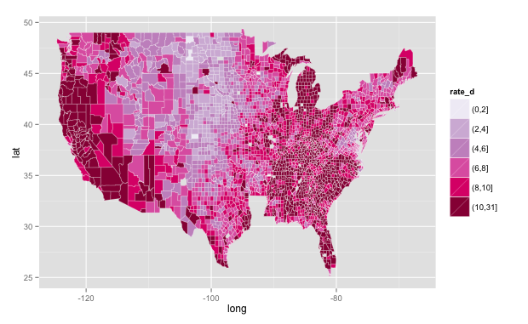 Figure 11.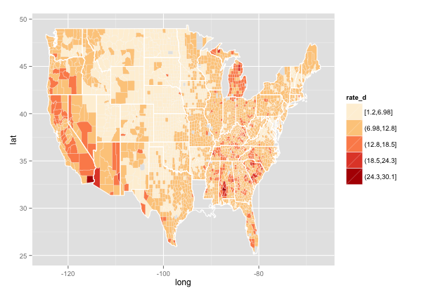Figure 12.

|  |
| --- |
| library(ggplot2)  library(maps)  library(scales)  unemployment <- read.csv("data/unemployment.csv", header= F, stringsAsFactors= F)  names(unemployment) <- c("id", "state\_fips", "county\_fips", "name", "year", "?", "?", "?", "rate")  #prepare data  **#Q2 what does gsub syntax mean? Can you use *grep* instead?**  unemployment$county <- tolower(gsub(" County, [A-Z]{2}", "", unemployment$name))  unemployment$state <- gsub("^.\*([A-Z]{2})", "\\1", unemployment$name)  #prepare map  county\_df <- map\_data("county")  names(county\_df) <- c("long", "lat", "group", "order", "state\_name", "county")  county\_df$state <- state.abb[match(county\_df$state\_name, tolower(state.name))]  county\_df$state\_name <- NULL    # Combine together  choropleth <- merge(county\_df, unemployment, by= c("state", "county"))  choropleth <- choropleth[order(choropleth$order), ]  # Discretise rate to use with Brewer color scheme  # choropleth$rate\_d <- cut\_number(choropleth$rate, 5) #(Figure 11)  # choropleth$rate\_d <- cut\_interval(choropleth$rate, 5)  choropleth$rate\_d <- cut(choropleth$rate, breaks = c(seq(0, 10, by = 2), 31)) #(Figure 11)  # summary(unemployment$rate)  # max\_rate <- max(unemployment$rate)    # plot the employment rate by counties across America into bins  ggplot(choropleth, aes(long, lat, group = group)) +  scale\_fill\_brewer(palette = "PuRd")+  geom\_polygon(aes(fill = rate\_d))  # outline state borders (Figure 12)  state\_df <- map\_data("state")  ggplot(choropleth, aes(long, lat, group= group)) +  scale\_fill\_brewer(palette = "OrRd")+  geom\_polygon(aes(fill= rate\_d)) +  geom\_polygon(data= state\_df, colour= "white", fill = NA)  **# Q3. What happen to Louisiana? How do you correct it?** |

2-b. Summarize mass data with thematic maps with maps + ggplot2 **(ggmap.R)**

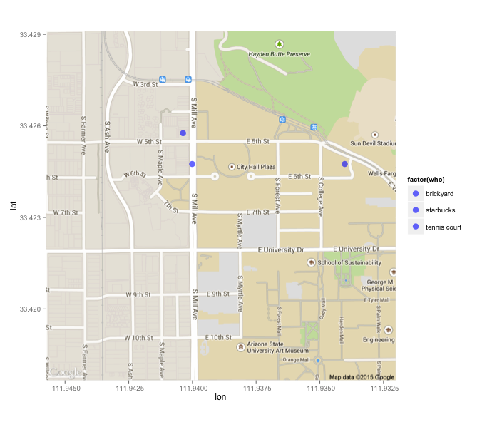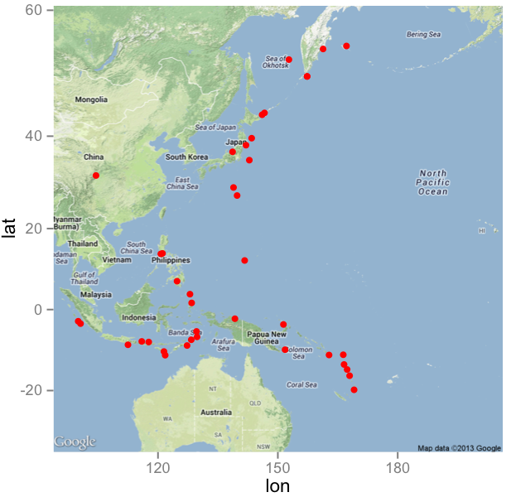

|  |  |  |
| --- | --- | --- |
| Figure 9 | Figure 10 | |
| library(ggplot2)  require(ggmap)  #CIDSE map (Figure 9)  #maptype: terrain, satellite, roadmap, hybrid, toner, watercolor  cidse.map <- get\_map(location=c(lon=-111.9389 , lat=33.4234), zoom=16, maptype="roadmap")  #nyc.map <- get\_stamenmap(bbox = c(left = -74.9975, bottom = 40.8125, right = -73.9750, top = 40.8000), zoom=12, maptype="watercolor")  # Generate some data  # http://www.gpsvisualizer.com/geocoder/  long = c(-111.94037, -111.94001,-111.93402 )  lat = c(33.42576, 33.42475,33.42475)  who = c("starbucks", "brickyard", "tennis court")  sharon = data.frame (long, lat, who)  # overlay the data on the googlemap (Figure 9)  ggmap(cidse.map) + geom\_point(data=sharon, aes(x=long, y=lat, fill= factor(who)), colour="blue", size=4, alpha= 0.6)  #earthquake map (Figure 10)  earthquake <- read.csv("data/earthquake.csv")  earthquake.points <-earthquake[,c("Longitude","Latitude")]  earthquake.map <- get\_map(location=c(lon=150, lat=20), zoom=3, maptype="terrain", filename="earthquake\_map.png")  ggmap(earthquake.map) + geom\_point(data=earthquake.points, aes(x=Longitude, y=Latitude), col="red", size=2) | |

**data source:** [Unemployment Rate Rankings by Region, MSA and County (xls)](http://www.labor.ny.gov/stats/ur_rank.xls) <http://www.labor.ny.gov/stats/ur_rank.xls>

|  |
| --- |
| Other Resources:   1. Leaflet Choropleth tutorial <http://leafletjs.com/examples/choropleth.html>  * DataMaps (using topojson) <http://datamaps.github.io> * Interactive Choropleth <http://bl.ocks.org/stevenae/8362841> * Interactive maps with rMaps <http://rmaps.github.io/blog/posts/animated-choropleths/> |

1. Leaflet tutorial (**leaflet\_tutorial.html** + us-states.js)
2. Duplicate the tutorial with ONLY Arizona population by county (**leaflet\_az.html** + az.js)
   1. you need AZ county information (maps coordinates) GeoJson or csv: <http://catalog.opendata.city>
   2. add density variable and value to az.js
   3. Q: how do you add a layer of 2012 election vote results by county to leaflet\_az.html?
3. Add heatmap data points by using (**leaflet\_heatmap.html** + leaflet-heat.js + cidse.js )

* TileMill tutorial

<http://columbiadataviz.wordpress.com/2013/02/27/tutorial-on-qgis-tillmile-2/>