1. Are the html tags and elements the same thing ?

* Html tags are building blocks of html page. Html elements are components that are used in html page.

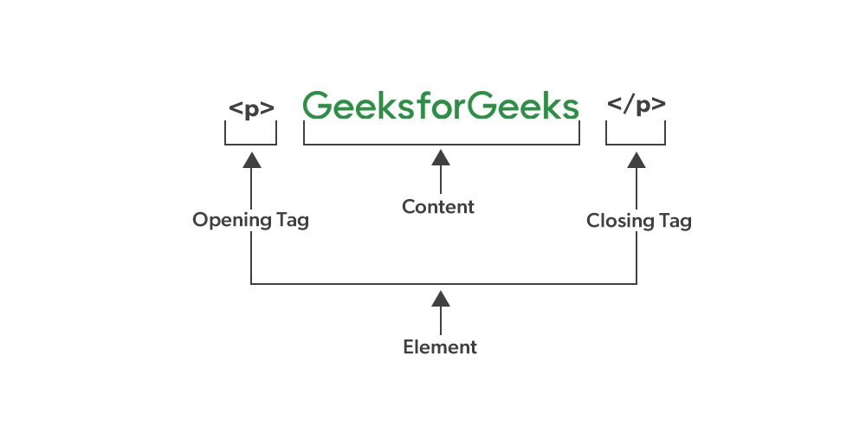

1. What are tags and attributes in html ?

* It is important to note that both the tags and attributes are within an elements.
* Example :- <p> this is paragraph </p>
* In example <p> and </p> is tags and content is attributes.

1. What are void elements in html ?

* A void element is an element in html that cannot have any child.
* <br> tag is self-closing and void element.
* <hr> tag is self-closing and void element.

1. What are html entity ?

* An html entity is a piece of text (“string”) that begins with an ampersand (&) and ends with a semicolon (;).

1. What are different types of list in html ?

* Unordered list or bulleted list
* Ordered list or numbered list
* Description list or definition list

1. What is the ‘class’ attribute in html ?

* The class attributes specifies one or more class names for an element.
* Example : <h1 class = ”tittle”> dot net tutorials </h1>.
* In tag class is attributes and tittle is class name.

1. What is the difference between the ‘id’ attribute and the ‘class’ attribute of html elements ?

* Remember the difference between class ID : a class name can be used by multiple html elements, while an id name must only be used by one html element within the page.
* Example of ID : unlque to each element on a page.
* Defined using the id attribute.
* Preceded by # in css selectors.
* There can only be one element on a page a specific id.
* Example of class : can be used to select multiple elements.
* Defined using the class attribute.
* Preceded by a , in css selectors.
* Multiple elements on a page can have the same class.

1. What are the various formatting tags in HTML?

* <b> - Bold text
* <strong> - Important text
* <i> - Italic text
* <em> - Emphasized text
* <mark> - Marked text
* <small> - Smaller text
* <del> - Deleted text
* <ins> - Inserted text
* <sub> - Subscript text
* <sup> - Superscript text

1. How is Cell Padding different from Cell Spacing?

* Cell spacing refers to the distance between the cells in a grid layout, and cell padding refers to the space around each cell.

1. How can we club two or more rows or columns into a single row or column in an HTML table?

* you can merge two or more table cells in a column using the colspan attribute in a <td> html tage (table data)
* to merge or more row cells, use the rowspan attributes.

1. What is the difference between a block-level element and an inline element?

* Inline elements never start from a new line. Block elements cover space from left to right as far as it can go. Inline elements only cover the space as bounded by the tags in the html element. Block elements have top and bottom margins.

1. How to create a Hyperlink in HTML?

* The <a> tag defines a hyperlink.

1. What is the use of an iframe tag?

* An inline frame is a html element that loads another html page within the documents. It essentially puts another webpage within the parent page. They are commonly used for advertisements, embedded videos, web analytics and interactive content.

1. What is the use of a span tag? Explain with example?

* In html, the span tag is a generic inline container element. You use this element to wrap sections of text for styling purposes or to add attributes to a section of text without creating a new line of content.
* Example : it is similar – but not the same as – the <div> tag.

1. How to insert a picture into a background image of a web page?

* The most common & simple way to add background image is using the background image attribute inside <body> tag. The background attributes which we specified in the <body> tag is not supported in html5. Using css properties, we can also add background image in a webpage.

1. How are active links different from normal links?

* Active link are typically links that are currently functional and lead to live web pages, while normal links can refer to any link, whether functional or broken. Active link are actively used and accessible, while normal links may or may not be functional at given time.

1. What are the different tags to separate sections of text?

* <br> tags – it is used to separate the line of text. It breaks the current line and shifts the flow of text to a new line.
* <p> tags – this tag is used to define large quoted sections.
* <blockquote> tag – this tag is used to define large quoted section.

1. What is SVG?

* <html>

<body>

<h1> my first svg </h1>

<svg width= “100” height=”100”>

<circle cx= “50” cy= “50” r= “40” stroke= “green” stroke-width= “4” fill= “yellow”/>

</svg>

</body>

</html> THIS IS SVG.

1. What is difference between HTML and XHTML?

* Html is more lenient in its syntax, while xhtml has a more strict syntax and follows xml rules.

1. What are logical and physical tags in HTML?

* <b> this is a physical tag, which is used to bold the text written between it. <strong> this is a logical tag, which tells the browser that the text is important.