Instructions for Setting Up a Simple CMS

Systems for managing content (WordPress)

Overview

More than 40% of websites on the internet are today powered by WordPress, an open-source content management system. This comprehensive user manual will help you set up and configure a WordPress CMS-powered website.

Requirements
- Before installation starts, make sure the following conditions are satisfied:
- central processing unit running Linux, macOS, or Windows
- Internet access
- Local server configuration (such as XAMPP or WAMP) or web hosting plan
- If you plan to use hosting, a domain name
- Only manual installations require an FTP client (FileZilla, Cute FTP, etc.).

Phase 1: Setting Up the Server

Option A: Using XAMPP to Install WordPress Locally
The local Apache, MySQL, and PHP environment that XAMPP offers on your computer is perfect for testing and development.
To download XAMPP, go to https://www.apachefriends.org/download.html.
2. Get XAMPP and set it up on your PC.
3. Open the XAMPP control panel and hit "Start" in opposition to MySQL and Apache.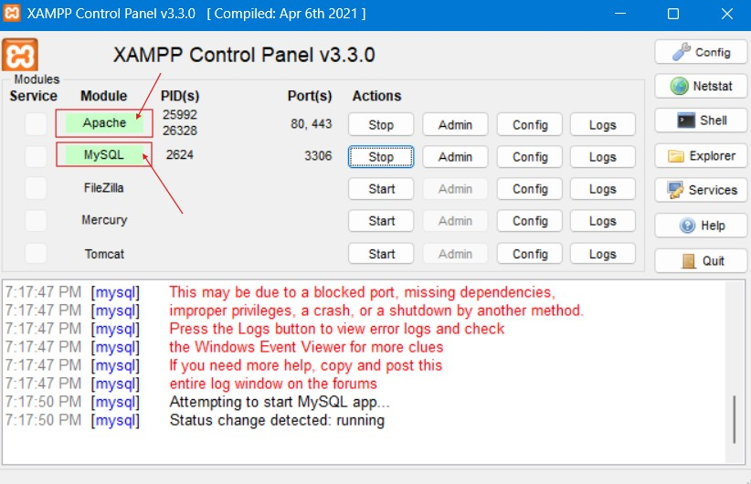
Figure 1: XAMPP Control Panel displaying services Apache and MySQL in ‘running’ mode.
4. Use your browser to explore your machine and visit http://localhost to see if the server is operational.

Live Web Hosting is Option B.
You would need a hosting account if you wanted others to be able to view your website online.
5. Choose a hosting provider that supports MySQL and PHP 7.4+ (Bluehost, SiteGround, or HostGator).
6. In the DNS management section, enter your domain name and connect it to your hosting account.
7. Open your hosting control panel (cPanel) and log in.

Creating a MySQL Database in Phase Two
For the WordPress website, which houses all the data and content, a MySQL database needs to be created.

8. Launch phpMyAdmin. Go to http://localhost/phpmyadmin on XAMPP, and use your cPanel to access PHP. MyAdmin on a live hosting server.
9. Click on the Databases tab.
10. Click the Create button after entering a database name under Create Database.

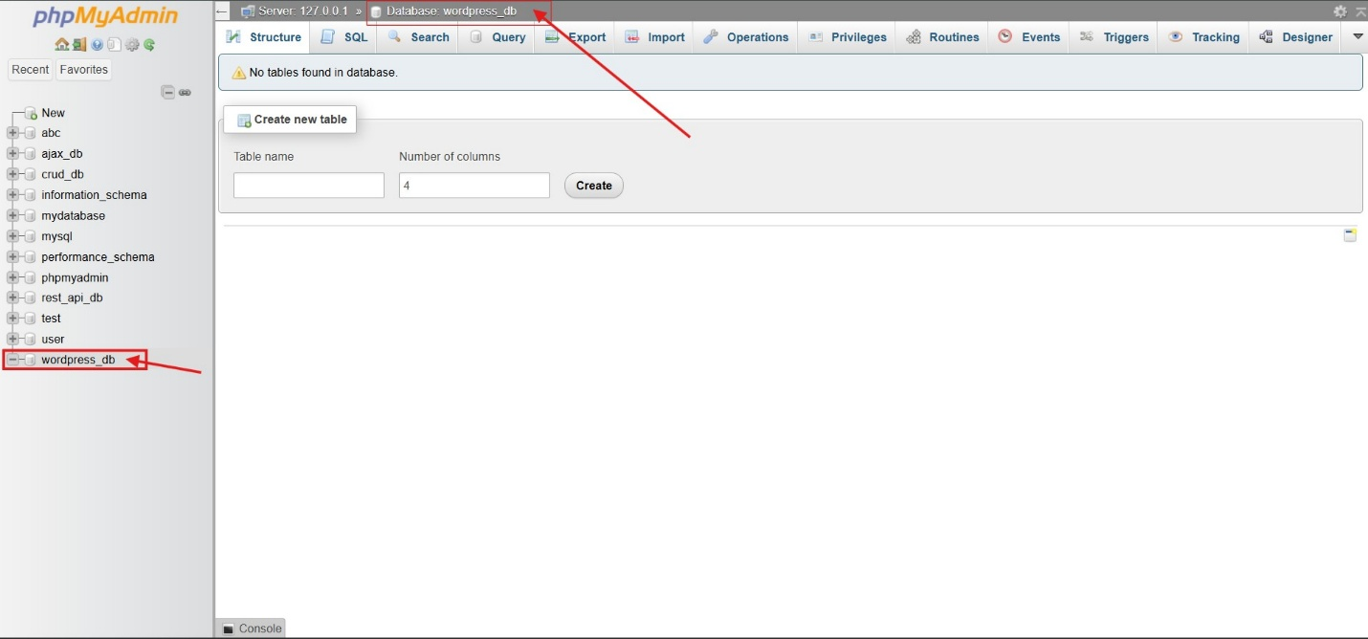
Figure 2: Using phpMyAdmin, create a new database named "wordpress_db."
11. After selecting User Accounts, select "Add User Account."
12. Enter your password and username. In the area labeled "Database for user," choose the previously created database and provide all privileges.

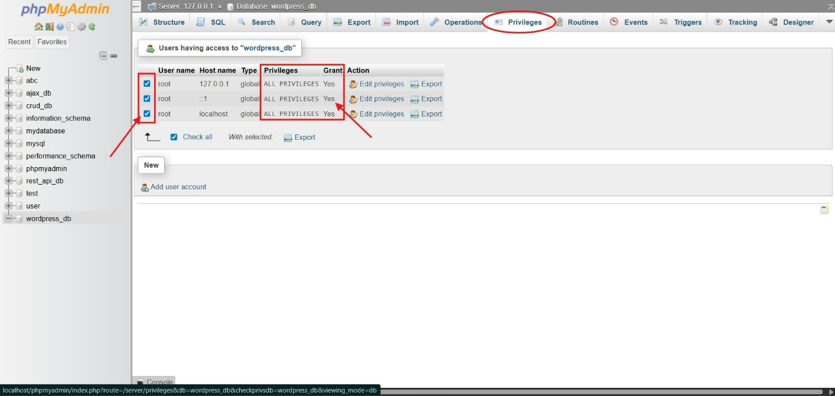
Figure 3: Configuring User Permissions to grant “All Permissions.”
13. To save the configuration, click Go. Keep your password, username, and database name safe.

Phase 3: WordPress installation
14. To obtain the most recent version of WordPress (a zip file), visit https://wordpress.org/download.
15. Open the downloaded file by unzipping it. The WordPress folder will be visible to you.

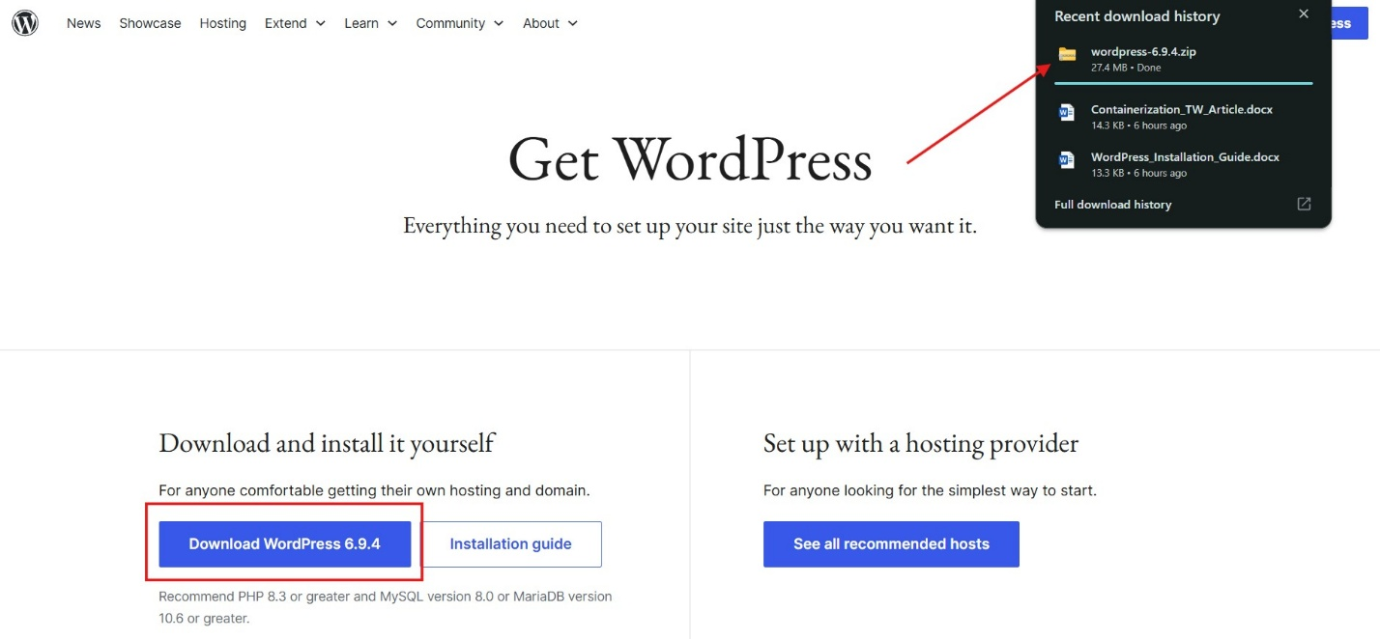
Figure 4: WordPress 6.9.4 Configuration
16. Transfer the files that were extracted to:
• Local (XAMPP): C:\xampp\htdocs\your-site-name
• Live Hosting: Use an FTP application or file manager to upload the files to the public_html folder.

Running the Installation Script for WordPress
17. Open the web browser.
Visit http://yourdomain.com (live) or http://localhost/your-site-name (local).
18. Click Continue after selecting a language.
19. Select "Let us get started."
20. Enter the database host (localhost by default), username, password, and database name. Press the "Submit" button.
21. Click Install WordPress once the connection has been established.
22. Enter your email address, password, admin username, and website name. Select "Install WordPress."
23. To access the WordPress administration page, click Login once the procedure is finished.

Phase 4: Fundamental Setup

Step 1: General Preferences
24. Use your administrator credentials to log in to http://yourdomain.com/wp-admin.
25. In the menu bar on the left, select Settings > General.
26. Configure your website title, slogan, time zone, and date format.
27. Click the "Save Changes" button.

Step 2 — Permalinks
28. Go to Settings > Permalinks.
29. Choose "Post name" for your website's permalink structure.
30. Save your modifications.

Step 3: Setting Up a Theme
31. From the sidebar menu, select Appearance > Themes.
32. Select "Add New" and look for a theme (such as Twenty Twenty-Four, OceanWP, or Astra) using the search field.
33. After choosing a theme, mouse over it and select "Install" and "Activate."

Step 4 — Setting Up Necessary Plugins
34. Go to Plugins > Add New.
35. Look for and set up the following plugins:
• Yoast SEO Plugin: for search engine optimization of your website
• Wordfence Security Plugin: for malware and firewall checks
• The UpdraftPlus Plugin, which automatically backs up your website
• WP Super Cache Plugin: to enhance the functionality of your website
36. Select "Install Now" and then "Activate."

Phase 5: Creating Your First Website and Posting Your First Article

Constructing a Website
37. Go to Pages > Add New in the Dashboard.
38. Enter the title of your page (such as "About Us") in the Title area.
39. Tap the + symbol to add material using the Gutenberg blocks editor.
40. Click Publish once you are done.

Making a Post
41. Select Posts > Add New.
42. Add the title and body of your post.
43. From the panel on the right, select a category and add a few tags.
44. From the menu in the sidebar on the right, choose your feature image.
45. Press the "Publish" button.

Typical Mistakes & Solutions
• Database connection establishment error: Please review the database details in the wp-config.php file.
• White screen of death: Using the FTP manager, rename the /wp-content/plugins directory to temporarily disable all plugins.
• 404 error on pages: Use the Settings > Permalinks menu to adjust your permalinks.
• Issues with media uploads: Verify the /wp-content/uploads folder's permission settings.

Conclusion
A WordPress content management system has been successfully established. With your theme chosen and the required plugins activated, your website is now completely operational. You can now investigate additional areas like adding new plugins, making menus, and altering your WordPress theme.

