Session 4 : Containers vs Virtual Machines

RECAP: Session 3 : Virtualization & Hypervisors
1. Virtualization Basics: Physical vs virtual resources; consolidation, isolation & utilization; types: server, storage, network, desktop, application
2. Hypervisors: Type 1 (bare-metal) vs Type 2 (hosted); Virtual Machine Monitor (VMM) & its role
3. Virtualization Techniques: Full virtualization; para-virtualization; hardware-assisted virtualization (VT-x / AMD-V)
4. Virtual Machine Anatomy: vCPU, virtual memory, virtual disk & virtual NIC; machine images, templates & snapshots
5. VM Lifecycle & Migration: Provision, start, suspend, snapshot, clone & terminate; live migration & its uses

Agenda for Today's Session
1. Container Fundamentals: Process-level isolation; Linux namespaces & control groups (cgroups); union filesystem & layered images
2. Docker Architecture: Client, daemon, images, containers & registries; image vs container; layers & build caching
3. Containers vs VMs: Boot time, memory footprint, image size & density; isolation strength & security trade-offs
4. Choosing Between Them: Container use cases; VM use cases; decision criteria
5. Tooling & Registries: VirtualBox, KVM, Hyper-V & VMware; Docker, Podman & containerd; public vs private registries; tagging strategy

--------------------------------------- SECTION 1: 1. Container Fundamentals: Process-level isolation; Linux namespaces & control groups (cgroups); union filesystem & layered images ---------------------------------------

Slide 1: What Is A Container
Heading: Container Isolation Basics
Subheading: Process-Level Isolation
Content:
A container is a running process that shares the host machine's kernel but gets its own isolated view of files, network and other processes, with no separate guest operating system of its own.
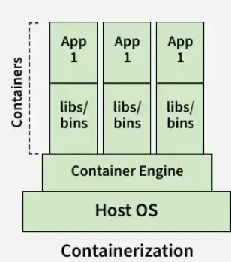
- Namespaces : limit WHAT a process can see
- Control groups : limit HOW MUCH it can use
- Union filesystem : layers that build the image itself
Analogy: A large building holds many separate flats: each flat has its own rooms and lock, but all share one foundation, electricity and water line — exactly as containers share one host kernel while each gets its own isolated view through namespaces.
Visual Guidance: Single host kernel box at bottom; three container boxes on top, each labelled with a small lock icon and tagged Namespaces / cgroups / Union FS.
Speaker Notes: "Stress that isolation here is logical, enforced by the kernel, not a separate virtual hardware layer. Interviewers often ask what actually makes a container 'isolated' — the answer is these three kernel features, not a hypervisor."

Slide 2: Linux Namespaces Explained
Heading: Linux Namespaces
Subheading: Isolating Process Views
Content:
A namespace isolates a process’s view of system resources, so each container gets its own view of processes, networking, and filesystems.
Namespace | Isolates
PID (process ID) | Own process tree, own PID 1
Network | Own interfaces, IP address, ports
Mount | Own filesystem view and mount points
UTS (UNIX time-sharing) | Own hostname and domain name
IPC (inter-process communication) | Own message queues, semaphores
User | Own user and group ID mapping
Visual Guidance: Six small labelled boxes around a central kernel icon, each box pointing to a different resource type from the table.
Speaker Notes: "A common interview trap is confusing PID namespace isolation with resource limiting — namespaces only change what is visible, not how much can be used. Mention that chroot was an early, narrower ancestor of the mount namespace idea."

Slide 3: Cgroups And Union Filesystem
Heading: Cgroups And Union FS
Subheading: Resource Limits Layers
Content:
Two more kernel features complete container isolation: control groups, known as cgroups, cap resource use, and a union filesystem builds the image itself from layers.
- CPU controller: caps processor time share per group
- Memory controller: breach triggers an out-of-memory kill
- Block I/O controller: caps disk read and write speed
- Union filesystem merges read-only layers; OverlayFS is the current standard driver
- Copy-on-write duplicates a file only when it is modified
Visual Guidance: One cgroup boundary box with CPU/Memory/Disk meter icons, beside a layered stack merging into one view with a writable top layer.
Speaker Notes: "A process crossing its memory ceiling is killed by the kernel, not slowed down. Layer caching from the union filesystem is why rebuilding an image after a small change is fast."

--------------------------------------- SECTION 2: 2. Docker Architecture: Client, daemon, images, containers & registries; image vs container; layers & build caching ---------------------------------------

Slide 4: Docker Architecture Overview
Heading: Docker Architecture Map
Subheading: Five Core Parts
Content:
Docker runs as a client-server system: a command-line client talks to a background daemon that builds and runs containers using images pulled from a registry.
- Docker client — CLI issuing commands like docker run
- Docker daemon (dockerd) — service building and managing containers
- Images — read-only templates stored locally or in a registry
- Containers — running instances created from images
- Registry — remote store such as Docker Hub for images
Visual Guidance: Diagram: client box with arrow to daemon box; daemon connects to an images store, a container box, and a registry cloud icon.
Speaker Notes: "Point out dockerd as the process name learners will see in ps output. Interviewers often ask to name all five Docker architecture pieces and how they interact."

Slide 5: Installing And Verifying Docker
Heading: Docker Installation Steps
Subheading: Setup Per OS
Content:
Docker installs differently per operating system, but every path ends with the same two verification commands before any practical work begins.
OS | Key Setup Steps
Windows | Install VS Code; wsl --install; Docker Desktop (WSL 2 backend); open Docker Desktop
macOS | Install VS Code; Docker Desktop (Apple Silicon or Intel build); open Docker Desktop
Linux / Ubuntu | Install VS Code; sudo apt install docker.io; sudo systemctl start docker
docker --version
docker run hello-world
- Line 1 — Displays the installed Docker CLI version.
- Line 2 — Verifies that Docker can run a container; it typically pulls the image if needed and prints Hello from Docker!
Linux OS: If a Docker command fails due to permission issues, try running it with sudo, for example, sudo docker run hello-world.
Step 1 — Confirm WSL 2 Is Enabled (Windows)
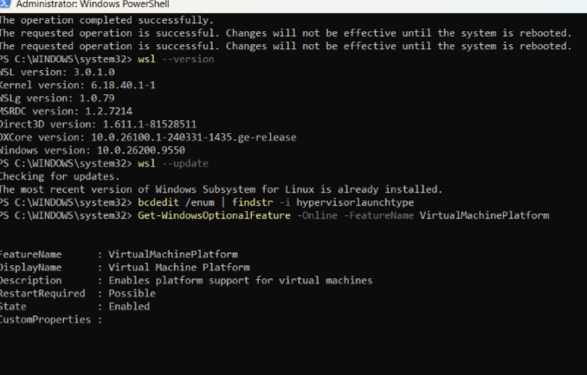
PowerShell confirms WSL is installed/updated and the Virtual Machine Platform feature is Enabled — required before Docker Desktop will run on Windows

Step 2 — Choose Installation Options
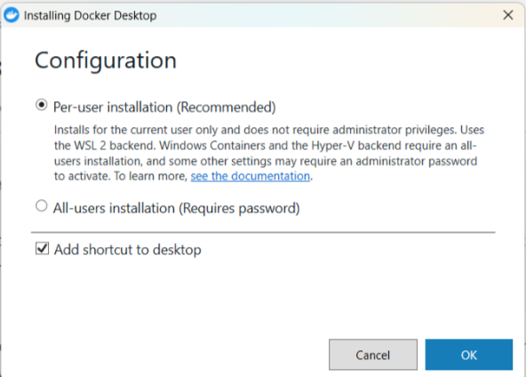
Docker Desktop installer — Configuration screen, per-user installation with the WSL 2 backend

Step 3 — Installation Completes
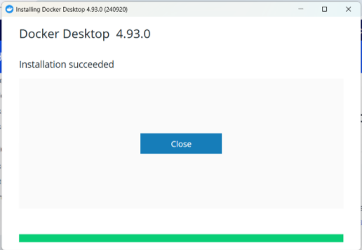
Docker Desktop installer confirms “Installation succeeded”

Step 4 — Sign In Or Skip
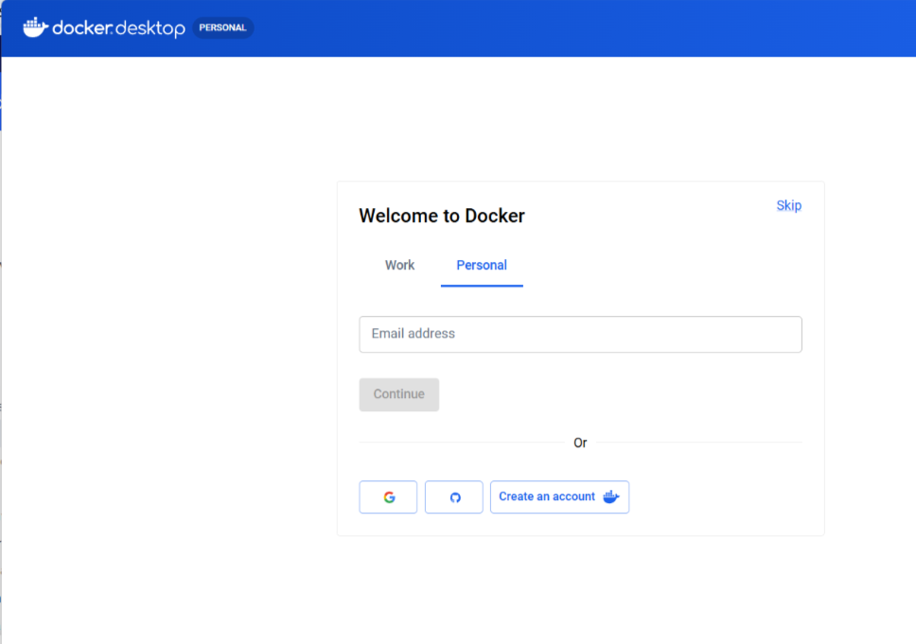
First launch — Docker prompts to sign in or create a Docker Hub account; signing in is optional for local use and can be skipped

Step 5 — Redirected To The Desktop App
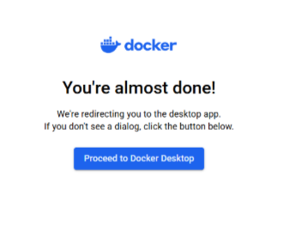
After sign-in (or skip), Docker redirects back to the desktop app

Step 6 — Confirm The Redirect
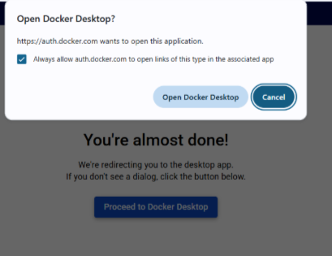
Windows asks permission to open Docker Desktop — confirms the handoff from browser back to the installed app

Step 7 — Docker Desktop Opens
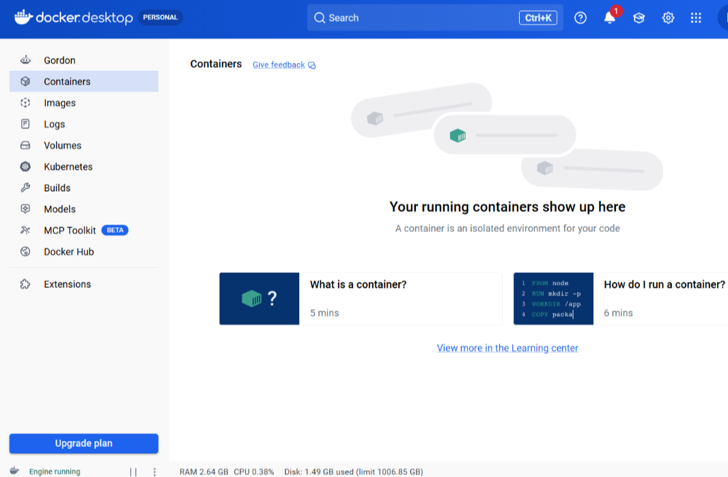
Docker Desktop's Containers tab on first launch — empty, since nothing has been run yet

Step 8 — Verify From The Terminal
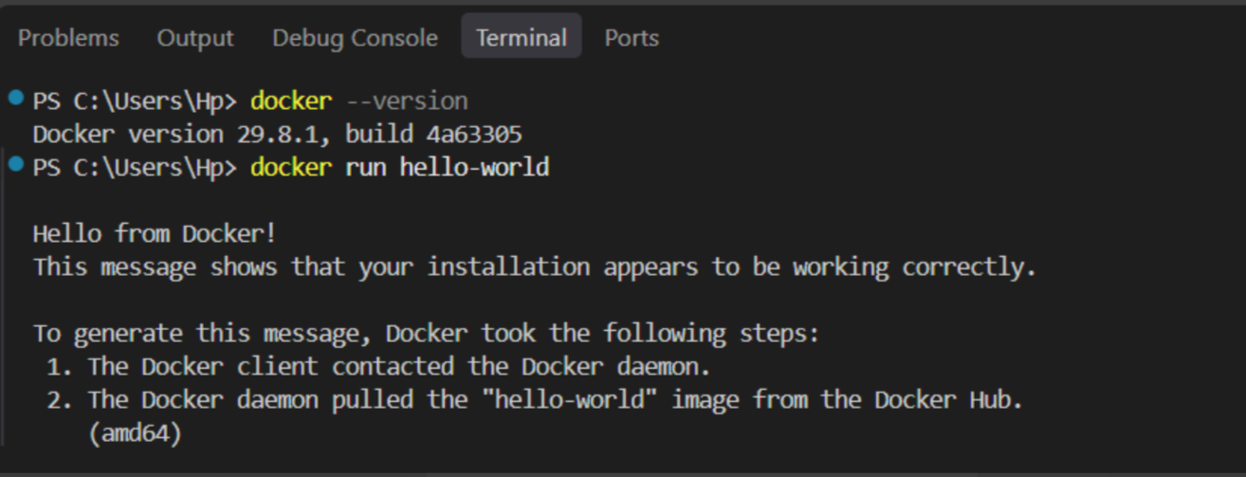
docker --version displays the installed Docker CLI version; docker run hello-world confirms the daemon pulled and ran an image — “Hello from Docker!” confirms success

Visual Guidance: See the 8-step screenshot walkthrough above — Windows install path shown end to end, from enabling WSL 2 through the docker run hello-world verification.
Speaker Notes: "Treat the final verification step as the gate before any practical work begins. A missing WSL 2 backend (Step 1) is the most common installation failure asked about. Docker Hub sign-in (Steps 4–6) is optional for local use — mention this so students don’t think an account is mandatory."

Slide 6: Image vs Container Distinction
Heading: Image Vs Container
Subheading: Template Vs Instance
Content:
An image is a frozen, read-only template; a container is that template brought to life with its own writable layer on top.
- Image: built once, never changes, stored by ID and tag
- Container: created from an image, has a thin writable layer
- One image can start many independent containers
- Deleting a container never deletes its source image
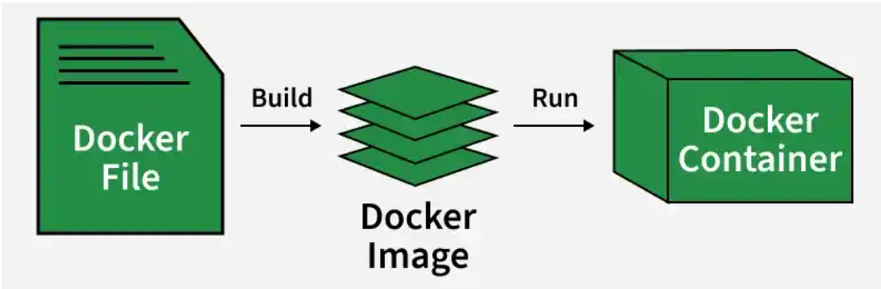
Analogy: A cake recipe card is reused to bake many separate cakes — just as one Docker image can start many independent containers.
Visual Guidance: Side-by-side: image box with locked layers next to a container box showing the same layers plus a writable top layer.
Speaker Notes: "Tags like nginx:alpine name images, not containers. Interviews often ask what survives container removal — the image."

Slide 7: Pulling From A Registry
Heading: Client Daemon Registry
Subheading: Pull And Run Flow
Content:
Running an image that the daemon does not have locally triggers a pull from a registry — Docker Hub by default — before a container starts.
- Explicit pull: docker pull nginx:alpine fetches an image with no container created — the same mechanism docker run triggers automatically
- docker run hello-world: no flags — image name only, pulled if absent locally
- Client sends the request over the daemon's local API socket
- Daemon checks its local image cache first by name and tag
- Pulled layers are cached, so a repeat run skips the registry
Visual Guidance: Arrow sequence: client -> daemon -> registry (dashed, only on cache miss) -> container created.
Speaker Notes: "Explain that a one-shot container exits once its process finishes, which is normal. Interviewers often ask why a stopped container still appears in docker ps -a."

Slide 8: Part A Practical Steps
Heading: Part A Practical Steps
Subheading: Images To Containers
Content:
Part A works with an existing image, tracing every command from an explicit pull to removing a running web server container.
- Step 1: docker pull nginx:alpine fetches the image explicitly, before any container runs
- Step 2: docker images lists images already pulled
- Step 3: docker run hello-world; expected Hello from Docker!
- Step 4: docker ps shows currently running containers
- Step 5: docker ps -a shows hello-world as Exited (0)
- Step 6: docker run -d --name web-demo -p 8080:80 nginx:alpine starts a server
- Step 7: docker ps confirms web-demo running with its port mapping
- Step 8: browser at localhost:8080 shows Welcome to nginx!
- Step 9: docker stop web-demo halts the container
- Step 10: docker rm web-demo removes it; docker ps -a confirms it is gone
Visual Guidance: Numbered step strip 1 to 10, icons for terminal, container box, and browser window at the matching steps.
Speaker Notes: "This full trace is the baseline practical before the custom build in Part B. Exited (0) on hello-world is expected, not an error."

Slide 9: Running A Container
Heading: Container Lifecycle Commands
Subheading: Run Check Stop Remove
Content:
A long-running service container is started, mapped to a host port, then checked, stopped and removed through the client-daemon flow.
Nginx is used only to demonstrate a web application running inside a container, not as a production choice.
docker run -d --name web-demo -p 8080:80 nginx:alpine
- Line 1 — -d: run in background. --name web-demo: name the container. -p 8080:80: map host port 8080 to container port 80. nginx:alpine: the image used.
- docker images: lists cached images before running
- docker ps: expected web-demo Up, PORTS 0.0.0.0:8080->80/tcp
- Browser at port 8080: expected the Welcome to nginx! page
- docker stop web-demo: expected the container name echoed back
- docker rm web-demo: expected web-demo absent from docker ps -a
Browser Check — Step 8
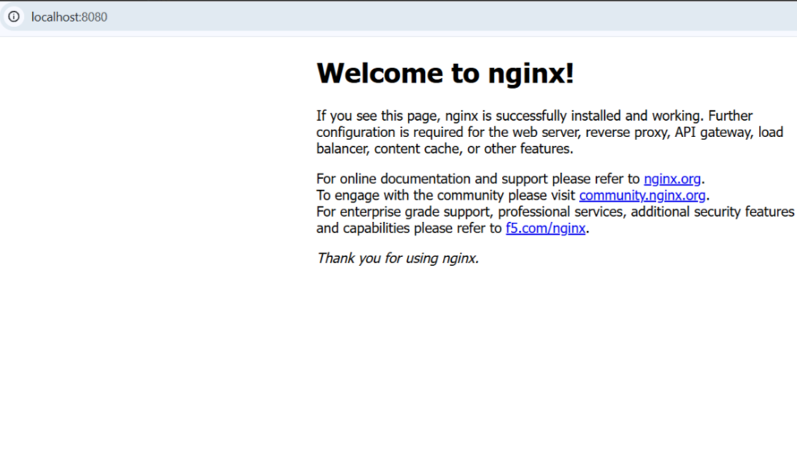
Browser at localhost:8080 — “Welcome to nginx!” confirms web-demo is serving traffic

Visual Guidance: Timeline strip: run -> ps -> browser -> stop -> rm, each step labelled with its command. Only the browser-result screenshot above is currently available.
Speaker Notes: "Nginx here is only a convenient web server to prove the container is serving traffic. Removing the container frees its name but the nginx:alpine image stays cached. [Instructor note: only the browser-result screenshot (Step 8) is currently available for this slide. Steps 1, 2, 4, 5, 6, 7, 9 and 10 still need to be captured from a live run — Step 3 (hello-world) is already shown on Slide 5 and does not need a separate capture here.]"

Slide 10: Layers And Build Caching
Heading: Layers Build Caching
Subheading: Dockerfile To Layers
Content:
Each Dockerfile instruction adds one layer on top of the base image; a rebuild reuses an unchanged layer instead of redoing its work.
FROM nginx:alpine
COPY index.html /usr/share/nginx/html/index.html
EXPOSE 80
- Line 1 — FROM sets the base layer.
- Line 2 — COPY adds the HTML layer.
- Line 3 — EXPOSE documents port 80, not published yet.
- Cache key: instruction plus the files it touches
- A changed instruction invalidates it and every layer after
- Stable instructions first, frequently changing ones last
Analogy : Building a house floor by floor — if the foundation and lower floors remain unchanged, you don't rebuild them when making a change to the top floor, just as Docker reuses cached layers when earlier instructions remain unchanged.
Visual Guidance: Vertical stack of layer blocks labelled FROM, COPY, EXPOSE, with a cache tick mark on the unchanged ones.
Speaker Notes: "EXPOSE only documents a port; -p at runtime actually publishes it. Interviews often ask why instruction order affects build speed."

Slide 11: Building A Custom Image
Heading: Build Run Verify
Subheading: Custom Image Trace
Content:
Part B builds a custom image from a Dockerfile, confirming the same image-container relationship already seen with pulled images.
cloud-docker-demo/
├── index.html
└── Dockerfile
- Lines 1-3 — A project folder holding the page content and the build instructions.
<!DOCTYPE html>
<html>
<head>
<title>My Docker App</title>
</head>
<body>
<h1>Hello from Docker!</h1>
<p>This web application is running inside a Docker container.</p>
</body>
</html>
- Lines 6-7 — The heading and paragraph this page serves, shown by the container once built and run.
- Step 1: create folder cloud-docker-demo/ with index.html and Dockerfile
- Step 2: write index.html with the page content above
- Step 3: write Dockerfile with FROM, COPY and EXPOSE
- Step 4: docker build -t cloud-docker-demo . builds the image
- Step 5: docker images confirms cloud-docker-demo stored locally
- Step 6: docker run -d --name cloud-web -p 8080:80 cloud-docker-demo starts it
- Step 7: docker ps expected cloud-web with 0.0.0.0:8080->80/tcp
- Step 8: browser at port 8080 expected the custom page
- Step 9: docker stop cloud-web and docker rm cloud-web remove it
- Step 10: docker images still lists cloud-docker-demo after removal
Step 1 — Project Folder Created
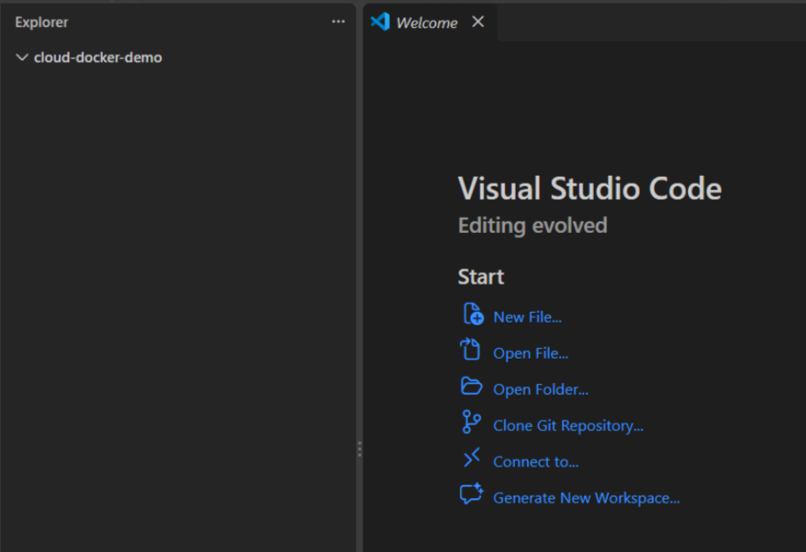
VS Code — cloud-docker-demo folder created in the file explorer

Step 2 — index.html Written
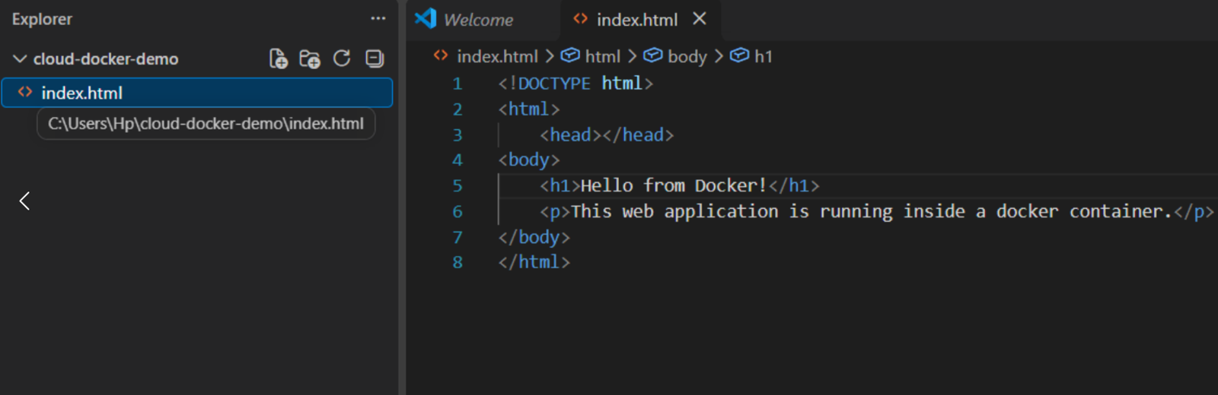
VS Code — index.html content: the custom page this container will serve

Step 3 — Dockerfile Written
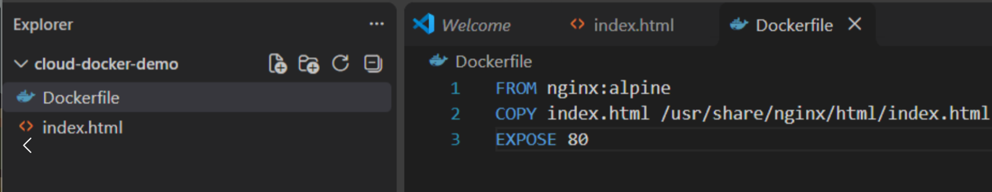
VS Code — Dockerfile content: FROM, COPY and EXPOSE directives

Step 6 — Container Started
Terminal after docker run — cloud-web container ID printed

Step 7 — Port Mapping Confirmed
docker ps — cloud-web mapped to 0.0.0.0:8080->80/tcp

Step 8 — Custom Page Verified
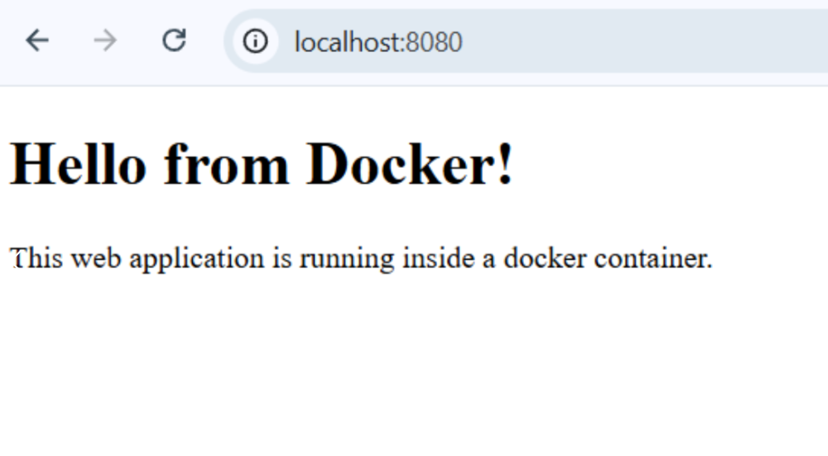
Browser at localhost:8080 — the custom “Hello from Docker!” page

Visual Guidance: Flow strip: Dockerfile -> docker build -> image -> docker run -> container -> browser output, matching the 6 screenshots above (Steps 1, 2, 3, 6, 7, 8).
Speaker Notes: "The same build-run-remove pattern applies to any custom image. Interviews often ask which flag tags an image during build. [Instructor note: screenshots for Steps 4, 5, 9 and 10 (docker build output, docker images before and after removal, and the stop/rm confirmation) still need to be captured — not available in the current set.]"

--------------------------------------- SECTION 3: 3. Containers vs VMs: Boot time, memory footprint, image size & density; isolation strength & security trade-offs ---------------------------------------

Slide 12: Comparing Containers And Virtual Machines
Heading: Four Comparison Dimensions
Subheading: Boot Memory Size Security
Content:
Containers and virtual machines isolate workloads differently, and that difference shows up in four measurable areas before any use case is chosen.
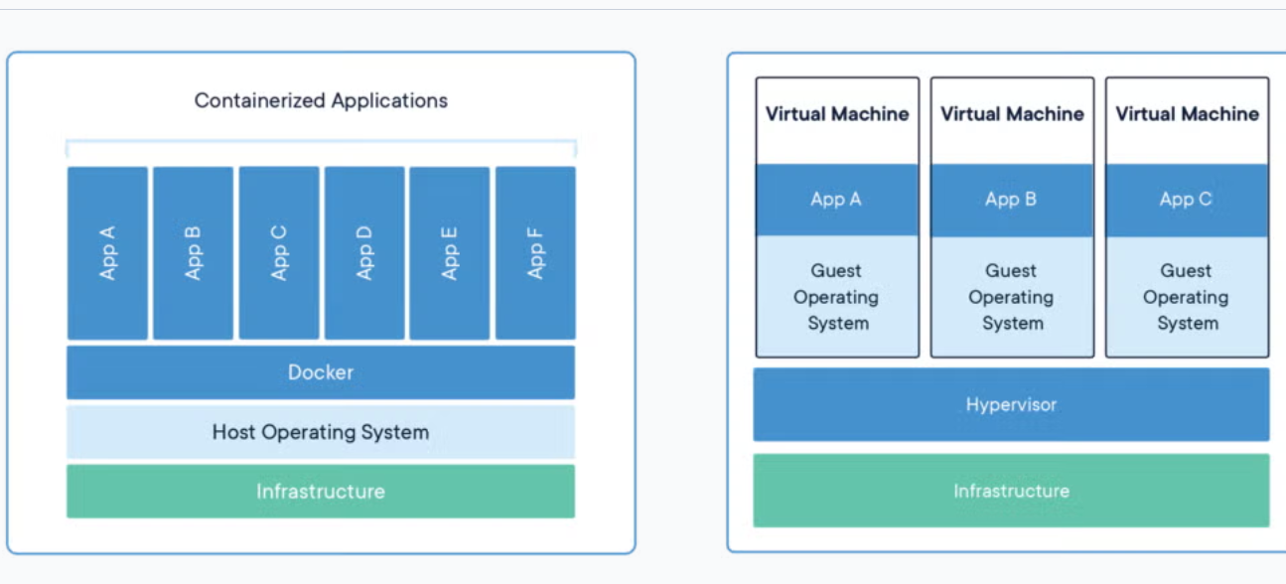
- Boot time: how quickly each starts and becomes usable
- Memory footprint: RAM consumed per workload at idle
- Image size and density: how many instances fit per host
- Isolation strength: kernel-level sharing versus hardware-level separation
- Security trade-offs: what fails if the boundary is breached
Visual Guidance: Two stacks side by side: left hardware to hypervisor to guest OS to VMs; right hardware to host OS kernel to container engine to containers.
Speaker Notes: "Set up the four comparison dimensions before any numbers appear on the following slides. Interviewers often open this exact topic by asking for these four axes directly."

Slide 13: Boot Time And Memory Footprint
Heading: Boot Time And Memory
Subheading: Startup Speed Compared
Content:
Starting a virtual machine boots a full guest operating system; starting a container launches one process on a kernel already running.
Metric | Virtual Machine | Container
Boot time | Tens of seconds (full OS boot) | Under a few seconds (process start)
Memory footprint (idle) | Several hundred MB to a few GB (guest OS overhead) | A few MB to tens of MB (app plus runtime)
- Cause: VM repeats bootloader, kernel init and service startup
- Container skips straight to launching the application process
- Lower per-instance memory lets more workloads run concurrently
Visual Guidance: Bar chart: boot time in seconds, VM bar far taller than container bar; second bar chart for idle memory, same proportion.
Speaker Notes: "Tie the boot-time gap to the OS boot sequence, not to raw hardware speed. The seconds-versus-tens-of-seconds contrast is a standard interview comparison point."

Slide 14: Image Size And Container Density
Heading: Image Size Density
Subheading: Packing Workloads Tighter
Content:
Containers fit more workloads per host by sharing the host kernel and avoiding separate guest operating systems.
Metric | Virtual Machine | Container
Image size | Several GB (full guest OS plus app) | Tens of MB to a few hundred MB (app layers only)
Typical density per host | Tens of VMs | Hundreds of containers
- Smaller images pull and deploy faster across a cluster
- Higher density lowers infrastructure cost per workload on identical hardware
- Shared base layers cut total storage across many container images
Visual Guidance: Grid diagram: one host square packed with few large VM blocks versus the same size host packed with many small container blocks.
Speaker Notes: "Density is the number behind why a host runs far more containers than VMs side by side. Expect a question on why container density beats VM density on identical hardware."

Slide 15: Isolation Strength Containers Versus VMs
Heading: Isolation Strength Compared
Subheading: Kernel Versus Hardware
Content:
A virtual machine isolates at the hardware boundary with its own kernel; a container isolates at the process boundary on one shared kernel.
- VM: separate guest kernel per instance, hypervisor enforces the boundary
- Container: namespaces separate the view, cgroups cap the resources
- Shared kernel means one kernel vulnerability can reach every container
- VM: A guest OS crash usually does not affect sibling VMs.
Visual Guidance: Boundary diagram: VM boundary drawn around hardware layer (per guest); container boundary drawn around process layer (one shared kernel line beneath all).
Speaker Notes: "This single fact explains why containers are called less isolated than VMs — shared kernel, not weaker code. Interviewers test this by asking what a kernel exploit can reach in each model."

Slide 16: Security Trade-offs Between Containers And VMs
Heading: Security Trade-offs
Subheading: Blast Radius Differs
Content:
Stronger isolation does not mean fewer attacks; it changes how far a successful attack can spread once the boundary is crossed.
- VM breakout may exploit a hypervisor vulnerability and can affect isolation between VMs
- Container breakout exploits the shared kernel: mitigated by seccomp, SELinux, non-root users
- Untrusted or multi-tenant code favours VM-grade isolation
- Trusted internal services accept container isolation for speed and density
Visual Guidance: Two circles labelled blast radius: small circle around one VM after a breakout, large circle around the whole host after a container breakout.
Speaker Notes: "Link blast radius back to the kernel-sharing fact from the isolation comparison just taught. This security-versus-density trade-off is a frequent systems-design interview question."

--------------------------------------- SECTION 4: 4. Choosing Between Them: Container use cases; VM use cases; decision criteria ---------------------------------------

Slide 17: Choosing Containers Or VMs
Heading: Choosing Between Them
Subheading: Use Cases And Criteria
Content:
Container and virtual machine strengths point to different workloads; matching the right one to the job is the real skill, not finding one universal winner.
- Workload type: stateless microservices vs full-stack legacy apps
- Isolation need: process-level sharing vs hardware-level separation
- OS requirement: same kernel vs mixed operating systems
- Scale and density: many light instances vs fewer, heavier ones
Visual Guidance: Diagram: a fork from one question mark — left arrow to a container icon tagged with workload types, right arrow to a VM icon tagged with workload types.
Speaker Notes: "Frame this as a workload-driven decision rather than a technology preference, since that is the real trade-off teams make daily. This exact mapping is what interviewers probe when testing container-versus-VM judgment."

Slide 18: Container Use Cases
Heading: Container Use Cases
Subheading: Where Containers Fit Best
Content:
Containers suit workloads that restart often, scale horizontally, and ship as small, repeatable units — the opposite of a slow-booting, heavyweight guest.
- Microservices: independently deployable services communicating over APIs
- CI/CD pipelines: identical images carried from build to production
- Cloud-native apps: run at scale on AWS ECS, EKS or Fargate
- Stateless, short-lived tasks: batch jobs and queue workers
- High-density hosting: many app instances packed onto one host
Visual Guidance: Row of icons: microservice mesh, CI/CD pipeline arrow, ECS/EKS logo, batch-job icon, stacked boxes for density.
Speaker Notes: "Tie each case back to the density and startup-speed advantages already established, applied here to real workload choices. Expect interview questions phrased as which workload suits a container — these five cases are the answer key."

Slide 19: Virtual Machine Use Cases
Heading: VM Use Cases
Subheading: Where VMs Fit Best
Content:
Virtual machines earn their heavier footprint when a workload needs a full, isolated operating system or hardware access the host runtime cannot provide.
- Legacy applications: tied to a specific OS version or kernel module
- Mixed operating systems: Windows and Linux guests on one host
- Strong multi-tenant isolation: separate kernels for untrusted workloads
- Kernel-level or driver work: isolated environments for kernel development and driver testing.
- Full-stack test labs: AWS EC2 instances cloning a production server exactly
Visual Guidance: Icons: Windows and Linux logos side by side, a lock for isolation, EC2 logo for the test-lab case.
Speaker Notes: "Connect each case back to the full-OS isolation and boot-time cost already established, now framed as the reason to choose a VM. A classic interview probe asks why not containerise everything — kernel dependency and tenant isolation are the answer."

Slide 20: Decision Criteria Compared
Heading: Decision Criteria Map
Subheading: Workload Fit Checklist
Content:
No single criterion decides the choice; the table weighs isolation, OS diversity, density and workload lifetime side by side.
Criterion | Favours Container | Favours VM
Isolation strength | Process-level, shared kernel | Hardware-level, separate kernel
OS diversity | Same kernel for all apps | Multiple OS types on one host
Density / footprint | Many instances per host | Fewer, heavier instances per host
Deployment and management | Frequent, consistent redeployment | Full OS control or legacy environment requirements
Tenant isolation | Lower guarantee, shared kernel | Strict guarantee for untrusted tenants
Production systems often combine both — containers scheduled onto VM-based hosts — using the VM as the security boundary and containers for density within it.
Visual Guidance: Keep the table as the slide centrepiece; below it, a small nested box showing container icons inside one VM icon to depict the hybrid pattern.
Speaker Notes: "Use this table as a quick checklist when justifying an architecture choice, since most real decisions weigh several rows together. Interview panels often ask for a one-line justification per row, which this table trains directly."

--------------------------------------- SECTION 5: 5. Tooling & Registries: VirtualBox, KVM, Hyper-V & VMware; Docker, Podman & containerd; public vs private registries; tagging strategy ---------------------------------------

Slide 21: Virtualization And Container Tooling Overview
Heading: Tooling Landscape
Subheading: Four Areas Mapped
Content:
Running virtual machines or containers in production means picking a hypervisor or engine, then a registry to distribute the resulting images.
- Virtualization tools: VirtualBox, KVM, Hyper-V, VMware
- Container engines: Docker, Podman, containerd
- Registries: public vs private
- Tagging: naming scheme for image versions
Visual Guidance: Two-column diagram: VM tools column, container tools column, both arrows pointing down into one shared Registry box.
Speaker Notes: "Set up these four areas before going tool by tool. Interviewers often ask for alternatives to Docker or VirtualBox by name."

Slide 22: Comparing VirtualBox, KVM, Hyper-V And VMware
Heading: VM Tooling Compared
Subheading: Four Hypervisor Products
Content:
Each virtualization product fits a different deployment, from a laptop test lab to a production data centre.
Tool | Type | Platform | Typical Use
VirtualBox | Type 2 hosted | Windows macOS Linux | Desktop testing, dev labs
KVM | Type 1, kernel module | Linux hosts | AWS Nitro, Google Cloud,  OpenStack clouds
Hyper-V | Type 1 bare-metal | Windows Server, 10/11 Pro | Microsoft Azure, enterprise
VMware | Type 1 (ESXi) / Type 2 (Workstation) | Bare-metal (ESXi); Windows, Linux, macOS (Workstation/Fusion) | Enterprise data centres
Visual Guidance: Four-row table, one small vendor logo icon beside each tool name.
Speaker Notes: "Tie each product back to the Type 1 versus Type 2 split already taught. Interviewers often ask which hypervisor backs a named cloud platform."

Slide 23: Containerd And Podman Beneath Docker
Heading: Beneath Docker's Daemon
Subheading: Containerd And Podman
Content:
Docker delegates container execution to containerd. Kubernetes can use containerd through the Container Runtime Interface (CRI), without relying on Docker Engine.
- containerd: split out of Docker in 2016, now a separate project
- containerd runs the OCI Runtime Spec through runc underneath
- Podman removes the central daemon altogether; each container is a direct process
- Podman's rootless mode starts containers without any root privilege
Analogy: A city bus needs a central depot dispatching every trip, while an auto-rickshaw driver picks up a passenger directly with no depot involved — exactly as Podman starts a container directly, with no daemon standing between the command and the running process.
Visual Guidance: Diagram: Docker box with arrow down to containerd box; separate Podman box with no daemon, arrow straight to container.
Speaker Notes: "Containerd living inside Docker, and now also standalone, is a common interview trick question. Note that Podman's daemonless design is the security motivation, not a performance one."

Slide 24: Docker Vs Podman Vs Containerd
Heading: Engines Compared
Subheading: Architecture And Role
Content:
The three tools sit at different layers of one stack, and that layering decides which one fits a given deployment.
Aspect | Docker | Podman | containerd
Daemon required | Yes, dockerd | No | Yes, lower-level service
Rootless by default | No | Yes, when run as a normal user | No, root-level service
Native CLI | Yes, full-featured | Yes, Docker-compatible | Minimal (ctr, for debugging); nerdctl for Docker-like use
Primary role | Dev workstation, CI | Secure, rootless hosts | Kubernetes CRI runtime (EKS, GKE)
Visual Guidance: Four-row comparison table, highlight the Primary Role row in a contrasting colour.
Speaker Notes: "This table is the one most asked about in container-tooling interviews. Stress that containerd, not Docker, is the runtime a Kubernetes node actually calls."

Slide 25: Public Vs Private Container Registries
Heading: Public Vs Private
Subheading: Image Registries
Content:
A registry stores and distributes container images; which kind is used decides who is able to pull a given image.
- Public registry: Docker Hub, where public images can generally be pulled by anyone
- Private registry: Amazon ECR, Azure Container Registry, Google Artifact Registry
- Self-hosted option: Harbor, run inside an organisation's own network
- Chosen for security, compliance or protecting proprietary images
Analogy: A public registry is like a library open to any visitor, while a private registry is like an office cupboard that opens only with an employee's key — exactly as a private registry demands authentication before an image can be pulled.
Visual Guidance: Split diagram: public registry with an open padlock icon, private registry with a closed padlock, both feeding a docker pull arrow.
Speaker Notes: "Distinguish a registry, the service, from a repository, one image's set of tags, if asked in an interview. Private registries are the default choice for any proprietary production image."

Slide 26: Tagging Strategy For Container Images
Heading: Tagging Strategy
Subheading: Naming Image Versions
Content:
Image tags provide human-readable names for versions, while digests identify exact image content for reliable redeployment.
- Semantic versioning: major.minor.patch, for example app:2.3.1
- latest tag: moves with every push, unsafe for production rollback
- Immutable tag: git-commit hash, for example app:a1b2c3d, never overwritten
- Environment tags: app:staging, app:prod mark the pipeline stage
Visual Guidance: Timeline of three pushes to one repository, each landing a different immutable tag, with the latest pointer jumping between them.
Speaker Notes: "Flag latest as the most common cause of a failed production rollback when this comes up in interviews. Immutable, hash-based tags are what real CI/CD pipelines rely on for traceability."

Heads-Up: Start Your AWS Account Setup Now
Why now: AWS account setup is required before Practicals. Account verification may take a day or more. A free-tier account is sufficient.

Key Takeaways
1. Container Fundamentals: Process-level isolation; Linux namespaces & control groups (cgroups); union filesystem & layered images
2. Docker Architecture: Client, daemon, images, containers & registries; image vs container; layers & build caching
3. Containers vs VMs: Boot time, memory footprint, image size & density; isolation strength & security trade-offs
4. Choosing Between Them: Container use cases; VM use cases; decision criteria
5. Tooling & Registries: VirtualBox, KVM, Hyper-V & VMware; Docker, Podman & containerd; public vs private registries; tagging strategy

Upcoming Session : Cloud Networking & VPC
Thank You | All the Best

