Session 5 : Cloud Networking & VPC

RECAP: Session 4 : Containers vs Virtual Machines
1. Container Fundamentals: Process-level isolation; Linux namespaces & control groups (cgroups); union filesystem & layered images
2. Docker Architecture: Client, daemon, images, containers & registries; image vs container; layers & build caching
3. Containers vs VMs: Boot time, memory footprint, image size & density; isolation strength & security trade-offs
4. Choosing Between Them: Container use cases; VM use cases; decision criteria
5. Tooling & Registries: VirtualBox, KVM, Hyper-V & VMware; Docker, Podman & containerd; public vs private registries; tagging strategy

Agenda for Today's Session
1. Cloud Networking Overview: The network as the deployment boundary; core building blocks
2. Virtual Private Cloud (VPC): Logically isolated networks; VPC concepts across providers
3. Subnets & IP Addressing: CIDR notation & subnet sizing; public vs private subnets; availability-zone placement
4. Routing & Gateways: Route tables; internet gateway; NAT gateway; VPC peering & private connectivity
5. Network Security Controls: Security groups (stateful) vs network ACLs (stateless); least-privilege network design

--------------------------------------- SECTION 1: 1. Cloud Networking Overview: The network as the deployment boundary; core building blocks ---------------------------------------

Slide 1: Cloud Networking As Deployment Boundary
Heading: Deployment Boundary
Subheading: Why Networking Matters
Content:
Every cloud resource needs connectivity rules deciding what it can reach and what can reach it. This connectivity layer, called cloud networking, is the deployment boundary — the line deciding whether a launched resource is reachable at all.
- An instance with no route, gateway or security rule is deployed but entirely unreachable.
- The deployment boundary decides what traffic reaches a resource and what traffic it can send out.
- Isolation, addressing, routing and security rules in this session all exist to control this one boundary.
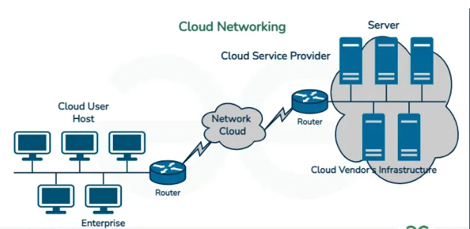

Analogy: A school has gates, corridors, and entry rules that decide who can enter, which rooms they can access, and where they can go — just as cloud networking controls how traffic reaches cloud resources and which resources it can access.
Visual Guidance: Simple box diagram: a cloud resource inside a dashed boundary line, with arrows showing allowed traffic crossing and blocked traffic stopped at the line.
Speaker Notes: "Explain that the network layer, not the compute layer, decides whether a launched resource is usable at all. Say it plainly: launching a server without network rules is like building a house with no road to it. This framing of 'boundary before compute' is a common way this topic is tested."

Slide 2: Core Building Blocks Of Cloud Networking
Heading: Core Building Blocks
Subheading: The Network Map
Content:
The deployment boundary is built from a small set of pieces that together control where traffic starts, stops and crosses isolation lines. On AWS (Amazon Web Services), all of them are configured from the VPC (Virtual Private Cloud) console.
All of it runs on software-defined networking (SDN) — the model where a control plane makes routing and security decisions in software, then pushes them onto hardware shared across many customers, so creating a VPC is an API call, not a cabling job
- The isolated network container groups all resources that should share one private address space.
- Subnets subdivide that container into smaller address ranges placed in specific availability zones.
- Gateways and route tables decide which subnets can reach the internet or other private networks.
- Security groups and network access control lists filter traffic allowed in and out of each resource.
- SDN separates the control plane (deciding where traffic should go) from the data plane (hardware actually forwarding packets) — this split is what makes every building block above configurable instead of physically wired
Visual Guidance: Diagram: a large box labelled VPC containing two smaller boxes (public subnet, private subnet), arrows to gateway icons, and a lock icon for security controls — a simplified preview of the full VPC diagram built in later slides.
Speaker Notes: "Point out that every building block named here is opened from the same AWS console screen, under VPC. Keep the explanation at map level only — the isolated network, the subnets, the gateways and the security filters each get their own detailed treatment shortly. Mention that an interviewer asking 'what makes up a VPC' expects this exact list of four pieces."

--------------------------------------- SECTION 2: 2. Virtual Private Cloud (VPC): Logically isolated networks; VPC concepts across providers ---------------------------------------

Slide 3: What A VPC Actually Is
Heading: What Is A VPC
Subheading: The Private Boundary
Content:
Public cloud infrastructure is shared by many customers, so each needs an isolated network. A VPC (Virtual Private Cloud) provides a logically isolated network with its own IP address range and traffic rules. Resources such as servers and databases commonly use a VPC to communicate securely.
- Subnets divide the VPC into smaller address blocks for grouping resources.
- Route tables decide where traffic leaving each subnet is sent next.
- Gateways, such as an internet gateway or NAT gateway, connect the VPC to outside networks.
- Security groups and network ACLs filter traffic allowed in or out of resources.
Analogy: A large gated residential society gives each resident association its own gate, internal roads and boundary wall inside one bigger campus — just as a VPC gives a customer its own addressed, routed and walled-off section of the provider's shared network.
Visual Guidance: Diagram: one VPC box containing labelled sub-boxes for subnets, a route table, an internet gateway and a NAT gateway.
Speaker Notes: "Explain a VPC as the customer's own walled section of a shared network, created the moment an account is opened. Point out that every part named here — subnets, route tables, gateways — is configured from the Amazon VPC dashboard in the AWS Console. Mention that AWS creates one default VPC per region automatically, which interviewers often probe. Flag that forgetting this boundary exists is a common mistake when tracing where traffic can and cannot go."

Slide 4: Default Vs Custom VPC
Heading: Default Vs Custom VPC
Subheading: Isolation In Practice
Content:
Isolation is enforced entirely in software: a provider's switches carry traffic for every tenant, but each VPC's address space and routing stay mathematically separate from the next. AWS gives two starting points for building one.
- A default VPC is created automatically in every AWS region, with one public subnet per Availability Zone ready to use.
- A custom VPC is built from scratch, letting an engineer choose the address range, subnet layout and route tables deliberately.
- The VPC's own CIDR (Classless Inter-Domain Routing) block, for example 10.0.0.0/16, sets the outer address range every subnet inside it must fit within.
- Production workloads generally use a custom VPC, since the default one does not enforce least-privilege network design.
Visual Guidance: Side-by-side diagram: an AWS region box with an automatic default VPC on the left, a hand-built custom VPC with chosen CIDR on the right.
Speaker Notes: "Walk through the console path VPC, then Your VPCs, then Create VPC, to show where this choice is actually made. Explain that the CIDR size decided here caps how many subnets and addresses are possible afterwards. Note that most production deployments retire the default VPC for security reasons. Exam hook: expect a question distinguishing default VPC behaviour from a deliberately designed custom VPC."

Slide 5: VPC Concepts Across Providers
Heading: Vpc Across Providers
Subheading: Same Idea Renamed
Content:
Every major provider offers the same isolation model under a different name, so the mental model built for one cloud transfers directly to another.
Concept | AWS | Azure | GCP
Isolated network | VPC (Virtual Private Cloud) | VNet (Virtual Network) | VPC Network
Default on signup | One default VPC per region | No general-purpose VNet created automatically | One default VPC, global scope
Cross-network link | VPC peering | VNet peering | VPC network peering
Address range unit | CIDR block on the VPC | CIDR block on the VNet | Subnet-level CIDR only
Visual Guidance: Four-row table on screen comparing AWS, Azure and GCP; highlight the GCP global-scope row.
Speaker Notes: "Emphasise that the underlying idea, a private addressed and routable network boundary, stays identical across providers; only the name and default scope change. Point out that GCP's VPC is unusual in spanning all regions globally, unlike AWS and Azure which scope it to one region each. Ask what AWS peering does, then name its Azure and GCP equivalents. Exam hook: interviewers often ask for the cross-provider name of an AWS VPC."

Slide 6: From VPC To Subnets
Heading: From Vpc To Subnets
Subheading: What Comes Next
Content:
A VPC provides an isolated network with its own address range. This range is divided into smaller subnets to organize and place resources.
- Logical isolation separates each customer's traffic in software, even while sharing physical switches and cables.
- The same boundary concept appears as AWS VPC, Azure VNet and GCP VPC Network with minor differences.
- That one large CIDR block must now be split into smaller subnets placed across Availability Zones.
Visual Guidance: Arrow diagram: one VPC box splitting into several smaller labelled subnet boxes.
Speaker Notes: "Recap that a VPC is the isolated network boundary and that the concept repeats across providers under different names. Remind that the VPC right now is just one undivided address block. Set up the transition by noting that block must be split into subnets before any server can be placed. This split-and-place logic is a frequent interview question about VPC design."

--------------------------------------- SECTION 3: 3. Subnets & IP Addressing: CIDR notation & subnet sizing; public vs private subnets; availability-zone placement ---------------------------------------

Slide 7: Subnets Inside A VPC
Heading: Subnets Overview
Subheading: CIDR Type Zone
Content:
A virtual private cloud's address block is split into subnets, smaller ranges sized using CIDR (Classless Inter-Domain Routing) notation, so that different resources can sit in different zones with different internet access rules.
- A larger slice kept for a subnet means fewer subnets can be carved from the same VPC block.
- Public subnets have a route to an internet gateway; private subnets do not.
- Every subnet is created inside exactly one availability zone, a physically separate data centre.
- Subnet type and size together decide how many resources a zone can host and how exposed they are.
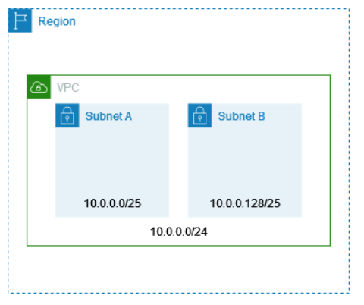
Visual Guidance: Diagram: one VPC box containing four subnet boxes, two labelled Public and two Private, grouped under two Availability Zone headers side by side.
Speaker Notes: "Set up the three threads this section ties together: sizing, public/private, and zone placement, made together whenever a VPC is designed. Point out that the diagram's grouping is exactly what the next slides unpack one at a time. Exam angle: a subnet's availability zone is fixed for its entire lifetime."

Slide 8: Sizing Subnets With CIDR
Heading: CIDR Subnet Sizing
Subheading: Reserved Address Cost
Content:
Sizing a subnet means choosing its prefix length, the /number in its CIDR (Classless Inter-Domain Routing) range. The bigger the number, the smaller the subnet, and every subnet pays a fixed address tax before any host gets an IP.
- AWS reserves five addresses per subnet for network, router, DNS, future use, and broadcast functions.
- A /24 subnet provides 256 addresses but only 251 remain usable after these reservations.
- A /28 is the smallest subnet AWS allows. It has 16 addresses but only 11 usable, so it saves VPC space but can run out of IPs quickly.
- A subnet's CIDR range cannot change after creation,so plan for extra space from the start.
Visual Guidance: Table-style graphic: a /24 block shown as 256 small squares, with 5 shaded squares labelled as AWS-reserved and the rest labelled usable.
Speaker Notes: "The address-count formula is already known; this slide adds the AWS-specific reservation on top of it. Say it plainly: five addresses are gone before anyone connects a single server. Point out that the console shows this exact usable-count when a subnet is created. Exam angle: expect a question asking for usable hosts after AWS reservations, not the raw formula alone."

Slide 9: Splitting A VPC Into Subnets
Heading: Worked Subnet Split
Subheading: Two Zones Four Subnets
Content:
A VPC block of 10.0.0.0/16 is split into four /24 subnets, pairing one public and one private subnet inside each of two availability zones for fault isolation.
Subnet CIDR | Availability Zone | Type
10.0.1.0/24 | ap-south-1a | Public
10.0.2.0/24 | ap-south-1a | Private
10.0.3.0/24 | ap-south-1b | Public
10.0.4.0/24 | ap-south-1b | Private
Each /24 subnet carries 251 usable addresses after AWS reservations, so the four subnets together offer 1004 usable addresses out of the 65,536 the /16 block holds.
Visual Guidance: Diagram: VPC 10.0.0.0/16 box split into four labelled subnet boxes arranged in two columns (zone 1a, zone 1b), public subnets on top row, private on bottom row.
Speaker Notes: "Walk through the table zone by zone, pointing out the public-private pair repeats identically in each zone. Explain why only a small slice of the /16 is used here: room is kept for more subnets later. Point at the Subnets list screen in the VPC console, which shows this exact CIDR, zone and usable-IP count. Exam angle: be ready to compute usable addresses for a stated subnet split."

Slide 10: Public Versus Private Subnets
Heading: Public Vs Private
Subheading: Classification By Route
Content:
A subnet is labelled public or private by what its route table sends internet-bound traffic to, not by any setting on the subnet itself.
Aspect | Public Subnet | Private Subnet
Internet-bound route | Points to an internet gateway | No direct internet gateway route
Typical resources | Load balancers, bastion hosts | Databases, internal application servers
Public IP exposure | Instances can hold a public IP | Instances cannot be reached directly from the internet
Zone pairing | Mirrored in every AZ used | Mirrored in every AZ used
Visual Guidance: Side-by-side VPC diagram: public subnet icon connected upward to an internet gateway symbol; private subnet icon with no outward arrow.
Speaker Notes: "Keep this to the classification itself; the mechanics of the route table and gateway are covered next. Say plainly that nothing is printed on a subnet calling it public — only its route decides that. Point at the Route Tables tab in the VPC console where this association is visible. Exam angle: a subnet with a public IP but no internet-gateway route is still private."

Slide 11: Placing Subnets Across Zones
Heading: AZ Placement
Subheading: High Availability Design
Content:
Availability zones are physically separate locations within one region, each made up of one or more data centres, so spreading subnet pairs across them keeps an application reachable even if one zone loses power or network.
- Production designs duplicate the public-private subnet pair in every zone that is used.
- The VPC console's Subnets page lists each subnet's assigned availability zone and CIDR.
- If one zone goes down, only the resources in that zone stop working, so a two-zone design keeps running on the other zone.
Visual Guidance: Map-style diagram: a region box containing two availability-zone boxes, each holding a public and private subnet, with a broken-link icon over one zone to show it still works.
Speaker Notes: "Emphasise that this placement decision is made once, at subnet creation, and never changes afterward. State the fault-isolation point directly: one zone's failure never touches the other zone's subnets. Point at the zone column in the console screenshot. Exam angle: explain why a load balancer's subnets must span at least two availability zones."

--------------------------------------- SECTION 4: 4. Routing & Gateways: Route tables; internet gateway; NAT gateway; VPC peering & private connectivity ---------------------------------------

Slide 13: Routing And Gateways Map
Heading: Connectivity Building Blocks
Subheading: Four Core Pieces
Content:
Subnets in a VPC reach each other through a built-in local route. Traffic leaving the VPC follows a route table to the right exit: an internet gateway, a NAT gateway, or a direct link to another network.
- Route tables decide the next hop for every outgoing packet, subnet by subnet.
- An internet gateway gives public subnets two-way access to the public internet.
- A NAT gateway lets private subnets reach the internet without accepting inbound connections.
- VPC peering and private connectivity link two networks directly, bypassing the public internet.
Visual Guidance: Diagram: VPC box with public subnet connected to an Internet Gateway, private subnet connected to a NAT Gateway sitting inside the public subnet, route-table icons beside each subnet, and a dashed line to a second VPC labelled Peering.
Speaker Notes: "Set up the four pieces as one connected map before going into each — a subnet alone cannot route anything on its own. Point at the AWS VPC console's left menu, where Route Tables, Internet Gateways, NAT Gateways and Peering Connections each have their own page. Each piece is examined in turn next, starting with the route table that every packet consults first."

Slide 14: Route Tables Direct Traffic
Heading: Route Tables
Subheading: Next-Hop Rules
Content:
A route table is a subnet’s rulebook for where traffic goes next. Each entry pairs a destination range with a target, such as local, a gateway, or a peering link, and the most specific match wins
- A local route keeps all traffic inside the VPC's own CIDR block, added automatically.
- A default route of 0.0.0.0/0 sends everything else to a gateway target.
- Each subnet associates with exactly one route table, though one table can serve many subnets.
- Longest-prefix-match order decides which entry wins when destinations overlap.
Analogy: A route table works like a postal sorting hub that reads only the pincode on a parcel and sends it to the correct delivery van, never opening the parcel itself — just as a route table reads only the destination address and forwards the packet without touching what it carries.
Visual Guidance: Show a two-row table on screen: Destination | Target, with 10.0.0.0/16 -> local and 0.0.0.0/0 -> igw-id, and an arrow from an incoming packet to the matching row.
Speaker Notes: "Teach the lookup as the same longest-prefix match used in CIDR, now deciding gateway choice rather than subnet size. Point at the Route Tables page in the AWS VPC console and its Routes tab. A route pointing at a gateway only works once that gateway exists, which is exactly where the internet gateway comes in next."

Slide 15: Internet Gateway Mechanism
Heading: Internet Gateway
Subheading: Public Two-Way Access
Content:
A subnet becomes public only when its route table sends outside-bound traffic to an internet gateway, the VPC component attached once per VPC that translates between a resource's private address and a public one. Without that route entry, even an instance holding a public IP stays unreachable.
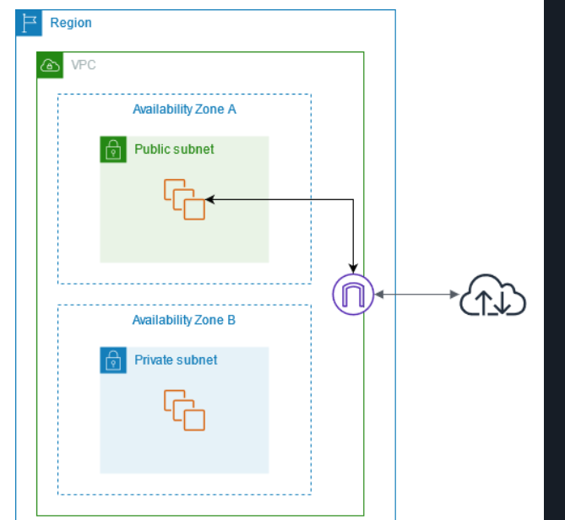
- Attaches at the VPC level, not inside any single subnet.
- Performs one-to-one network address translation between private and public IP addresses.
- A subnet is called public precisely because this route exists, nothing else makes it so.
- An instance also needs a public or elastic IP address for the translation to have something to map.

Visual Guidance: Highlight the Internet Gateway icon attached to the VPC boundary, with an arrow from the public subnet route table's 0.0.0.0/0 row into it, then out to a public internet cloud icon.
Speaker Notes: "Stress that being a public subnet is a route-table fact, not a special subnet type — many learners assume otherwise. Point at the Internet Gateways page in the AWS VPC console and its Attach to VPC action. A private subnet still needs outbound internet access without this two-way exposure, which is the gap the NAT gateway fills next."

Slide 16: NAT Gateway For Private Subnets
Heading: NAT Gateway
Subheading: Outbound-Only Access
Content:
A private subnet still needs to download updates or call external services, but it must never accept an unsolicited inbound connection. A NAT (Network Address Translation) gateway, placed in a public subnet, lets private instances start outbound connections while blocking anything started from outside.
- Deployed inside a public subnet so it can itself reach the internet gateway.
- Private subnet's route table sends 0.0.0.0/0 to the NAT gateway, not the internet gateway.
- Translates many private source addresses to the gateway's own single public address.
- Billed per hour running plus per gigabyte processed, so an idle NAT gateway still costs money.
Analogy: A NAT gateway works like a ticket counter at a venue. Visitors inside can go out and return using their tickets, but outsiders cannot enter through the exit without permission.
Visual Guidance: Diagram: private subnet's route table entry 0.0.0.0/0 -> nat-gateway-id, NAT gateway sitting inside the public subnet, arrow onward to the internet gateway, with a blocked (X) mark on any inbound arrow from the internet.
Speaker Notes: "Point out that the NAT gateway is the reason patching a private database server still works without exposing it to the internet. Show the NAT Gateways page in the AWS VPC console and its hourly-plus-data-processed pricing line; this per-hour cost is why teams route only necessary traffic through it rather than leaving it idle. When two private networks must talk to each other directly instead of to the open internet, VPC peering is the better fit, covered next."

Slide 17: VPC Peering Private Links
Heading: VPC Peering
Subheading: Direct Network Link
Content:
Two VPCs that need to exchange data privately, without the traffic ever touching the public internet, connect through VPC peering, a one-to-one networking connection between two VPCs' private address spaces. Each side still adds its own route table entries pointing the peer's CIDR block at the peering connection.
- Works between VPCs in the same account or across accounts, same region or across regions.
- Non-transitive: a peering connection does not extend automatically to a third VPC.
- Overlapping CIDR blocks between the two VPCs cannot be peered.
- Costs only data-transfer charges, far cheaper than routing the same traffic through NAT and the internet.
- A Site-to-Site VPN connects a VPC to an on-premises network instead of another VPC — encrypted over the public internet using IPsec, anchored by a virtual private gateway on the AWS side and a customer gateway on the on-premises side.
Analogy: VPC peering is like a private telephone line installed directly between two offices, bypassing the public telephone exchange entirely — just as peered traffic moves straight between the two VPCs without touching the public internet.
Visual Guidance: Two VPC boxes side by side joined by a dashed line labelled Peering Connection, with each VPC's route table showing an entry that points the other VPC's CIDR at the peering connection id.
Speaker Notes: "Clarify non-transitivity with a quick question: if VPC A peers with B and B peers with C, can A reach C directly — the answer is no, a frequent interview trap. Point at the Peering Connections page in the AWS VPC console. This non-transitive limit is exactly why connecting many VPCs needs one peering link per pair, which the comparison next weighs against the other routing options on cost and direction."

Slide 18: Gateways And Peering Compared
Heading: Routing Options Compared
Subheading: Side By Side
Content:
Route tables decide where traffic goes, while each remaining piece answers the same question differently: reach the public internet, go out only, reach another VPC directly, or reach an on-premises network.
Component | Direction | Typical Cost Driver
Internet Gateway | Two-way, public | No hourly charge, only data transfer
NAT Gateway | Outbound only | Hourly charge plus data processed
VPC Peering | Two-way, VPC-to-VPC | Data transfer only, no hourly charge
VPN (Site-to-Site) | Two-way, to on-premises | Hourly charge per connection, plus standard data-transfer rates
Together these pieces route traffic from a subnet to the internet or to another VPC; whether a packet is allowed to leave or enter at all is a separate decision, made by the network's security controls.
Visual Guidance: Simple three-row comparison table on screen; highlight the NAT Gateway cost cell to flag it as the most expensive routing option.
Speaker Notes: "Let the table carry the comparison rather than repeating it in words, and close by distinguishing routing from permission. Point at the Route Tables, Internet Gateways, NAT Gateways and Peering Connections pages together as the complete routing picture for one VPC. A good exam question traces a packet from a private subnet to the internet and names every component it passes through."

--------------------------------------- SECTION 5: 5. Network Security Controls: Security groups (stateful) vs network ACLs (stateless); least-privilege network design ---------------------------------------

Slide 19: Network Security Layers in a VPC
Heading: Network Security Layers
Subheading: Two Control Types
Content:
Inside a VPC, the local route makes every resource reachable from every other, so filters must decide which traffic is allowed. Two controls do this at different points in the network
- Security groups filter traffic at the individual instance's network interface.
- Network ACLs (Access Control Lists) filter traffic at the subnet boundary.
- Least-privilege design combines both controls so only the traffic a workload truly needs is allowed.
Analogy: A security group is like a two-way door with an electronic access system: once an allowed connection is established, its response traffic can pass back automatically. A network ACL is like a security checkpoint at the entrance and exit of a campus, where each packet is checked against the rules independently.
Visual Guidance: Diagram of a VPC box with an inner instance (security group ring) inside a subnet (ACL boundary ring around it), two concentric layers.
Speaker Notes: "Open by stating that an open network is a risk, then name the two layers that close it. Point out these sit at different depths: one around the instance, one around the subnet. Mention the AWS VPC console has a separate page for each. Exam hook: distinguishing instance-level versus subnet-level controls is a frequent interview question."

Slide 20: Security Groups: The Stateful Filter
Heading: Security Groups Explained
Subheading: Stateful Instance Filter
Content:
A security group attaches to an instance's network interface and acts as a virtual firewall for that instance . Being stateful, it automatically permits the return traffic of a connection it already allowed, without needing a matching reverse rule.
- Only allow rules exist; inbound traffic is blocked unless a rule permits it, while a new group allows all outbound traffic by default.
- All rules in a group are evaluated together, not checked in a fixed order.
- Reply traffic for an already-permitted request is tracked and let through automatically.
- Managed on the EC2 Security Groups console page, attached per instance or interface.
- Multiple security groups can attach to one instance, and their allowed rules combine.
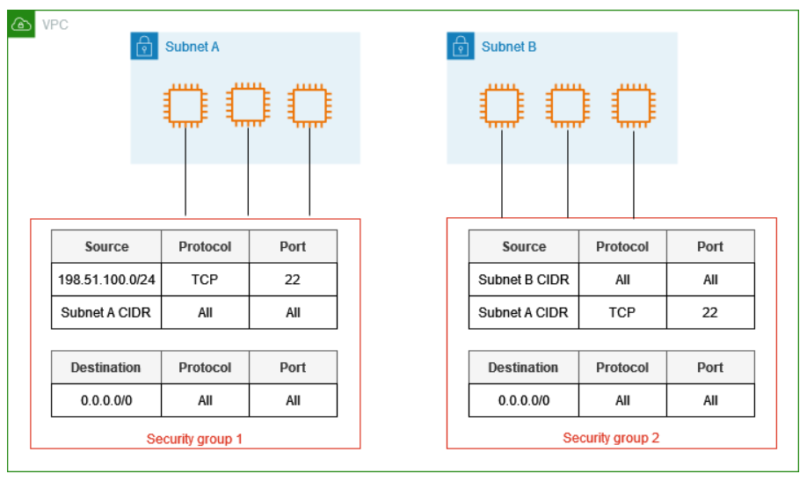
Visual Guidance: Instance box with an inbound rule table (port, source, allow) and an arrow showing the automatic return path.
Speaker Notes: "Explain stateful with a request-reply picture: once a request is let in, its reply needs no separate rule. Stress that there is no deny rule here, only allow. Point to the AWS console page name when discussing where this is configured. Interviewers often ask why security groups cannot explicitly block a specific IP."

Slide 21: Network ACLs: The Stateless Filter
Heading: Network ACLs Explained
Subheading: Stateless Subnet Filter
Content:
A network ACL sits at the subnet boundary and inspects every packet entering or leaving it, independent of any earlier traffic. Being stateless, it must explicitly allow both a request and its reply, since it keeps no memory of the connection.

- Support both allow and deny rules, so specific traffic can be blocked outright.
- Rules are numbered and checked in order; the first matching rule decides the outcome.
- Outbound reply traffic needs its own separate rule because no connection state is kept.
- Applied to an entire subnet, so every instance inside shares the same rule set.
- Managed on the VPC console's Network ACLs page, separate from security groups.
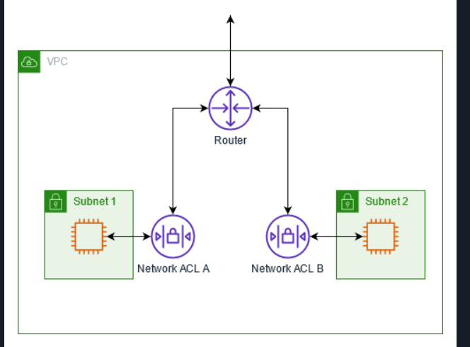
Visual Guidance: Subnet boundary box with a numbered rule list (rule number, allow/deny, port) and separate arrows for inbound and outbound packets.
Speaker Notes: "Walk through why a reply rule is needed here but not for security groups — that is the stateless difference. Emphasise the numbered, first-match evaluation order, unlike the group's unordered rules. If a screenshot is used, point at the rule numbers and the explicit deny row. A common interview trap is forgetting the outbound rule for ephemeral ports."

Slide 22: Security Groups Versus Network ACLs
Heading: Groups Vs ACLs
Subheading: Side By Side
Content:
Security groups and network ACLs operate at different layers, so a workload normally passes through both as a two-tier filter rather than relying on just one.
Aspect | Security Group | Network ACL
Scope | Instance / interface | Entire subnet
State | Stateful, return traffic automatic | Stateless, needs rule each way
Rule type | Allow only | Allow and deny
Evaluation | All rules together | Numbered, first match wins
Default | Inbound denied, all outbound allowed | Default ACL allows all; a new custom ACL denies all
Visual Guidance: Two-column table rendered large; highlight the State and Rule type rows as the two biggest exam-tested differences.
Speaker Notes: "Read the table row by row, pausing on state and rule type since those are the two most interview-tested distinctions. Mention that the default ACL AWS creates allows everything, unlike a default security group which denies all inbound. No analogy needed here, the table does the comparing. Ask aloud: why does only the ACL need an explicit deny rule?"

Slide 23: Designing for Least Privilege
Heading: Least Privilege Design
Subheading: Combining Both Layers
Content:
Least-privilege design means granting a workload only the network access it genuinely needs, nothing wider. Security groups and network ACLs together implement this by narrowing both the instance-level and subnet-level entry points.
- Open only the exact ports a workload needs, such as port 443 for a web tier.
- Restrict allowed sources to specific IP ranges or security group IDs, not open to all.
- Use a network ACL as a subnet-wide backstop to explicitly deny traffic a group might miss.
- Review rules periodically, since an unused open port is a common cause of breaches.
Visual Guidance: Funnel diagram narrowing from 'all traffic' through security group rules then ACL rules down to 'allowed traffic only'.
Speaker Notes: "Tie the two mechanisms together as one layered defence rather than two separate tools. Use the funnel visual to show traffic narrowing at each layer. Mention that this combination is what AWS documentation calls defense in depth for networking. A typical interview question asks how to design security group and ACL rules together for a three-tier application."

--------------------------------------- PRACTICAL HANDS-ON: Building a Cloud Network with AWS VPC ---------------------------------------

Slide 24: Lab Overview And Major Steps
Heading: Lab Overview
Subheading: What We Will Do
Content:
This practical builds a small custom network in the AWS VPC console and shows that a subnet is public because of its route table, not its name.
- Create a VPC (10.0.0.0/16) in the Mumbai Region.
- Create a public subnet (10.0.1.0/24) and a private subnet (10.0.2.0/24).
- Create an Internet Gateway and attach it to the VPC.
- Create a public route table (default route to the Internet Gateway) and a private route table (local route only, no route to the internet), and associate each with its subnet.
- Create a security group and inspect the network ACL.
- Verify the VPC, subnets, Internet Gateway and route tables in the console.
Important Note: No EC2 instance, NAT Gateway or load balancer is launched, so only the network configuration is verified, not live connectivity. The resources created here should not be deleted, as they will be used in future sessions.

Slide 25: Creating The VPC
Heading: VPC Created
Subheading: Address Range Confirmed
Content:
The VPC s5-cloud-network-vpc is created first, with CIDR 10.0.0.0/16. Every subnet, gateway and route table that follows must belong to it.
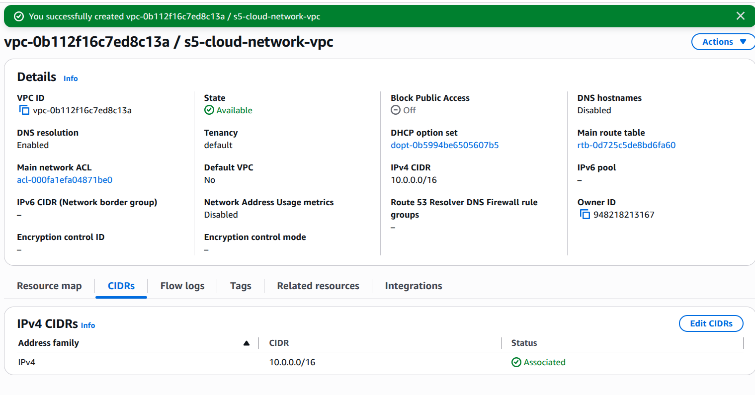
s5-cloud-network-vpc: state Available, IPv4 CIDR 10.0.0.0/16

Slide 26: Creating The Subnets
Heading: Subnets Created
Subheading: Public And Private
Content:
Two non-overlapping subnets are created in ap-south-1a.Until a route to the Internet Gateway is added, both subnets are private, whatever their names say.
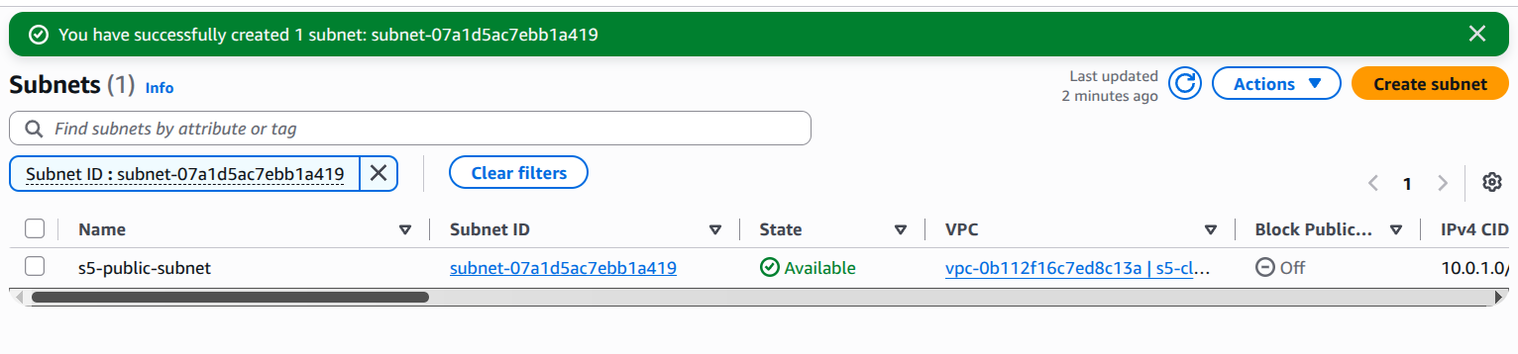
s5-public-subnet (10.0.1.0/24) created and Available
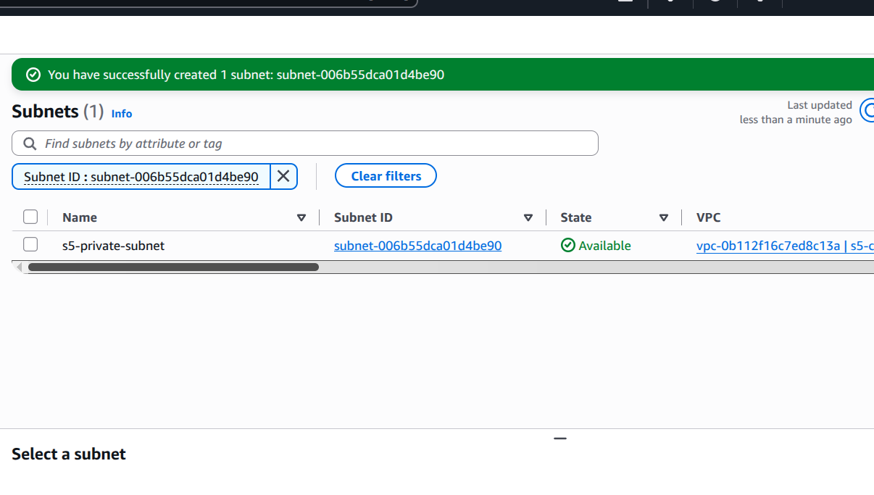
s5-private-subnet (10.0.2.0/24) created and Available

Slide 27: Attaching The Internet Gateway
Heading: Internet Gateway
Subheading: Created And Attached
Content:
The Internet Gateway s5-igw is created and attached to the VPC. Attaching it does not make any subnet public; a route table must point to it.
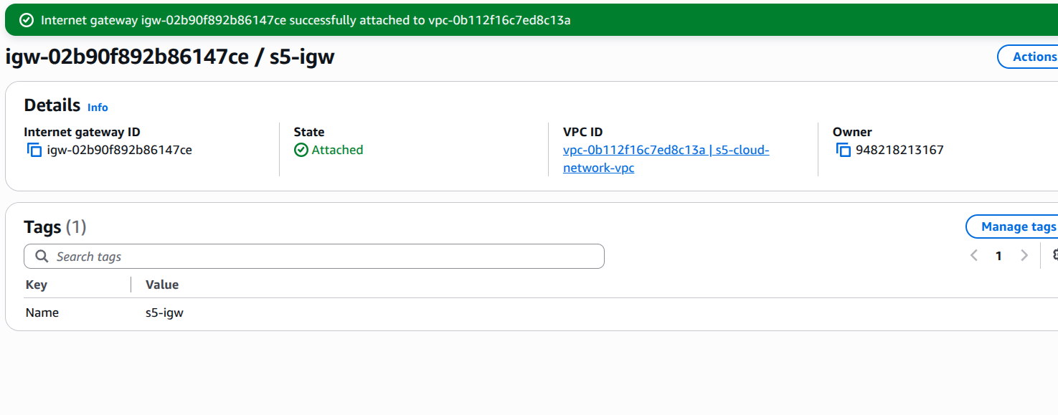
s5-igw in Attached state, linked to s5-cloud-network-vpc

Slide 28: Creating The Route Tables
Heading: Route Tables
Subheading: Public Versus Private
Content:
One route table is created for each subnet. The only difference is the default route to the Internet Gateway.
Route Table | Destination | Target | Associated Subnet
s5-public-rt | 10.0.0.0/16 | local | s5-public-subnet
s5-public-rt | 0.0.0.0/0 | s5-igw | s5-public-subnet
s5-private-rt | 10.0.0.0/16 | local | s5-private-subnet

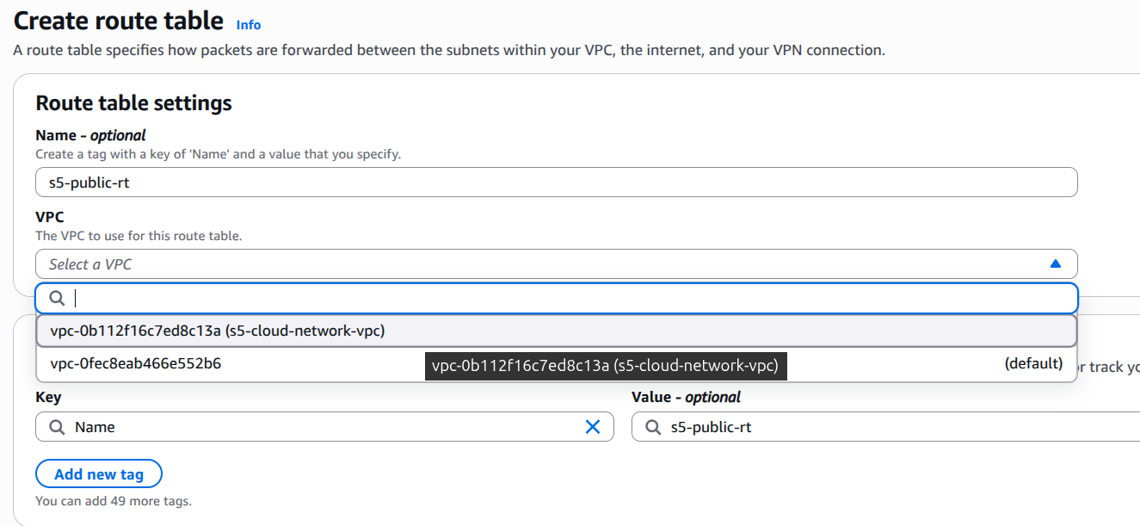
Creating s5-public-rt
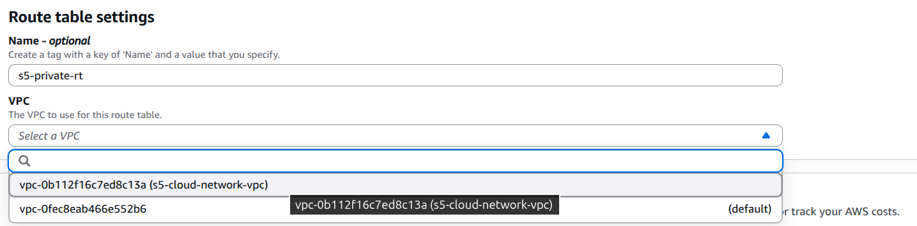
Creating s5-private-rt
Important Note: Select s5-cloud-network-vpc in the VPC drop-down, not the default VPC.

Slide 29: Exploring Network Security
Heading: Network Security
Subheading: Security Group And Network ACL
Content:
The last part of the practical looks at the two filtering layers of the VPC, without launching any resource.
- Security group: create s5-demo-sg in the VPC with no inbound rules, and inspect its rules. It is stateful and applies to resources.
- Network ACL: inspect the inbound and outbound rules of the VPC's network ACL without changing them. It is stateless and applies to a whole subnet.
Important Note: In the VPC field, select s5-cloud-network-vpc. The default VPC is pre-selected.

Key Takeaways
1. Cloud Networking Overview: The network as the deployment boundary; core building blocks
2. Virtual Private Cloud (VPC): Logically isolated networks; VPC concepts across providers
3. Subnets & IP Addressing: CIDR notation & subnet sizing; public vs private subnets; availability-zone placement
4. Routing & Gateways: Route tables; internet gateway; NAT gateway; VPC peering & private connectivity
5. Network Security Controls: Security groups (stateful) vs network ACLs (stateless); least-privilege network design

Upcoming Session : Load Balancing & CDN
Thank You | All the Best

