Session 2 : Deployment & Service Models

RECAP: Session 1 : Cloud Computing Fundamentals
1. Cloud Computing Basics: Definition & the NIST view; on-premise IT vs cloud; drivers: cost, scale & speed
2. History & Evolution: Mainframes & time-sharing; client-server & virtualization; grid & utility computing; the public cloud era
3. Essential Characteristics - I: On-demand self-service; broad network access; resource pooling & multi-tenancy
4. Essential Characteristics - II: Rapid elasticity vs scalability; measured service & pay-per-use metering
5. Benefits & Challenges: Cost model shift, elasticity, global reach & speed to market; vendor lock-in, cost overruns, latency & data residency

Agenda for Today's Session
1. Cloud Deployment Models: Public cloud; private cloud: on-premise vs hosted; hybrid & cloud bursting; community cloud
2. Multi-Cloud: Motivations: resilience, negotiation & regulation; operational cost of multiple platforms
3. Service Models: IaaS, PaaS & SaaS: what each provides & abstracts; representative services (e.g. EC2 for IaaS, AWS Elastic Beanstalk for PaaS)
4. Beyond the Big Three: Function as a Service (FaaS) & serverless; AI/ML-as-a-Service; responsibility boundaries across models
5. Cloud Economics & Providers: CapEx vs OpEx; total cost of ownership (TCO); pricing: on-demand, committed use & spot; AWS, Azure, GCP & Indian providers

--------------------------------------- SECTION 1: 1. Cloud Deployment Models: Public cloud; private cloud: on-premise vs hosted; hybrid & cloud bursting; community cloud ---------------------------------------

Slide 1: Cloud Deployment Models Landscape
Heading: Deployment Models Map
Subheading: Four Ways To Deploy
Content:
A cloud deployment model defines who owns the infrastructure, where it is hosted, and who has access to it.
Different organisations choose different deployment models based on their *control, security, scalability, and sharing requirements.*
Let’s explore the four major deployment models.
- Public cloud: provider-owned, shared across tenants
- Private cloud: dedicated, either on-premise or hosted
- Hybrid cloud: private and public linked together
- Community cloud: shared by organisations with common needs
Visual Guidance: Four boxes labelled Public, Private, Hybrid, Community arranged around a central 'Infrastructure Choice' node, arrows showing a spectrum from fully shared to fully dedicated.
Speaker Notes: "Frame deployment choice as a spectrum from fully shared to fully dedicated infrastructure. A common exam question gives a scenario and asks which model fits it best."

Slide 2: Public Cloud Explained
Heading: Public Cloud
Subheading: Shared Multi-Tenant Infrastructure
Content:
A public cloud is a cloud environment where a cloud provider owns and manages the infrastructure, and multiple customers use its resources over the internet.
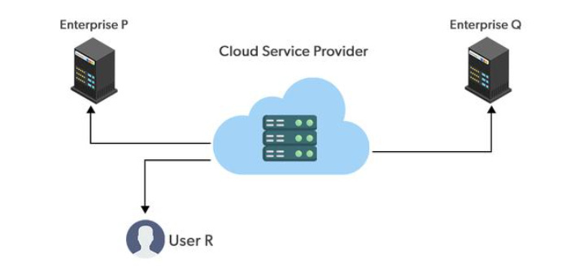
- Infrastructure owned and run entirely by the provider
- Many tenants share hardware, isolated logically from each other
- Capacity scales rapidly across resources pooled across customers
- Best fit: variable workloads, fast launch, low compliance limits
Analogy: A shared cab is owned by the cab company; many riders book seats and pay only for the ride taken, never owning the vehicle — just as public cloud tenants share provider-owned servers and pay only for the capacity used.
Visual Guidance: One large building labelled 'Provider Data Centre' with multiple small logos (different companies) drawing from it over an internet cloud icon.
Speaker Notes: "Note that AWS, Azure and Google Cloud Platform (GCP) are the leading public cloud providers offering this shared model. Interviewers often test whether a given scenario needs public or private cloud based on tenancy and control."

Slide 3: Private Cloud: On-Premise Vs Hosted
Heading: Private Cloud
Subheading: On-Premise Vs Hosted
Content:
Private cloud dedicates infrastructure to one organisation only, chosen when compliance, data residency or latency needs rule out shared public hardware.
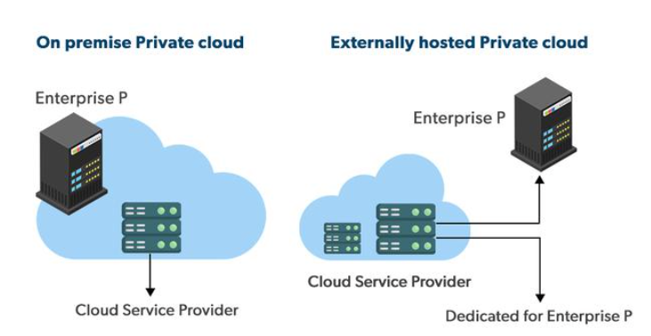
Aspect | On-Premise Private | Hosted Private
Location | Organisation's own data centre | Provider's data centre, dedicated section
Owned by | The organisation itself | Provider, leased to one customer
Example | In-house VMware or OpenStack cluster | VMware Cloud on AWS
Control | Full physical and logical control | Full logical control, no physical access
Analogy: Building a house on owned land gives full control forever; renting a private bungalow built by a developer gives the same exclusivity without construction effort — just as on-premise private cloud means owned infrastructure, while hosted private cloud means dedicated but provider-managed infrastructure.
Visual Guidance: Split diagram: left shows a building icon inside an organisation's fence (on-premise); right shows the same dedicated building inside a provider's larger data centre fence (hosted).
Speaker Notes: "Contrast on-premise physical custody against hosted convenience using the table on screen. A frequent interview question asks which private cloud variant suits a bank that must keep servers within its own walls."

Slide 4: Hybrid Cloud And Cloud Bursting
Heading: Hybrid Cloud
Subheading: Cloud Bursting Explained
Content:
Hybrid cloud links private and public infrastructure so workloads move between them, avoiding the need to size on-premise capacity for rare demand peaks.
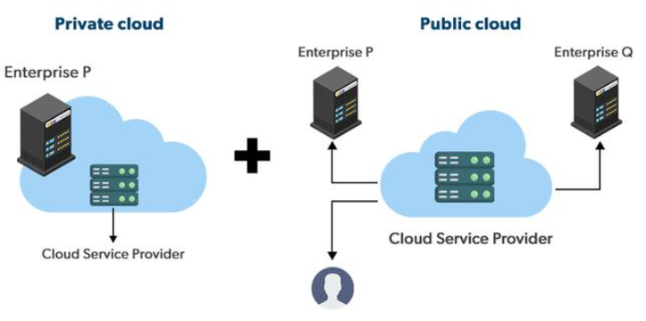
- Sudden overload bursts into public cloud capacity temporarily
- Cloud bursting: automatic overflow triggered by demand thresholds
- Example: AWS Outposts extends AWS infrastructure into on-premise sites
Analogy: A restaurant kitchen handles daily orders alone, but during a wedding rush it hires a banquet hall's ovens for the overflow and releases them once the rush ends — just as cloud bursting shifts excess load to public cloud only during demand spikes.
Visual Guidance: Two linked boxes, 'Private Infrastructure' and 'Public Cloud', with a dashed arrow labelled 'burst' flowing from private to public only when a load gauge crosses a threshold line.
Speaker Notes: "Stress that bursting is temporary and automatic, not a permanent migration of workloads. A common interview question asks how hybrid architecture avoids over-provisioning private capacity for rare peaks."

Slide 5: Community Cloud Explained
Heading: Community Cloud
Subheading: Shared Among Peers
Content:
Community cloud is infrastructure shared by several organisations with common regulatory, security or mission needs, rather than opened to the general public.
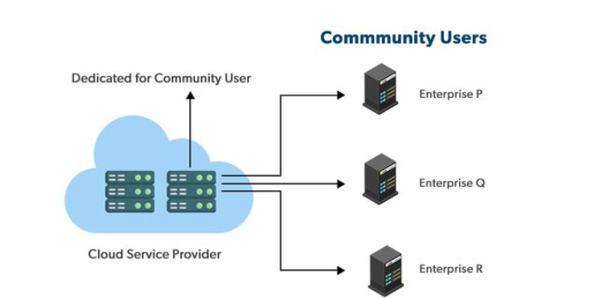
- Governance and compliance rules set jointly by member organisations
- Cost split among fewer tenants than public, more than solo private
- Example: AWS GovCloud (US), reserved for government agencies and partners
- Typical users: government bodies, healthcare consortiums, research collaborations
Visual Guidance: One shared infrastructure block in the centre with several matching organisation icons (government, healthcare, research) connected to it, ringed off from the general public cloud.
Speaker Notes: "Position community cloud as narrower than public but broader than private, sized to one sector's shared compliance need. An interviewer may ask why a government agency would pick AWS GovCloud over standard public cloud."

Slide 6: Deployment Models At A Glance
Heading: Deployment Models Compared
Subheading: Ownership Tenancy Use Case
Content:
Choosing a deployment model trades control for convenience: full ownership costs more effort, full sharing costs less control.
Model | Owned By | Tenancy | Typical Use
Public | Provider | Multi-tenant | Variable, public-facing workloads
Private (on-premise) | Organisation | Single-tenant | Strict compliance, latency-sensitive systems
Private (hosted) | Provider, dedicated to one customer | Single-tenant | Dedicated capacity without own data centre
Hybrid | Shared: organisation and provider | Mixed | Steady load with occasional bursts
Community | Member organisations, or a third party | Shared within group | Sector-specific compliance, e.g. government
Visual Guidance: The five-row comparison table rendered full-width, with the 'Owned By' column colour-coded to visually reinforce the control-versus-sharing spectrum from slide one.
Speaker Notes: "Use this table to map any given scenario, such as a hospital or a startup, to its best-fit deployment model. A recurring exam pattern gives a scenario and asks which model minimises cost while meeting its compliance need."

--------------------------------------- SECTION 2: 2. Multi-Cloud: Motivations: resilience, negotiation & regulation; operational cost of multiple platforms ---------------------------------------

Slide 7: Multi-Cloud: Beyond Hybrid
Heading: Multi-Cloud Defined
Subheading: Multiple Providers Together
Content:
Multi-cloud means running workloads across two or more independent public providers at once, unlike hybrid cloud, which mixes public with private infrastructure.
- AWS handles general-purpose compute and storage workloads
- Azure serves Microsoft-integrated enterprise applications
- GCP powers data analytics and AI/ML pipelines
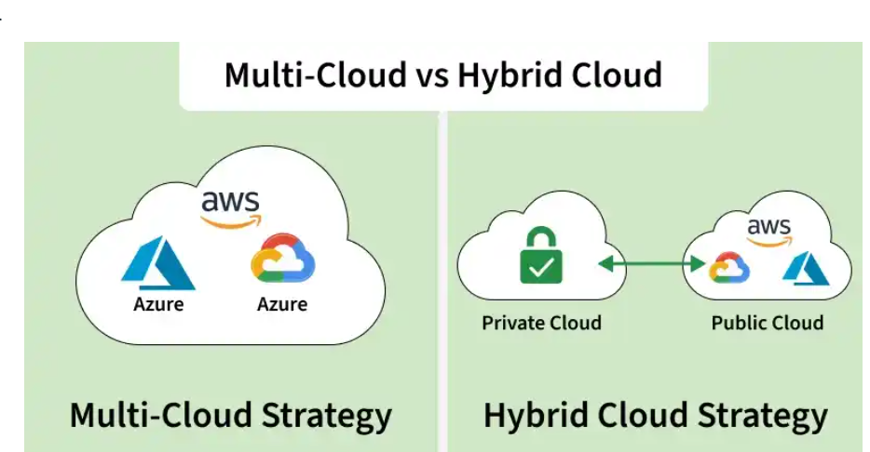
Analogy: Spreading savings across two different banks guards against one bank freezing withdrawals or raising fees — just as multi-cloud spreads workloads across providers so one outage or price hike does not stop operations.
Visual Guidance: Diagram: one company icon with three arrows branching to AWS, Azure and GCP logos, each labelled with a workload type.
Speaker Notes: "Stress that multi-cloud is a deliberate split among public providers, not a synonym for hybrid cloud. A common interview question asks to differentiate multi-cloud from hybrid cloud with an example."

Slide 8: Why Organizations Adopt Multi-Cloud
Heading: Multi-Cloud Motivations
Subheading: Resilience Negotiation Regulation
Content:
Three business pressures push organizations toward multiple providers even though it adds complexity.
- Resilience: a second provider keeps services running during an outage
- Negotiation leverage: comparing quotes across vendors avoids one-sided pricing
- Regulation: in-country hosting or concentration-risk rules may require a compliant region or a second provider
Visual Guidance: Three labelled icons (shield, handshake, gavel) mapped to resilience, negotiation and regulation respectively.
Speaker Notes: "Walk through each motivation with a one-line business scenario before naming it. Interviewers frequently ask why a company would choose multi-cloud over a single vendor — resilience, leverage and compliance form the three-part answer."

Slide 9: Cost Of Multi-Cloud Complexity
Heading: Operational Overhead Cost
Subheading: Managing Multiple Platforms
Content:
Multi-cloud earns its resilience and leverage at a real operational price: every added provider multiplies what must be learned, managed and paid for.
- Separate consoles, APIs and billing dashboards per provider
- Distinct certifications and skill sets needed for each platform's staff
- Cross-cloud data transfer (egress) charges between providers
- Duplicate monitoring, security and IAM policies to maintain
Visual Guidance: Table-style graphic: rows for Skills, Tooling, Billing, Security — each row showing duplicated icons across AWS/Azure/GCP columns.
Speaker Notes: "Frame overhead as the price paid for multi-cloud's benefits, not a separate flaw. A typical exam question asks to list the operational costs of running a multi-cloud environment."

--------------------------------------- SECTION 3: 3. Service Models: IaaS, PaaS & SaaS: what each provides & abstracts; representative services ---------------------------------------

Slide 10: Service Models: Provides vs Abstracts
Heading: Service Model Spectrum
Subheading: Stack Ownership Map
Content:
The three service models share one technology stack; each shifts the line dividing provider-managed layers from customer-managed layers.Deployment models say where the infrastructure sits and who owns it; service models say what is abstracted. Any service model can run on any deployment model (e.g. private-cloud IaaS, public-cloud SaaS).
Stack Layer | IaaS | PaaS | SaaS
Application | Customer | Customer | Provider
Data & access configuration | Customer | Customer | Customer
Runtime & middleware | Customer | Provider | Provider
Operating system | Customer | Provider | Provider
Virtualization, servers, storage, network | Provider | Provider | Provider
Visual Guidance: Horizontal stack bar split into four layers, shaded by owner colour for IaaS, PaaS and SaaS side by side.
Speaker Notes: "Point out that only the ownership line moves, not the stack itself. Interviewers often test whether a named service can be placed on the correct layer."

Slide 11: IaaS: Renting Raw Infrastructure
Heading: IaaS Explained
Subheading: Raw Infrastructure Rental
Content:
Infrastructure as a Service rents compute, storage and network as raw building blocks, leaving the operating system and everything above it to the customer.
- Abstracts physical hardware, racking and data-centre wiring
- Customer installs OS, runtime, middleware and application
- Representative services: AWS (Amazon Web Services) EC2, EBS, VPC
- Azure Virtual Machines, GCP Compute Engine offer same layer
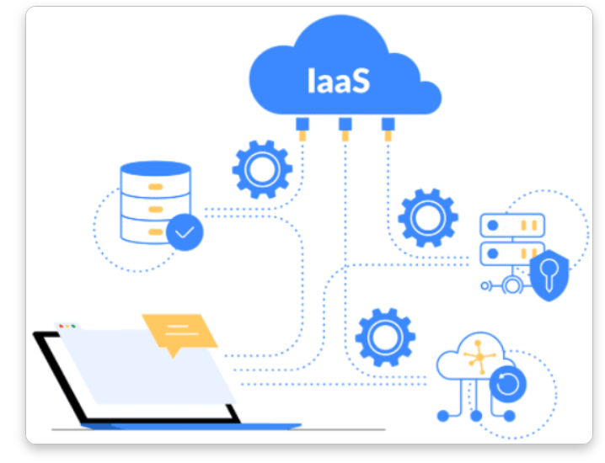
Analogy: Domino's kitchen space and oven are used, but the dough, sauce and toppings are supplied separately and the pizza is cooked from scratch — just as the IaaS provider manages only the physical infrastructure while the customer manages the operating system, runtime and application.
Visual Guidance: Icon of empty kitchen equipment (oven, gas line) labelled Infrastructure, with a chef bringing own recipe cards labelled OS, Runtime, App to bake the pizza.
Speaker Notes: "IaaS gives maximum control at the cost of managing everything above hardware. Interviewers often ask to map EC2 or a virtual machine to this layer."

Slide 12: PaaS: Managed Runtime Platform
Heading: PaaS Explained
Subheading: Ready-Made Platform
Content:
Platform as a Service adds a managed operating system and runtime atop infrastructure, so the customer only builds, deploys and runs application code.
- Abstracts OS patching, runtime setup and server scaling
- Less control over OS-level tuning than IaaS allows
- Representative services: AWS Elastic Beanstalk, AWS App Runner
- Azure App Service, GCP App Engine offer same layer
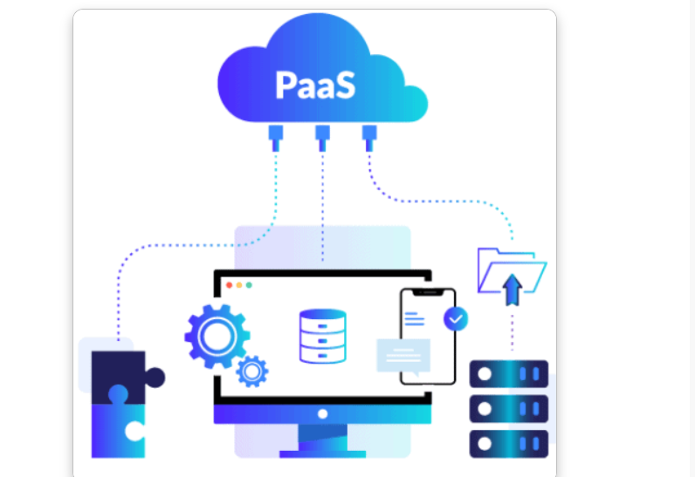
Analogy: Domino's kitchen, oven and ready dough are already set up, so only assembling and baking the pizza on that setup remains — just as the PaaS provider manages infrastructure, operating system and runtime while the customer manages only the application.
Visual Guidance: Icon of ready kitchen setup labelled Platform, chef adding only dough labelled Application Code.
Speaker Notes: "PaaS trades some flexibility for less operational work than IaaS. Interviewers often ask why Elastic Beanstalk beats raw EC2."

Slide 13: SaaS: Ready-To-Use Software
Heading: SaaS Explained
Subheading: Complete Application Delivered
Content:
Software as a Service delivers a finished application; the provider manages every layer beneath it, leaving the customer only account setup and data.
- Abstracts the entire stack below the application
- Provider pushes feature updates automatically, no customer action
- Representative services: Gmail/Google Workspace, Salesforce, Microsoft 365
- Customer effort and control both fall sharply toward SaaS
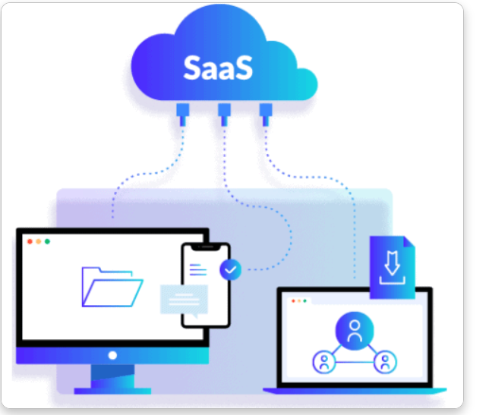
Analogy: A ready-made pizza is ordered directly from Domino's with no kitchen work at all — just as SaaS provider manages the entire stack while the customer only uses the finished application.
Visual Guidance: Icon of a finished pizza box handed over, labelled Application, contrasted with the empty and ready kitchens from the IaaS and PaaS slides.
Speaker Notes: "SaaS trades all control for zero operational burden, completing the IaaS-PaaS-SaaS spectrum. Interviewers often ask to classify Gmail or a CRM tool by service model."

--------------------------------------- SECTION 4: 4. Beyond the Big Three: Function as a Service (FaaS) & serverless; AI/ML-as-a-Service; responsibility boundaries across models ---------------------------------------

Slide 14: Beyond IaaS, PaaS And SaaS
Heading: Beyond The Big Three
Subheading: New Service Models
Content:
Cloud service models did not stop at IaaS, PaaS and SaaS. Two further models push abstraction higher, changing what the provider manages and what the developer retains.
- Function as a Service (FaaS): runs code per trigger, no visible server
- Serverless: broader term covering FaaS plus managed databases and queues
- AI/ML-as-a-Service: consumes pre-built AI and ML models via API
- Both shift most infrastructure responsibility onto the cloud provider
Visual Guidance: Spectrum diagram: IaaS -> PaaS -> SaaS -> FaaS/Serverless -> AI/ML-as-a-Service, arrow showing rising abstraction and shrinking user responsibility.
Speaker Notes: "Position FaaS and AI/ML-as-a-Service as the next step beyond the three classic models, removing the server concept entirely. Interviewers often ask where FaaS sits relative to PaaS on the abstraction ladder."

Slide 15: Function As A Service And Serverless
Heading: FaaS And Serverless
Subheading: Pay Per Execution
Content:
Function as a Service (FaaS) runs a single function only when triggered, removing any need to provision or manage a server.
- Triggers: HTTP request, scheduled timer, queue message, file upload
- Scales automatically from zero to many parallel invocations
- Billed per invocation and execution time, not idle time
- Runs on AWS Lambda; cold start delay if idle first
Analogy: Booking a cab only when travel is needed and paying just for that ride, instead of owning an idle car, mirrors FaaS: code runs only on a trigger and billing counts only execution time.
Visual Guidance: Timeline: idle -> trigger event -> function instantiated -> executes -> torn down, labelled with AWS Lambda.
Speaker Notes: "Emphasise that FaaS removes even the persistent runtime instance PaaS still manages. Interview question: differentiate FaaS from PaaS by billing granularity."

Slide 16: AI/ML-as-a-Service Explained
Heading: AI ML As Service
Subheading: Pre-Built Intelligence APIs
Content:
AI/ML-as-a-Service (Artificial Intelligence, Machine Learning as a Service) exposes pre-trained vision, language and forecasting models through a plain API call.
- Representative services: Amazon Rekognition, Comprehend (pre-built APIs)
- Provider manages model training, GPUs (Graphics Processing Units) and hosting
- User manages input data and API integration only
- Used in vision, chatbots, fraud and forecasting
Analogy: Consulting a specialist doctor for one diagnosis instead of building a hospital, paying only for that consultation — just as AI/ML-as-a-Service delivers intelligence via API without building the model.
Visual Guidance: Icon flow: application -> API call -> pre-trained model service -> prediction returned, labelled Amazon SageMaker / Rekognition.
Speaker Notes: "Distinguish SageMaker, a full ML platform, from Rekognition and Comprehend, narrow pre-built APIs. Interviewers often ask when to call a managed AI service instead of training a custom model."

Slide 17: Responsibility Boundaries Across Service Models
Heading: Full Responsibility Spectrum
Subheading: Provider Vs User
Content:
Moving from IaaS toward SaaS steadily shifts management from user to provider; FaaS and AI/ML-as-a-Service remove the server concept, but the user still manages function code or input data respectively.
Model | Provider Manages | User Manages
IaaS | Hardware, virtualization, network | OS, runtime, applications, data
PaaS | + OS, runtime, middleware | Application code, data
SaaS | Entire application stack | Configuration, user data
FaaS / Serverless | Servers, OS, runtime, scaling | Function code, triggers, logic
AI/ML-as-a-Service | Model training, hosting, GPUs | Input data, API integration
Visual Guidance: Full-width table, one row per model, shading intensity rising left to right to show growing provider responsibility.
Speaker Notes: "Point out this table extends the same responsibility axis used for IaaS, PaaS and SaaS to FaaS and AI/ML-as-a-Service. This full spectrum is a favourite interview format for comparing cloud service models."

--------------------------------------- SECTION 5: 5. Cloud Economics & Providers: CapEx vs OpEx; total cost of ownership (TCO); pricing: on-demand, committed use & spot; AWS, Azure, GCP & Indian providers ---------------------------------------

Slide 18: Cloud Economics Landscape
Heading: Cloud Economics Map
Subheading: Costs And Providers
Content:
Cloud adoption decisions turn on how spending is structured and who supplies the infrastructure.
- CapEx vs OpEx: how spend is classified
- TCO: true multi-year cost of a choice
- Pricing models: on-demand, committed use, spot
- Providers: global hyperscalers and Indian regional players
Visual Guidance: Four-quadrant map, one label per quadrant: CapEx/OpEx, TCO, Pricing Models, Providers.
Speaker Notes: "Set up the four building blocks of cloud economics before going deep into each. Exam and interview questions often ask to classify a cost or pick the right pricing model for a scenario."

Slide 19: CapEx vs OpEx — The Accounting View
Heading: CapEx vs OpEx
Subheading: Balance Sheet Impact
Content:
Cloud does not just change how much is paid; it changes which financial statement absorbs the cost, reshaping approvals and tax treatment.
- CapEx: capitalised, depreciated over asset life, sits on balance sheet
- OpEx: expensed immediately, hits the income statement same period
- CapEx typically needs board-level capital approval
- OpEx approval sits within departmental budgets
- Depreciation deductions (CapEx) shift tax timing versus OpEx's immediate deduction
- AWS Cost and Usage Report classifies spend for finance systems
Analogy: Buying a house needs a large loan and years of EMIs recorded as an asset, while renting is a monthly expense with nothing recorded — just as CapEx locks value on the balance sheet while OpEx flows straight through the income statement.
Visual Guidance: Split panel: balance sheet with a depreciation curve versus income statement with a flat recurring expense line.
Speaker Notes: "Stress that AWS invoices are OpEx by default, which is why finance teams favour the flexibility. Interviewers often ask why cloud shifted budgeting power from capital committees to individual teams."

Slide 20: Total Cost of Ownership Defined
Heading: Total Cost Ownership
Subheading: Beyond The Price Tag
Content:
Total cost of ownership (TCO) totals every direct and indirect cost of running a workload across its life, not only the sticker price.
- Direct costs: compute, storage, licensing, network transfer
- Indirect costs: staffing, training, downtime, migration effort
- On-premise adds power, cooling, floor space, hardware refresh
- AWS Pricing Calculator estimates cloud cost.
- Migration Evaluator builds the on-premise vs cloud business case
Analogy: A smartphone's price tag ignores the data plan, repairs and accessories bought over its life — just as a server's purchase price ignores the staffing, power and downtime that TCO adds back in.
Visual Guidance: Layered bar: sticker price at the base, staffing/power/downtime stacked above it to show true TCO.
Speaker Notes: "Emphasise that TCO, not sticker price, is the number that should justify a migration. TCO comparisons are a favourite whiteboard question when interviewers test cloud cost reasoning."

Slide 21: Pricing Models: On-Demand, Committed & Spot
Heading: Three Pricing Models
Subheading: On-Demand To Spot
Content:
Providers meter usage but let buyers trade commitment for discount; three payment patterns cover most cloud spend.
- On-demand: metered pay-as-used rate, zero commitment
- Committed use: one to three-year term for lower fixed rate
- Spot: spare capacity at a steep discount; can be reclaimed at short notice
- Trade-off across all three: flexibility versus price
Analogy: A general train ticket costs full fare and needs no planning, a season pass costs less for a fixed daily route, and a standby ticket is cheapest but the seat can be given away — just as on-demand, committed use and spot trade flexibility for price.
Visual Guidance: Three tickets side by side, labelled On-Demand, Committed Use, Spot, with a price arrow decreasing left to right.
Speaker Notes: "Frame on-demand as the metered billing model already familiar from pay-per-use pricing. Interviewers ask when to pick spot versus reserved capacity for a given workload."

Slide 22: Comparing Pricing Models
Heading: Pricing Models Compared
Subheading: Discount And Risk
Content:
Each pricing model suits a different workload shape; committed-use discounts deepen with longer terms and more upfront payment.
Model | Commitment | Typical Discount | Key Risk | Best For
On-Demand | None | Baseline rate | Highest unit price; cost runs on if left running | Unpredictable, short-lived workloads
Committed Use | 1 or 3 years | Up to ~70% off on-demand | Upfront lock-in, must forecast usage | Steady, predictable baseline load
Spot | None | Up to ~90% off on-demand | Reclaimed with short notice (~2 min AWS, ~30 sec Azure/GCP) | Fault-tolerant batch, stateless jobs
Visual Guidance: Three-column bar chart showing discount depth against flexibility surrendered for each model.
Speaker Notes: "AWS Reserved Instances and Savings Plans anchor committed use, while EC2 Spot Instances anchor the spot row. A common interview question asks which model fits a CI/CD build farm versus a production database."

Slide 23: Global Cloud Providers Compared
Heading: Global Cloud Providers
Subheading: AWS Azure GCP
Content:
Three hyperscalers dominate global cloud spend, each with a different platform strength that shapes provider choice.
Provider | Parent Company | Notable Strength
AWS | Amazon | Broadest service catalog, largest market share
Azure | Microsoft | Strong enterprise and hybrid integration (Active Directory)
Google Cloud (GCP) | Google | Data analytics, AI/ML tooling strength
Visual Guidance: Three logos in a row, one strength keyword under each.
Speaker Notes: "Keep the comparison at strategic strength rather than a feature-by-feature list. Interviewers often ask which provider suits an AI-heavy startup versus a Windows-heavy enterprise."

Slide 24: Indian Cloud Providers & Data Residency
Heading: Indian Cloud Providers
Subheading: Regional Alternatives
Content:
Alongside global hyperscalers, Indian providers compete on data residency, latency for local users, and rupee-denominated billing.
- CtrlS, Yotta, E2E Networks: private data-centre players
- Government's GI Cloud (MeghRaj) hosts public-sector workloads
- BFSI and government workloads often mandate in-country storage
- Regional providers can undercut hyperscaler pricing for local traffic
Visual Guidance: Map of India with data-centre pins beside the hyperscaler logos for scale comparison.
Speaker Notes: "Note that data-residency and sector regulation, not just price, drive some workloads to Indian providers. This regulatory angle is a common follow-up question after any provider-comparison discussion."

Key Takeaways
1. Cloud Deployment Models: Public cloud; private cloud: on-premise vs hosted; hybrid & cloud bursting; community cloud
2. Multi-Cloud: Motivations: resilience, negotiation & regulation; operational cost of multiple platforms
3. Service Models: IaaS, PaaS & SaaS: what each provides & abstracts; representative services
4. Beyond the Big Three: Function as a Service (FaaS) & serverless; AI/ML-as-a-Service; responsibility boundaries across models
5. Cloud Economics & Providers: CapEx vs OpEx; total cost of ownership (TCO); pricing: on-demand, committed use & spot; AWS, Azure, GCP & Indian providers

Upcoming Session : Virtualization & Hypervisors
Thank You | All the Best

