## **What is Selenium?**

****SELENIUM**** is a free (open-source) automated testing framework used to validate web applications across different browsers and platforms. You can use multiple programming languages like Java, C#, Python etc to create Selenium Test Scripts. Testing done using the Selenium tool is usually referred to as Selenium Testing.

Selenium Software is not just a single tool but a suite of software, each piece catering to different testing needs of an organization. Here is the list of tools

* Selenium Integrated Development Environment (IDE)
* Selenium Remote Control (RC)
* WebDriver
* Selenium Grid

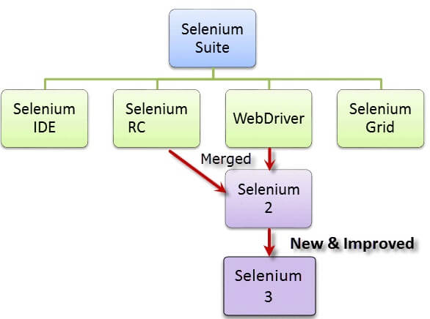

****The Same Origin Policy Issue****

****Same Origin policy prohibits JavaScript code from accessing elements from a domain that is different from where it was launched. Example, the HTML code in www.google.com uses a JavaScript program "randomScript.js". The same origin policy will only allow randomScript.js to access pages within google.com such as google.com/mail, google.com/login, or google.com/signup. However, it cannot access pages from different sites such as yahoo.com/search or guru99.com because they belong to different domains.****

****This is the reason why prior to Selenium RC, testers needed to install local copies of both Selenium Core (a JavaScript program) and the web server containing the web application being tested so they would belong to the same domain****

****Selenium Remote Control (Selenium RC)****

****Unfortunately; testers using Selenium Core had to install the whole application under test and the web server on their own local computers because of the restrictions imposed by the same origin policy. So another ThoughtWork's engineer, Paul Hammant, decided to create a server that will act as an HTTP proxy to "trick" the browser into believing that Selenium Core and the web application being tested come from the same domain. This system became known as the Selenium Remote Control or Selenium 1.****

****Selenium Grid****

****Selenium Grid was developed by Patrick Lightbody to address the need of minimizing test execution times as much as possible. He initially called the system "Hosted QA." It was capable of capturing browser screenshots during significant stages, and also of sending out Selenium commands to different machines simultaneously.****

****Selenium IDE****

****Shinya Kasatani of Japan created Selenium IDE, a Firefox extension that can automate the browser through a record-and-playback feature. He came up with this idea to further increase the speed in creating test cases. He donated Selenium IDE to the Selenium Project in 2006.****

****WebDriver****

****Simon Stewart created WebDriver circa 2006 when browsers and web applications were becoming more powerful and more restrictive with JavaScript programs like Selenium Core. It was the first cross-platform testing framework that could control the browser from the OS level.****

## **How to Choose the Right Selenium Tool for Your Need**

| **Tool** | **Why Choose?** |
| --- | --- |
| ****Selenium IDE**** | * To learn about concepts on automated testing and Selenium, including: * Selenese commands such as type, open, clickAndWait, assert, verify, etc. * Locators such as id, name, xpath, css selector, etc. * Executing customized JavaScript code using runScript * Exporting test cases in various formats. * To create tests with little or no prior knowledge in programming. * To create simple test cases and test suites that you can export later to RC or WebDriver. * To test a web application against Firefox and Chrome only. |
| ****Selenium RC**** | * To design a test using a more expressive language than Selenese * To run your test against different browsers (except HtmlUnit) on different operating systems. * To deploy your tests across multiple environments using Selenium Grid. * To test your application against a new browser that supports JavaScript. * To test web applications with complex AJAX-based scenarios. |
| ****WebDriver**** | * To use a certain programming language in designing your test case. * To test applications that are rich in AJAX-based functionalities. * To execute tests on the HtmlUnit browser. * To create customized test results. |
| ****Selenium Grid**** | * To run your Selenium RC scripts in multiple browsers and operating systems simultaneously. * To run a huge test suite, that needs to complete in the soonest time possible. |

## **A Comparison between Selenium and QTP(now UFT)**

****Quick Test Professional(QTP)****is a proprietary automated testing tool previously owned by the company ****Mercury Interactive**** before it was ****acquired by Hewlett-Packard in 2006****. The Selenium Tool Suite has many advantages over  QTP as detailed below -

Advantages of Selenium over QTP

|  |  |
| --- | --- |
| ****Selenium**** | ****QTP**** |
| ****Open source****, ****free to use****, and ****free of charge.**** | ****Commercial****. |
| ****Highly extensible**** | Limited add-ons |
| Can run tests across ****different browsers**** | Can only run tests in ****Firefox****, ****Internet Explorer**** and ****Chrome**** |
| Supports ****various operating systems**** | Can only be used in ****Windows**** |
| Supports ****mobile devices**** | QTP Supports Mobile app test automation (iOS & Android) using HP solution called - HP Mobile Center |
| Can execute tests ****while****the ****browser is minimized**** | Needs to have the application under test to be visible on the desktop |
| Can execute tests ****in parallel****. | Can only execute in parallel but using Quality Center which is again a paid product. |