**Case study of Test case writing**

Objective :

When i was started working on Falcon project and worked on the task **FAL-66 Create TCs for "Connect Sources page in App Planner"**. I would like to share my experience in test case writing, review mechanics and points observed with the team discussion.

The user story details are

https://blackswantechnologies.atlassian.net/browse/FAL-46

**Story details :** Connect Sources page in App Planner

## **Description**

**Story** I as a user logged in into BST element and being in Application Planner should be able to define sources to my entities  
(see the mockups)  
**Acceptance Criteria**

The screens should be accessible even when the entities are not created yet but the connect now button will be inavailable and greyed out (it will have a tooltip - “create data model first

The mockup:

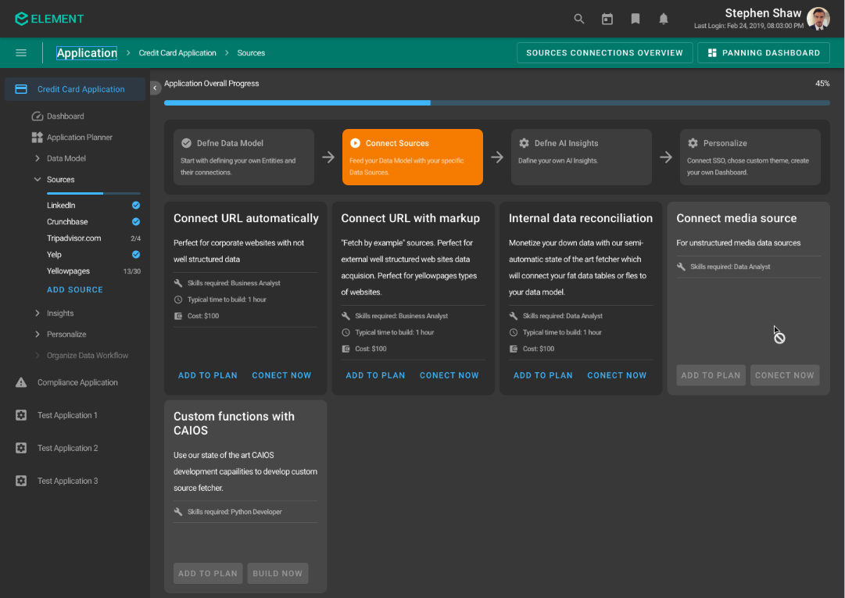

I have gone through the user story , Falcon PRD document and wire frames and started writing the test cases.

Initially I have written the following test cases

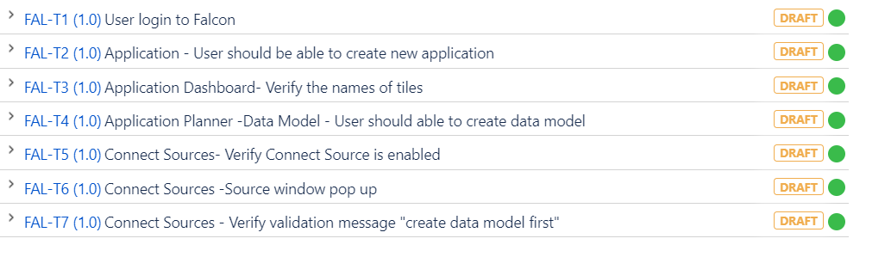

The above is first feature , where I started to write test case on Falcon product and Falcon is altogether new product. I wrote test cases in view of the navigation flow and functionality of the story. And after the review of my test cases by my team, I found the following comments

Lot of test cases are not relevant and needs to delete the following stories.

FAL-T1 User login to Falcon

FAL- T2 Application- User should be able to create new application

FAL-T3 Application Dashboard - verify the names of tiles

FAL-T4 Application Planner - Data model - User should able to create data model

The above test cases are not relevant because they are not part of the user story's.

**Lessons learned:**

1) We had test cases workshop and participated with team and wrote acceptance test cases

1. I understand the folder structure and naming of the window frames. Which is useful in writing the title of the test case
2. I am new to BDD Gherkin langaguge , which I understood very well and implement in writing effective test cases writing .
3. Avoid duplicates of test cases across different story's
4. Provide the answers to each comment on test case it self and once both of them agreed , then only finalize the test case review
5. Include the UI level test cases as part of each story which helps in providing more test coverage
6. The per-requisite steps needs to include in Given statement of test cases appropriately
7. More understand of product functionality helps very well in writing effective test cases and understand the user stores completely.
8. Need more details on the User storys helps in identify more test cases

Conclusion: After study the wire-frames, I need to include the UI elements also as part of test cases and delete the unnecessarily test cases and modify the test cases as per review comments.

Please refer the link for effective testcase writing

<https://blackswantechnologies.atlassian.net/wiki/spaces/QA/pages/1415118942/How+to+write+a+Test+Case>