Software Architecture:

One-Tier, Two-Tier, Three Tier, N Tier
Software Architecture: Software Architecture consists of One Tier, Two Tier, Three Tier and N-Tier architectures.
A “tier” can also be referred to as a “layer”.
Three layers involved in the application namely Presentation Layer, Business Layer and Data Layer. Let’s see each layer in detail:
Presentation Layer: It is also known as Client layer. Top most layer of an application. This is the layer we see when we use a software. By using this layer we can access the webpages. The main functionality of this layer is to communicate with Application layer. This layer passes the information which is given by the user in terms of keyboard actions, mouse clicks to the Application Layer.
For example, login page of Gmail where an end user could see text boxes and buttons to enter user id, password and to click on sign-in.
Please be patient. The video will load in some time.
If you liked this video, then please subscribe to our YouTube Channel for more video tutorials.
Application Layer: It is also known as Business Logic Layer which is also known as logical layer. As per the gmail login page example, once user clicks on the login button, Application layer interacts with Database layer and sends required information to the Presentation layer. It controls an application’s functionality by performing detailed processing. This layer acts as a mediator between the Presentation and the Database layer. Complete business logic will be written in this layer.
In a simple words, it is to perform operations on the application.
Data Layer: The data is stored in this layer. Application layer communicates with Database layer to retrieve the data. It contains methods that connects the database and performs required action e.g.: insert, update, delete etc.
In a simple words, it is to share and retrieve the data.

Types of Software Architecture:

One Tier Architecture:
One Tier application AKA Standalone application
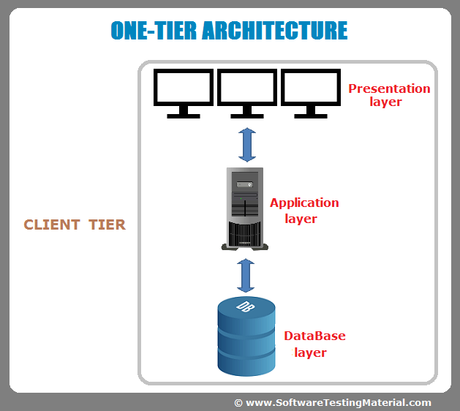
One tier architecture has all the layers such as Presentation, Business, Data Access layers in a single software package. Applications which handles all the three tiers such as MP3 player, MS Office are come under one tier application. The data is stored in the local system or a shared drive.

Two-Tier Architecture:
Two Tier application AKA Client-Server application
The Two-tier architecture is divided into two parts:
1. Client Application (Client Tier)
2. Database (Data Tier)
Client system handles both Presentation and Application layers and Server system handles Database layer. It is also known as client server application. The communication takes place between the Client and the Server. Client system sends the request to the Server system and the Server system processes the request and sends back the data to the Client System

Three-Tier Architecture:
Three Tier application AKA Web Based application

The Three-tier architecture is divided into three parts:
1. Presentation layer (Client Tier)
2. Application layer (Business Tier)
2. Database layer (Data Tier)
Client system handles Presentation layer, Application server handles Application layer and Server system handles Database layer.
Client Server Architecture
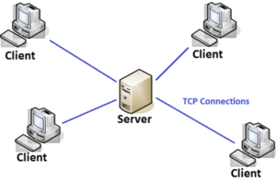
Figure 1. source: Practice
Client-server architecture is an architecture of a computer network in which many clients (remote processors) request and receive service from a centralized server (host computer).
Client computers provide an interface to allow a computer user to request services of the server and to display the results the server returns.
Servers wait for requests to arrive from clients and then respond to them. Ideally, a server provides a standardized transparent interface to clients so that clients need not be aware of the specifics of the system
- e., the hardware and software) that is providing the service. Clients are often situated at workstations or on personal computers, while servers are located elsewhere on the network,
- usually on more powerful machines. This computing model is especially effective when clients and the server each have distinct tasks that they routinely perform.

- In hospital data processing, for example, a client computer can be running an application program for entering patient information while the server computer is running another program that manages the database in which the information is permanently stored. Many clients can access the server’s information simultaneously, and, at the same time, a client computer can perform other tasks, such as sending e-mail. Because both client and server computers are considered intelligent devices, the client-server model is completely different from the old “mainframe” model, in which a centralized mainframe computer performed all the tasks for its associated “dumb” terminals.

