**PROJECT TITLE : REHABILITATION SYSTEM**

NAME: SIMON OKAKA WAIRIMU

REG NO: N11\3\1364\020

LAIKIPIA UNIVERSITY

**Declaration.**

I, Simon Okaka wairimu, hereby declare that the project document titled rehabilitation system is my original work and has been prepared in accordance with the guidelines and requirements provided. Any contributions from external sources have been properly cited and acknowledged.

I further declare that:

The content of this document is the result of my own independent work, except where otherwise stated.

All sources used for research and information have been appropriately referenced.

The document does not contain any material that has been submitted for another academic purpose or assessment.

All data and information presented in this document are accurate and have been collected and analysed following ethical research standards.

The opinions, findings, and conclusions expressed in this document are those of the author and do not necessarily reflect the views of [Your Organization].

I understand that any act of plagiarism or academic misconduct may result in severe consequences, including but not limited to academic penalties and the revocation of any degrees or certifications conferred.

Date:

Signature: ___________________________

SIMON OKAKA WAIRIMU,

Student,

Laikipia university

**Dedication**

I dedicate this project to the inspiring educators at Laikipia University, whose passion for learning has ignited my own curiosity and shaped my academic journey. Your dedication to fostering knowledge and critical thinking has been a guiding light throughout this project.

To my classmates and friends, thank you for the camaraderie, collaboration, and shared moments of both challenge and triumph. Your support has made the educational experience truly enriching.

This project is also dedicated to the tireless efforts of the administrative staff and all those behind the scenes who contribute to creating a conducive learning environment at Laikipia University.

May this project stand as a testament to the collective spirit of inquiry and learning that defines our school community.

Simon okaka wairimu

**Acknowledgment**

I would like to express my sincere gratitude to the following individuals and organizations whose contributions and support have been instrumental in the completion of this project:

[Supervisor's Name]: Thank you for your guidance, feedback, and unwavering support throughout the entire duration of this project. Your expertise and mentorship have been invaluable.

[LAIKIPIA UNIVERSITY]: I am grateful to Laikipia University for providing the necessary resources, facilities, and access to information essential for the successful execution of this project.

Family and Friends: My heartfelt thanks to my family for their patience, encouragement, and understanding during the demanding phases of this project. To my friends, thank you for being a constant source of support and motivation.

Participants or Respondents: I extend my appreciation to the participants or respondents who generously shared their time and insights, making a significant contribution to the research.

I am truly grateful for the collaborative efforts of everyone involved, and I recognize the collective impact of their contributions on the successful completion of this project.

Simon okaka wairimu.

**Abstract**

The rapid evolution of [Technology/Field/Area] has prompted an in-depth investigation into its impact on [Specific Aspect or Problem]. This project endeavors to explore and analyze the [phenomenon/issue] through a comprehensive examination of [Key Elements or Variables]. The study employs [Research Methodology/Approach] to gather and interpret data, shedding light on the intricate dynamics involved.

The objectives of this project are twofold: firstly, to assess the current state of [Technology/Field/Area] and its implications on [Specific Aspect]; secondly, to propose viable recommendations for [Potential Solutions or Improvements]. Through a combination of literature review, empirical analysis, and case studies, this project aims to contribute valuable insights to the ongoing discourse in the field.

Key findings highlight [Major Discoveries or Trends], providing a nuanced understanding of the challenges and opportunities inherent in [Technology/Field/Area]. The results underscore the need for [Policy Changes/Strategic Interventions] to address [Key Issues] and capitalize on emerging prospects.

In conclusion, this project not only advances our understanding of [Technology/Field/Area] but also offers practical recommendations for stakeholders seeking to navigate the complexities of [Specific Aspect or Problem]. The implications of this research extend beyond the academic realm, impacting [Relevant Industry/Community] and paving the way for future exploration in this dynamic and evolving landscape.

Table of content

1. Introduction

1.1 Background

1.2 Problem Statement

1.3 Aim of the Study

1.3.1 General Objectives

1.3.2 Specific Objectives

1.4 Justification of the Study

1.5 Scope of the Study

1.6 Limitations of the Study

2. Literature Review

2.1 Introduction

2.2 Case Studies (Discuss at least 4 and include screenshots of each)

2.2.1 Case 1 – Application 1

2.2.2 Case 2 – Application 2

2.2.3 Case 3 – Application 3

2.2.4 Case 4 – Application

4 2.3 Comparison of Features of Reviewed Cases Feature

3. Methodology

3.1 Introduction

3.2 System Development Methodology

3.2.1 Stage

1 3.2.2 Stage

2 3.2.3 Stage

3.3 Requirements Gathering Process (Data Collection)

3.3.1 Target Users (Population)

3.3.2 Requirements Collection Tools (Data Collection Tools)

3.3.3 Analysis and Results of requirement collection

# 1.Introduction

In today's dynamic digital landscape, the demand for innovative web applications continues to surge as businesses and users alike seek seamless, efficient, and user-friendly solutions. This project, titled "Rehabilitation system" is a response to this evolving need, aiming to deliver a cutting-edge web application that helps people with diversity of problems.

## 1.1 Background

Development of this web application is to enhance a great choice of stations that offers great service and helps the need with all means.

An application that entitles user to gain a sense of belonging and value .

Lastly the application reduces place to place search of schools offering rehabilitation services.

Due to development of technologies and evolvement of new digital strategies triggered a part of this project to help the needy.

The increasing reliance on [relevant technologies] and the growing expectations of users have created an opportune moment to develop a robust web application that can help people regain a cognitive abilities. In recognizing these trends, our team embarked on the journey to create Rehabilitation system.

1.2 Problem statement.

The ever-increasing reliance on outdated existing system within community has created inefficiencies and limitations that hinder the optimal functioning of rehabilitation progresses. This poses a significant challenge as communities tries to reach out for help, ultimately impeding effectiveness.

1.3 Aim of Study

The primary aim of this web application project, titled "Rehabilitation system," is to reach individuals who are unable to get center for their problems. Through the development and implementation of this web application, we aspire to accomplish the following key objectives:

### 1.3.1General objectives:

The first objective focuses on reduction of paper work . This objective is designed to reduce the fact that people travel around with papers to look for centers.

Another objective is that it make the search of rehabilitation center o be easy since things are done online

### 1.3.2Specific goal:

The main objective is to to create a system that brings the user near and to be apple to find rehabilitation centers with specific services they are looking for. By achieving this objective, we aim to have people helped to attain their goals.

1.4 Justification of the Study

The development of rehabilitation system is grounded in a compelling set of justifications that underscore the project's relevance and significance within community. The following factors substantiate the necessity and importance of this study:

1.4.1Addressing community Challenges

Community currently faces substantial challenges related to specific problems . These challenges, if unaddressed, can result in negative consequences such as inefficiencies, customer dissatisfaction, etc.. The implementation rehabilitation system aims to alleviate these challenges by working the problems down within the community.

1.4.2Advancements in Technology

The rapid evolution of technology, particularly in web applications, presents an opportunity to revolutionize specific practices. Rehabilitation system leverages these technological advancements to to bring new solutions, ensuring it remains at the forefront of industry standards.

1.4.3 Meeting User Expectations

With the increasing sophistication of digital experiences, users have come to expect specific features in web applications. Rehabilitation system is designed to meet and exceed these expectations, providing an intuitive and seamless user experience that fosters user satisfaction, engagement, etc..

1.4.4Potential Impact on Community

The successful implementation of Rehabilitation system has the potential to make a substantial impact on community. This impact includes peoples growth, mental health and cognitive mentalities that contribute to the overall growth and well-being of community.

1.5 Scope of the Study

The scope of the study for Rehabilitation system is defined by the following key aspects and limitations:

1.5.1 Inclusions

1.5.2 Functional Scope

The project will encompass the development of Rehabilitation system, including the following key functionalities:

[Feature 1]: provide user with the appropriate rehabilitation centers

[Feature 2]: Allows users to interact with the rehabilitations online

[Feature 3]: users can get help from their place online without having to join physical class and routines

1.5.3 User Types

The web application is designed to cater to the following user types:

End Users: the primary users of this web are those who are suffering and needs a rehabilitation section to find good centers offering their required problematic solution

Administrators: are those stations looking for people with needs mostly with their health and provide them with knowledge and great help.

1.5.4Supported Platforms

Rehabilitation system will be developed to run on the following platforms:

Web browsers: chrome, Microsoft edge

5 Exclusions

5.2.1 Advanced Features

The project will not include the development of functionalities that are outside the current project scope.

Integration with External Systems

Integration with specific external systems is beyond the scope of this project.

Hardware Requirements

The study will not cover specific hardware requirements for the deployment of Rehabilitation system.

1.6 Limitations of study

The project is subject to the following limitations:

Timeframe: The development and deployment will be completed within specified timeframe.

Budget: The project will adhere to the allocated budget constraints.

Technological Constraints: The development will utilize specified technologies, and deviations from this may impact project feasibility.

2.literature review

.1 Introduction

The literature review for Rehabilitation system explores key themes and concepts within the realm of specific focus area, e.g., web application development, user experience, etc.. By examining existing research and industry practices, we gain valuable insights that inform the design, development, and implementation of the proposed web application.

2.2 Case Studies

To gain a deeper understanding of effective web application design and functionality, we conducted an in-depth analysis of four case studies. These case studies highlight best practices, innovative solutions, and lessons learned from existing web applications.

2.2.1 Case Study 1: [upwork]

Overview: it’s a web application that connects and links employers with employees to have certain tasks done.it have the posted jobs where the employees requests tasks from the employers

Challenges faced by user

Inaccessible design elements may exclude users with disabilities, limiting the overall user base.

Compliance with Accessibility Standards: Design the web app in accordance with accessibility standards (e.g., WCAG)

Screenshots: Screenshot 1: 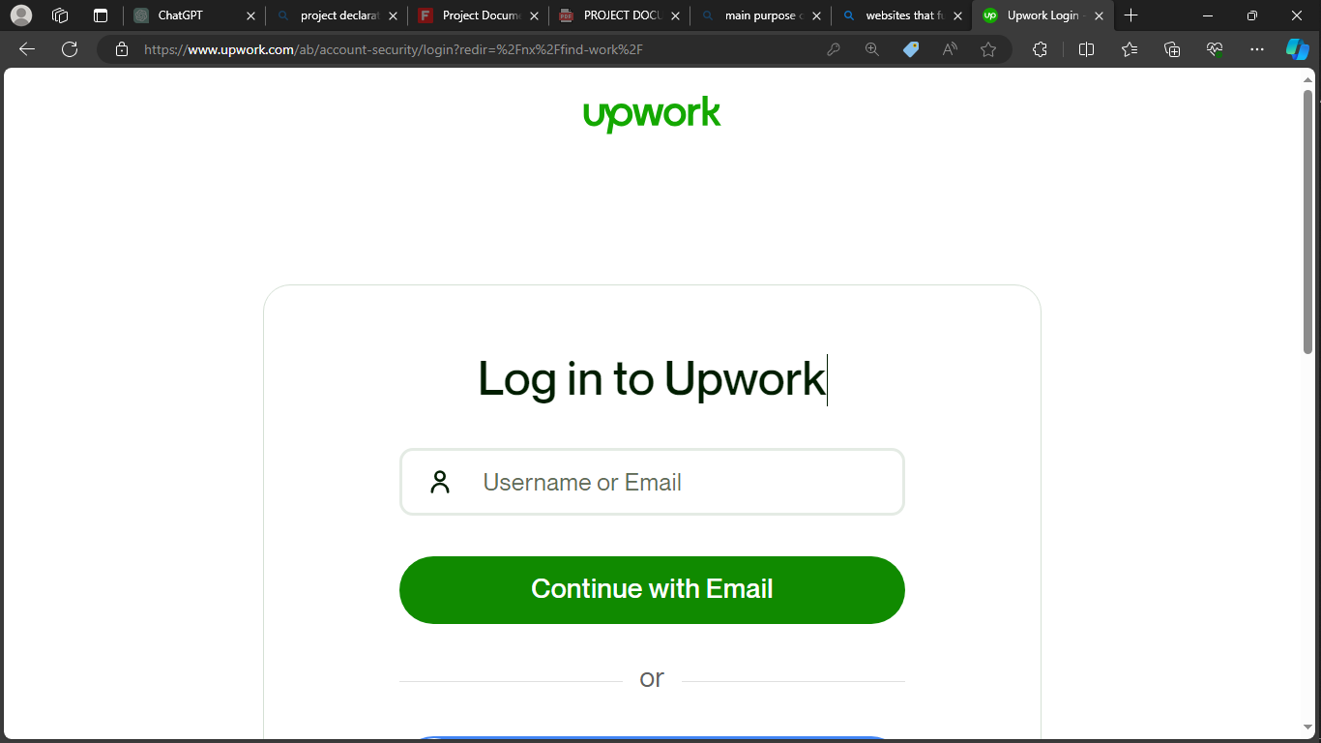

Is the login part where the user provides the login details. Some user prefers using username and others prefers using email as their login necessity

Screenshot 2: 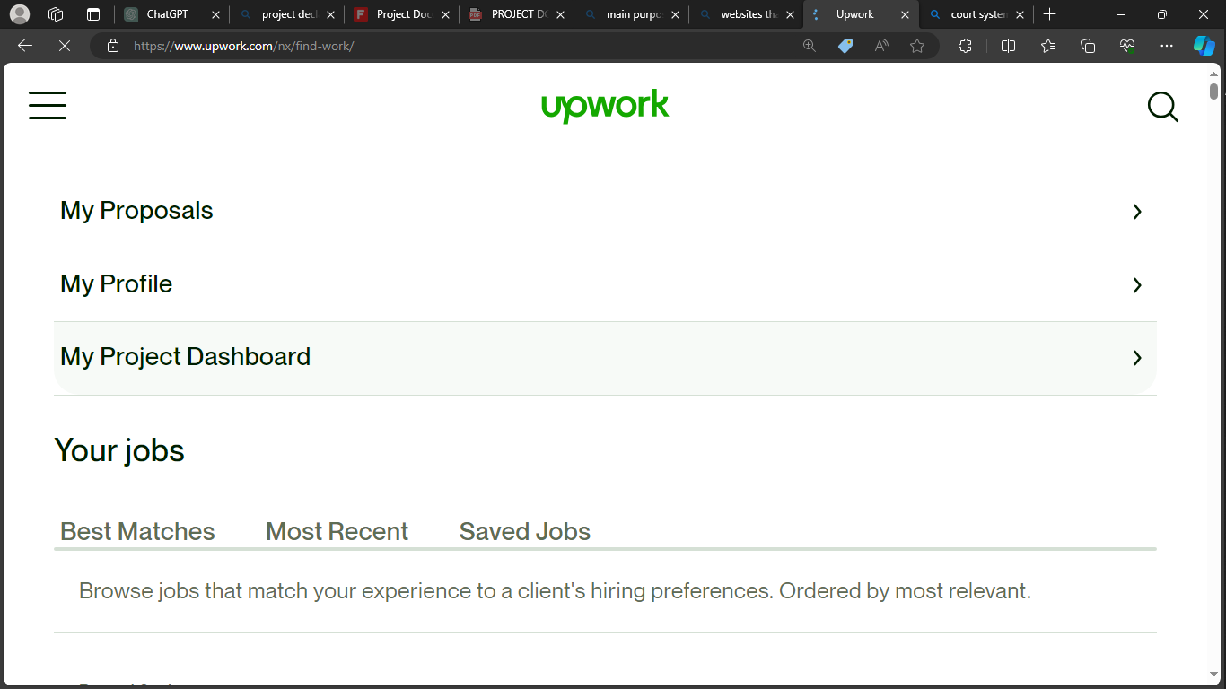

The web provides the dashboard after user have login in successfully.This dashboard has the users profile and jobs provided and posted by different employers.

2.2.2 Case Study 2 world health organization (WHO)

Overview:it’s a world wide web application that keeps people alert and aware of their health.

Uses features such as rehabilitation to work and help along.

Screenshots: Screenshot 1: [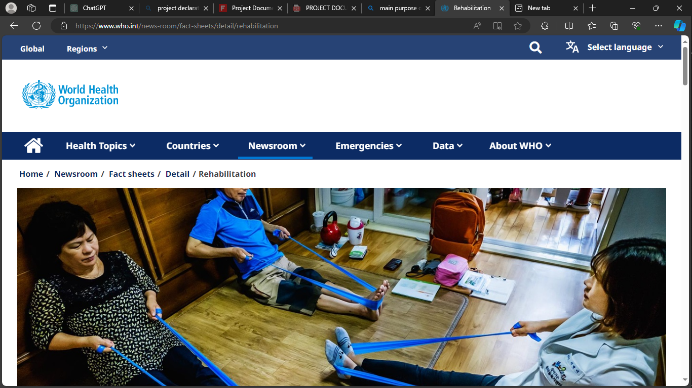

Screenshot 2: 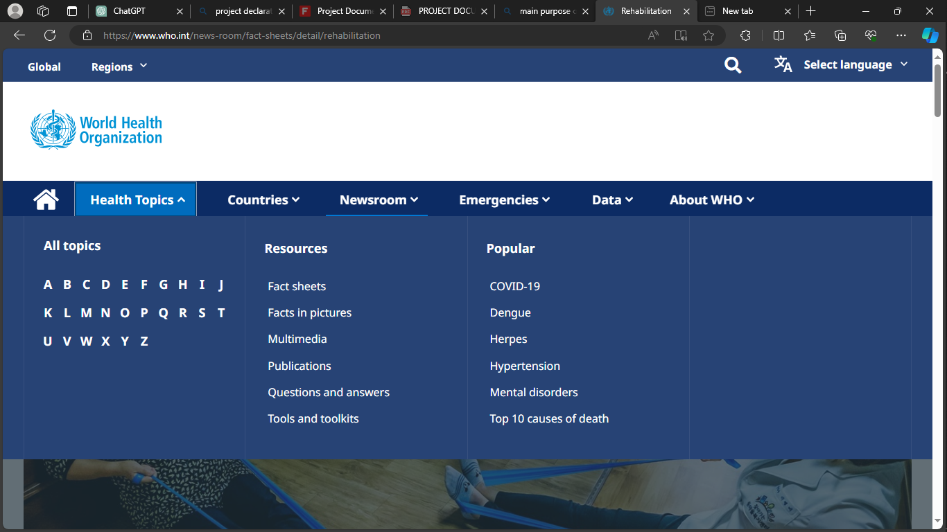

Show the user what they want to know about their health, sub topics and raising issues in the world,especially worldwide.

2.2.3 Case Study 3: toloka yandex

Overview: [it’s a web application that deals with artificial intelligence jobs and tasks that people get paid for after access the tasks.it leads to income and connects to different personnel’s to help each other.

Key Findings:they uses a responsive layout that Ensure the web app is responsive, adapting seamlessly to various screen sizes and devices for a consistent user experience.

Challenges faced:

Users may be hesitant to use the web app if they perceive security risks or if sensitive information is not adequately protected,solution to this is by:

Regular Security Audits: Conduct regular security audits to identify and address vulnerabilities.

User Education: Educate users on security measures and reassure them about data protection.

Screenshots: Screenshot 1: 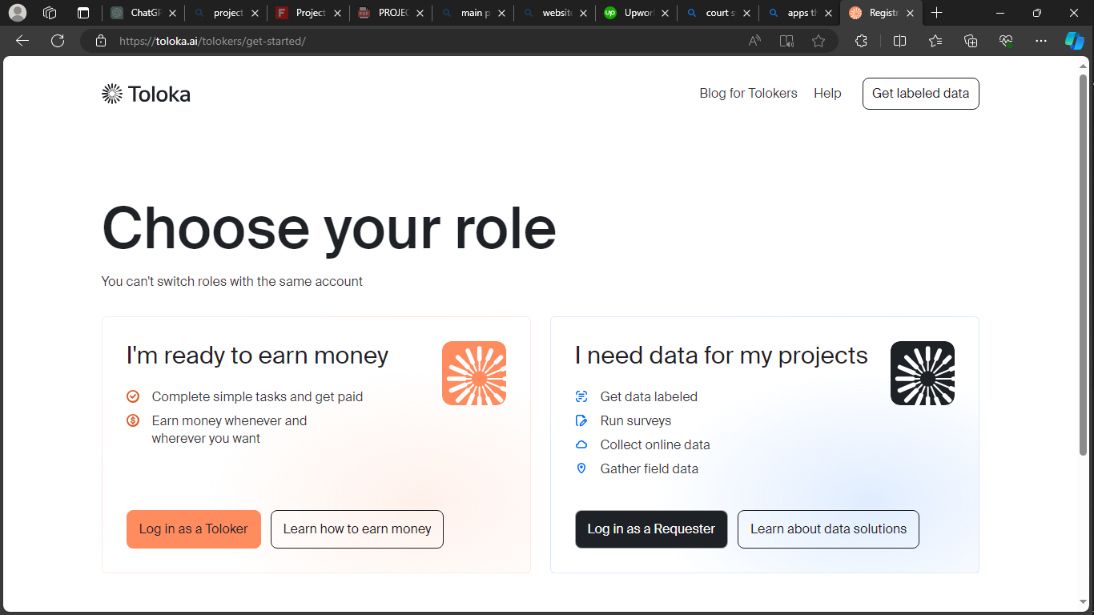

It’s the landing page that user visit first in h web it got to parts of login that is login as a toloka or as an employer.this part tells the user what they are need to do.

Screenshot 2: 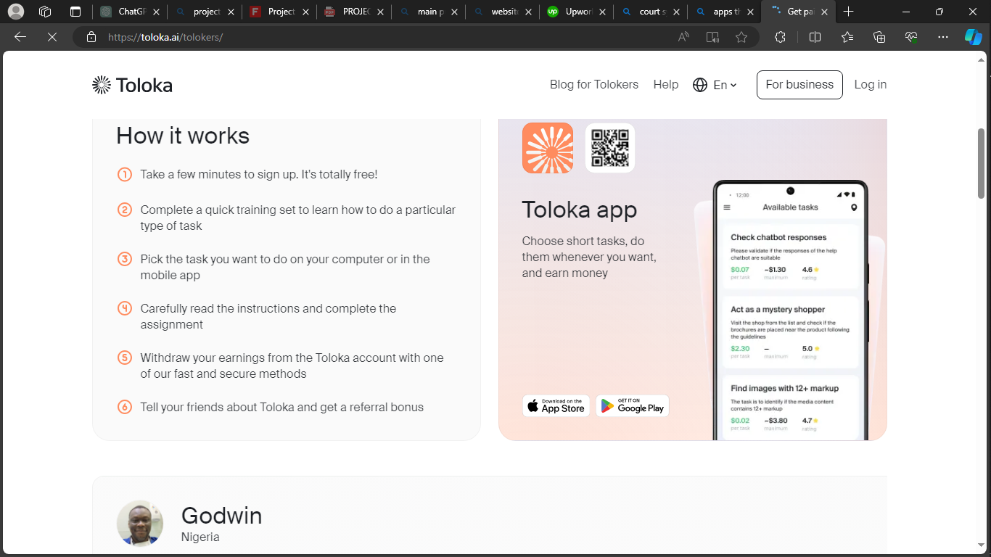

In this screenshot it guides the user how it is done ,ad what is expected of them.

2.2.4 Case Study 4: betterhelp

Overview: Betterhelp application is used to help user find help more of therapist

Challenge faced:

Users may struggle to understand how to use certain features or navigate the web app if instructions are unclear or absent.

Solved by implement onboarding tutorials to guide users through key features.

Screenshots: Screenshot 1: 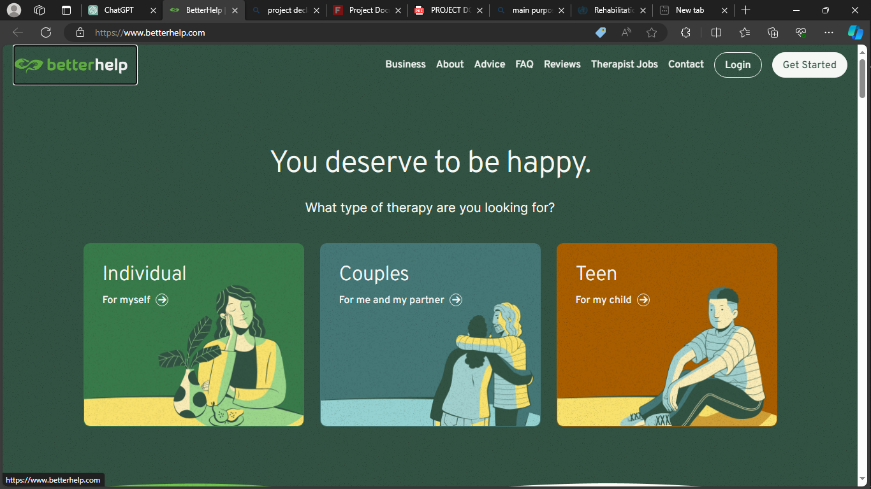Screenshot 2: 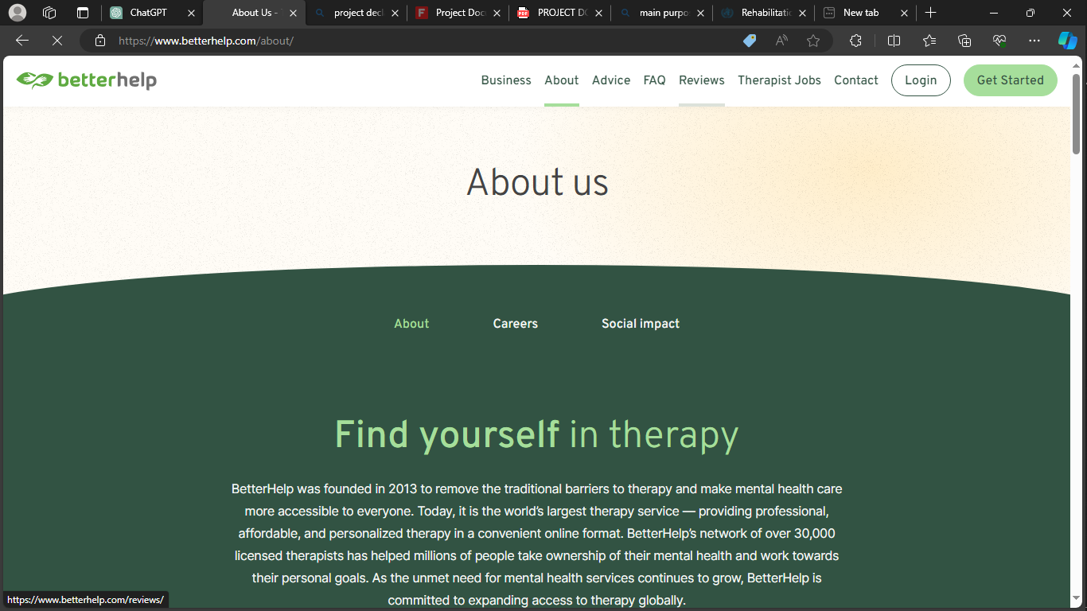

The insights gained from these case studies will inform the design and functionality of rehabilitation system, ensuring the incorporation of successful strategies and innovative solutions.

Comparison of features.

|  |  |  |  |  |  |
| --- | --- | --- | --- | --- | --- |
| Features | Case1 | Case2 | Case3 | Case4 | soution |
| i | ✔ | ✔ | ✔ | ✔ | ✔ |
| Ii | ✔ | ❌ | ✔ | ❌ | ✔ |
| Iii | ❌ | ✔ | ❌ | ✔ | ✔ |
| Iv | ✔ | ✔ | ✔ | ❌ | ✔ |
| v | ❌ | ✔ | ✔ | ✔ | ❌ |

Legend:

✔: Feature is present.

❌: Feature is not present.

3. Methodology

3.1 Introduction

The methodology section delineates the systematic approach employed for the development of a comprehensive rehabilitation system. This includes stages in the system development methodology and the meticulous process of requirements gathering to ensure the system caters to the needs of its users.

3.2 System Development Methodology

The system development methodology is designed to facilitate the creation and implementation of the rehabilitation system in a structured manner. The methodology comprises several key stages, each contributing to the overall success of the project.

3.2.1 Stage 1: Needs Assessment and Planning

During this initial stage, an in-depth needs assessment is conducted to identify the requirements and goals of the rehabilitation system. Stakeholder consultations are held, and a detailed project plan is formulated, outlining project scope, objectives, timelines, and resource allocation.

3.2.2 Stage 2: Prototyping and Design

In the prototyping and design stage, wireframes and prototypes are developed to visualize the user interface and functionalities of the rehabilitation system. User feedback is solicited, and design iterations are made to ensure alignment with user expectations.

3.2.3 Stage 3: Development and Implementation

The actual development of the rehabilitation system takes place in this stage. The system is coded, and features are implemented based on the design specifications. Iterative testing is conducted to identify and address any issues promptly.

3.2.4 Stage 4: Testing and Evaluation

Comprehensive testing is performed to validate the functionality and reliability of the rehabilitation system. This includes unit testing, integration testing, and system testing. User acceptance testing is also carried out to ensure the system meets user requirements.

3.3 Requirements Gathering Process (Data Collection)

Effectively understanding user needs and expectations is pivotal for the success of the rehabilitation system. The requirements gathering process involves targeted data collection strategies.

3.3.1 Target Users (Population)

The primary users of the rehabilitation system include healthcare professionals, therapists, and patients undergoing rehabilitation. These users are integral to the system's success, and their diverse needs are considered during development.

3.3.2 Requirements Collection Tools (Data Collection Tools)

A combination of tools is employed for requirements collection, including:

Stakeholder Interviews: In-depth interviews with healthcare professionals and therapists.

User Surveys: Surveys distributed to patients to gather their preferences and expectations.

Observation Sessions: Direct observation of rehabilitation sessions to understand the workflow and pain points.

3.3.3 Analysis and Results of Requirements Collection

The collected data is meticulously analyzed to derive key insights and requirements for the rehabilitation system. The analysis includes categorizing user needs, prioritizing features, and addressing any conflicting requirements. The results of the requirements collection process form the foundation for subsequent stages of system development.