Circular are flexible hinge stiffness character analysis
Chunhui Yang Shimin Luo
China
2010 Intemational Conference on System,Engineering Drdign and Manufacturing Informatization

Abstract
Flexible hinges are widely used in micro robotic. Its tigidity directly influences an organization’s terminal localization. Its actual structure geometry size cannot satisfy the theoretical analysis completely in a theoretical supposition condition. In this paper. We analayzed the rotation rigidity of a ellliptical flexible hinge in different parameters using finite element software ANSYS. The errors are discovered and compared with theoretical result. Though the graph of the flexible hinge parameters on the performance of a elliptical flexible hinge was carried out. The key manufacture parameters that affect the performance of an elliptical flexible hinge the most and rules of design are given, which can provide directions of design precision for the flexible hinge.
Keywords-flexible hinge; elllipse; finite element analysisl;rigidity

Ⅰ.INTRODUCTION
Flexible hinge have some characteristics, such as small volume, without tubs, ceaseless, good rigidity and high sensitivity. With micocomputer electrical system series (MEMS) technical rapidly expanding, flexible hinge are widely applied in the displacement which requests small angular and high-precision rotation, such as gyroscopes,accelerometers, percision instruments and so on. It has broad application prospects in the micron level domain.
The common flexible hinge is in two kinds:beam-shape flexible hinge and arc-shaped flexible hinge. The beam-shaped flexible hinge has a big slewing area, but the movement precision is bad. The arc-shaped flexible hinge’s movement percision is bad. The arc-shaped flexible hinge is relatively small. In order to take into account the movement ptecision and scope, the following several rotation flexible hinges have been generated: parabolic flexure hinge, an elliptical flexure hinge and a hyperbola-shaped hinge, etc. The properties of flexible hinges are rigidity precision and stress characteristic etc. the rigidity performance reflects the stress ability and also manifests movement to a vice-flexible degree. In 1965, Parosetal announced his design development of the circular flexible hinge for the first time, and gave the rigidity formula.Smithetal used the similar method to obtain an elliptic flexible hinge mechanics expression. Nicolae Lodonitu inferred the parabola and the hyperbolic flexible hinge’s rigidity formula. Wei Xu and Tim king analyzed the tectangular and elllipse flexible hinge’s rigidity and rotarion precision using the finite element method.
In this paper the elliptical flexible hinge stiffness to different geometrical parameters is analyzed with software ANSYs10.0. Compared with ressults of theoretical analysis and finite element analysis(FEA), the errors are analyzed. Theough the graph of the flexible hinge parameters and its performanve, an analysis of changes of parameters on the performance of the elliptical fexible hinge was carried out. The key manufacture parameters that affect the performances of an elliptical flexible hinge the most and rules of design are given, which can guve direcrions of design precision for the flexible hinge.

Ⅱ.RIGIDITY FORMULA OF THE ELLIPTICAL FLEXIBLE HINGE
An elliptical flexible hing,as shown in Figure 1, is a particular type of flexure that consists of a neckde down section. Parameters t,h,b are flexible hinge’s smallest thickness,height and width ,resoectively, Parameter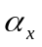 is the semimajor axis of ellipse, and 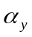 is the semimajor axis of elllipse.
As shown in Figure 1(a), the infinitesimal is intercepted in the abscissa axis. To begin, the infinitesimal section is vertical to the abscissa axis. The flexible hinge’s angular deformation 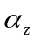 is generated under torque 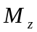 as given in Equation(1).
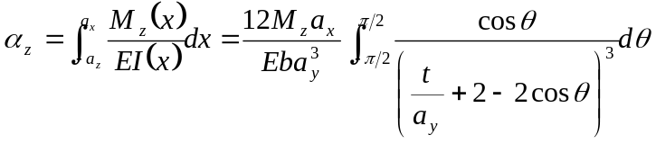（1）
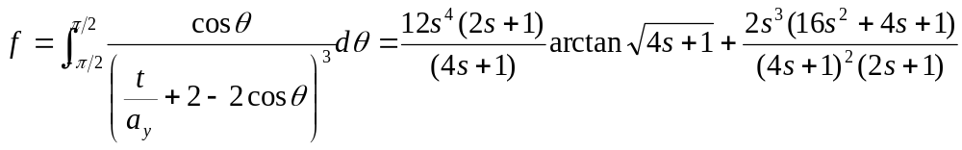（2）
Where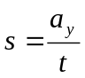
The rotation rigidity fotmula is given by Euation(3)
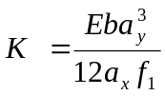(3)
When 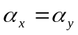, the flexible hinge is the circular flexible hinge. Its rotantion rigidity formula is given by Equatuin(4)
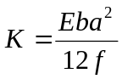 (4)
The rorarion rigidity formula of circular flexible hinge is consistent with the reference[2].
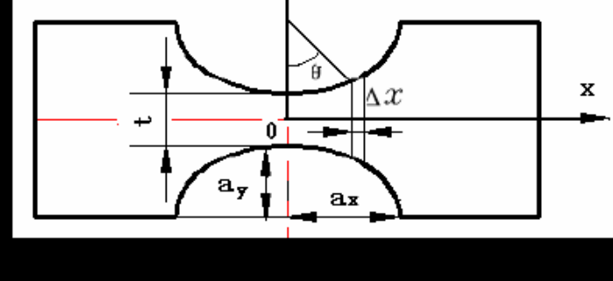
(a)
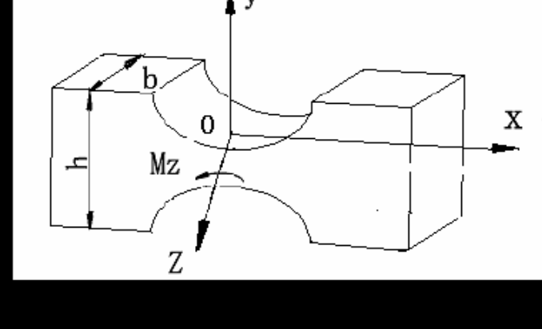
(b)
Figure 1 Model of elliptical flexible hinge

Ansys has some characteristics that the general finite element analysis technologt, powerful computing, and reliable result. The elliptical flexible hinge’s basic srtuture size is . The materical is bertllium copper alloy, 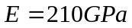,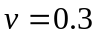. The FEA model is shown in Figure2(a). The model left end surface is restrained completely, the right end surface exerts bending moment 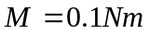. The special node 1 of the grid model right end surface represents the output displacement. The unit type chooses 3_D the entity SOLID92 unit model, the entire model usrs Smartsize to free mesh. The deformation of the FEA model is shown in Figure 2(b). The FEA model and the output displacement have been obtained with changing elliptical flexible hinge’s paramters E,b,t and as well as
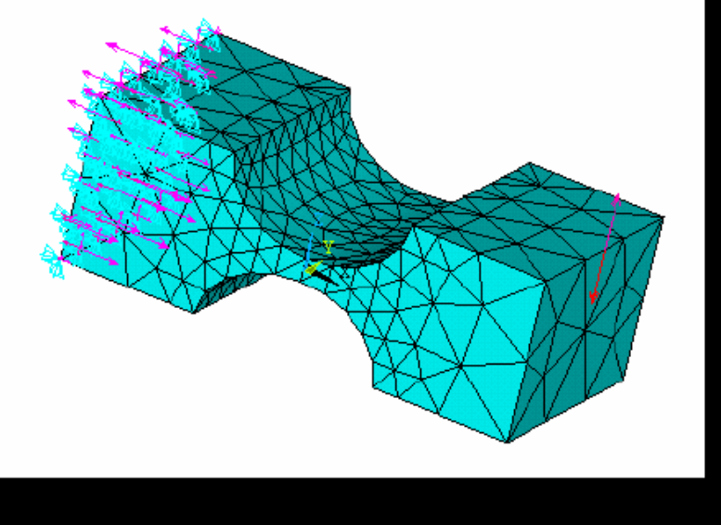
(a)
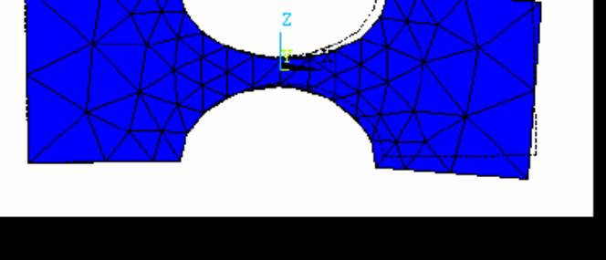
(b)
Figure 2 . FEA model of elliptical flexure hinge
The theoretical calculation and FEA rotational stiffness are obtaoned through changing elliptical flexure hinge’s parameters E,b,t and as well as , as shown in Figure 3 to 7.
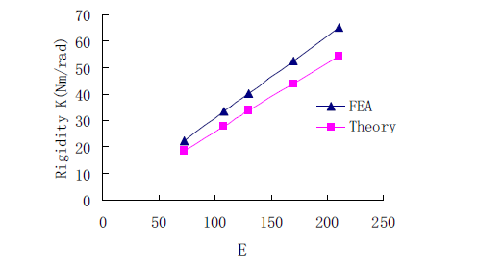
Figure 3. Comparison of FEA value and the theoretical value of flexure hinge with changing E
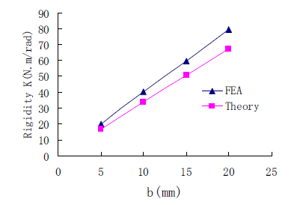
Figure 3. Comparison of FEA value and the theoretical value of flexure hinge with changing width b
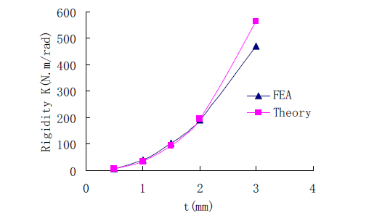
Figure 5. Comparison of FEA value and the theoretical value of flexure hinge with chinging thickness t
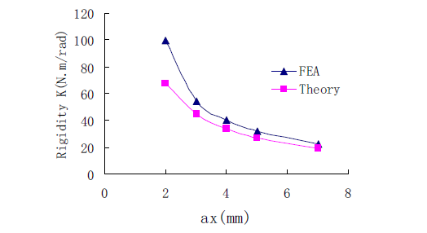
Figure 6. Comparison of FEA value and the theoretical value of flexure hinge with chinging semimajor axis
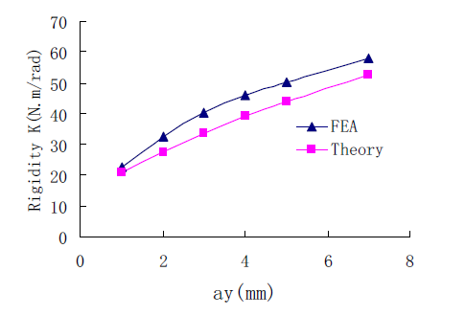
Figure 7. Comparison of FEA value and the theoretical value of flexure hinge with chinging semimajor axis
From Equation (3) and Figures 3 to 7 the following conclusions can be observed.
From Figures 3and 4 it can be observed that the rotation stiffness is a linearly increasing realtion with material young’s modulus E and width b. The FEA value is bigger than the theoretical value. When E and b are smallerm the FEA value and the theoretical value are closer .
From Figure 5 it can observed that the rotantion of the stiffness FEA value and the theoretical value is a vurve increasing with thickness t, end the speed-up is getting quicker and quicker. When t is bigger, the difference of the theoretical value and the FEA value is bigger. When t<2mm, the FEA value and the theorerical value are close.
From Figure 6 it can observed that the rotantion of rotation rigidity and semimajor axis is a decreasing curve, and the rate of reduced scope is gradually decreased. When >3mm, the FEA value and the theoretical value are closer.
From Figure 7 it can observed that the rotantion of rotation ridity and semiminor axis is a linearly increasing, but the increasing scope is small. The FEA value is bigger than the theoretical value.
From Figure 3 to 7 it can observed that the influence of flexure hinge’s parameter to its rotation stiffness is:the influence of thickness t is biggest, followed by semimajor axis , semimajor axis width b and E.
The theoretical value and the FEA value of an elliptical flexible hinge rotation rigidity is not equal, even if has a big differential value. The reasons are:
The flexible hinge theoretical model that is eastablished using materials mechanics’ bending strain theory is built on the basis of certain assumptions.
From Figure 2(b) it can be observed that the FEA model not only has the displancement in the y axis direction, but also has the displacement change on the z axis direcrion, when the torque 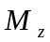 exerted on the z axis for the model. In other words, the flexible hinge not only has the bending strain,but also will have the shearing force to cause upward deformation. Under certain design parameters, the flexible hinge’s theory and FEA solution achieve a good match.
Ⅳ.CONCLUSIONS
The different design parameters to the flexible hinge rotation rigidity influence and the linear relationship are obtained by comparing the rotation rigidity theory solution stiffness is:the influence of thickness is biggest,followed by semimajor axis R,width b and E. The teasons that the theoretical value and the FEA value of an elliptical fexible hinge not only has the bending strain,but also will have the shearing force to cause upward deformation. It is helpful to further analyze the movement of the mechanical deformation mechanism, using the finite element technology to simulate the flexible hinge performance.

摘 要
柔性铰链是目前被广泛用于微动机器人的主要部件之一，其刚度性能直接影响微动机器人的终端定位。 由于实际需要的多样性和复杂性，使得其实际结构的几何尺寸不能完全满足传统理论分析的假设条件，因此影响到对其性能的准确分析。利用有限元软件ANSYS对双边圆弧形柔性铰链和单边圆弧形柔性铰链在不同结构参数下的转动刚度进行分析，并与其解析计算结果进行了比较，分析了其间产生误差的原因。为MEMS中柔性铰链的设计与应用提供一定的依据。

关键词: 双边圆弧形柔性铰链 单边圆弧形柔性铰链 有限元分析 刚度

Ⅰ引言
随着微机电系统（MEMS）技术的迅速发展，柔性铰链因具有体积小、无机械摩擦、无间隙、刚性好和高灵敏度的特点，柔性铰链被广泛地应用于各种要求小角位移、高精度转动的场合，如陀螺仪、加速度计、精密天平等仪器仪表。柔性铰链在微米级领域内有着广阔的应用前景。
常见的柔性铰链有两种：直梁形柔性铰链和圆弧形柔性铰链。直梁形柔性铰链有较大的转动范围，但运动精度较差；而圆弧形柔性铰链的运动精度较高，但转动范围相对小。为了兼顾运动精度和运动范围，又衍生出下面几种转动柔性铰链：抛物线形柔性铰链、椭圆形柔性铰链、双曲线形柔性铰链等。柔性铰链的基本性能主要包括刚度、精度及应力特性等几方面，其中刚度性能直接反映了柔性铰链抵抗外载的能力，也体现了运动副的柔性程度，是主要的研究因素。1965年，Paros 等人首次公布其设计开发的圆形柔性铰链，并给出了刚度计算公式。
本文应用有限元软件ANSYS10.0 对双边圆弧形柔性铰链和单边圆弧形柔性铰链在不同结构参数下的转动刚度进行分析，并与其解析计算结果进行了比较， 分析了其间产生误差的原因。通过建立的双边、单边圆弧形柔性铰链参数与其刚度性能关系图，分析了圆弧形柔性铰链各参数变化对其刚度性能的影响；通过分析比较双边、单边圆弧形铰链的刚度特性，结果显示单边圆弧形柔性铰链具有更大的转动能力，但其对轴向载荷的影响更为敏感，设计的单边圆弧形柔性铰链更适用于结构紧凑、需要大位移应用场合。给出了对柔性铰链影响最大的关键加工参数，为圆弧形铰链的选择和工程设计提供了理论依据。

Ⅱ圆弧形柔性铰链刚度计算公式
双边圆弧形柔性铰链的主视图如图1（a）所示，其横截面为矩形。立体图如图1（b）所示。t、h、b 分别为圆弧型柔性铰的最小厚度、高度和宽度，R 为圆弧的圆半径，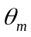为圆弧的圆心角。如图1（a）所示，在横轴上截取微元，在受力作用前微元截面垂直于横轴。微元高度为a，长度为 ，宽度等于圆弧的最小宽度b，在力矩Mz 的作用下柔性铰链的角变形为
（1）
（2）
式中：
圆弧型铰链的转动刚度计算公式为：
（3）
当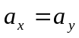（4）
（a）
(b)
图1 双边圆弧型柔性铰链模型

Ⅲ圆弧型柔性铰链的有限元模型
ANSYS 是一种大型通用的有限元分析技术，计算功能强大，计算结果可靠的软件。圆弧型柔性铰链的基本结构尺寸为：；材料选用铍铜合金，其杨氏模量，泊松比，材料特性为各向同性。双边圆弧形柔性铰链有限元模型如图2（a）所示，对该模型左端面进行全约束，网格模型右端面的自由端为载荷的施加位置，施加弯矩；网格模型右端面的特殊节点1 为节点位移代表输出位移；单元类型选择3-D 实体SOLID92 单元模型，对整个模型使用Smartsize进行自由网格划分。单边圆弧形柔性铰链的有限元模型如图2（b）所示。通过分别改变圆弧型柔性铰链的结构尺寸参数b、t、以及R，得到各类结构参数改变的有限元模型。
（a）
（b）
图2 有限元模型
刚度性能分析改变圆弧形柔性铰链的结构尺寸参数b、t、以及R，分别计算出在不同结构参数下圆弧型柔性铰链的理论计算转动刚度和有限元分析结果转动刚度，如图3 ~7所示。
图3 改变材料的杨氏模量E的圆弧型柔性铰链转动刚度有限元值与理论值比较
图4 改变宽度b的柔性铰链转动刚度有限元值与理论值比较
图5 改变厚度t的圆弧型柔性铰链转动刚度有限元值与理论值比较
图6 改变圆弧半径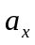的圆弧型柔性铰链转动刚度有限元值与理论值比较
图7改变圆弧半径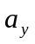的圆弧型柔性铰链转动刚度有限元值与理论值比较
由式（3）、（4）和图3-7分析得：
(1) 由图3、4 可见，转动刚度与杨氏模量E、宽度b 呈线性递增关系，且理论值比有限元值大，杨氏模量E 和宽度b 越小，有限元值与理论值越接近。
(2) 由图5 可知，转动刚度的有限元值和理论值都与厚度t 呈曲线递增关系，且增速越来越快。当t 越大，有限元值与理论值相差越大；当t＜ 2mm，有限元值与理论值越接近。
(3）由图6-7 可知，转动刚度的有限元和理论值都与半径R 呈曲线递减关系，减幅较小；转动刚度的有限元值与理论值接近。
(4）分析图3 - 7可知，双边圆弧形铰链的刚度比单边圆弧形铰链的刚度大。
分析图3-7可得圆弧型柔性铰链各设计参数对其转动刚度的影响程度依次为：厚度t 影响最大，其次为圆弧半径R，再次为圆心角，最后为杨氏模量E、宽度b。圆弧型柔性铰链的转动刚度理论值与有限元值不相等，甚至有较大差值的可能原因是：
（1）利用材料力学的梁弯曲理论建立的柔性铰链理论模型，是建立在一定假设条件基础之上。
（2）从有限元模型图3可见，当给模型自由端施加Z 轴的转矩MZ 时，有限元模型不仅在Y 轴方向产生位移，同时在Z 轴上也有位移变化。也就是说，柔性铰链不仅只发生弯曲变形，同时有剪力将引起柔性铰链截面曲翘变形。在一定的结构参数下，柔性铰链的理论解与有限元分析吻合的很好。

Ⅳ 结论
通过分析比较双边、单边圆弧形柔性铰链的转动刚度理论解与有限元分析，得出不同结构参数对柔性铰链转动刚度的影响程度及线性关系。其中圆弧型柔性铰链各设计参数对其转动刚度的影响程度依次为：厚度t 影响最大，其次为圆弧半径R，，最后为杨氏模量E、宽度b。并阐述了圆弧型柔性铰链的转动刚度理论值与有限元值不相等的主要原因是：柔性铰链不仅只发生弯曲变形，同时有剪力将引起柔性铰链截面曲翘变形。通过分析比较双边、单边圆弧形铰链的刚度特性，结果显示单边圆弧形柔性铰链具有更大的转动能力，但其对轴向载荷的影响更为敏感，设计的单边圆弧形柔性铰链更适用于结构紧凑、需要大位移应用场合。为圆弧形铰链的选择和工程设计提供了理论依据。

