# 附录：

# 外文资料与中文翻译

**Micro-feed Mechanism with High-Resolution and Large-Stroke  
Based on Friction Drive**

Haitao Liu∗, Zesheng Lu

School of Mechantronics Engineering, Harbin Institute of Technology  
**ABSTRACT**

Based on friction driving principle, design a long stroke length and high resolution walking micro-feeding device driven by piezoelectric ceramic elements and combined with the screw shaft and aerostatic guide way. The design was made to the adjustable preload device by flexible four-bar linkage. The static properties of flexible linkage device are analyzed with FEM. The transmission characteristics of micro-feeding device are exhaustively analyzed.

**Keywords:** Friction drive, Piezoelectric actuator, Flexure hinge,Finite element

**1. INTRODUCTION**

Aspheric optics has been widely used in industries such as aviation, aerospace, national defense and so on. However, the manufacture of large aspheric optics faces many problems such as great difficulty, low efficiency, high cost, increased requirement on process equipment etc [1, 2] . In order to arrive at high precision, the micro displacement resolution of ultra-precision machine must be further advanced, so as to compensating the processing error online. Therefore, the design of micro-feed mechanism has become one of the key technologies [3-7] . PZT is the new micro-feed mechanism developed in recent years. It has the advantages such as small volume, large power, high resolution, and high frequency response and so on and phenomena such as no heating, no backlash and mucosity, so it’s widely used micro controller in micro-feed mechanism. Nowadays, friction gearing mechanism is gradually been acquired and used [8, 9].

**2. STRUCTURE AND OPERATING PRINCIPLE OF MICRO-FEED MECHANISM**

The micro-feed mechanism is made up of three parts: friction gearing, ball screw and static-pressure air-bearing guide way. Micro-feed mechanism uses the piezoelectricity ceramic friction gearing block, which twist up the sleeve and drive the ball screw, so as to bring along the air-bearing guide way to realize the micro-feed movement. The structure is shown as Figure 1.

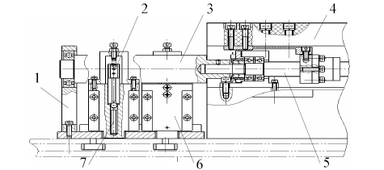

1-Bearing bracket 2-Friction gearing block 3 Friction gearing sleeve 4-Static-pressure air-bearing

guide way 5- Ball screw 6- Piezoelectricity ceramic base 7-Piezoelectricity ceramic used for feeding Figure 1: (a) Structure of the feed mechanism

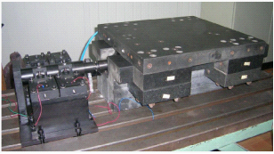As shown in Figure 2, the operating principle of the feed mechanism is that, friction gearing sleeve connects with ball screw, four friction gearing blocks are placed symmetrically at both sides of the sleeve. Each block is droved by the corresponding piezoelectricity ceramic used for feeding and is gripped by the corresponding gripping mechanism, which is droved by the piezoelectricity ceramic used for gripping to produce clamp force. When feeding mechanism works, the piezoelectricity ceramic used for gripping on the same side drive both the friction gearing blocks to work in certain orderliness, so as that the friction gearing sleeve turn continuously.

Figure 1: (b) Picture of the feed mechanism

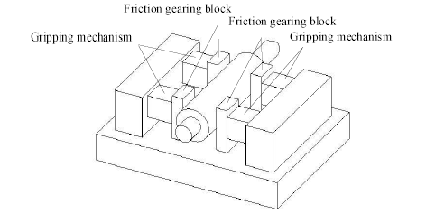

Figure 2: Operating principle of the feeding mechanism

**3. DESIGN OF THE ADJUSTABLE PRETIGHTENING MECHANISM**

An adjustable retightening mechanism is required in the friction gearing mechanism, which must has enough pretightening force. The typical pretightening methods are plate spring pretightening mechanism, helical pretightening mechanism, and air pressure pretightening mechanism and so on. The retightening mechanism designed in this paper is flexible parallel four bars mechanism. It’s droved by piezoelectricity ceramic to supply pretightening force. The pretightening force can be changed by controlling the input voltage of piezoelectricity ceramic.

As shown in Figure 3, use the finite element software to analysis the static characteristic. When the drive force of piezoelectricity ceramic is 500N in maximum, the rigidity of flexible four bars mechanism, analyzed by finite element software, is K=24. 1 5N/µm, and the maximum stress of flexible hinges is σ=32.7Mpa. If there is no distortion in flexible four bars mechanism (that is when the friction gearing blocks contact rigidly), the output force of piezoelectricity ceramic will completely translates to pretightening force through the flexible four bars mechanism.

**4. DRIVE CHARACTERISTIC ANALYSIS OF THE MECHANISM**

Studying and mastering the drive characteristic of mechanism redounds to adopting the proper measures to improve the whole performance and provides the design basis for designing the control system.

**4.1 Drive torque**

When system starts, there is a problem on initial inertia moment as a result of the existence of parts quality. To research the drive torque, choose the friction gearing sleeve as subject investigated. According to the theory that the kinetic energy of gearing train is same before and after conversion, the rotary inertia of each part is transformed to friction sleeve. Because of that, we can get the rotary inertia after conversion is

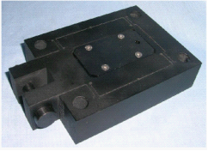

(a) Structure of the pretightening mechanism

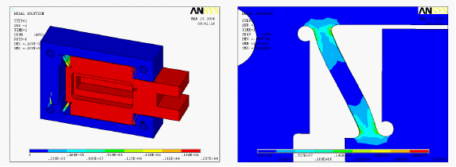

(b) Node motion nephogram (c) Von-mise stress envelope

Figure 3: The static characteristic assay plan of pretightening mechanism

C:\DOCUME~1\ADMINI~1\LOCALS~1\Temp\ksohtml\wps_clip_image-24104.png

Where *p* is pitch of lead screw, m;

*r* is radius of the friction sleeve, m;

mSis quality of the ball screw, kg;

Tis quality of the friction sleeve, kg.

Through the above analysis, we get the equivalent rotary inertia of friction sleeve. Now we choose the friction sleeve as subject investigated to discuss the drive torque （ drive force） that is needed when device starts and it’s influencing factors. The following equation works when device starts:

C:\DOCUME~1\ADMINI~1\LOCALS~1\Temp\ksohtml\wps_clip_image-23157.png

Where *J'* is equivalent rotary inertia, kg·m2;

*α* is angular acceleration of friction sleeve, rad/s2;

*r* is radius of the friction sleeve, m;

*M* is drive torque, N·m;

*F* is drive force （breakout friction between friction block and friction sleeve） , N.

When system starts, a condign drive deflecting couple should be applied on the friction sleeve, in order that the sleeve can have certain angular acceleration. The drive deflecting couple is generated by the output force of piezoelectricity ceramic. From equation 2 we can get that the equivalent rotary inertia of system, radius of the friction sleeve and drive force of the piezoelectricity ceramic (breakout friction between friction block and friction sleeve) are the influencing factor of mechanism start, so we should think over the influence of each factor to ensure the normal start of mechanism. Same questions exist when feed mechanism stop moving.

**4.2 Driving rigidity**

The driving rigidity is one of the important driving characteristics of feed mechanism. Now we will analyze the driving rigidity of feed mechanism in detail as following.

The rigidity of the feed mechanism is the cascade connection of the each segment rigidity of the feed mechanism, which has the calculated equation as follows:

C:\DOCUME~1\ADMINI~1\LOCALS~1\Temp\ksohtml\wps_clip_image-19377.png

Where *K* is the total rigidity of the feed mechanism;

*K*Fis the touching rigidity of surface in contact between friction block and friction sleeve;

*K*Sis the axial rigidity of lead screw;

*K*S' is the axial rigidity changed from the torsional rigidity of lead screw;

*K*Nis the rigidity of nut;

*K*Bis the rigidity of axial bearing;

*K*His rigidity of nut bracket and bearing block;

*K*Dis the axial rigidity of nut link block;

Here is the analysis and calculation of part rigidity.

**4.2.1 Rigidity of the piezoelectricity ceramic**

The piezoelectricity ceramic in this paper is the ceramic micro positioner typed WTYD0808055 produced by China Electronics Technology Group Corporation No.26 Research Institute. It’s rigidity measured through experiment is 15.1 5N/µm, as shown in Figure 4.

**4.2.2 Touching rigidity of surface in contact between friction block and friction sleeve**

Two objects contacting with each other will have certain tangential transition before relative slip in the action of tangential external force, which is called pre-displacement. The proportional relation between force and displacement reflects a rigidity characteristic in fact [10]. The corresponding rigidity now is:

C:\DOCUME~1\ADMINI~1\LOCALS~1\Temp\ksohtml\wps_clip_image-1155.png

Where *k* is const;

N is normal pressure;

r is the radius of idealized sphere on friction surface.

It’s clear in the equation that, in special friction gearing system, k is got from experiment, r is const, the only influencing factor of touching rigidity is normal pressure N. It’s evident that the larger N is, the larger the touching rigidity K is.

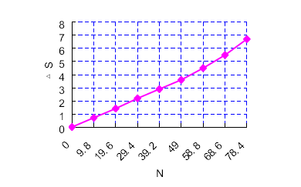

Figure 4: Rigidity curve of piezoelectricity ceramic

**4.2.3 Axial rigidity changed from the torsional rigidity of lead screw**

The dimension of driving chain needs to be transformed uniformly when calculating it’s rigidity. Therefore, the torsional rigidity must be transformed into axial rigidity as the following equation:

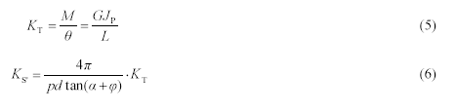

Where *a* is the rising angle of lead screw, (°);

*d* is the diameter of lead screw, mm;

*F* is the axial force of lead screw, N;

*M* is the input moment of lead screw, N·mm;

*q* is the friction angle between lead screw and nut, (°);

*K*Tis the torsional rigidity of lead screw, N·mm/rad;

*0* is the torsional deformation of lead screw, rad;

*p* is the lead of lead screw, mm;

*G* is the shear modulus of elasticity of lead screw material, Mpa;

*J*Pis the inertia moment of cross section, mm4, *J*P=π*d*4/32;

*L* is the maximum distance from loading point to two thrust bearing, mm.

The axial rigidity of nut link block can be gained by the finite element analysis. The rigidity of nut bracket and bearing

block is very large, which can be dismissed. The rigidity of other parts can be got by looking up table and calculating.

In a word, by deducing the equation of drive rigidity of feed mechanism, we have found the influencing factors of

driving rigidity caused by each driving segment, which offers the basis for further study on the driving characteristic.

**5. EXPERIMENTAL STUDY OF THE FEED MECHANISM 5.1 Foundation of the experiment system**

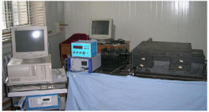As shown in Figure 5, the experiment system is made up of feed mechanism, computer, piezoelectricity ceramic driver and its power supply and the inductance amesdial.

Figure 5: Foundation of experiment system

This paper uses a control method based on average curve model to set up the open loop control model. Above all, measure the experimental curve of relation between piezoelectricity ceramic control voltage and slide carriage distance. Using the Matlab software to fit the line with cubic algebraic multinomial, and the fitted line and fitted error line are as shown in Figure 6, from which we get the corresponding relational expression of control voltage and distance and therefore control the distance of feed mechanism.

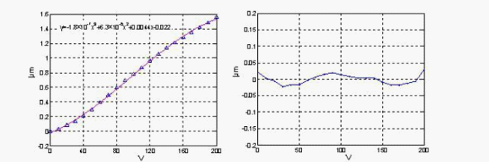 a) Fitted line b) Fitted error line

Figure 6: Fit with cubic algebraic multinomial

Relational expression of control voltage and distance is as shown in equation 7:

C:\DOCUME~1\ADMINI~1\LOCALS~1\Temp\ksohtml\wps_clip_image-10412.png

Where *x* is the output distance, µm;

*u* is the control voltage, V.

**5.2 Experimental study of system resolution**

As shown in Figure 7, piezoelectricity ceramic has certain elongation. At this time, the distance of micro working table is 0.1 5µm. Then step elongating gradually on this base and keep 1.5s in each moment. The sampling time is 100ms. The resolution curve can be gained by measuring the practice distance of micro feed mechanism using the inductance amesdial.

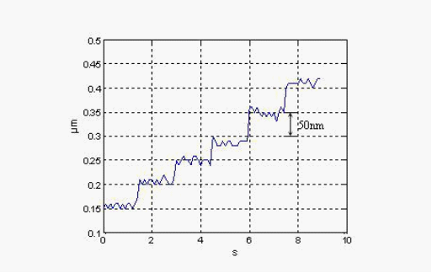

Figure 7: Distance resolution curve of feed mechanism

**6. CONCLUSION**

A step micro feed mechanism with long march and high resolution was designed in this paper, and the following conclusions were concluded:

1. Designed the pretightening mechanism based on the piezoelectricity ceramic flexible iron hinges and analyzed its static characteristic using the finite element software;

2. Analyzed the starting torque of micro feed mechanism and calculated the equivalent rotary inertia; analyzed the driving rigidity characteristic of micro feed mechanism and found its influencing factors;

3. The march of the micro feed mechanism can reach 300mm, and the resolution is less than 0.05µm.

**REFERENCES**

1. Seugng-Bok Choi, Sang-Soo Han. Position Control System Using ER Clutch and Piezoactuator. *Pro. of SPIE,* 2003, 5056: 424~431

2. Suzuki H, Kodera S, Mabkawa S, et al. Study on Precision Grinding of Micro a Spherical Surface. *JSPE,* 1998, 64(4):61 9~623.

1. Arrasmith S. R, Kozhinova I A, Gregg L L et al. Details of The polishing Spot in Magnetorheological Finishing(MRF).*Proceedings* *of SPIE-the International Society for Optical Engineering,*

2001 ,Vol.3782:92~100.

2. Atherton P D, Xu Y, McConnell M. New X-Y Stage for Precision Positioning and Scanning. *SPIE,* 1996, 2865:1 5~20.

3. Liu Yung -Tien, Toshiro Higuchi, Fung Rong-Fong. A Novel Precision Positioning Table Utilizing Impact Force of Spring-Mounted Piezoelectric Actuator. *Precision Engineering,* 2003, 27:14221

4. Lobontiu N, Goldfarb M, Garcia E. A Piezoelectric Drive Inchworm Locomotion Device. *Mechanism and Machine Theory,* 2001, 36: 425~443.

5. A. A. Elmustafa, Max G. Lagally. Flexural-hinge Guided Motion Nanopositioner Stage for Precision Machining: Finite Element Simulations. *Precision Engineering,* 2001, 25: 77~8 1

6. Jaehwa Jeong, Young-Man Choi, Jun-Hee Lee. Design and Control of Dual Servo Actuator for Near Field Optical Recording System. *Pro. of SPIE,* 2005, 6048: 1~8

7. Kim Jeong-Du, Nam Soo-Ryong. Development of a Micro-depth Control System for an Ultra-precision Lathe Using a Piezoelectric Actuator. *International Journal of Machine Tools and Manufacture.* Volume:37,Issue:4, April, 1997, pp.495~509

8. Li Sheng-yi, Luo Bing, Dai Yi-fan, Peng Li. Design and Experiment of The Ultra Precision Twist-roller Friction Drive. *ICAMT’99.* 1999.

**基于摩擦传动的高分辨率和大冲程的微量进给机械系统**

哈尔滨工业大学机电工程学院刘海涛，卢泽生

# 摘 要

在摩擦传动原理的基础上,设计了一种通过压电陶瓷结合螺杆轴和气体静压引导的方式驱动的长冲程和高分辨率的微量进给系统。设计用来使加载装置可以灵活的起落。利用有限元方法对柔性连接装置对它的静态特性进行分析。对这种微量进给系统的传输特性进行了详细的分析。

**关键词**： 摩擦传动 压电传动装置 柔性铰链 有限元

# 1.简介

光学在航空、航天、国防等领域中已得到广泛应用的行业。然而,生产的大型光学镜面面临着巨大的困难,效率较低、成本较高、增加在工艺设备的要求等。为了获得更高的精度，高微位移分辨率超-先进精密机床有待进一步深入,以补偿加工误差。因此,微量进给机制的设计已成为其关键技术之一。压电陶瓷是一种近年来发展起来的新型的微量进给机制。它所拥有的优势,比如体积小、功率大、分辨率高和高频率响应,恒温,不反弹，无粘性。因此它广泛使用在微量进给机制。如今,摩擦传动机制逐步被获得和使用。

# 2．微量进给机制的结构和工作原理

微量进给机制是由三个部分组成:摩擦传动装置、滚珠螺杆及静态压力空气轴承引导的方式。采用压电陶瓷微量进给机制阻滞,这些摩擦传动扭曲向上套筒和驱动器

滚珠丝杠,从而带动空气轴承引导地实现了微量进给运动。 结构如图1所示。

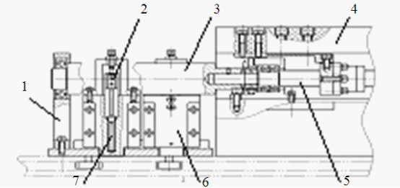

1， 轴承支架，2.活塞，3、活塞缸，4.精压力空气轴承导轨，5.滚珠丝杠，6. 压电陶瓷底座，7.压电陶瓷底座

图一：进给机构的结构

按照图2所示的进给系统工作原理是,套筒连接着球摩擦传动螺杆、四个模块是放置的两侧对称的轴套。每一块由相应的压电陶瓷用于驱动,这种机制由于是由压电陶瓷驱动，适用于夹持产生夹力。进给机制的运作,压电陶瓷适用于夹持在同一阵营的摩擦传动驱动都工作在特定块整齐,从而使摩擦传动套筒连续的传动。

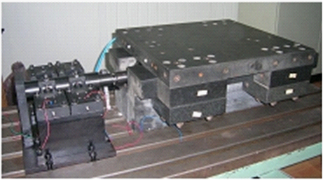

图1:(b)进给系统图片

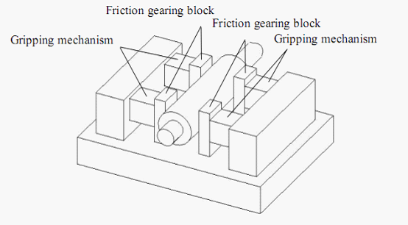

图2:进料机构的运行原理

# 3．结合设计的可调机制

拧紧调节机制是一个需要在摩擦传动机构，它必须有足够的 预紧力。典型的方法是钢板弹簧预紧预紧机制，螺旋预紧 机制，气压预紧机制等。该拧紧机制本文设计的 灵活的平行四杆机构。这是由压电陶瓷droved供应预紧力。该 预紧力可以改变控制的压电陶瓷输入电压。 如图3所示，利用有限元软件分析的静态特性。当驱动力的 压电陶瓷是在最大500N的，灵活安排四杆机构刚度，有限元分析 软件，是K =24.15N/μm，以及最大应力弹性铰链是= 32.7Mpa。如果没有灵活失真 四杆机构（即当摩擦传动板块跟硬性），输出力的压电 陶瓷将完全转化为预紧通过灵活的四杆机构的力量。

# 4．驱动特性分析的机制

学习和掌握辐射源驱动特性的机制以便采取适当的措施，以改善整体性能，并提供了设计控制系统设计的基础。

## 4.1驱动力矩

当系统启动时，有一个初步的转动惯量作为零件的质量存在问题的结果。为了研究驱动力矩，选择摩擦传动套筒为主体的影响。根据该理论认为，动力学传动装置的能量是一样的火车前和转换后，各部分的转动惯量，转化为摩擦套。正因为如此，我们可以得到转换后的转动惯量。

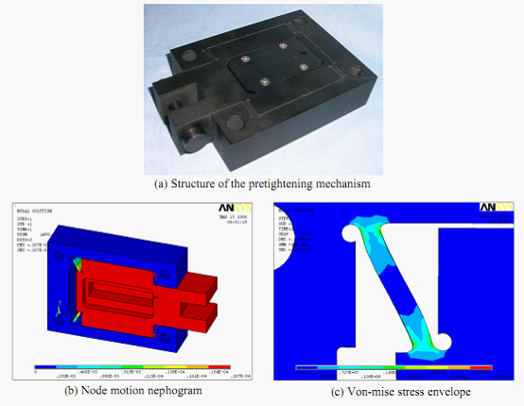

图三:计划的静态特性分析结合的机制

C:\DOCUME~1\ADMINI~1\LOCALS~1\Temp\ksohtml\wps_clip_image-7203.png

P:导程，m

R：套筒半径，m

Ms：滚珠螺杆质量，kg

Mt：套筒质量，kg

通过以上分析,我们得到的等效转动惯量的摩擦的袖子。现在我们选择摩擦的袖子一样对象来讨论这个驱动力矩(动力),是需要装置时开始及其影响因素。下列方程装置时开始工作：

C:\DOCUME~1\ADMINI~1\LOCALS~1\Temp\ksohtml\wps_clip_image-7850.png

J：等效转动惯量，kg。m2

R：摩擦套筒半径，m

C:\DOCUME~1\ADMINI~1\LOCALS~1\Temp\ksohtml\wps_clip_image-1968.png：套筒摩擦角加速度，rad/s2

M：驱动力矩，n。m

F：驱动力（摩擦片与套筒之间的摩擦力），n

当系统启动时，一个适宜的驱动器偏转组应该被应用于摩擦套，以使该套可以有一定的角加速度。该驱动器偏转组所产生的压电输出力陶瓷。由式2我们可以得到的等效转动惯量的系统，半径套的摩擦和驱动器对压电陶瓷（爆发摩擦块之间的摩擦和摩擦套），是影响力机制启动的因素，所以我们应该考虑各因素，以确保机制正常启动。

## 4.2驱动刚性

刚性的驱动是其中的重要驱动进给机构的特征之一。现在我们将分析驾驶进给机构的刚度详细的证明。不灵活的进给机构的级联连接刚度的饲料的每一个片段的机制,这种机制有计算公式如下:

C:\DOCUME~1\ADMINI~1\LOCALS~1\Temp\ksohtml\wps_clip_image-28025.png

K：进刀机构总体硬度

Ky：压电陶瓷刚度

Kf：接触刚度之间的接触摩擦表面的摩擦刚性块体和压电陶瓷套筒

Ks：导螺杆轴向刚度

Ks'：从轴向刚度改变导螺杆的扭转刚度

Kn：螺母刚度

Kb：轴向载荷

Kh：轴承座机轴承架螺母的刚度

Kd：螺母连接块轴向刚度

这是部分的分析和计算的刚性。

4.2.1压电陶瓷刚度

本文用压电陶瓷微定位是打印的WTYD0808055陶瓷生产的中国电子科技集团公司先研究所。通过它的刚度测量实验15.15N /µm,如图4

4.2.2接触表面的接触刚度、摩擦块之间的套筒

两个物体互相接触将在以前的某些行动切向相对滑移过渡切向外部力量，这被称为预位移。力和位移之间的比例关系，实际上反映了一个刚性的特点。相应的刚性现在是：

C:\DOCUME~1\ADMINI~1\LOCALS~1\Temp\ksohtml\wps_clip_image-16771.png

K：常数

N：正压力

R：对摩擦半径的理想化的球体表面

很明显的,特殊摩擦方程出发,得到了齿轮传动系统、钾是由实验,r是常量,唯一的影响

动人的刚性因素常压N .很明显,更大的N、较大的接触刚度K。

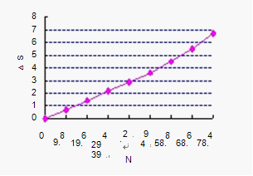

图4:刚度曲线的压电陶瓷

4.2.3 轴向刚度的改变,从扭转刚度的导螺杆

传动链方面的需要进行改造时统一计算它的刚性。因此，扭转刚性必须转换成下面的公式轴向刚度：

C:\DOCUME~1\ADMINI~1\LOCALS~1\Temp\ksohtml\wps_clip_image-2339.png

C:\DOCUME~1\ADMINI~1\LOCALS~1\Temp\ksohtml\wps_clip_image-12650.png

C:\DOCUME~1\ADMINI~1\LOCALS~1\Temp\ksohtml\wps_clip_image-30993.png是螺旋上升的铅角，（°）;

D是丝杆直径，mm;  
F是丝杆轴向力,N;  
M是丝杆输入时刻，N·mm;

C:\DOCUME~1\ADMINI~1\LOCALS~1\Temp\ksohtml\wps_clip_image-30679.png是在丝杆和螺母之间的摩擦角，（°）;

C:\DOCUME~1\ADMINI~1\LOCALS~1\Temp\ksohtml\wps_clip_image-29889.png是对丝杠扭转刚度，Nmm/rad;

C:\DOCUME~1\ADMINI~1\LOCALS~1\Temp\ksohtml\wps_clip_image-25344.png是丝杠扭转，rad

P是丝杆长度，mm;

G是丝杆剪切弹性模量，Mpa;

C:\DOCUME~1\ADMINI~1\LOCALS~1\Temp\ksohtml\wps_clip_image-14146.png是截面惯性矩，mm

L是两个推力轴承的距离，mm

螺母连接的刚性块轴向可以得到的有限元分析。螺母支架的刚度和轴承块是非常大的，可以予以辞退。其他部分可以得到刚性通过查找表和计算。总之，通过演绎着驱动进给机构的刚性方程，我们已经找到了影响因素每一次驾驶驾驶部分，它提供了有关驾驶特性研究的基础上进一步造成刚性。

# 5.进刀机构的实验研究

## 5.1实验系统的基础

如图5所示，该实验系统是由送料机构，计算机，压电陶瓷驱动器其电源供应器及电感测微仪。

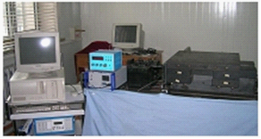

图5:基础的实验系统

本文采用一种基于平均控制曲线模型建立开环控制模型。首先,实验曲线测量压电陶瓷控制电压之间的关系和滑动运输距离。利用Matlab软件以适应线,以三次代数多项式拟合线,线拟合误差,是一样的显示在图6,由此我们得到相应的关系表达式的控制电压和距离和因此控制距离的进给机制。

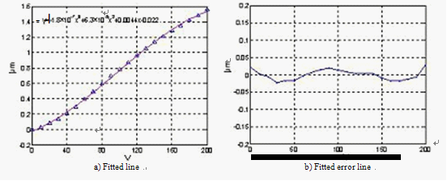

图6:适合以三次代数多项式

控制电压和距离的关系式公式7所示

C:\DOCUME~1\ADMINI~1\LOCALS~1\Temp\ksohtml\wps_clip_image-3206.png

x是输出的距离,µm;

u控制电压,V。

5.2实验研究系统分辨率

如图7,压电陶瓷具有一定的伸长。就在这个时候,距离工作表微0.15µm。 然后一步拉伸逐渐在此基础上,保持1.5在每一时刻。采样时间是控寄存器。这分辨率曲线可以获得实践的距离,通过测量微进给机构使用的电感测微仪。

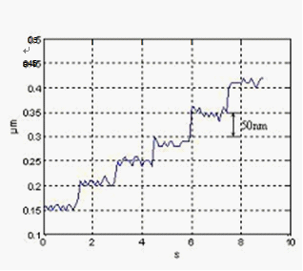

图7:距离分辨率曲线的进给机制

# 6．结论

微进给机构一步用长征、高分辨率的设计,并在此基础上从以下结论分析得出:

1.结合机理的基础上,设计了压电陶瓷灵活的铁铰链和分析了它静态特性,采用有限元分析软件;

2.分析了起动转矩的微进给机构的等效转动惯量计算;分析了驾驶刚度特性的微进给机构,发现其影响因素;

3. 微进给机构可以达到300mm，分辨率小于0.05μm少。

# 参考文献

1.Seugng-Bok Choi, Sang-Soo Han. Position Control System Using ER Clutch and Piezoactuator. Pro. of SPIE, 2003, 5056: 424~431

2．Suzuki H, Kodera S, Mabkawa S, et al. Study on Precision Grinding of Micro a Spherical Surface. JSPE, 1998, 64(4):619~623.

3.Arrasmith S. R, Kozhinova I A, Gregg L L et al. Details of The polishing Spot in Magnetorheological Finishing(MRF).Proceedings of SPIE-the International Society for OpticalEngineering,2001,Vol.3782:92~100.

4.Atherton P D, Xu Y, McConnell M. New X-Y Stage for Precision Positioning and Scanning. SPIE, 1996, 2865:15~20.

5.Liu Yung -Tien, Toshiro Higuchi, Fung Rong-Fong. A Novel Precision Positioning Table Utilizing Impact Force of Spring-Mounted Piezoelectric Actuator. Precision Engineering, 2003, 27:14221

6.Lobontiu N, Goldfarb M, Garcia E. A Piezoelectric Drive Inchworm Locomotion Device. Mechanism and Machine Theory, 2001, 36: 425~443.

7.A. A. Elmustafa, Max G. Lagally. Flexural-hinge Guided Motion Nanopositioner Stage for Precision Machining: Finite Element Simulations. Precision Engineering, 2001, 25: 77~81

8.Jaehwa Jeong, Young-Man Choi, Jun-Hee Lee. Design and Control of Dual Servo Actuator for Near Field Optical Recording System. Pro. of SPIE, 2005, 6048: 1~8

9.Kim Jeong-Du, Nam Soo-Ryong. Development of a Micro-depth Control System for an Ultra-precision Lathe Using a Piezoelectric Actuator. International Journal of Machine Tools and Manufacture. Volume:37,Issue:4, April, 1997, pp.495~509

10.Li Sheng-yi, Luo Bing, Dai Yi-fan, Peng Li. Design and Experiment of The Ultra Precision Twist-roller Friction Drive. ICAMT'99.1999.