EXP-7 Recipe sharing Preferences using Cookies (Servlet)
AIM
To develop a Servlet-based user preferences (like pet type and age group) using cookies and retrieves them on subsequent visits.

ALGORITHM
- Input:
  - The user selects pet type and preferred age group.
- Form Handling:
  - Create an HTML page to accept pet adoption preferences.
- Servlet Processing:
  - Create PreferenceServlet to read user inputs.
  - Store preferences using cookies.
- Cookie Retrieval:
  - Create DisplayServlet to retrieve cookies and display saved preferences.
- Deployment:
  - Configure web.xml and deploy in Apache Tomcat Server.
- Output:
  - User preferences are stored and displayed on subsequent visits.

SOURCE CODE
index.html
<html>
<head>
<style>
body{
margin:0;
font-family:Arial;
background:linear-gradient(135deg,#16a34a,#064e3b);
display:flex;
justify-content:center;
align-items:center;
height:100vh;
color:white;
}
.container{
background:#022c22;
padding:30px;
border-radius:12px;
width:320px;
text-align:center;
}
select,button{
width:100%;
padding:10px;
margin:10px 0;
border:none;
border-radius:5px;
}
button{
background:#16a34a;
color:white;
font-weight:bold;
}
a{color:#86efac;}
</style>
</head>
<body>
<div class="container">
<form action="PreferenceServlet" method="post">
<label>Select Pet Type</label>
<select name="pet">
<option>Dog</option>
<option>Cat</option>
<option>Bird</option>
<option>Rabbit</option>
</select>
<label>Select Age Group</label>
<select name="age">
<option>Puppy/Kitten</option>
<option>Young</option>
<option>Adult</option>
</select>
<button type="submit">Save Preferences</button>
</form>
</div>
</body>
</html>

PreferenceServlet.java
import java.io.*;
import javax.servlet.*;
import javax.servlet.http.*;
public class PreferenceServlet extends HttpServlet {
protected void doPost(HttpServletRequest request,HttpServletResponse response)
throws IOException {
String pet = request.getParameter("pet");
String age = request.getParameter("age");
Cookie c1 = new Cookie("pet",pet);
Cookie c2 = new Cookie("age",age);
c1.setMaxAge(24*60*60);
c2.setMaxAge(24*60*60);
response.addCookie(c1);
response.addCookie(c2);
PrintWriter out = response.getWriter();
out.println("<html><body style='text-align:center;font-family:Arial;margin-top:100px;'>");
out.println("<h2>Preferences Saved Successfully 🐾</h2>");
out.println("<a href='DisplayServlet'>Go to Adoption Dashboard</a>");
out.println("</body></html>");
}
}

DisplayServlet.java
import java.io.*;
import javax.servlet.*;
import javax.servlet.http.*;
public class DisplayServlet extends HttpServlet {
protected void doGet(HttpServletRequest request,HttpServletResponse response)
throws IOException {
Cookie cookies[] = request.getCookies();
String pet="Dog";
String age="Not Set";
if(cookies!=null) {
for(Cookie c : cookies) {
if(c.getName().equals("pet"))
pet = c.getValue();
if(c.getName().equals("age"))
age = c.getValue();
}
}
PrintWriter out = response.getWriter();
out.println("<html><body style='background:#ecfdf5;color:black;text-align:center;font-family:Arial;'>");
out.println("<h1>PET ADOPTION DASHBOARD 🐶🐱</h1>");
out.println("<h2>Preferred Pet : "+pet+"</h2>");
out.println("<h2>Preferred Age : "+age+"</h2>");
out.println("<h3>Find your perfect companion today!</h3>");
out.println("<a href='index.html'>Change Preferences</a>");
out.println("</body></html>");
}
}

web.xml
<web-app>
<welcome-file-list>
<welcome-file>index.html</welcome-file>
</welcome-file-list>
<servlet>
<servlet-name>PreferenceServlet</servlet-name>
<servlet-class>PreferenceServlet</servlet-class>
</servlet>
<servlet-mapping>
<servlet-name>PreferenceServlet</servlet-name>
<url-pattern>/PreferenceServlet</url-pattern>
</servlet-mapping>
<servlet>
<servlet-name>DisplayServlet</servlet-name>
<servlet-class>DisplayServlet</servlet-class>
</servlet>
<servlet-mapping>
<servlet-name>DisplayServlet</servlet-name>
<url-pattern>/DisplayServlet</url-pattern>
</servlet-mapping>
</web-app>

OUTPUT
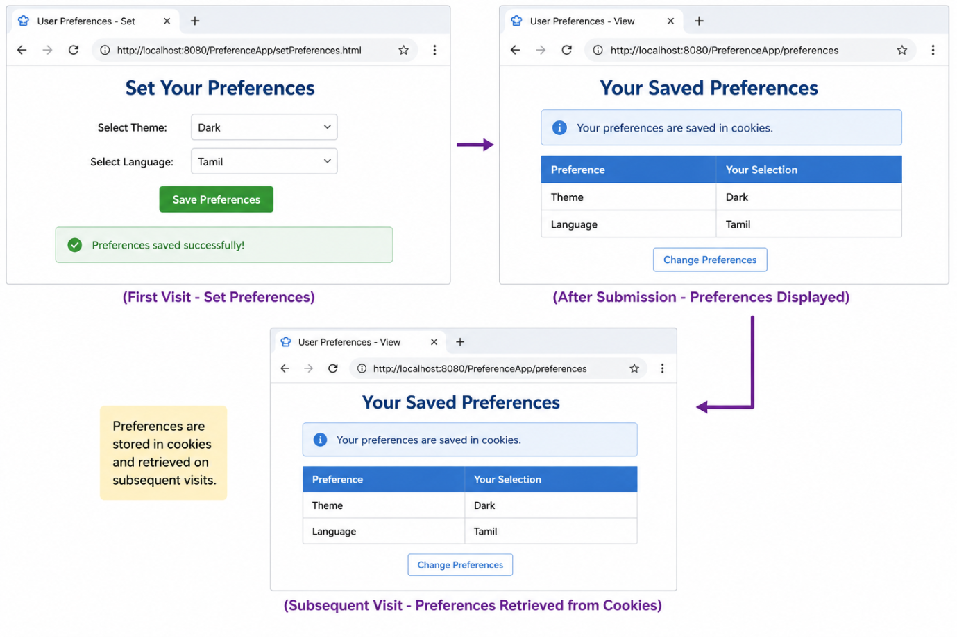
RESULT
Thus, a Servlet program was successfully created to store user preferences using cookie

