10.Develop an application to change the font and color of
the text and display toast message when the user presses the button.

AIM:
To develop an Android application that allows the user to change the font and color of text displayed on the screen and display a Toast message when a button is pressed.

ALGORITHM:
- Initialize the Android Application:
  - Set up a new Android project in Android Studio.
  - Create a MainActivity Java file for the main screen of the application.
- Design the User Interface (UI):
  - In the XML layout file, add the following UI components:
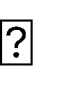

TextView: For displaying the text whose font and color will be changed.

Button: To trigger the change in font and color, and show a Toast message.

Spinner or Color Picker: To let the user choose a color (optional, or a simple button for a predefined color change).
RadioButtons or a Dropdown Menu to select different font styles (optional).
- Declare Variables:
  - Create references for the TextView, Button, Color Picker (if used), and Radio Buttons (if used to change font style).
  - Define variables for the font style, color, and the message to display in the Toast.

- Set Event Listener for the Button:
  - Set an OnClickListener for the Button.
  - Inside the onClick() method, write the logic to:



Change the font of the TextView based on the selected font style. Change the color of the TextView based on the selected color.
Display a Toast message indicating the action has been performed.

- Implement Font Style Changes:
  - Change the TextView’s font using setTypeface() to apply a selected font style
(e.g., bold, italic).
  - You can either use predefined styles (like Typeface.BOLD or Typeface.ITALIC) or let the user choose from a list of font styles.

- Implement Color Change:
  - Change the TextView’s text color by using the setTextColor() method and applying the selected color (e.g., Color.RED, Color.BLUE, or a color from the Color Picker).
  - If using a color picker or dropdown, get the selected color and set it on the TextView.

- Show Toast Message:
  - Display a Toast message to the user when the button is clicked, informing them that the text style or color has changed. You can also show a message like Cquot;Font and color changed!Cquot; or any other appropriate message.

- End the Operation:
  - After the changes are made, the application will display the updated TextView with the new font and color, and the Toast message will appear to provide Feedback.

Code:

- XML Layout (activity_main.xml):
<?xml version="1.0" encoding="utf-8"?>
<LinearLayout xmlns:android="http://schemas.android.com/apk/res/android" android:orientation="vertical" android:layout_width="match_parent" android:layout_height="match_parent" android:gravity="center"
android:padding="20dp">

<TextView android:id="@+id/weatherText" android:layout_width="wrap_content" android:layout_height="wrap_content" android:text="Weather Information" android:textSize="24sp" android:textColor="#000000" android:padding="20dp"/>

<Button android:id="@+id/changeBtn"
android:layout_width="wrap_content" android:layout_height="wrap_content" android:text="Change Style"/>

</LinearLayout>

Java Code (MainActivity.java):
package com.example.weatherapp;

import android.graphics.Color; import android.graphics.Typeface; import android.os.Bundle;
import android.view.View; import android.widget.Button; import android.widget.TextView; import android.widget.Toast;

import androidx.appcompat.app.AppCompatActivity;

public class MainActivity extends AppCompatActivity {

TextView weatherText; Button changeBtn;

boolean changed = false;

@Override
protected void onCreate(Bundle savedInstanceState) { super.onCreate(savedInstanceState); setContentView(R.layout.activity_main);

weatherText = findViewById(R.id.weatherText); changeBtn = findViewById(R.id.changeBtn);

changeBtn.setOnClickListener(new View.OnClickListener() { @Override
public void onClick(View v) {

if (!changed) { weatherText.setTextColor(Color.BLUE);
weatherText.setTypeface(null, Typeface.BOLD_ITALIC); weatherText.setText("Weather Updated ●");

Toast.makeText(MainActivity.this,
"Style Changed!", Toast.LENGTH_SHORT).show();

changed = true;
} else { weatherText.setTextColor(Color.BLACK);
weatherText.setTypeface(null, Typeface.NORMAL);

weatherText.setText("Weather Information");

Toast.makeText(MainActivity.this,
"Back to Default!", Toast.LENGTH_SHORT).show();

}
});
}
}
changed = false;
}

AndroidManifest:
<application android:allowBackup="true" android:label="Weather App"
android:theme="@style/Theme.AppCompat.Light.DarkActionBar">

<activity android:name=".MainActivity">
<intent-filter>
<action android:name="android.intent.action.MAIN" />
<category android:name="android.intent.category.LAUNCHER" />
</intent-filter>
</activity>

</application>

Output:

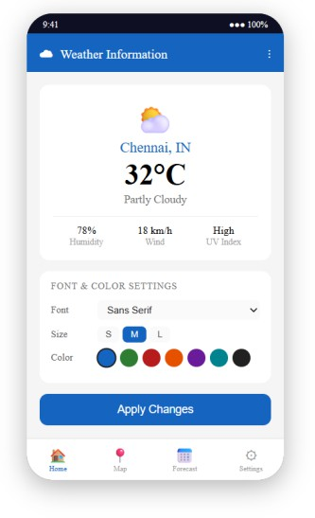

RESULT:
An mobile application is developed in Android studio to change the font and color of the text and display toast message when the user presses the button.

