EXP-5: Servlet GET & POST Demo
AIM
To create a web application that demonstrates the difference between HTTP GET and POST methods using Servlets. The application is a Pet Adoption Portal where users can search for pets using the GET method and submit adoption requests using the POST method.

ALGORITHM
- Input:
The user interacts with the Pet Adoption form.
- Form Handling:
  - Create an HTML page with two forms.
  - One form uses GET method to search for available pets.
  - Another form uses POST method to submit adoption details.
- Servlet Processing:
  - Create a Servlet class PetServlet.
  - Override doGet() method.
  - Override doPost() method.
- Request Handling:
  - GET → Retrieve pet type and display search result.
  - POST → Retrieve adopter details and pet info, then confirm adoption request.
- Deployment:
  - Configure web.xml
  - Deploy using Apache Tomcat
- Output:
  - GET → Data visible in URL
  - POST → Data hidden from URL

SOURCE CODE
User Interface (index.html)
<html>
<head>
<title>Pet Adoption Portal - GET POST Demo</title>

<style>
body{
font-family:Arial;
background: linear-gradient(135deg,#16a34a,#064e3b);
margin:0;
color:white;
}

.container{
width:450px;
margin:70px auto;
padding:30px;
background:#022c22;
border-radius:15px;
box-shadow:0 0 20px rgba(0,0,0,0.5);
text-align:center;
}

h1{
color:#4ade80;
}

form{
margin-top:20px;
padding:20px;
border:1px solid #065f46;
border-radius:10px;
}

input{
width:90%;
padding:10px;
margin:10px 0;
border:none;
border-radius:6px;
}

button{
width:95%;
padding:12px;
border:none;
border-radius:25px;
background:#16a34a;
color:white;
font-weight:bold;
cursor:pointer;
transition:0.3s;
}

button:hover{
background:#22c55e;
transform:scale(1.05);
}
</style>

</head>

<body>

<div class="container">

<h1>PET ADOPTION PORTAL</h1>

<!-- GET FORM -->
<form action="PetServlet" method="get">
<h3>GET Method - Search Pet</h3>
<input type="text" name="petType" placeholder="Enter Pet Type (Dog/Cat)" required>
<button type="submit">Search Pet (GET)</button>
</form>

<!-- POST FORM -->
<form action="PetServlet" method="post">
<h3>POST Method - Adopt Pet</h3>
<input type="text" name="name" placeholder="Your Name" required>
<input type="text" name="petType" placeholder="Pet Type" required>
<input type="text" name="contact" placeholder="Contact Number" required>
<button type="submit">Adopt Pet (POST)</button>
</form>

</div>

</body>
</html>

Controller Servlet (PetServlet.java)
import java.io.*;
import javax.servlet.*;
import javax.servlet.http.*;
public class PetServlet extends HttpServlet {
public void doGet(HttpServletRequest request, HttpServletResponse response)
throws ServletException, IOException {
response.setContentType("text/html");
PrintWriter out = response.getWriter();
String petType = request.getParameter("petType");
out.println("<html><body style='text-align:center;font-family:Arial;background:#15803d;color:white;'>");
out.println("<h1>GET METHOD - PET SEARCH</h1>");
out.println("<h2>Pet Type Searched: "+petType+"</h2>");
out.println("<h3>Available pets displayed successfully</h3>");
out.println("<h3>Data visible in URL (GET Method)</h3>");
out.println("</body></html>");
}
public void doPost(HttpServletRequest request, HttpServletResponse response)
throws ServletException, IOException {
response.setContentType("text/html");
PrintWriter out = response.getWriter();
String name = request.getParameter("name");
String petType = request.getParameter("petType");
String contact = request.getParameter("contact");
out.println("<html><body style='text-align:center;font-family:Arial;background:#14532d;color:white;'>");
out.println("<h1>POST METHOD - ADOPTION REQUEST</h1>");
out.println("<h2>Name: "+name+"</h2>");
out.println("<h2>Pet Type: "+petType+"</h2>");
out.println("<h2>Contact: "+contact+"</h2>");
out.println("<h3>Adoption request submitted successfully</h3>");
out.println("<h3>Data hidden from URL (POST Method)</h3>");
out.println("</body></html>");
}
}

web.xml
<web-app>
<welcome-file-list>
<welcome-file>index.html</welcome-file>
</welcome-file-list>
<servlet>
<servlet-name>PetServlet</servlet-name>
<servlet-class>PetServlet</servlet-class>
</servlet>
<servlet-mapping>
<servlet-name>PetServlet</servlet-name>
<url-pattern>/PetServlet</url-pattern>
</servlet-mapping>
</web-app>

OUTPUT
GET Method:
- User searches pet (e.g., Dog)
- URL shows: ?petType=Dog
POST Method:
- User submits adoption form
- Data is not visible in URL

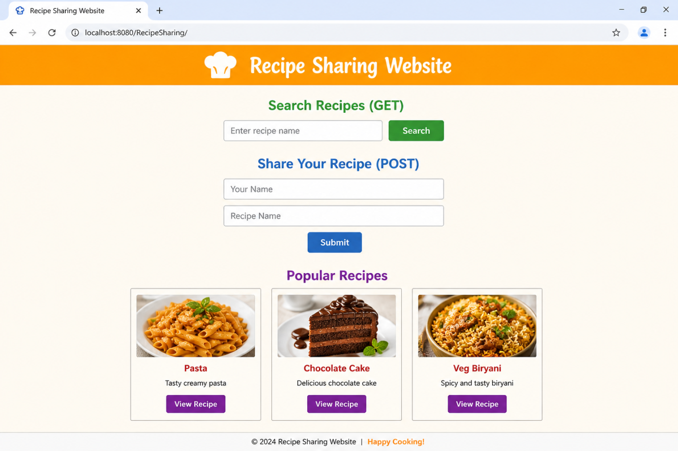

RESULT
Thus, a Servlet program was successfully created to demonstrate the difference between HTTP GET and POST methods using a Pet Adoption Portal.
GET Method – Pet Search:

