A Method of Speech Recognition and Text Summarization to Ease Understanding of Lengthy Speeches

Abstract: Speech is a powerful way of communication which is a boon granted only to human beings. The pace and dialect of speech differs with each person even if the language of communication is the same which often create confusions. Sometimes lengthy speeches are quite difficult to track up, due to various reasons. Speech recognition which is an inter-disciplinary field of computational linguistics aids in developing technologies that empowers the recognition and conversion of speech into text. Text summarization extracts the utmost important information from a speech source and provides the adequate summary of the same in text format. This research work intends to describe a method of recognizing the speech and converts it to the corresponding text and provides the user the exact text summary.

Keywords: Feature extraction, Natural Language Processing, Natural Language Toolkit, Speech recognition, Text summarization

- Introduction
Speech recognition is the process of making a machine recognize the speech of various people based on certain words or phrases. Variations in the pronunciation are quite evident in each individual’s speech. The original form of the speech is a signal, and a signal is processed such that all the information present in the signal is converted in to the text format. The feature extraction is the process of taking a signal and converting it to the required format with certain logic. Even though speech is the easiest way of communication, there exist some problems with speech recognition like the fluency, pronunciation, broken words, stuttering issues etc. All these have to be addressed while processing a speech. Text summarization is one of the major concepts used in the field of documentation. Lengthy documents are difficult to read and understand as it consumes lot of time. Text summarization solves this problem by providing a shortened summary of it with semantics.
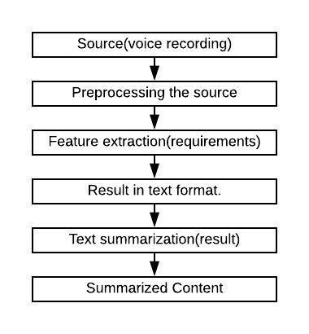
Figure 1. Block diagram of the speech recognition and text summarization process

In the proposed work a combination of speech to text conversion and text summarization is implemented. This hybrid method will aid applications that require brief summary of lengthy speeches which is quite useful for documentation. The different stage for speech recognition and summarization in the proposed model is as shown in Figure. 1. The speech recognition and text summarization is given as two different modules. The combination of these two modules aids any application in which summarization is required. The first and foremost step to work with NLP (Natural Language Processing) is to extract the features from speech which has some values. If a word or a sentence is recognized as meaningless, then it becomes an obstacle to summarization process. Even the punctuation plays a vital role in summarization as semantics is important while summarizing the text.

- Related Works

Speech to text conversion finds applications in various scenarios. An effective method to gain fluency in English language that enhances the user's way of speech through correctness of pronunciation following the English phonetics was developed by Jose et al. [1]. A comparative analysis mentioning the benefits and demerits of the various sizes of vocabulary speech recognition systems was done by Sivakumar et al. [2]. This work demonstrated the role of language model in improving the accuracy of speech to text conversion with different scenarios with noises and broken words. Yogita et al. [3] presented a multilingual speech-to text conversion system using Mel-Frequency Cepstral Coefficient (MFCC) feature extraction technique and Minimum Distance Classifier, Support Vector Machine (SVM) methods for speech classification. In [4] a model to convert natural Bengali language to text was proposed which used open source framework Sphinx 4. Authors claim an average of 71.7% accuracy for their approach in the tested dataset. English text summarization based on association semantic rules was proposed by Wan [5]. According to the author, the new extraction scheme proved to have better convergence and precision performance in the extraction process. LDA is the most accepted algorithm for text classification based on a particular topic. An improvement of the same is proposed in a novel similarity computation method.

Saiyed and Sajja [6] gave a brief introduction to the categories of summarization techniques highlighting their advantages and drawbacks. This works gives insights to the researchers for selecting specific methods based on their requirement. The sentence selection process modelled as a multi-objective optimization problem was described in [7]. The authors used human learning optimization algorithm for this purpose. In [8] feature extraction based on neural networks was proposed which the authors claim to be more effective compared to the online extractive options. Vythelingum et al. [9] had proposed a technique for error detection of grapheme to-phoneme conversion in text-to-speech synthesis. According to them their approach gave better error correction rate which can aid the human annotator. From the literature review, it is quite evident that the requirement of speech to text conversion as well as the summarization is a necessity and hence this research work.

The rest of the paper is organized as follows. Section 3 gives the details of the proposed model; Section 4 mentions the results obtained followed by Summary and Conclusions in Section 5.

- Proposed Model
3.1. Experimental setup
A microphone is used as a source to record the voice in mp3 format. The feature i.e. the speech is extracted from the recorded voice and is converted to text format using Google Application Programming Interface (API). But in the sentences extracted using Google API, there is no period (.) at the end of the sentence. This can lead to confusion in the termination of each statement that is being spoken. In order to avoid this, a custom code has been written in the proposed model to have a full stop after a long pause which is 2e+6 µs and above. This makes the sentence clearer.
In order to proceed with the concept of adding a full stop to the spoken content, 2e+6 µs has been considered as a pause. If it continues more than that, it will still wait for the user to receive an input. Since full stop plays a vital role in the completion of a sentence, if there is a place without full stop a new sentence will be started with the concept of conjunction. To overcome that sort of problem the concept of temporary storage is used. Therefore the full stop will be stored in the temporary variable at the occurrence of a pause. If the next sentence begins with some kind of conjunction, then the temporary variable value will be removed and the conjunction would be used. Contradicting the conjunction, if the sentence begins with the subject then the temporary variable value will be used and the full stop will be appended to the sentence.

The ‘wh-’ questions are focused to proceed with the concept of the question mark (?). Whenever the sentence begins with ‘wh-’, the temporary variable will hold the value of (?) on pause of 2e+6 µs and more than that. In case the next sentence begins with the question tag statement then the temporary variable value will not be used. If the sentence begins with a completely new subject then question mark will be appended to the end of the sentence.

The frequency of every word is found with the help of sentence tokenize and word tokenize techniques which are packages from the python NLTK. The recorded text is given as input to the ‘sentence_tokenize()’ method and the sentences are separated based on the occurrence of dot. The words in the sentences will extracted using ‘word_tokenize()’ method based on the space between them. When a proper text is given for summarizing, it is less complex to process as it in the exact format of writing and often quite precise and clear. But this is not the case when speech itself is taken as the input source. Here the speech has to be converted to text and then text summarization has to happen.

The problems to be tackled here are the occurrence of repeated words, broken words, different dialect and synonyms used to convey the message. Therefore, to overcome such problems, a minimum and maximum range is set for the occurrence of the words. Even though the sentence and word frequency are used to find the important sentence in the whole content, a ranking model is applied. Finally, by the summarization algorithm, the frequency of every word is calculated and weight of the sentence is found with the consideration of the frequency. The index of the sentence is ranked according to the weight of the sentence and the sentence is summarized with the identification of the index. Python ‘nlargest()’ method is used to rank the sentence based on the weight of the sentence. The summary of the given paragraph will be derived according to the rank of sentences. The implementation procedure of the proposed model is as shown in Figure. 2.

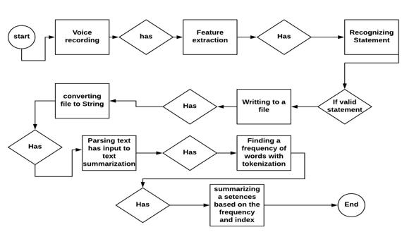
Figure. 2: Flow chart of the proposed model

3.2 Proposed procedure

Step-1: Set a microphone as a source to record the voice of the user. The starting and ending time of input is recorded as microseconds.

Step-2: Using API the recorded audio is converted to text using the ‘recognize-google(audio)’ method which is supported by python. The recorded audio is passed as a parameter to the method to convert it to corresponding text.

Step-3: Add ‘.’ and ‘?’ to the text wherever required.

Step-4: Create a document by appending the text, start time and end time. The interval of speech is computed using the recorded start and end time.

Step-5: Prepare the document by summarizing the important points in the text based on the proposed model.

Step-6: Read the document generated in step-5 into a string format using python.

Step-7: Tokenize the sentences present in the document using ‘sentence_tokenize()’ method supported by python.

Step-8: From the tokenized sentences, tokenize each word with the help of ‘word_tokenize()’ method supported by python.

Step-9: Find the frequency of each word.

Step-10: The maximum and minimum occurrence for a word to be considered is set as 0.9 and 0.1 respectively. Only the words which is within the defined range is considered.

Step-11: The sentence is ranked based on the frequency of the words considered in step-10.

Step-12: Finally, store the summarized content in the dataset.

- Experimental Results

The speech data for the experiment is recorded using a microphone. It contains 50 samples and is converted to text using Google API. The extracted text is summarized using both gensim package supported by python and the proposed model. The computation time for both models are compared for summarized data. In proposed model, the punctuations (‘.’ and ‘?’) are added to the text to convert it to proper format. Computation time for speech recognition with and without adding punctuations are recorded and compared to check efficiency of the proposed model.
Compared to the basic recognition (without punctuations), the proposed model differs in time complexity. The basic recognition produces the result without any pre-processing. In the proposed approach, pre-processing is required to prepare the document for the summarization. In order to proceed with the summarization, the dot (.) is introduced to indicate the end of statement. For python sentence tokenize, dot is one of the major aspects to recognize sentence. Though there are many punctuation marks, the proposed model focus only on full stop and question mark. In Table 1 and Table 2, the time taken to recognize speech with and without addition of punctuations is recorded. The sample sentence, start time and end time of speech are recorded. The total speech time is computed using the formula (1).

Difference time = End time - Start time (1)

Table 1: Time taken to recognize speech without punctuation

Recognized sentence | Starting time(µs) | Ending time(µs) | Difference (µs)
The computer was born to solve problems that did not exist before | 947269 | 586273 | 360996
Standards are always out of state that is what makes them standard | 588896 | 490641 | 98255
The greatest enemy of knowledge is not ignorance it is the illusion of knowledge | 494519 | 254341 | 240178
We have to stop optimizing for programmers and start optimizing for users | 258129 | 654787 | 396658
Low level programming is good for programmers soon | 890962 | 957103 | 66141

Table 2: Time taken to recognize speech with punctuation

Recognized sentence | Starting time(µs) | Ending time(µs) | Difference (µs)
The computer was born to solve problems that did not exist before. | 846389 | 662408 | 183981
Standards are always out of state that is what makes them standard. | 727367 | 275260 | 452107
The greatest enemy of knowledge is not ignorance. It is the illusion of knowledge. | 888701 | 778334 | 110367
We have to stop optimizing for programmers and start optimizing for users. | 800141 | 722007 | 78134
Low level programming is good for programmers soon. | 745754 | 637428 | 108326

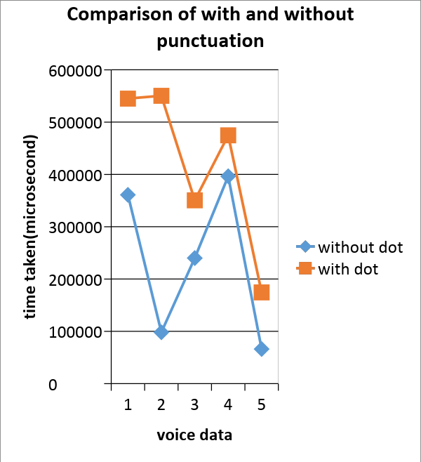

Figure. 3: Comparison of speech with and without dot (.).

Table 3: Summarization using Gensim dataset.

Number of lines | Summarized lines | Time difference(µs)
10 | 1 | 163680
5 | 1 | 2336
8 | 1 | 3675
5 | 1 | 873887
6 | 1 | 5576

Table 4: Summarization using Custom code dataset.

Number of lines | Summarized lines | Time difference(µs)
10 | 3 | 6190
5 | 2 | 1886
8 | 2 | 3640
5 | 2 | 3279
6 | 2 | 3279

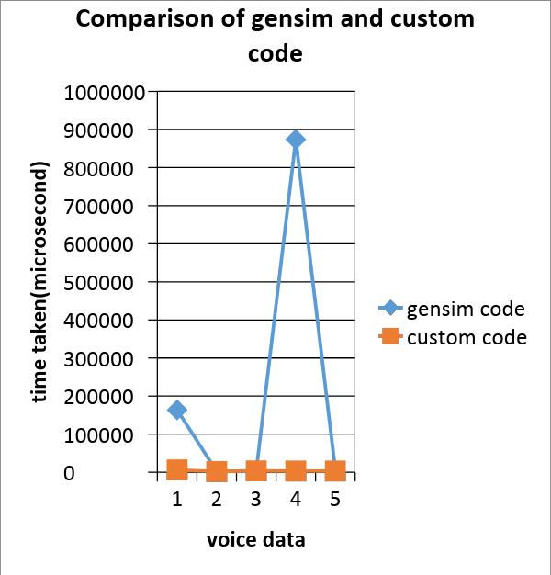

Figure. 4: Comparison of gensim and proposed algorithm

Figure. 3, depicts the graph that compares the computation time of the proposed model with and without addition of punctuations. The blue line symbolizes recognition without punctuation and the orange line symbolizes recognition with punctuation. To find the time difference of the recognizing the time library is used from python. The plot is drawn to visualize the difference between both scenarios.

Summarization results using gensim package and the proposed model are recorded in Tables 3 and 4 respectively. Compared to the gensim package, the proposed algorithm takes less time to produce the result. In gensim summarization, though document is very big, result of the algorithm would be a line mostly. Proposed algorithm can summarize the whole document into a number of lines by the user requirement. The frequency of the single word can be computed using the formula (2). From here, the index of the sentence can be found by the ranking method.

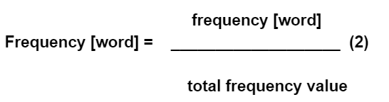

Figure. 4 depicts a graph that compares the time taken for text summarization by gensim package and proposed model. The blue line stands for the gensim package and the orange line stands for the proposed algorithm. The time complexity and performance of the proposed approach is consistent.

- Conclusion

Speech recognition and text summarization are two vast areas to be explored. The proposed research work aims to reduce the time and effort of manual documentation of lengthy speeches in an event. Speech recognition and text summarization can ease the work of documentation. Even for the verification purpose of the summarized content, the system can be automated to read out the summarized content with the help of text to speech conversion. As of now the termination of sentence in the speech when encountered with ‘.’ is experimented. The future work is to include all punctuation marks into to the proposed model which helps in improving the speech recognition and the text summarization performance. This model can be most widely used wherever there is a requirement of summarizing lengthy lectures into precise documents. The automated system will convert the speech to text and also summarize the content. It can be of great help for students to archive lecture notes from classes, conferences or seminars.

References
[1] Jose D V, Alfateh Mustafa, Sharan R, “A Novel Model for Speech to Text Conversion”, International Refereed Journal of Engineering and Science (IRJES)”, Vol 3, Issue 1, 2014.

[2] K. M. Shivakumar, V. V. Jain and P.K. Priya, “A study on impact of language model in improving the accuracy of speech to text conversion system”, 2017 International Conference on Communication and Signal Processing (ICCSP), Chennai, 2017, pp. 1148-1151.

[3] Y. H. Ghadage and S. D. Shelke, "Speech to text conversion for multilingual languages”, 2016 International Conference on Communication and Signal Processing (ICCSP), Melmaruvathur, 2016, pp. 0236-0240.
[4] Umar Nasib, Abdullah & Kabir, Humayun & Ahmed, Ruhan & Uddin, Jia. (2018). “A Real Time Speech to Text Conversion Technique for Bengali Language”, 1-4. 10.1109/IC4ME2.2018.8465680.

[5] L. Wan, "Extraction Algorithm of English Text Summarization for English Teaching",2018 International Conference on Intelligent Transportation, Big Data & Sm art City (ICITBS), Xiamen, Fujian, China, 2018, pp. 307-310.

[6] Saiyed S, Sajja PS, “Review on text summarization evaluation methods”, Indian Journal of Computer Science and Engineering, Vol.8, No. 4, pp.497, 2017.

[7] R. Alguliyev, R. Aliguliyev and N. Isazade, "A sentence selection model and HLO algorithm for extractive text summarization", 2016 IEEE 10th International Conference on Application of Information and Communication Technologies (AICT), Baku, 2016, pp. 1-4.

[8] Jain, D. Bhatia and M. K. Thakur, "Extractive Text Summarization Using Word Vector Embedding", 2017 International Conference on Machine Learning and Data Science (MLDS), Noida, 2017, pp. 51-55.

[9] K. Vythelingum, Y. Estève and O. Rosee, "Error detection of grapheme-to-phoneme conversion in text-to-speech synthesis using speech signal and lexical context", 2017 IEEE Automatic Speech Recognition and Understanding Workshop (ASRU), Okinawa, 2017, pp. 692-697.

