NY Times links for state Covid19 data:

CA : <https://www.nytimes.com/interactive/2020/us/california-coronavirus-cases.html>

At least 51 new coronavirus deaths and 5,242 new cases were reported in California on Nov. 3. Over the past week, there has been an average of 4,394 cases per day, an increase of 31 percent from the average two weeks earlier.

As of Wednesday afternoon, there have been at least 950,400 cases and 17,763 deaths in California since the beginning of the pandemic, according to a New York Times database.

TX : <https://www.nytimes.com/interactive/2020/us/texas-coronavirus-cases.html>

At least 96 new coronavirus deaths and 8,488 new cases were reported in Texas on Nov. 3. Over the past week, there has been an average of 7,098 cases per day, an increase of 32 percent from the average two weeks earlier.

As of Wednesday afternoon, there have been at least 977,924 cases and 18,736 deaths in Texas since the beginning of the pandemic, according to a New York Times database.

**.csv files for cases by county**: <https://github.com/nytimes/covid-19-data>

How each county is reopening:

<https://www.nytimes.com/interactive/2020/us/states-reopen-map-coronavirus.html>

CA : **Reopened May 25.** Gov. Gavin Newsom, a Democrat, emphasized caution as he allowed counties to reopen sectors in May and June. As cases rose in the summer, Mr. Newsom backtracked, ordering statewide closures of bars and indoor activities in many sectors including dining and entertainment. In late August, the state introduced a new plan for reopening and closing counties based on risk level, which allowed indoor retail and hair salons to open even in counties where the virus was widespread. By fall, cases had declined enough that San Francisco could move into the lowest risk tier, but many counties remained in the highest risk level.

<https://www.latimes.com/projects/california-coronavirus-cases-tracking-outbreak/reopening-across-counties/>

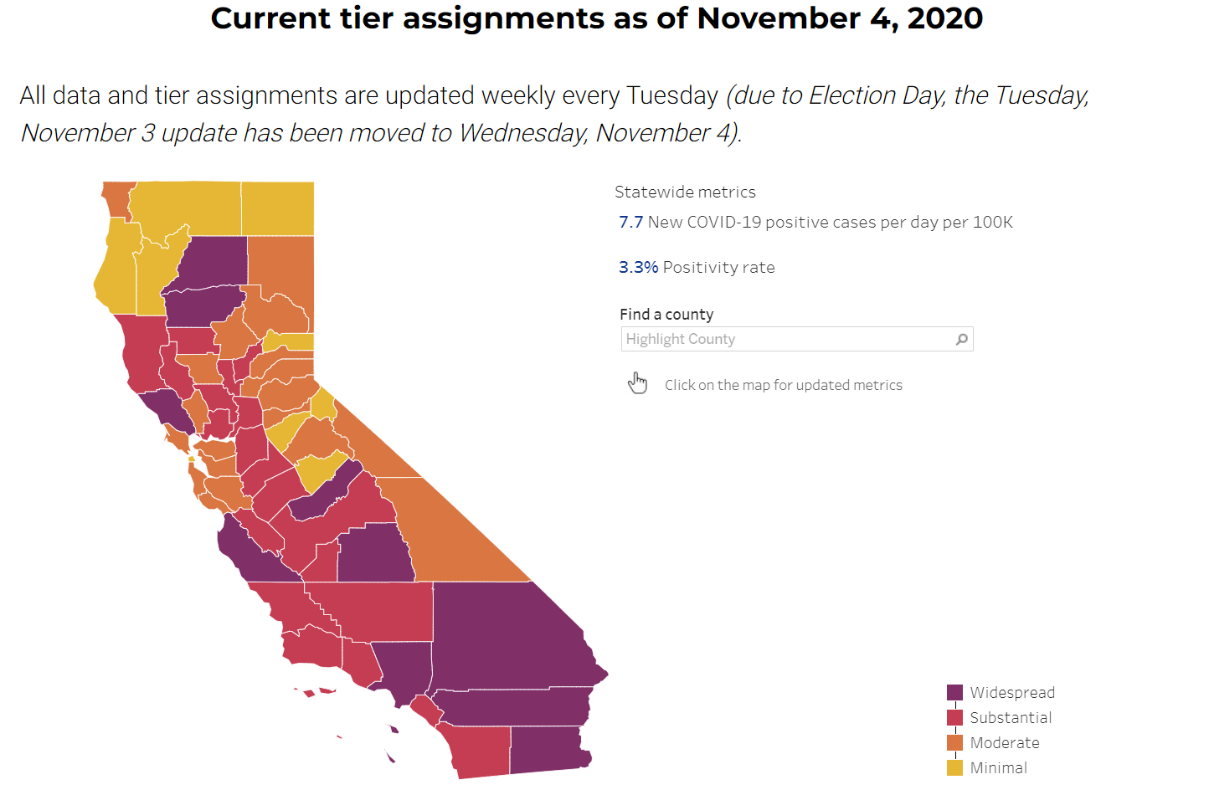

Source: <https://covid19.ca.gov/safer-economy/>

TX: **Reopened May 1.** Gov. Greg Abbott allowed his stay-at-home order to lapse on April 30, a move that gave Texas one of the shortest such orders in the country. A surge in cases in late June caused Mr. Abbott to order bars to close and restaurants to reduce capacity, among the first reopening reversals in the country. Starting July 3, he once again encouraged Texans to stay home and required face coverings in public places in counties with more than 20 cases. Starting Oct. 15, counties with low Covid-19 hospitalizations could reopen bars at 50 percent capacity and other businesses at 75 percent.

[**https://www.texastribune.org/2020/10/07/texas-bars-reopen-greg-abbott/**](https://www.texastribune.org/2020/10/07/texas-bars-reopen-greg-abbott/)

[**https://www.dshs.state.tx.us/coronavirus/opentexas.aspx**](https://www.dshs.state.tx.us/coronavirus/opentexas.aspx)

ways to compare states / cases connected to:

CA:

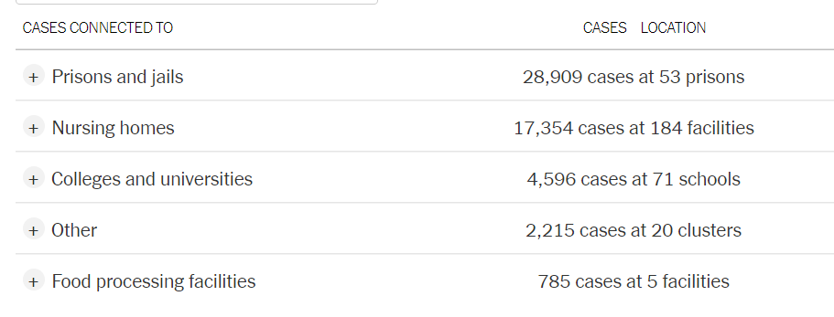

TX:

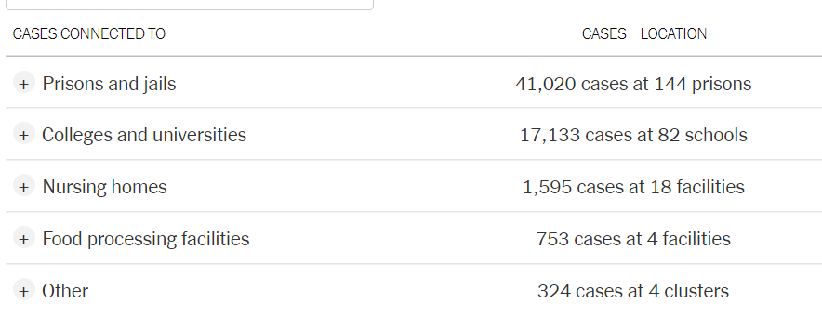

chart located on each state breakdown page about halfway down.

Prisons = CA 545.45 per prison, TX 284.86 per prison

Colleges = CA 64.73 per university, TX 208.93 per university

Nursing Homes = CA 94.31 per home, TX 88.61 per home

Food Processing Facilities = CA 157 per facility, TX 188.25 per facility

List of schools in CA by county: <https://www.cde.ca.gov/SchoolDirectory/active-or-pending-districts-counties-schools>

List of schools in TX by county (and a bunch of other school stuff): <https://schoolsdata2-tea-texas.opendata.arcgis.com/>

TX vs. CA excess death rate compared:

Source: <https://www.nytimes.com/interactive/2020/05/05/us/coronavirus-death-toll-us.html>

“Our analysis examines deaths from all causes — not just confirmed cases of coronavirus — beginning when the virus took hold. That allows comparisons that don’t depend on the availability of coronavirus tests in a given place or on the accuracy of cause-of-death reporting. “

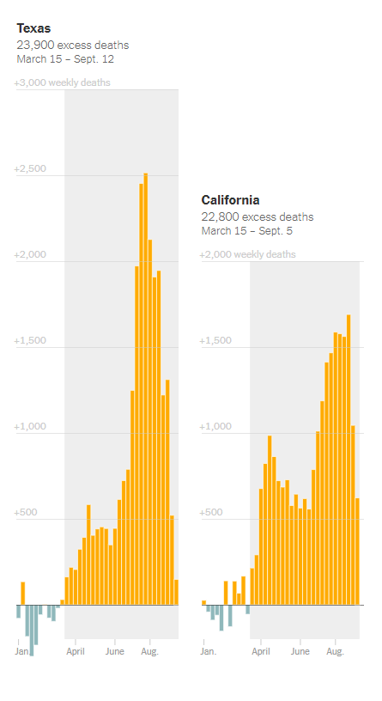

## How excess deaths compare with the official coronavirus counts

In many states with excess deaths, the total number of them exceeded the official number of measured Covid-19 deaths. Given the ongoing [limitations on coronavirus testing](https://www.nytimes.com/interactive/2020/04/17/us/coronavirus-testing-states.html) in the United States, these gaps are not a big surprise. Similar gaps have been found in [other countries](https://www.nytimes.com/interactive/2020/04/21/world/coronavirus-missing-deaths.html) with high numbers of Covid-19 deaths.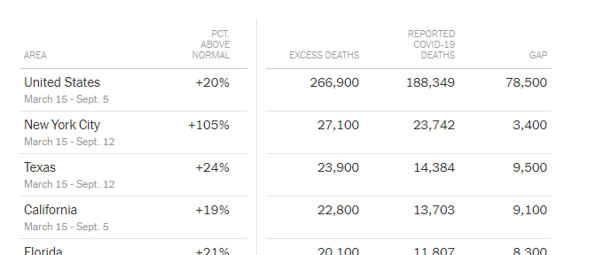

TX has two in the top 20 of cities in USA with fastest growing cases in the past two weeks:

Lubbock – 105.1 daily per 100k

El Paso – 159.3 daily per 100k

<https://www.nytimes.com/interactive/2020/04/23/upshot/five-ways-to-monitor-coronavirus-outbreak-us.html>

Of the cities hit hardest (cumulative confirmed cases) since the beginning of Covid19, 3 are in TX and 1 in CA:

Eagle Pass, TX – 74.3 per 1000

Lubbock, TX – 65.6 per 1000

El Paso, TX – 62.7 per 1000

El Centro, CA – 73.2 per 1000

Corona virus testing by State:

<https://www.nytimes.com/interactive/2020/us/coronavirus-testing.html>

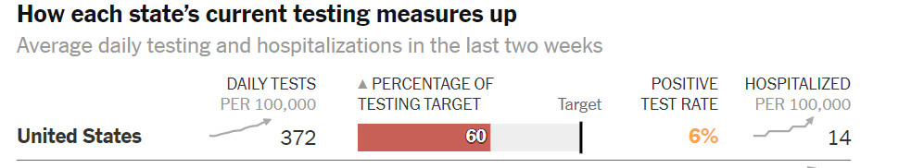





Rate of testing compared to target: TX remains far from the minimum level of testing needed to reduce the spread of the virus. CA is closer to the recommended level.

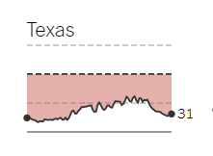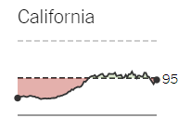

Fun facts:

CA’s population is one third larger than that of the next most populous state, TX.

Adjusted for population, Texas ranks 19th nationally, with 59 deaths per 100,000 residents, [according to the U.S. Centers for Disease Control and Prevention](https://covid.cdc.gov/covid-data-tracker/#cases_deathsper100k). (California, by comparison, has had 43 deaths per 100,000 residents.)

Source: <https://www.county.org/Resources-for-County-Officials/COVID-19-Information-and-Resources/Daily-Updates-COVID-19>