“Music Playlist Creation Tools”
Instruction Manual
Table of Contents
1 Introduction 2
2 Requirements 2
2.1 Stanton SCS.4DJ Users
3 Preparing Your Music Files 2
3.1 Stanton SCS.4DJ Users
4 Using The Playlist Creation Tools 6
4.1 Running “ShowPlaylists”
4.2 Running “MakePlaylists”
4.3 Updating Your Playlists
4.4 Deleting Your Automatic Playlists
5 Important Notes 7
5.1 Music Files Outside Music Folders
5.2 Music Files Outside the Scripts or Applications Folder
5.3 Preexisting Playlists
5.4 Stanton SCS.4DJ Users
5.4.a Preexisting Playlists
5.4.b User Forums
6 Reminder When Ejecting USB Devices 9
7 Credits 9
8 Trademarks 9

Introduction
This is a set of instructions for using the “Music Playlist Creation Tools”, by Vinnie Falco from One Guy Group, Inc.
You can always get the latest version of the tools, as well as the source code from the official project location, "Music Playlist Creation Tools".

Requirements
It is assumed that the reader is familiar with the operation of either the Finder on a Macintosh, or Windows Explorer on Windows, to perform the following tasks:
- Understand folders and sub-folders
- Create, rename, move, and delete folders and sub-folders
- Copy or move files from one folder to another folder

Stanton SCS.4DJ Users
In addition to the requirements above, readers who intend to use these playlists with the Stanton SCS.4DJ device should be familiar with performing the following operations on USB Storage Devices:
- Inserting the USB Device into a desktop or laptop computer
- Inspecting the files and folder contents of a USB Devices
- Safely removing a USB Device from the computer or SCS.4DJ

Preparing Your Music Files
To set up your storage device to use the Playlist Creation Tools you will need to put the folders and sub-folders containing your music files and the scripts together in the same place. Do this by copying either the Macintosh applications or the Windows batch files that came with the Tools. If you will use both Macintosh and Windows computers to access your music files, you can copy both the Macintosh applications and the Windows batch files if you want.

For example, if all of your music files were sorted into two folders called “Dance” and “Urban”, then after you copy the Playlist Creation Tools scripts for Windows and applications for Macintosh into the same place containing those folders (“Dance” and “Music” in this example) you should see something like this in Windows Explorer:
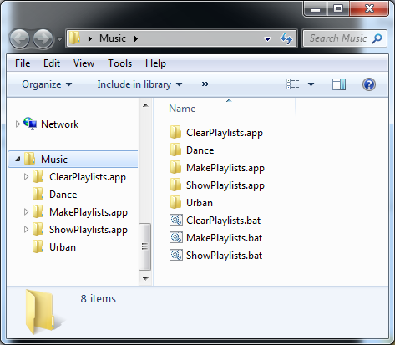

Stanton SCS.4DJ Users
When preparing a USB Stick, external USB Hard Drive, or other USB Device for use with the Stanton SCS.4DJ, it is important to create a new folder, and move the folders containing your music files into this new folder. For example, if you examine the contents of your USB Device you may see something like this in Windows Explorer:
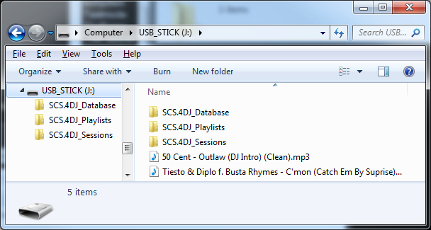

In order to prepare your USB Device correctly so that the Stanton SCS.4DJ analysis information is preserved, you should create a new folder in the USB Device that does not start with the name “SCS.” Then, inside that new folder, copy the scripts in the Tools, create new folders to organize your music, and move your music files into those new folders. For this example, we will use the name “All My Music” for the new folder. After performing these steps, your USB Device would look something like this in Windows Explorer:
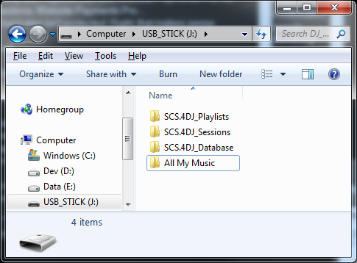
After this step, you would open up the “All My Music” folder (or whatever name you chose) and follow the same steps as described in the previous section for preparing your music files. When you are done, your USB Device should resemble something like this in Windows Explorer:
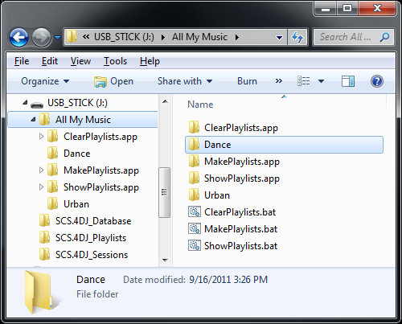

Using The Playlist Creation Tools
Now that you have organized your music into folders and sub-folders, and copied the Playlist Creation Tools scripts and/or applications appropriate for your operating system(s), you are ready to run the tools to create automatic playlists.

Running “ShowPlaylists”
Included in the Tools is a simple script or application named “ShowPlaylists” that you copied to your storage device. Run this script located on the storage device whose playlists you wish to see. This will display all of the playlists in all folders and sub-folders in the same place as the ShowPlaylists script or application.
This tool is useful to check to make sure that none of your own playlists, or playlists created by other programs, will get removed when you run “MakePlaylists”.

Running “MakePlaylists”
Run the batch file for Windows or application for Macintosh named “MakePlaylists”, that you copied into the same place as the folders containing your music. This will first clear out all your old existing playlists, if any, and then create new ones for you. A new playlist containing all of the music files found in each folder, and all of its sub-folders, will be automatically created with a suitable name and filled in for you. After running MakePlaylists on the example above, there would be two playlists (“Dance.m3u” and “Urban.m3u”). This is what your playlists might look like in Windows Explorer:
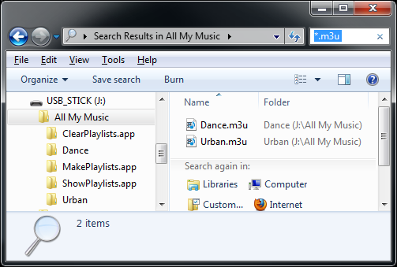

Updating Your Playlists
Every time you add, remove, move, or rename music files, or if you add, remove, move, or rename folders, you will need to update the automatically generated playlists by running the MakePlaylists script or application again.

Deleting Your Automatic Playlists
If for any reason you want to delete all of the automatically generated playlists, you can run the included script or application called “ClearPlaylists” that you copied to your storage device. This will delete all of the playlists in all folders and sub-folders in the same place as the ClearPlaylists script or application.
Before you run ClearPlaylists, you can use ShowPlaylists to confirm that only the automatically generated playlists will be deleted.

Important Notes
These notes should be carefully observed to prevent a loss of data, or unexpected results from using the Playlist Creation Tools.

Music Files Outside Music Folders
Music files located in the same folder as the place containing the scripts or applications, and the folders containing your music files, will NOT be discovered by the scripts. For example, the music files shown in this Windows Explorer example will not be added to any playlists:
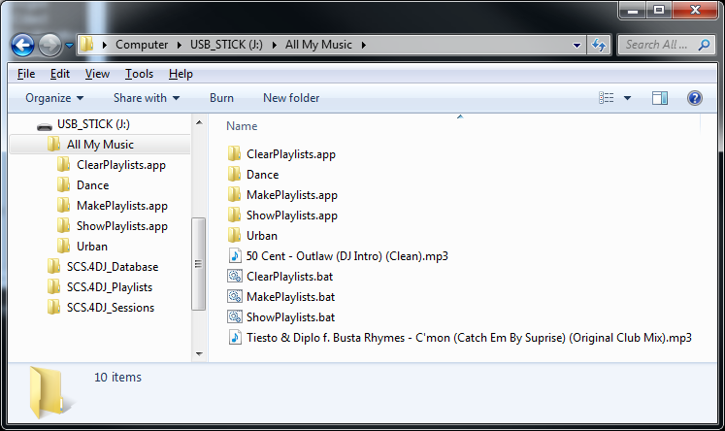

Music Files Outside the Scripts or Applications Folder
Music files and playlists that exist in folders above the location where the scripts and/or applications exist, or music files and playlists that exist in folders that are not in the same place as the scripts and/or applications or any of its sub-folders, will not be discovered, indexed into playlists, or deleted by the Playlist Creation Tools.

Preexisting Playlists
Any playlists that existed in your music folders will be deleted. This means that if your music folders or sub-folders contained playlists that you created yourself, or if they were created through other programs, they will be removed.
Make sure when organizing your collection that you move your already existing playlists to a location outside of the folder containing the Playlist Creation Tools scripts and applications and your folders containing your music.

Stanton SCS.4DJ Users
In addition to the important notes in the previous section, Stanton SCS.4DJ users should be aware of the following items.

Preexisting Playlists
Because you moved your music files into a newly created folder on your external USB Device (“All My Music” in the previous examples), any playlists that you created using your Stanton SCS.4DJ device should not appear or be affected by running the “ShowPlaylists” or “ClearPlaylists” scripts or applications. To confirm that your previously created playlists will be preserved before generating new automatic playlists by running MakePlaylists, run “ShowPlaylists” first.

User Forums
Users of the SCS.4DJ may visit the Stanton SCS.4DJ Forums for tips, support, or to exchange ideas and interact with other users. You can also find the author of the Playlist Creation Tools there.

Reminder When Ejecting USB Devices
Always remember to safely eject your external USB device from your Windows or Macintosh computer, or from your Stanton SCS.4DJ unit if you are using that device, or else files may become damaged.

Credits
Credit goes to Vinnie Falco from One Guy Group, Inc. for the idea, code, and instructions for the Playlist Creation Tools. Please visit his other open source projects:
“A Collection of Useful C++ Classes for Digital Signal Processing”
“Music Playlist Creation Tools”
Vinnie Falco's github Home Page
Credit also goes to Sveinbjorn Thordarson for developing Platypus, used to help make the Macintosh applications of the Creation Tools easy to use:
Platypus for Mac OS X

Trademarks
All trademarks belong to their respective owners:
Stanton SCS.4DJ is a trademark of Stanton Magnetics Inc.
Music Playlist Creation Tools is a trademark of One Guy Group, Inc.

