Implementation approaches of

Fixed-point iteration method for Systems of

Nonlinear equations

D. A. Vinnik

Taras Shevchenko National University of Kyiv

Kyiv 2019

Kyiv 2019

# Basic Concepts

Let we need to solve a system:

Let us write it as operator:

,

We shall rewrite it in the form:

*,*

where ,

– numeric parameter, – matrix.

Consider an iterative process:

, [1; Pt. 2, Ch. 5, p. 208]

when

For such a case:

* [2; Ch. 4, §24, p. 184]
* Such estimates of accuracy is fair

, [3; Ch. 1, §1.5.3, p. 44]

, [4; Ch. 7, §1, p. 326]

[2; Ch. 4, §24, p. 180]

* Sufficient convergence condition:

[2; Ch. 4, §24, p. 180]

* Priority estimate for accuracy :

[2; Ch. 4, §24, p. 181]

# Computer implementation questions

1. Norm selection

The most convenient norm is:

Because is searched as max value and most of math packages uses box searching borders, which corresponds norm.

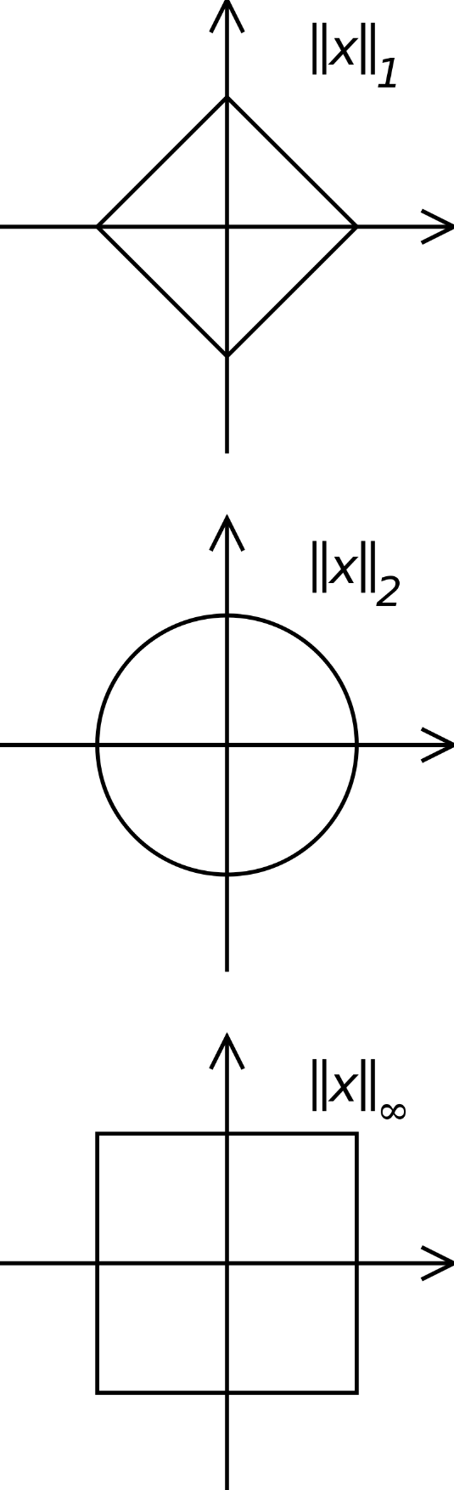

1. selection

Consider one equation case:

(1)

Define borders:

Let

(2)

Let us search optimal :

Rewrite it as:

Introduce an error:

Rewrite:

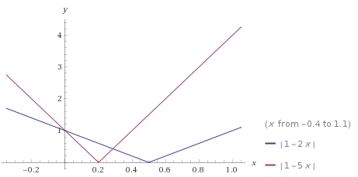Mean value theorem:

(3)

Let us make analogue for multiple-equations case:

There is no such restriction on as (2) because we cannot disclose the norm as a module.

In addition, there is no natural mean value theorem for operators, but (3) is met with small in norm vectors .

will be

Expand , :

References

1. *A. A. Samarsky, A. V. Gulin “Chislennyye metody” (“Numerical methods”). “Nauka”, 1989.*
2. *E. A. Volkov “Chislennyye metody” (“Numerical methods”). “Lan’", 2008.*

*ISBN 978-5-8114-0538-1.*

1. *Ya. S. Bugrov, S. M. Nikolsky "Vysshaya matematika. Differentsial'nyye uravneniya. Kratnyye integraly. Ryady. Funktsii kompleksnogo peremennogo" (“Higher Mathematics. Differential Equations, Multiple Integrals, Series, Theory of Functions of a Complex Variable”). “Drofa”, 2004. ISBN 5-7107-8450-8.*
2. *M. M. Moskalkov, A. I. Ryzhenko, S. O. Voitsekhovsky, A. V. Kuzmin, O. F. Kashpur etc. “Praktykum z metodiv obchyslenʹ” (“Workshop on calculation methods”). MAUP (IAPM—Interregional Academy of Personnel Management), 2006. ISBN 966-608-504-6.*