**Digital Business Enablement**

# Fireworks IOT

2TDSA

**Integrantes**

**RM**: 85642 | Gabriel Montovani Da Silva

**RM**: 85508 | João Marcos Santos de Almeida

**RM**: 84259 | Ronie Santos de Menezes

**RM**: 84401 | Vinicius Barbosa Santos

**RM**: 82077 | Vinicius Rodrigues Alves

# **Repositório no GitHub:** [**( LINK )**](https://github.com/vinnirx/GS-DIGITAL)

# **GET RESERVA SHOW**: [**( LINK )**](http://localhost:8080/hospedagem/api/setups/1)

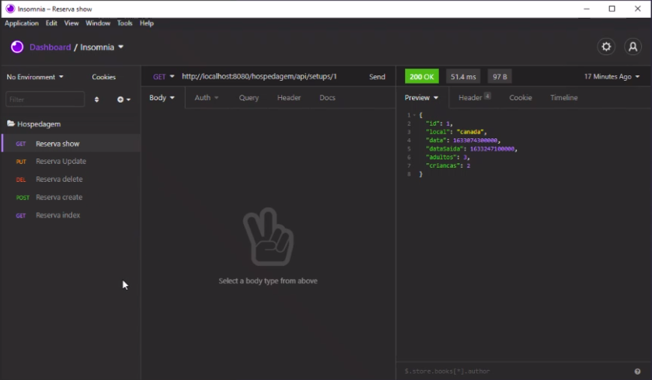

# **PUT RESERVA UPDATE:** [**( LINK )**](http://localhost:8080/hospedagem/api/setups/1)

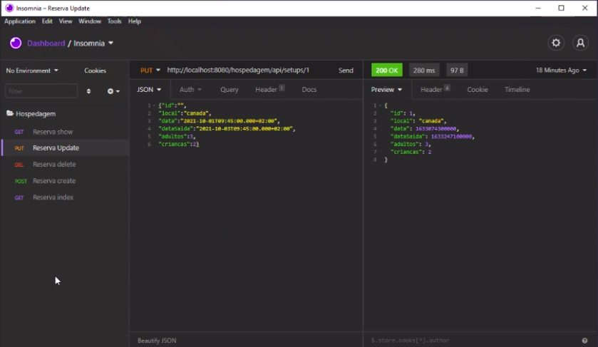

# **DEL RESERVA DELETE:** [**( LINK )**](http://localhost:8080/hospedagem/api/setups/22)

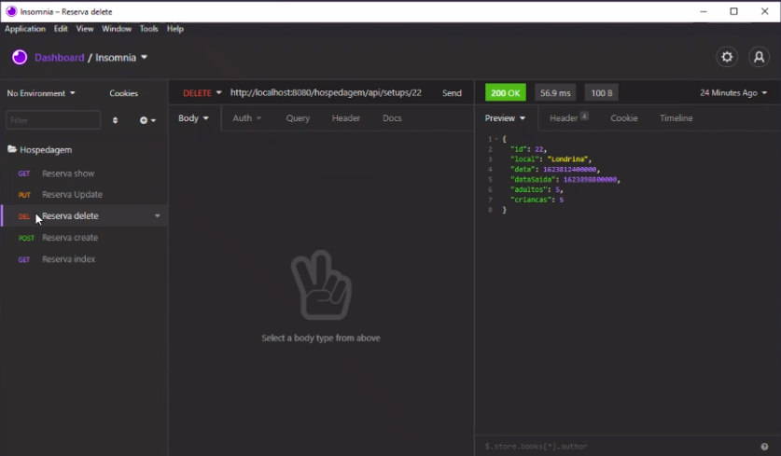

# **POST RESERVA CREATE**: [**( LINK )**](http://localhost:8080/hospedagem/api/setups/cadastrar)

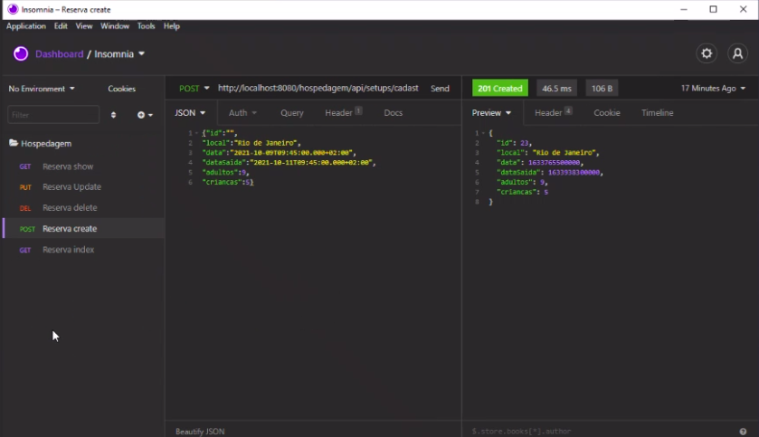

# **GET RESERVA INDEX:** [**( LINK )**](http://localhost:8080/hospedagem/api/setups)

