Database and Related Targets Discovery in OEM:-

1. Setup -> Add Target -> Add Targets Manually

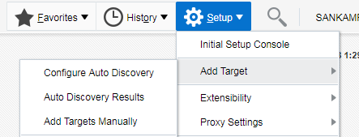

1. Click on “Add Using Guided Process”

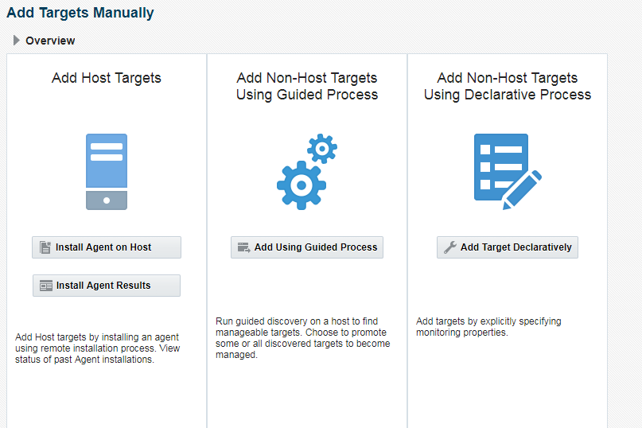

1. Add Using Guided Process screen will pop up.

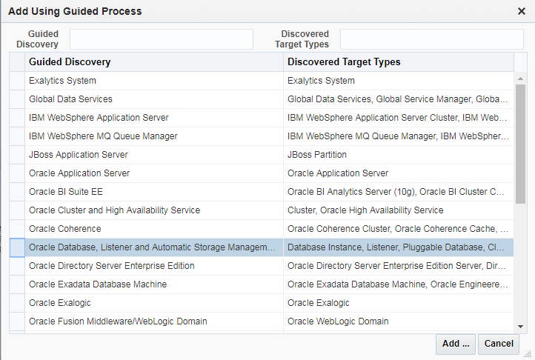

Select “Oracle Database, Listener and Automatic Storage Management” and click on “Add”

1. You will get the “Database Discovery: Search Criteria” screen

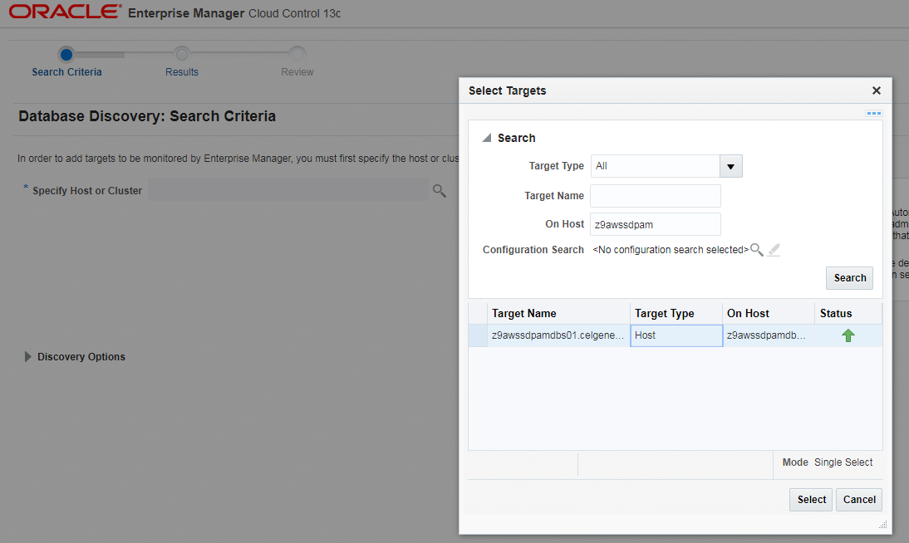

Search and select the server name on which you want to discover the database or related targets and click on “Next”

1. You will get “Database Discovery: Results” screen.

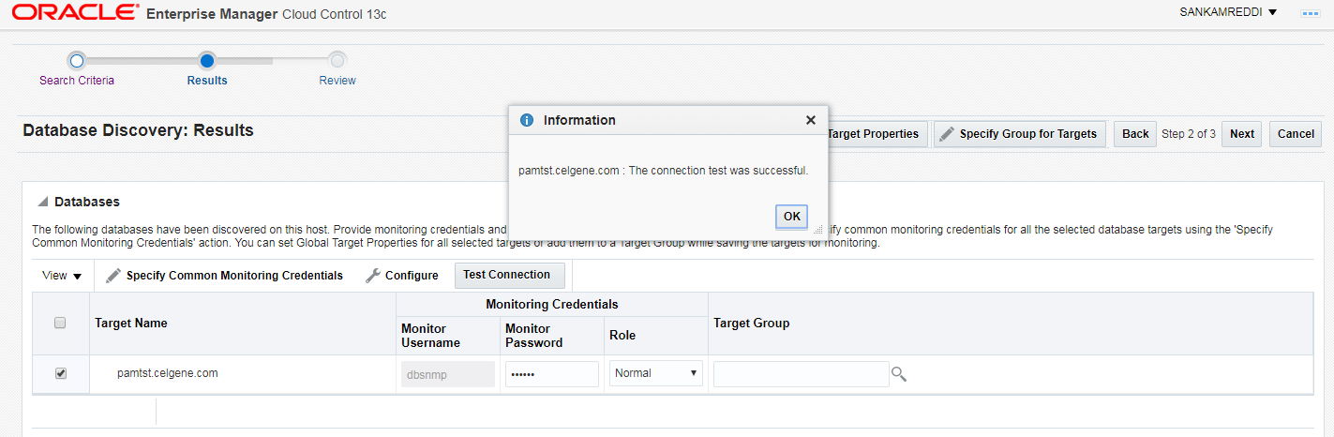

Select the database and other targets from the list and provide the monitoring password and test the connectivity by clicking on “Test Connection” and also select the appropriate Target Group depending on the environment of the database and click on “Next”.

1. You will get the “Database Discovery: review” Screen.

Once you click on save we will get the “Confirmation” screen.

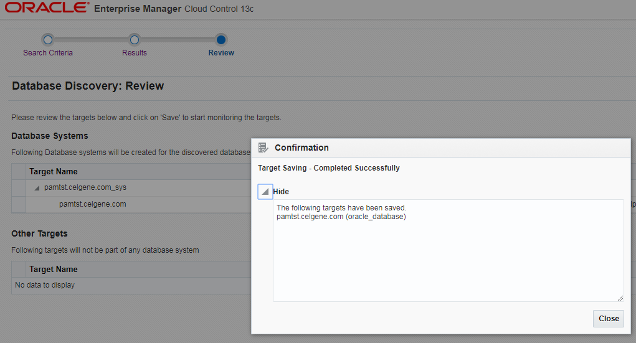

Close and search for the targets to confirm the status. Sometimes it may take few minutes to reflect the target status as “UP”

