Housekeeping Management System
Software Requirements Specification



Submitted By

Anugrah Shukla(B15CS035)
Vinayak Singla(B15CS039)
Revision History
Date | Version | Description | People
16 Jan 2017 | 1.0 | First draft | Project Group: Flash
 |  |  | Vinayak Singla
 |  |  | Anugrah Shukla
2 Feb. 2017 | 2.0 | Second draft
1 Mar 2017 | 3.0 | Third draft

Table of Contents
1. Introduction 4
1.1 Purpose 4
1.2 Scope 4
1.3 Constraints 4
1.4 Assumptions and Dependencies 4
1.5 Definitions, Acronyms and Abbreviations 4
1.6 References 4
1.7 Organization of the Document 4
2. Overall Description 5
2.1 Product Functions 5
2.2 User Characteristics 14
3. Specific Requirements 15
3.1 Use case description 15

Software Requirements Specification

Introduction
This Housekeeping Management System enables automation of the Housekeeping system. From lodging of complain to checking the progress status to re-open an unsatisfied complaint, a user can do what not!, Just on the click of a button. It eases most of the rigorous part of housekeeping activities along with maintaining transparency in the system. All these can be effectively done with the help of our software.

Purpose
The purpose of the software is to automate the process of housekeeping so as to reduce human effort and thus save both time and energy.

Scope
This software will be used by the housekeeping department of any institute to make the process of housekeeping management more efficient.

Constraints
1.3.1 Update of status of complaints would be done only after each shift .
1.3.2 Update of status of complaints has to be done manually .
1.3.3 User must be familiar with an internet browser and also familiar with handling of the keyboard and mouse.
1.3.4 User must possess decent internet connectivity.
1.3.5 Hardware designated for the software product has a operational internet browser.
1.3.6 The user must register once and then each time should log in to use software.

Assumptions and Dependencies
1.4.1 Enough number of employees to address the complaints generated each day(i.e. huge pile of unaddressed complaints won't be generated)
1.4.2 It is assumed that at the time of registration user will provide right credentials.

Definitions, Acronyms and Abbreviations
Term | Definition
User | Someone who interacts with the software
Admin | System administrator who is given specific permission for managing and controlling the system
Shift | 8:00am-1:00pm  2:00pm-7:00pm

References
1.6.1 UML@Classroom

Organization of the Document
The remainder of this document includes UML diagrams.

Overall Description

Product Functions

Functional Requirement-
This software provides various functionalities to the users like check the status of complaint and Re- open a complaint. Also a user can give his valuable feed-back to let the admin improve his service. This software also enables the admin to keep a check on all the complaints, generate a to-do list of all complaints to be addressed on a particular day, check the complaints made on a particular date in the past (up to two weeks at max). The admin has to update the status of a complaint and close a complaint after its completion.

Use Case Diagram

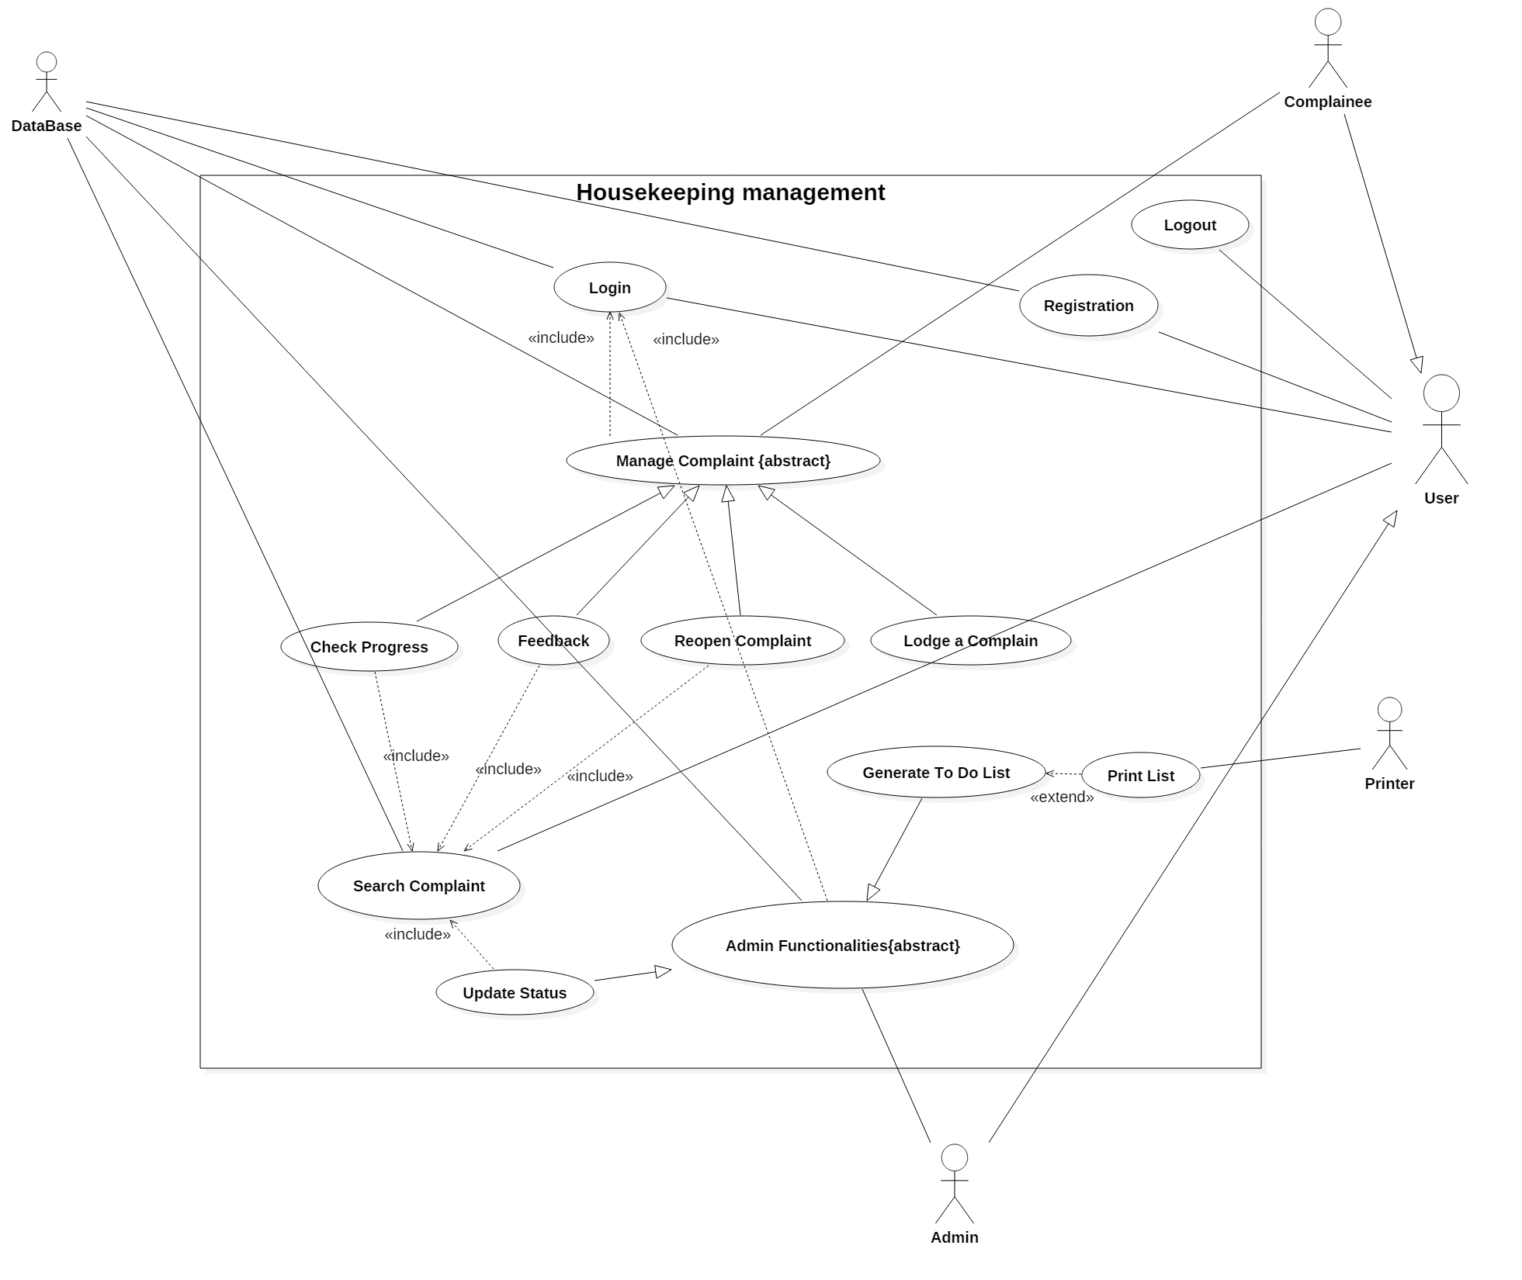

Class Diagram

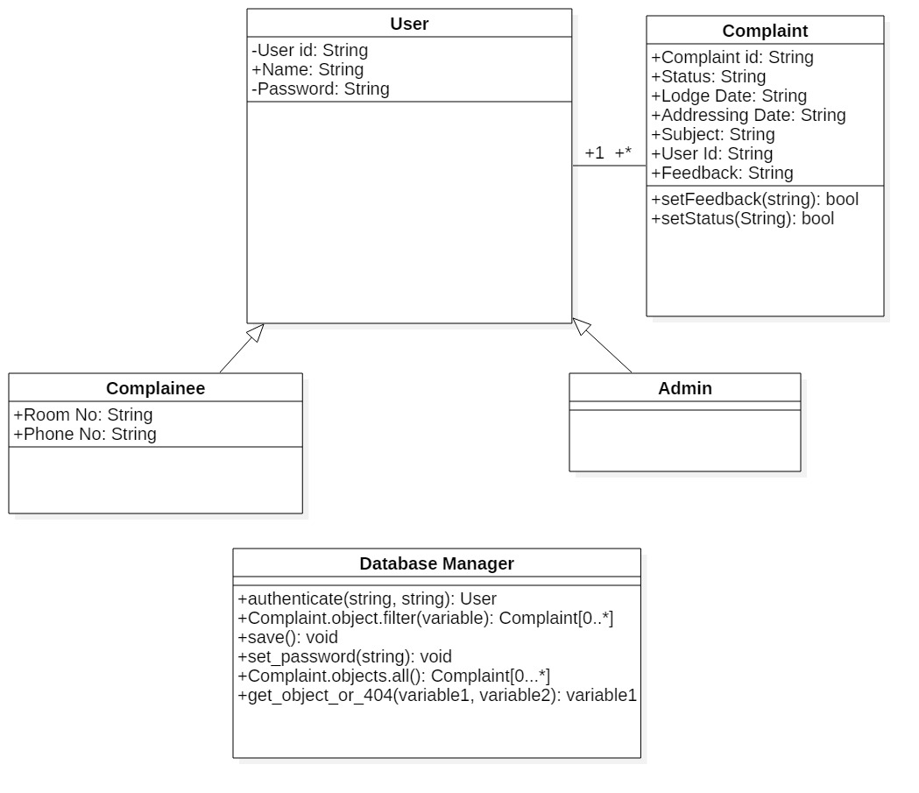

Sequence Diagram

2.1.1.3.1

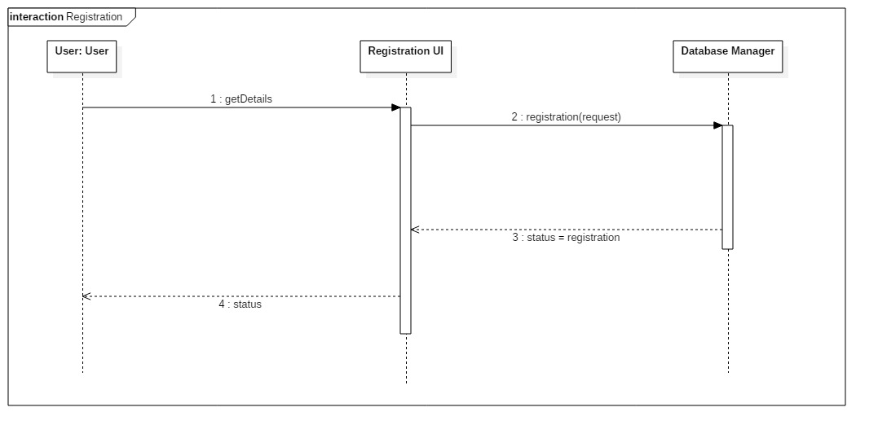
2.1.1.3.2

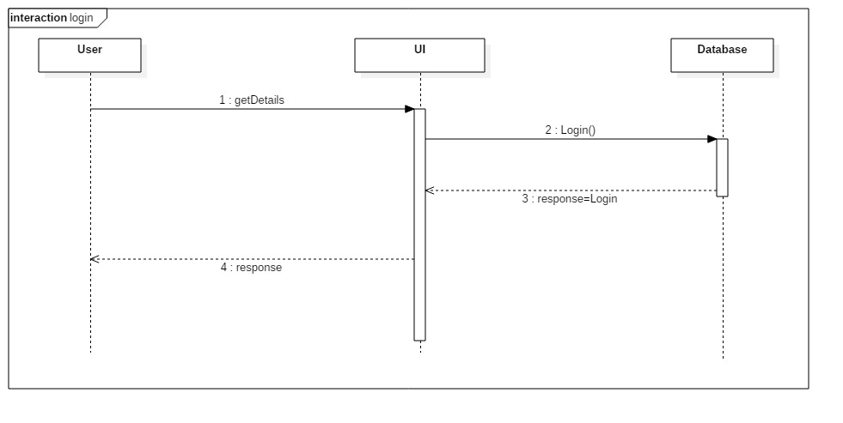

2.1.1.3.3

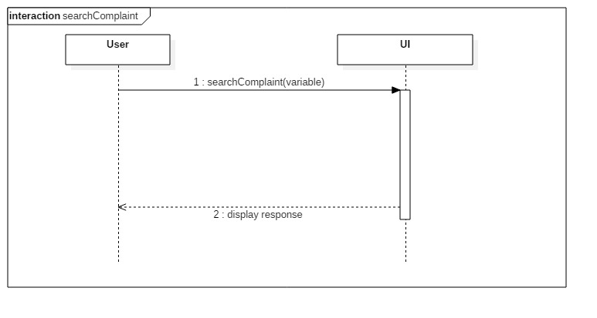
2.1.1.3.4

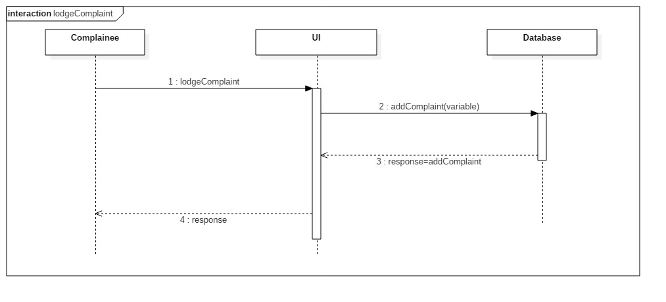
2.1.1.3.5
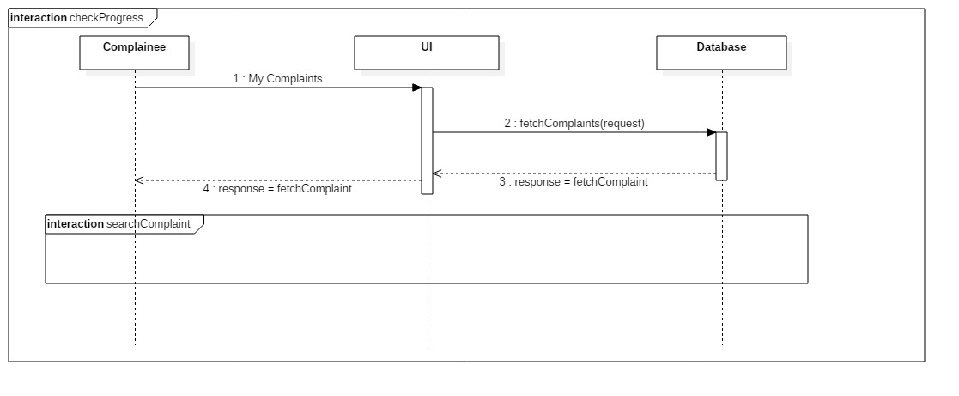

2.1.1.3.6
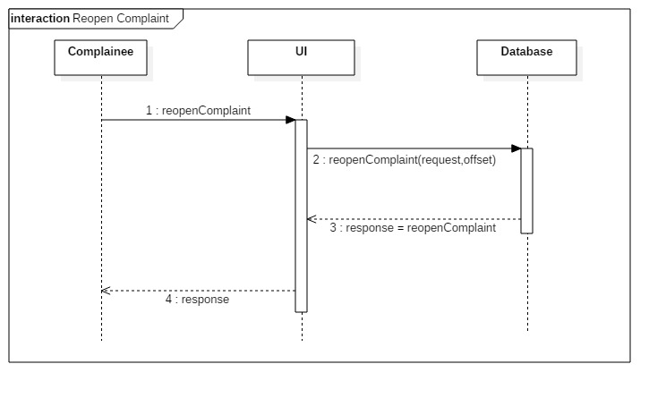
2.1.1.3.7
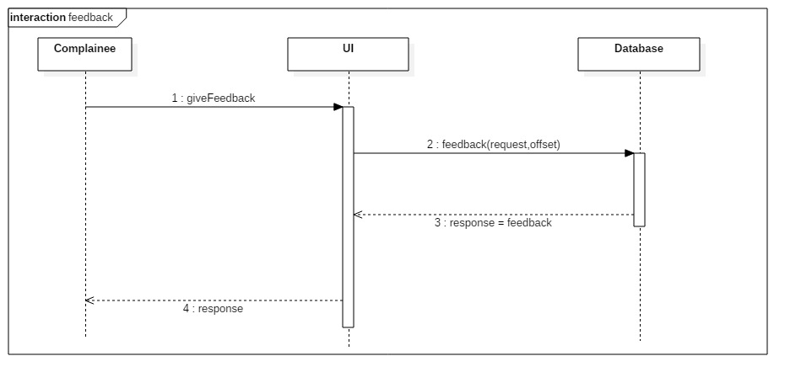

2.1.1.3.8
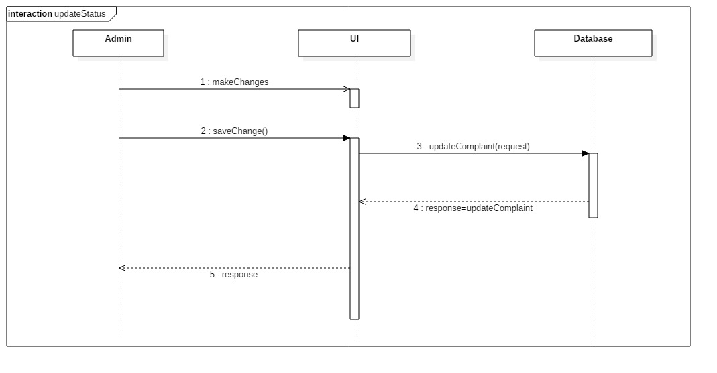
2.1.1.3.9
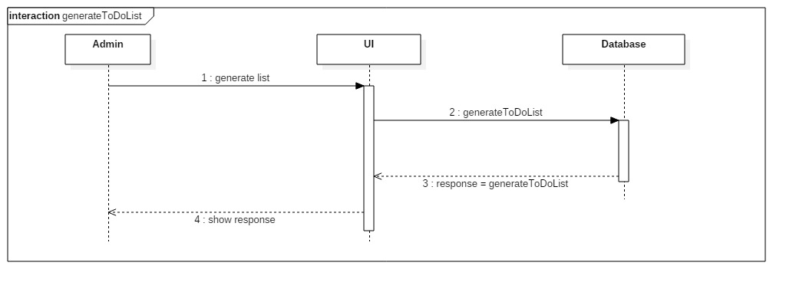
2.1.1.3.10

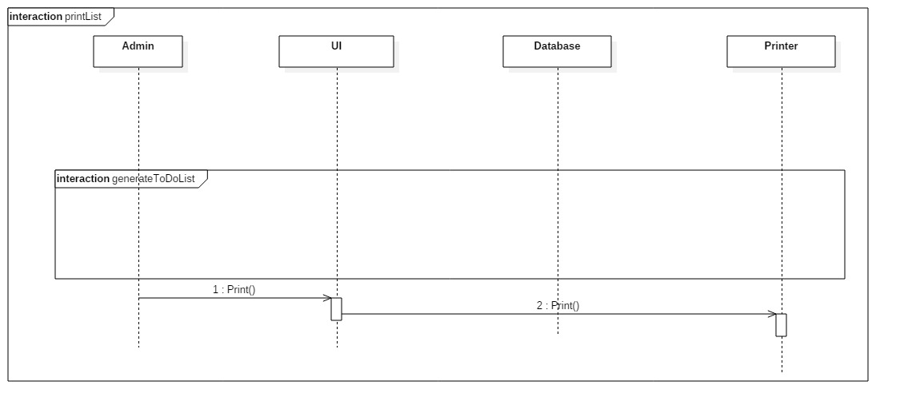

Activity Diagram

2.1.1.4.1 Complainee Activity Diagram
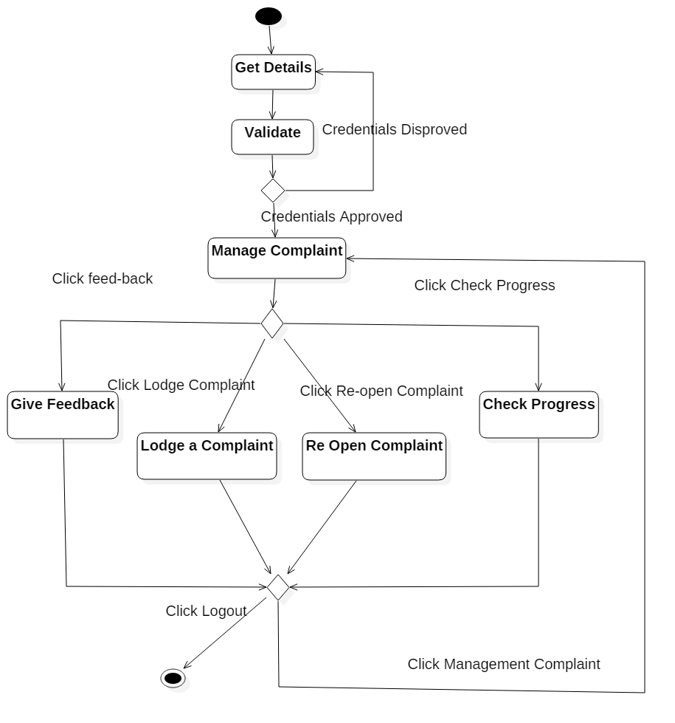

2.1.4.1.2 Admin Activity Diagram

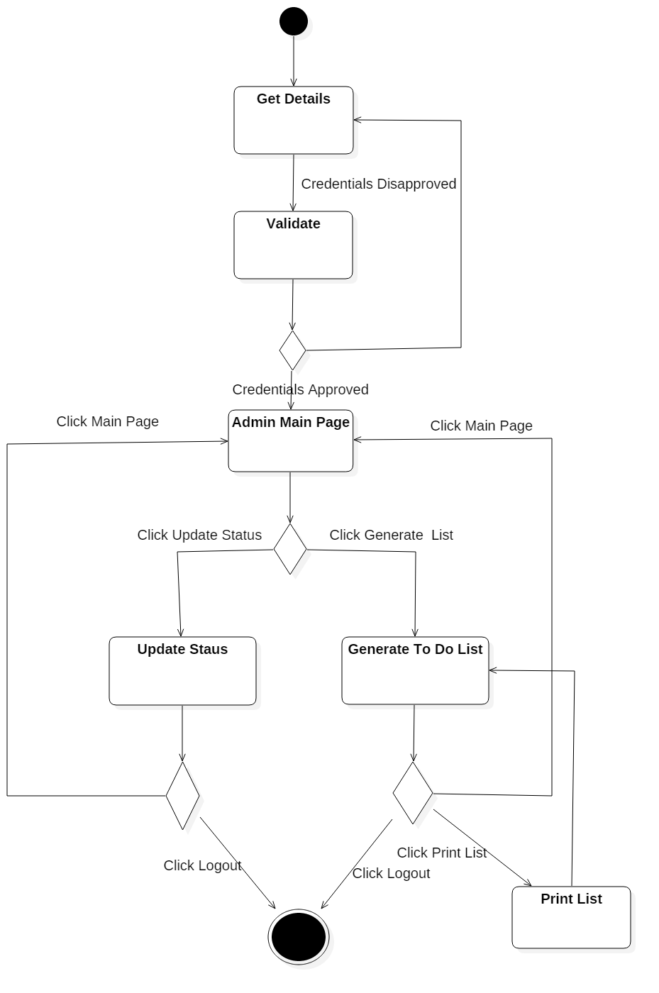

Non-Functional Requirements
There should be internet connection. A domain name and server would be required to make it completely ready to use apart from that a web browser on a compatible machine is required to use the software. The scalability of the software is that it can be used by institute like hostels also the user can use this software at any time.

User Characteristics

Specific Requirements

Use case description

Registration

Name: | Registration
Short Description | A person can enter his details and register to the system
Pre-Condition | The person has to be a resident of the institute the software is designed for
Post-Condition | The user is registered with the system and can login using these credentials to make use of the software
Error Situations | Database connection is lost
System state in the event of an error | Registration is not complete
Actors | Person
Trigger | Person enters personal details and clicks on ‘register’
Standard process | 1)The person who is a resident has to enter personal details and sign up  2)These details are then entered in the data base and validated from here whenever the person tries to login in future  3)Registration is complete
Alternative process | NULL

Login
Name: | Login
Short Description | The user or the admin has to enter valid credentials to login the system
Pre-Condition | The user has to be registered in the system
Post-Condition | The user has logged in the system
Error Situations | Database connection is lost
System state in the event of an error | Login is not permitted
Actors | user
Trigger | User enters credentials and clicks on login
Standard process | 1)User has to be registered with the system  2)He enters his credentials and tries to login  3)These credentials are the validated with the help of data base  4)if found correct he is directed to the main page  else error message is shown asking to enter valid details
Alternative process | NULL

Search Complaint

Name: | Search Complaint
Short Description | The user/admin can search for a particular complaint with the help of the complaint id or view many complains based on a criteria and select one he needs(in case he doesn't remember the complaint id)
Pre-Condition | The complaint to be searched has to be lodged in the past.
Post-Condition | The desired complaint details is shown on the screen
Error Situations | Database connection is lost
System state in the event of an error | The complaint is not searched
Actors | Admin/User
Trigger | A complaint is searched either via an id or other parameter
Standard process | 1)The user or the admin enters the id and clicks on the search button to search for the complaint.  2)He/she may also search for the complaint via other parameters.  3)Then after co-ordination with the data base the complaint details are put up on screen.
Alternative process | -

Lodge Complaint

Name: | Lodge a complaint
Short Description | The user can after longing into his account can make a fresh complaint.
Pre-Condition | The user has to login.
Post-Condition | A fresh complaint will be registered and stored in the data base.
Error Situations | Database connection is lost
System state in the event of an error | Complaint is not lodged
Actors | User
Trigger | User logs in and lodges a complaint by clicking on ‘make-complaint’ button
Standard process | 1)The user has to login and click on the ‘make-complaint’ button prompting the software to store his complaint in the data base.  2)The admin then sees the complaint and schedules it to be serviced on a particular date.
Alternative process | The user will have to make a personal visit or telephone the admin office to make the complaint.

Show Progress

Name: | Check Progress
Short Description | The user can check the progress of his complaint
Pre-Condition | A complaint has to be lodged
Post-Condition | The progress status of the complaint service is displayed on screen
Error Situations | Database connection is lost
System state in the event of an error | The progress status is not shown
Actors | User/Admin
Trigger | User/Admin clicks on the check Progress status button associated with a complaint
Standard process | 1)The complaint whose progress has to be checked has to be lodged prior  2)The user/admin clicks on the check status button  3)Progress status of the complaint is fetched from the data base and displayed on screen
Alternative process | User may call the admin office to know the status.

Re Open Complaint

Name: | Re-open Complaint
Short Description | In case the user is not satisfied with the service he can re-open the complaint within 1 months time (from date of lodging the complaint)
Pre-Condition | Complaint was lodged prior and is closed now
Post-Condition | The complaint re-opens again
Error Situations | Database connection is lost
System state in the event of an error | Complaint is not re-opened
Actors | User
Trigger | When the user clicks on the reopen complaint button
Standard process | 1) Whenever a complaint is closed after servicing and the complainee feels unsatisfied he/she can re-open the complaint with the help of the complaint id generated during initial lodging.  2)As soon as the complaint is reopened, the admin can see it and update the status of the complaint.
Alternative process | The user can call the admin office and personally request to re-open the complaint.

Feedback
Name: | Feedback
Short Description | The user can give his feedback regarding the service or incase if the complaint is not serviced also
Pre-Condition | Complaint has to be lodged prior and feedback can only be given for a complaint lodged within recent 1 month
Post-Condition | Feedback is stored against that complaint in the database
Error Situations | Database connection is lost
System state in the event of an error | Feedback is not taken
Actors | User
Trigger | The user clicks on the feedback button to give his feedback
Standard process | 1)A complaint has to be lodged prior for which the feedback is to be given  2)If allowed the user clicks on the feedback button and writes his feedback regarding the service  3)This feedback is then stored in the database
Alternative process | The user can telephone the admin office and give his feedback

Generate To Do List
Name: | Generate To Do List
Short Description | The admin can generate a list of all the complains scheduled to be serviced on a particular date
Pre-Condition | Certain complains are to be scheduled by the admin on a particular date
Post-Condition | A list of all services for a particular date has to be generated on screen
Error Situations | Database connection is lost
System state in the event of an error | To do list is not generated
Actors | Admin
Trigger | Admin commands generation of To Do list
Standard process | 1) Complains are to be scheduled for a particular date  2)The admin commands generation of a To Do list for a particular date to distribute work to workers  3)List is generated after fetching required data from data base  4)List is to be printed and handed over to workers
Alternative process | NULL

Update Status
Name: | Update Status
Short Description | The admin can update the status of a complaint as closed,in-progress,etc
Pre-Condition | Complaint has to be lodged by a user
Post-Condition | The status of the complain is now changed in the data base
Error Situations | Database connection is lost
System state in the event of an error | The status of a complaint is not updated
Actors | Admin
Trigger | Admin clicks on the ‘update-complaint’ button
Standard process | 1) Complains are to be lodged by users  2)The admin after the complain is serviced updates the status of the complaint as closed,etc.  3)The status of the complaint is now updated in the data base
Alternative process | NULL

Print List

Name: | Print List
Short Description | Prints the To-Do list of complaints to be serviced on a particular date
Pre-Condition | To-Do list is generated on screen and printer connection is present
Post-Condition | A printed document of To-Do list of complaints is printed
Error Situations | Printer is not working
System state in the event of an error | List won't be printed
Actors | Admin
Trigger | Print command for printing
Standard process | 1)A To-Do list of complaints is generated on screen and is ready to be printed  2)If the printer is working the print command is given and the document is printed
Alternative process | -

