**TICKET NUMBER:-**INC0076734

**NAME**:- Srichandana chada

**Employee ID:-** 46280736

**SHORT DESCRIPTION:-** User Modification 2

**Description**:- Every New user added to organization should have simlab.policy file present in their home directory. Simlab.policy file should have content 'All policies applicable to this asset as per organisation policies. Please go through policy documents'

Step1:- creating user and giving policy to directory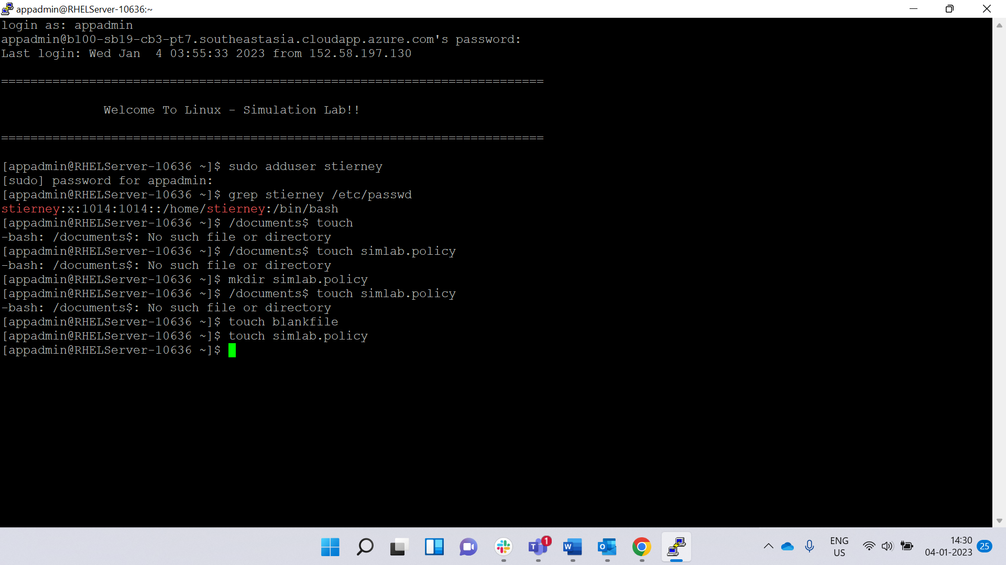

Step2:-verification :-giving content to directory