**TICKET NUMBER:-**INC0076857

**NAME**:- Srichandana chada

**Employee ID:-** 46280736

**SHORT DESCRIPTION:-** Job Creation 1

**Description**:- Schedule a job to run daily at 3.30 pm and test for the following:

Get following server configuration items[CI] details into file named 'Health-checkup.txt' with timestamp. Save the file in /root folder.

CI's: CPU usage, Processes running, Memory usage,Server Uptime, File System's mounted, kernel version, OS release version, IP details.

Step1:- Schedule a job to run daily at 3.30 pm and test for the following:

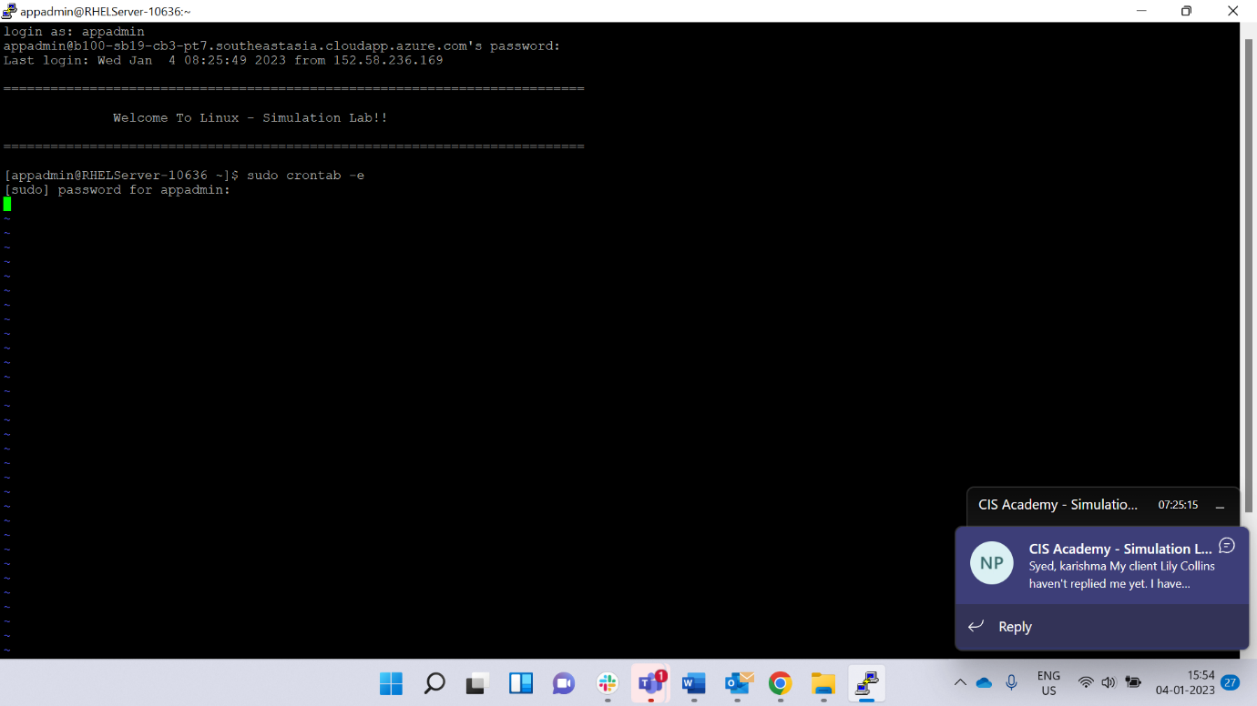

Step 2:- Schedule a job to run daily at 3.30 pm and test for the following

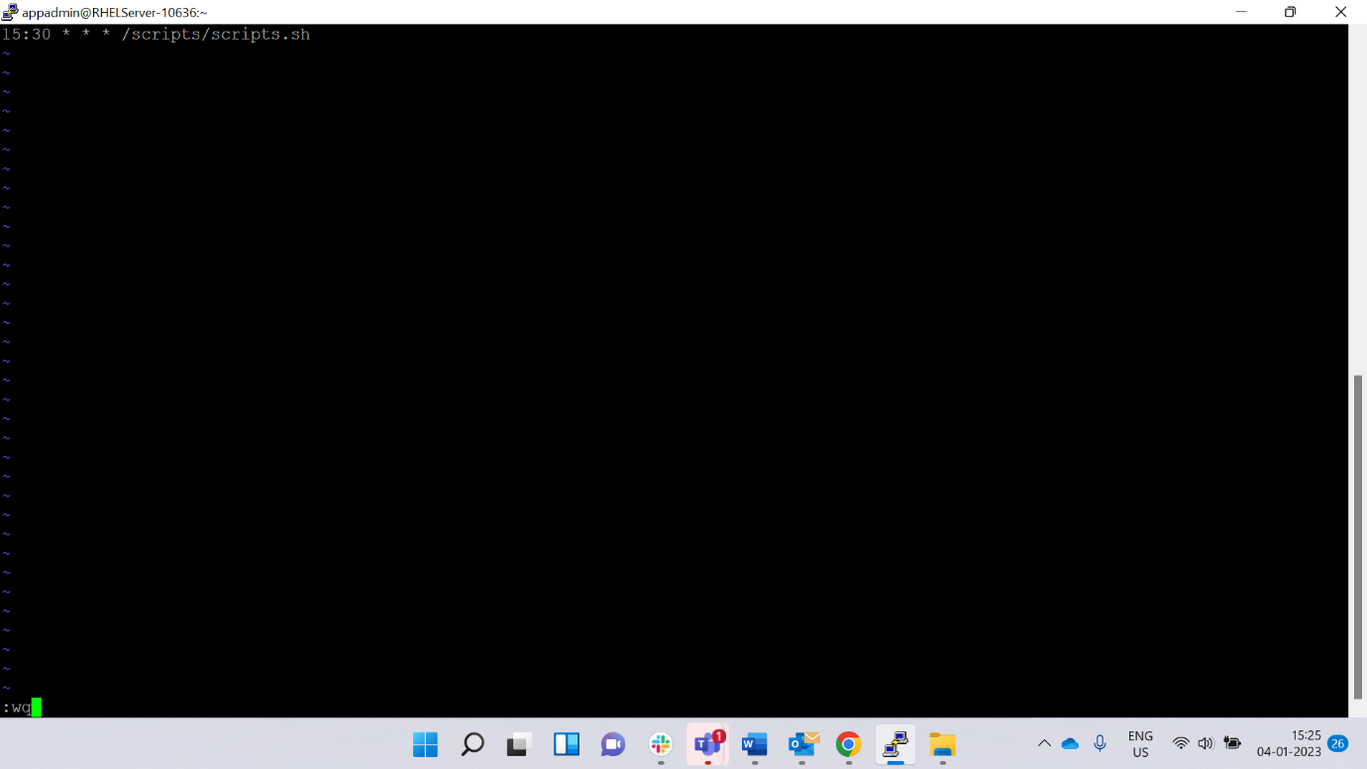

Step 3:- Get following server configuration items[CI] details into file named 'Health-checkup.txt' with timestamp. Save the file in /root folder 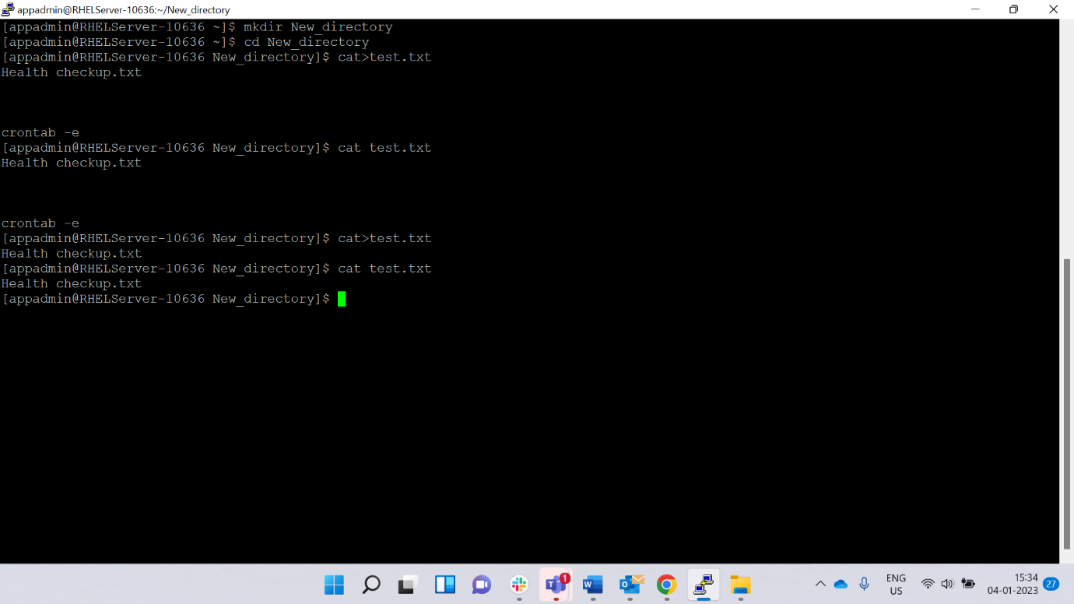

Step 4:- verification

