**TICKET NUMBER:-**INC0076965

**NAME**:- Srichandana chada

**EMPLOYEE ID:-** 46280736

**SHORT DESCRIPTION:-** Special Permission 1

**Description**: i) Create sales group with GID 1000 and finance group with GID 1001

ii) Create users:

a) ram and shyam member of sales group

b) alex and bob member of finance group

iii) Create a directory /depts. Create sub directories sales and finance under /depts folder.

iv) Set group ownership of directories with their respective groups. For ex: /depts/finance is group owned by finance group

v) Change the permissions on each subdirectory to grant full permissions to the respective group and deny access to others.

vi) Files/Folders created within those directories should be owned by the appropriate group, recursively automatically.

vii) Users cannot delete each other files created inside their respective group directories.

Step1:- Created sales group with GID 1000 and finance group with GID 1001

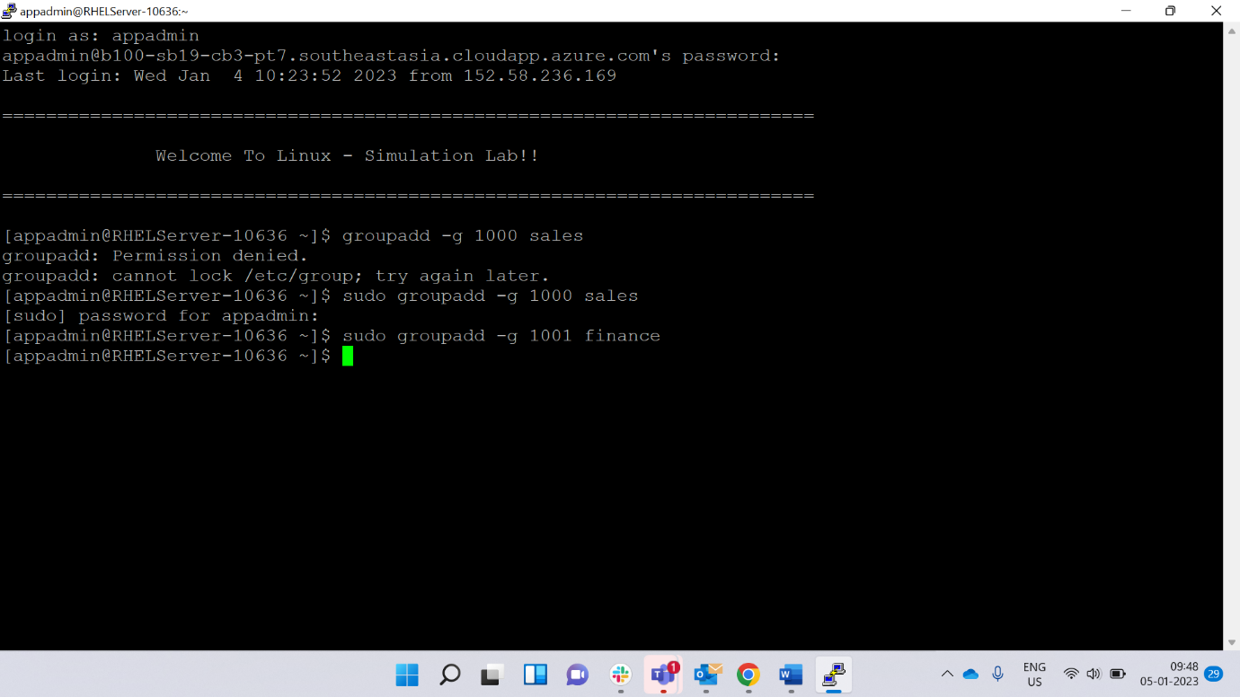

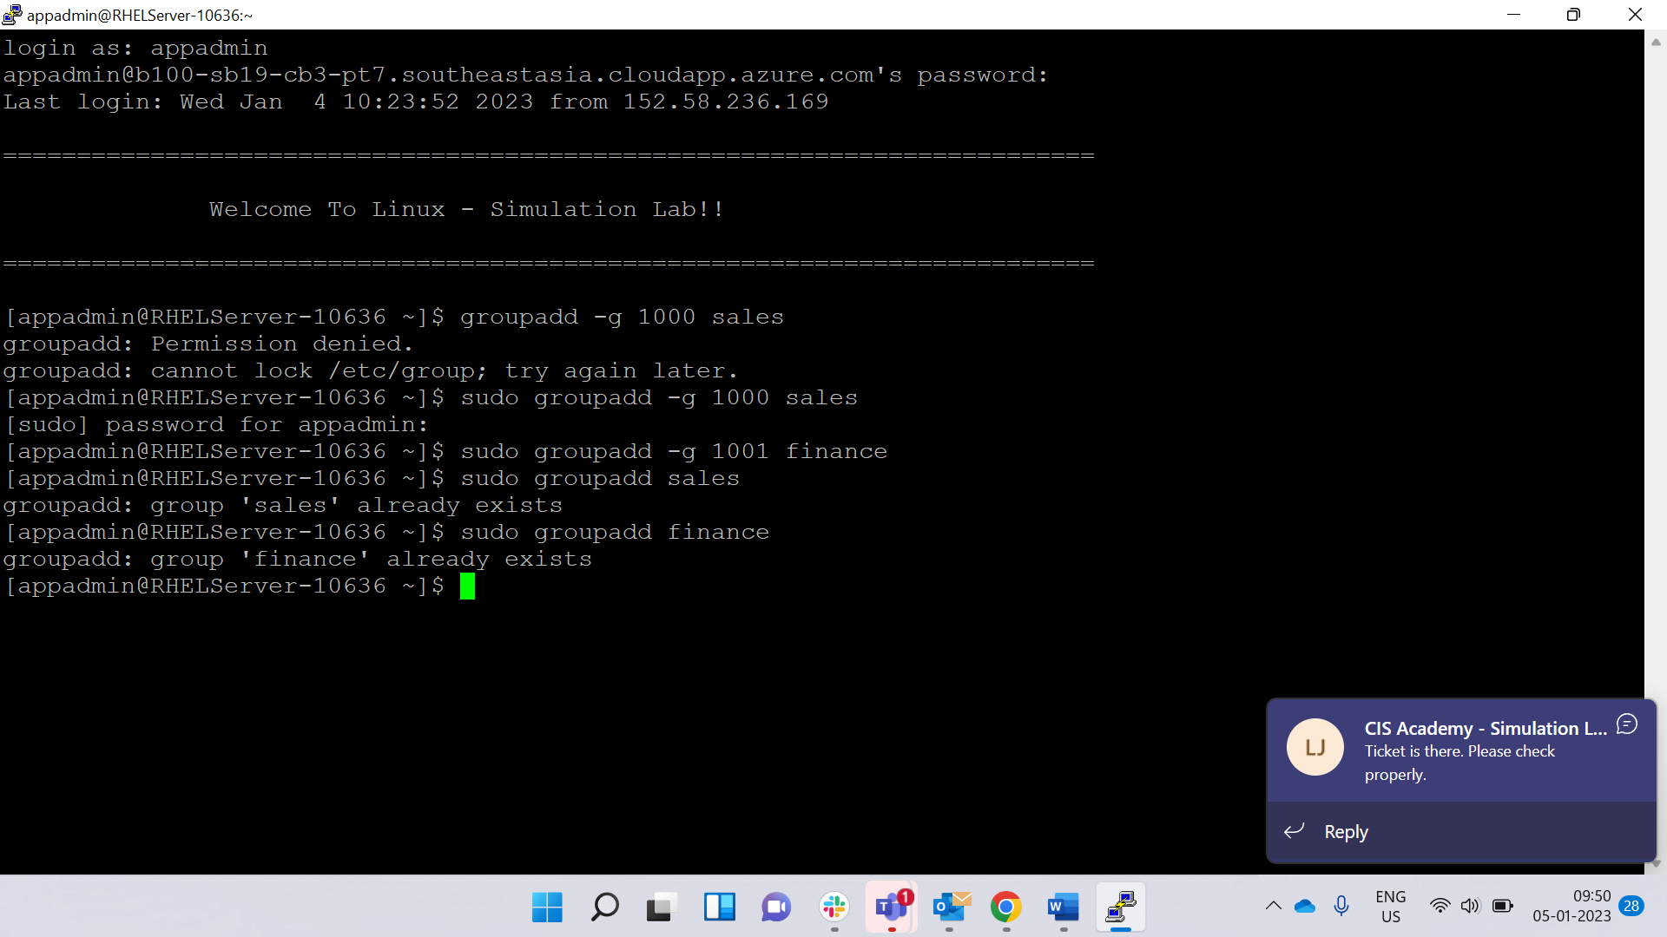

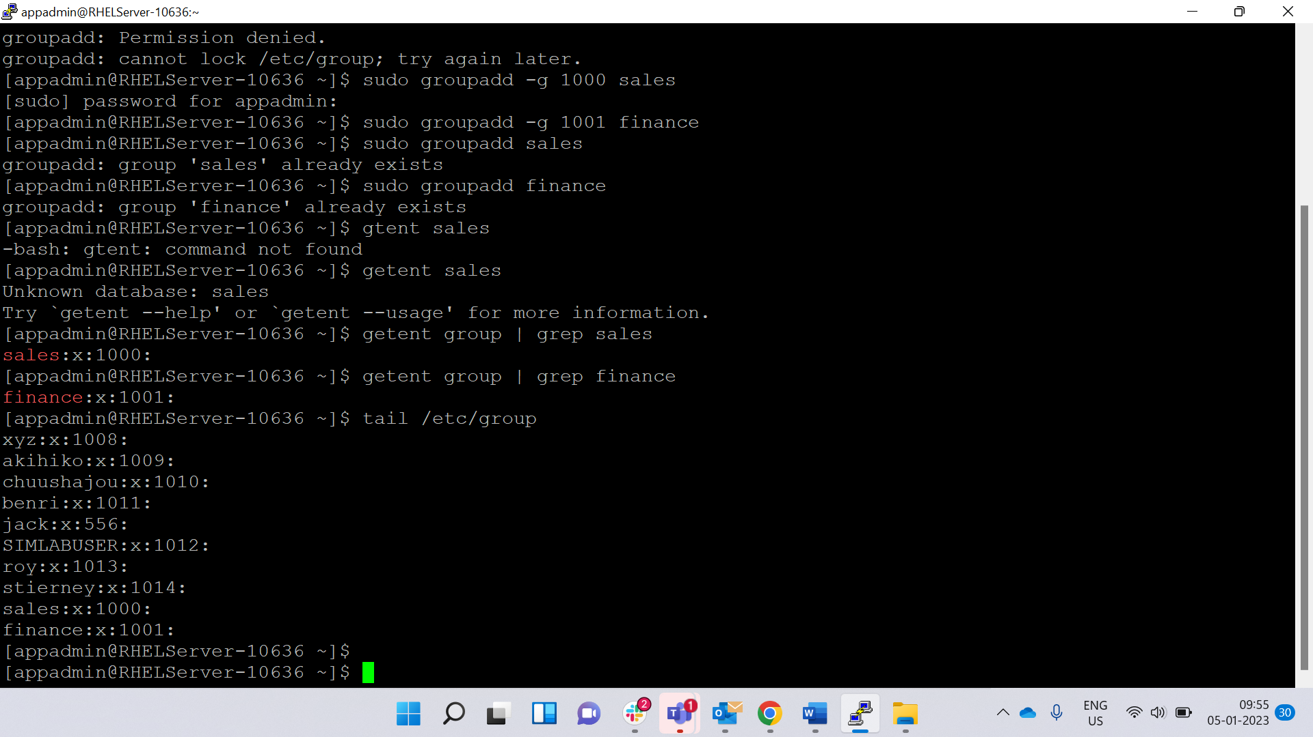

Step 2:- Created users:

a) ram and shyam member of sales group

b) alex and bob member of finance group

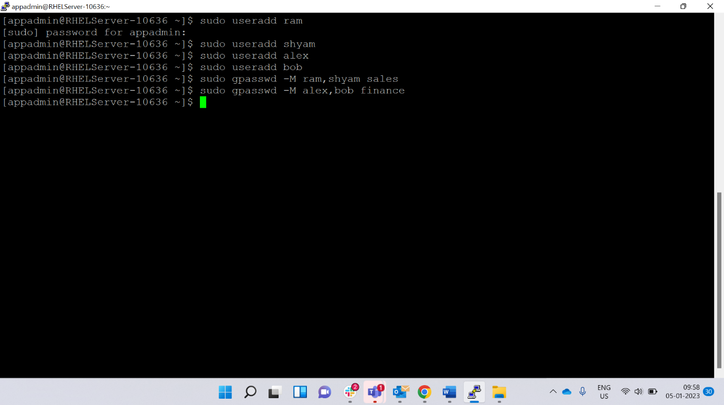

Step 3:- ) Created a directory /depts. Create sub directories sales and finance under /depts folder.

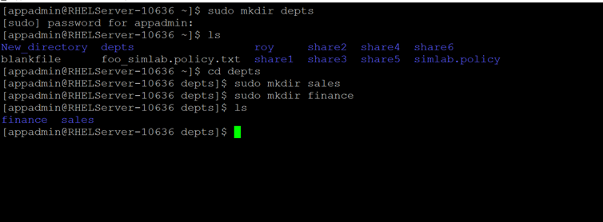

Step 4:- Set group ownership of directories with their respective groups. For ex: /depts/finance is group owned by finance group

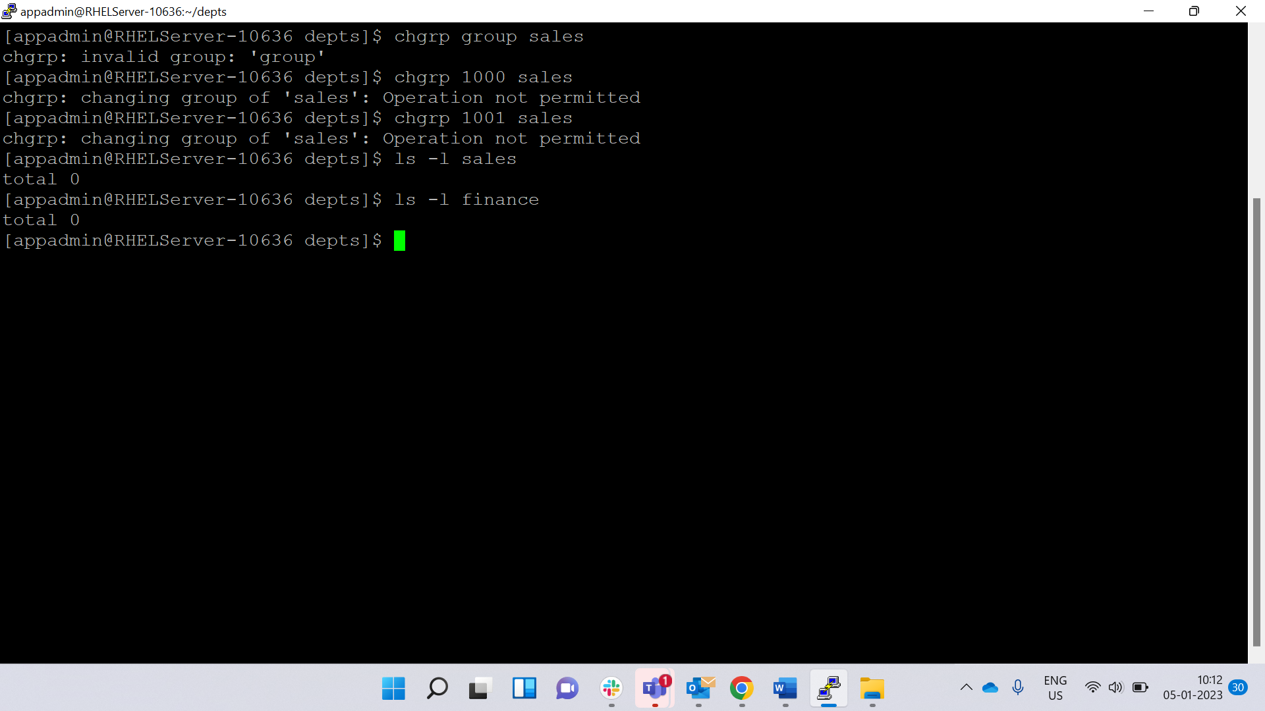

Step 5:- Change the permissions on each subdirectory to grant full permissions to the respective group and deny access to others.

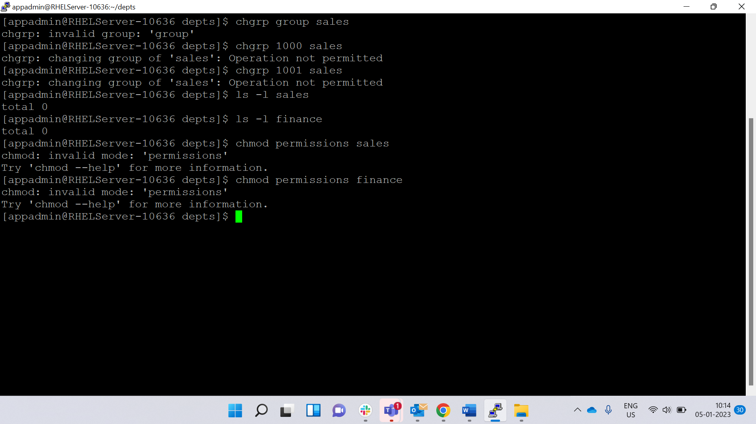

Step 6:-verification

Files/Folders created within those directories should be owned by the appropriate group, recursively automatically.

vii) Users cannot delete each other files created inside their respective group directories.

