**TICKET NUMBER:-**INC0077091

**NAME**:- Srichandana chada

**EMPLOYEE ID:-** 46280736

**SHORT DESCRIPTION:-** User Modification 3

**Description****:** Create a new group HR with a group ID 777

Add users Akihiko & Benri to the group HR.

Create a folder HR in docker with only access to members of HR group. & only members of HR can delete files being created in this folder.

Step 1:- Create a new group HR with a group ID 777

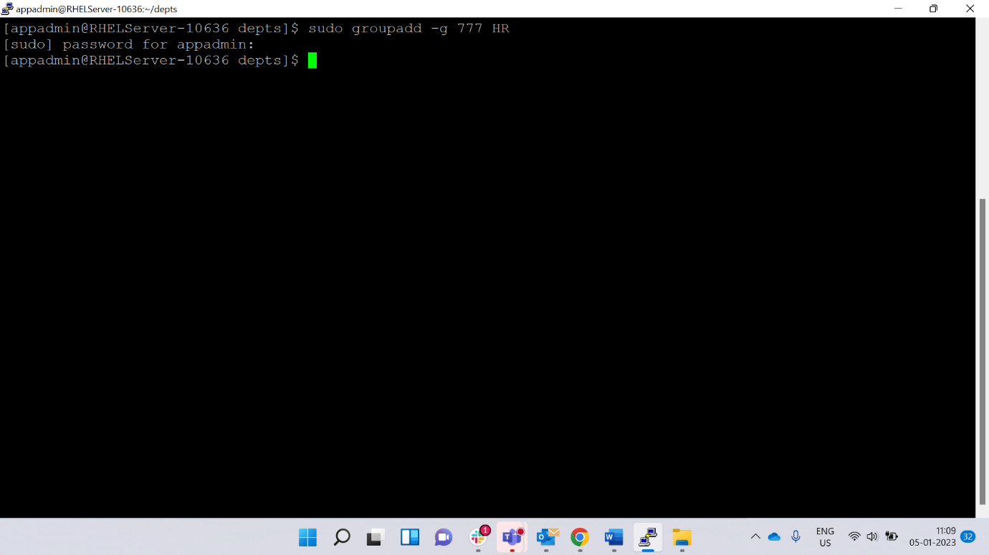

Step 2:- Add users Akihiko & Benri to the group HR.

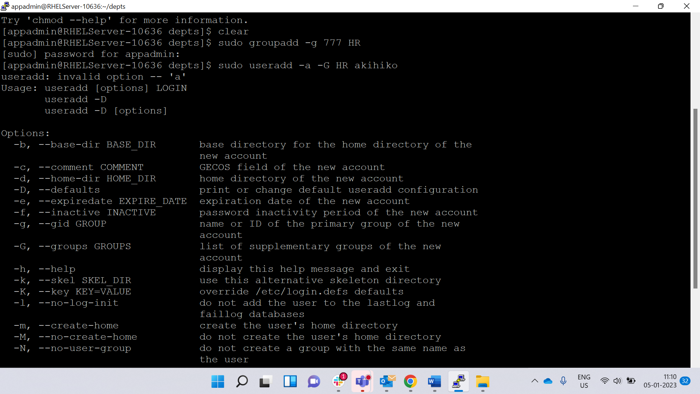

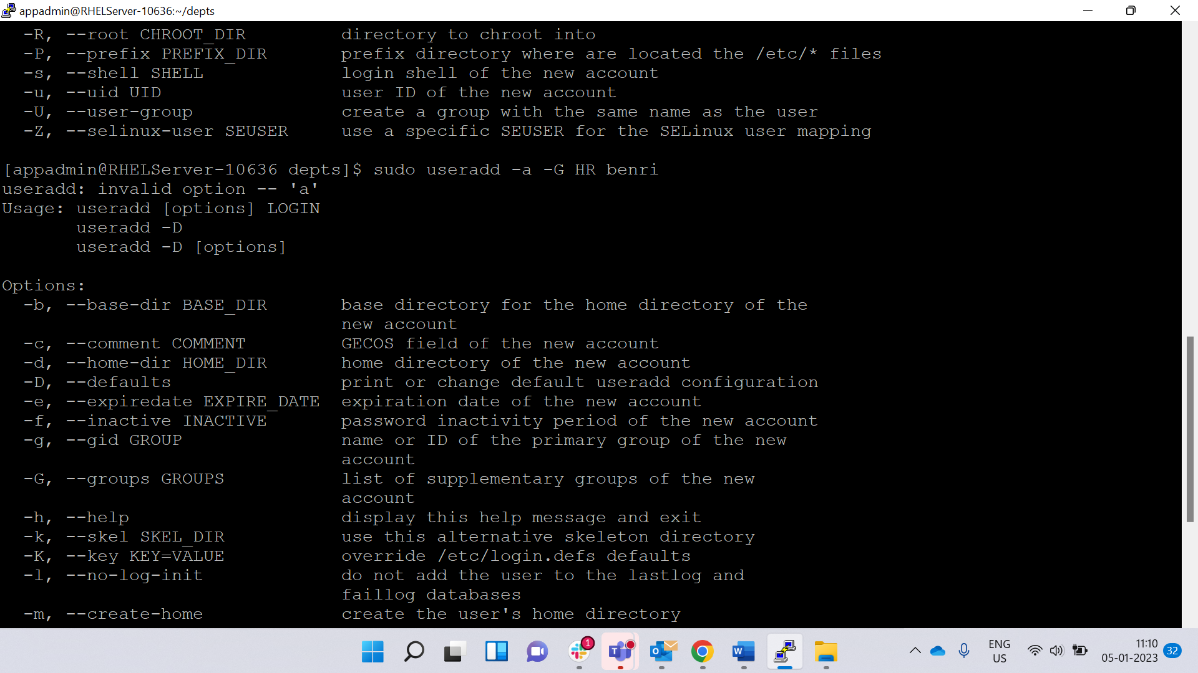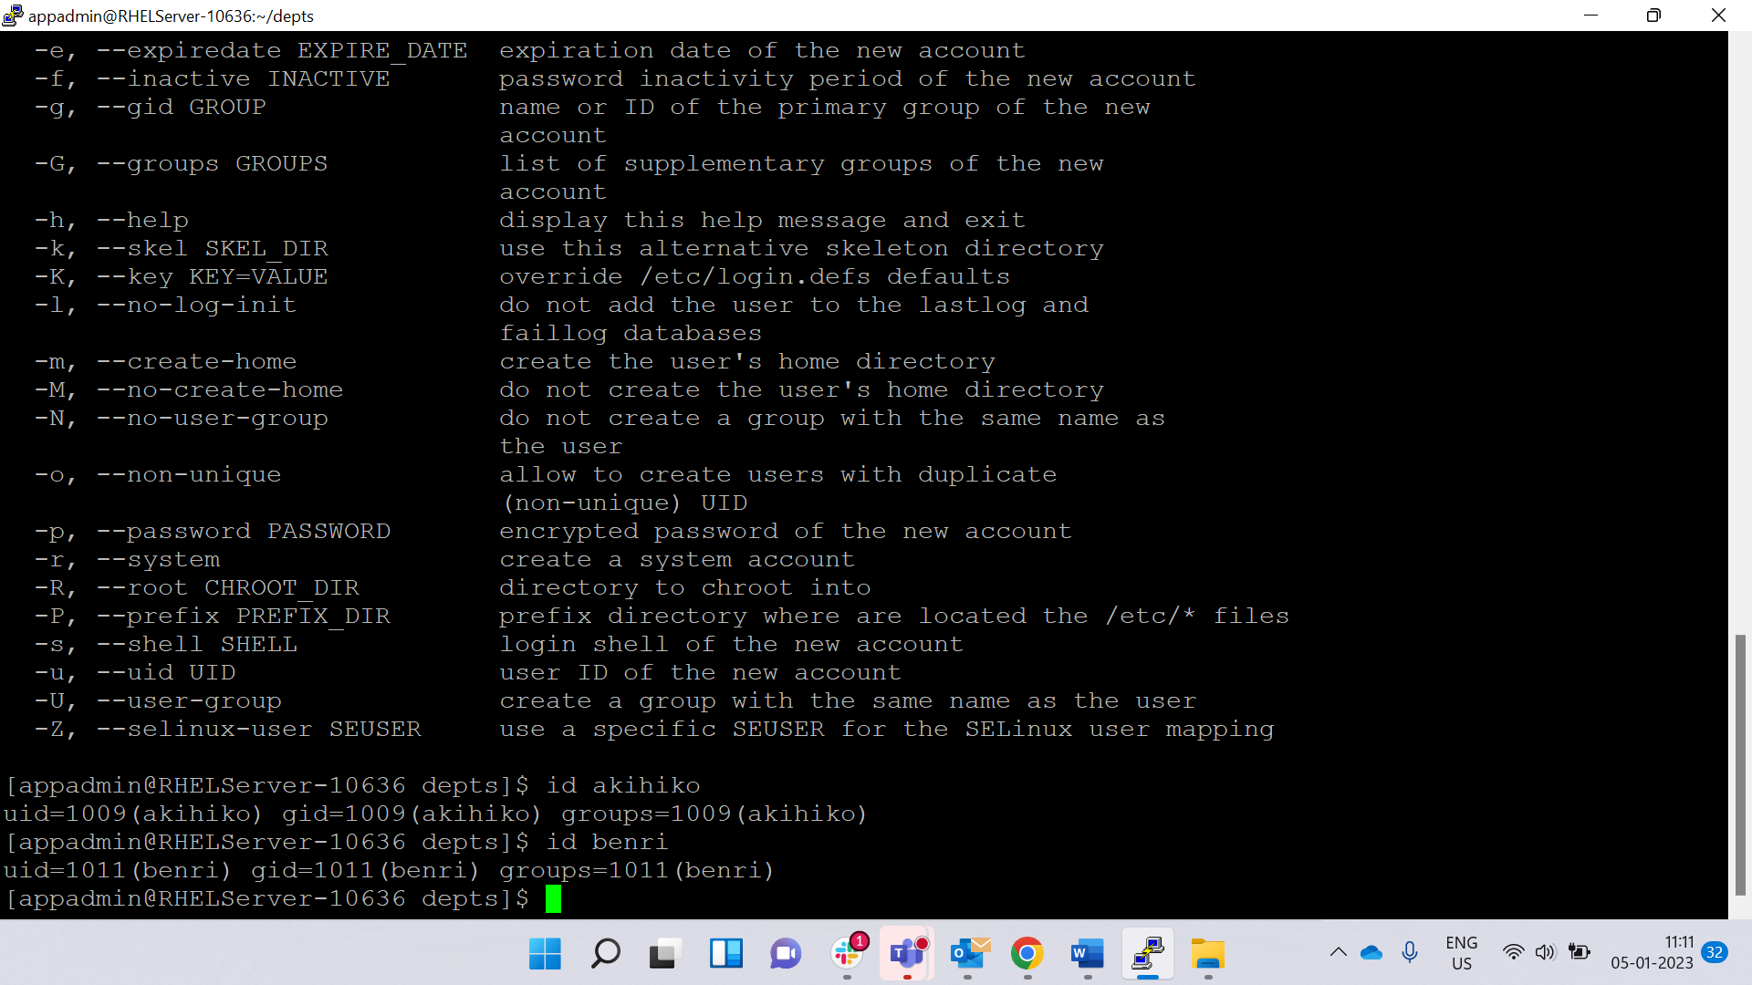

Step 3:-Verification

Create a folder HR in docker with only access to members of HR group. & only members of HR can delete files being created in this folder. 