POINTERS
A pointer is a programming language object, whose value refers to another value stored elsewhere in the computer memory using its memory address. A pointer refers to a location in memory, and obtaining the value stored at that location is known as dereferencing the pointer. As an analogy, a page number in a book's index could be considered a pointer to the corresponding page; dereferencing such a pointer would be done by flipping to the page with the given page number.
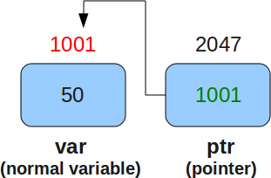

DECLARATION OF A POINTER
int *p // declares a pointer p.
p= &var //stores address of Variable var in Pointer p.

HOW TO USE A POINTER?
EXAMPLE
#include<stdio.h>
void main()
{
int var=6;
int *p;
p=&var;
printf(“Address of var is %d \n”,p );
printf(“Value stored at var is %d”,*p);
}
When the above code is compiled and executed, it produces the following result −
Address of var is 300
Value stored at var is 6

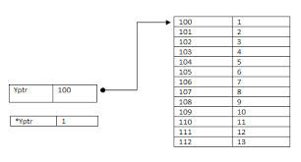

BENEFITS
Pointers to data significantly improve performance for repetitive operations such as traversing strings, lookup tables, control tables and tree structures. In particular, it is often much cheaper in time and space to copy and dereference pointers than it is to copy and access the data to which the pointers point.

USES
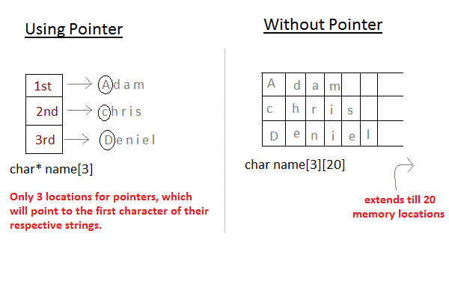

Pointers are directly supported without restrictions in languages such as PL/I, C, C++, Pascal, and implicitly in most assembly languages. They are primarily used for constructing references, which in turn are fundamental to constructing nearly all data structures, as well as in passing data between different parts of a program.
When dealing with arrays, the critical lookup operation typically involves a stage called address calculation which involves constructing a pointer to the desired data element in the array. In other data structures, such as linked lists, pointers are used as references to explicitly tie one piece of the structure to another.
Pointers are used to pass parameters by reference. This is useful if the programmer wants a function's modifications to a parameter to be visible to the function's caller. This is also useful for returning multiple values from a function.
Pointers can also be used to allocate and deallocate dynamic variables and arrays in memory. Since a variable will often become redundant after it has served its purpose, it is a waste of memory to keep it, and therefore it is good practice to deallocate it (using the original pointer reference) when it is no longer needed. Failure to do so may result in a memory leak (where available free memory gradually, or in severe cases rapidly, diminishes because of an accumulation of numerous redundant memory blocks)

NULL Pointers
It is always a good practice to assign a NULL value to a pointer variable in case you do not have an exact address to be assigned. This is done at the time of variable declaration. A pointer that is assigned NULL is called a null pointer.

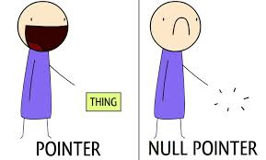

The NULL pointer is a constant with a value of zero defined in several standard libraries. Consider the following program −
#include <stdio.h>
int main () {
int *ptr = NULL;
printf ("The value of ptr is : %x\n", ptr );
return 0;
}
When the above code is compiled and executed, it produces the following result −
The value of ptr is 0

STRUCTURE TO POINTER
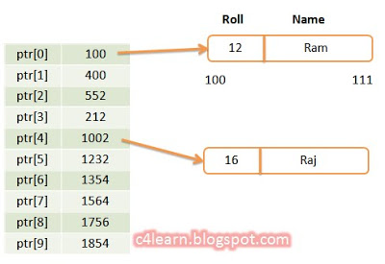

A structure's member can be accesssed through pointer in two ways:

1.Using dynamic memory allocation- Referencing pointer to another address to access the memory
Consider an example to access structure's member through pointer.

#include <stdio.h>
typedef struct person
{
int age;
float weight;
};
int main()
{
struct person *personPtr, person1;
personPtr = &person1; // Referencing pointer to memory address of person1
printf("Enter integer: ");
scanf("%d",&(*personPtr).age);
printf("Enter number: ");
scanf("%f",&(*personPtr).weight);

printf("Displaying: ");
printf("%d%f",(*personPtr).age,(*personPtr).weight);
return 0;
}
In this example, the pointer variable of type struct person is referenced to the address of person1. Then, only the structure member through pointer can be accessed.
Structure pointer member can also be accessed using -> operator.
(*personPtr).age is same as personPtr->age
(*personPtr).weight is same as personPtr->weight
2. Accessing structure member through pointer using dynamic memory allocation
To access structure member using pointers, memory can be allocated dynamically using malloc() defined under "stdlib.h" header file.

Syntax to use malloc()--
ptr = (cast-type*) malloc(byte-size)
Example to use structure's member through pointer using malloc() function.

#include <stdio.h>
#include <stdlib.h>
struct person {
int age;
float weight;
char name[30];
};

int main()
{
struct person *ptr;
int i, num;

printf("Enter number of persons: ");
scanf("%d", &num);

ptr = (struct person*) malloc(num * sizeof(struct person));
// Above statement allocates the memory for n structures with pointer personPtr pointing to base address */

for(i = 0; i < num; ++i)
{
printf("Enter name, age and weight of the person respectively:\n");
scanf("%s%d%f", &(ptr+i)->name, &(ptr+i)->age, &(ptr+i)->weight);
}

printf("Displaying Infromation:\n");
for(i = 0; i < num; ++i)
printf("%s\t%d\t%.2f\n", (ptr+i)->name, (ptr+i)->age, (ptr+i)->weight);

return 0;
}
Output
Enter number of persons: 2
Enter name, age and weight of the person respectively:
Adam
2
3.2
Enter name, age and weight of the person respectively:
Eve
6
2.3
Displaying Information:
Adam 2 3.20
Eve 6 2.30

POINTER WITH ARRAY

POINTER TO FUNCTION

ARITHMETIC POINTER

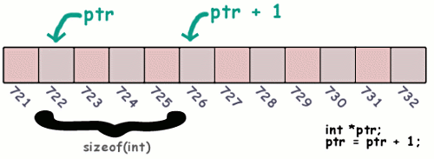

A pointer in C is an address, which is a numeric value. Therefore, you can perform arithmetic operations on a pointer just as you can on a numeric value. There are four arithmetic operators that can be used on pointers: ++, --, +, and -
We prefer using a pointer in our program instead of an array because the variable pointer can be incremented or decremented, unlike the array name which cannot be incremented or decremented because it is a constant pointer.
EXAMPLE 1
#include <stdio.h>
const int MAX = 3;
int main () {
int var[] = {10, 100, 200};
int i, *ptr;
/* let us have array address in pointer */
ptr = var;
for ( i = 0; i < MAX; i++) {
printf("Address of var[%d] = %x\n", i, ptr );
printf("Value of var[%d] = %d\n", i, *ptr );
ptr++; //moves the pointer to the next location
}

return 0;
}
When the above code is compiled and executed, it produces the following result −

Address of var[0] = bf882b30
Value of var[0] = 10
Address of var[1] = bf882b34
Value of var[1] = 100
Address of var[2] = bf882b38
Value of var[2] = 200

EXAMPLE 2
#include <stdio.h>

const int MAX = 3;

int main () {

int var[] = {10, 100, 200};
int i, *ptr;
ptr = &var[MAX-1];

for ( i = MAX; i > 0; i--) {

printf("Address of var[%d] = %x\n", i-1, ptr );
printf("Value of var[%d] = %d\n", i-1, *ptr );
ptr--; //move to the previous location
}
return 0;
}
When the above code is compiled and executed, it produces the following result −

Address of var[2] = bfedbcd8
Value of var[2] = 200
Address of var[1] = bfedbcd4
Value of var[1] = 100
Address of var[0] = bfedbcd0
Value of var[0] = 10

EXAMPLE 3
#include <stdio.h>
const int MAX = 3;
int main () {
int var[] = {10, 100, 200};
int i, *ptr;
ptr = &var;
i = 0;
while ( ptr <= &var[MAX - 1] ) {
printf("Address of var[%d] = %x\n", i, ptr );
printf("Value of var[%d] = %d\n", i, *ptr );
ptr++;
i++;
return 0;
}
When the above code is compiled and executed, it produces the following result −

Address of var[0] = bfdbcb20
Value of var[0] = 10
Address of var[1] = bfdbcb24
Value of var[1] = 100
Address of var[2] = bfdbcb28
Value of var[2] = 200

