Local AI Studio — Technical Overview
State as of 6 August 2026 · Video (MiniMax H3), Sprite Studio, Composer, Lullaby + Track Splitter, ACE-Step 1.5 music, audiobook naturalness pipeline, ComfyUI git checkout

1. What it is, and why
Local AI Studio is a private, zero-API-cost AI workstation: one browser app (http://127.0.0.1:8800) that runs language, image, video, music, speech-to-text, text-to-speech, voice-cloning, story-writing and audiobook models entirely on the local NVIDIA GPU (design target: 16 GB, RTX 4080 SUPER). Nothing leaves the machine; nothing is billed. The backend (server.py) is pure Python stdlib; each capability is a 'worker' process the user explicitly loads and stops.

2. Architecture at a glance
server.py (stdlib HTTP, port 8800) serves index.html (single-file UI) and brokers every request to a backend: Ollama (:11434) for LLM/vision; ComfyUI headless (:8188) for image AND music; conda-env worker subprocesses for STT/TTS/voice (persistent --serve stdin/stdout JSON protocol); koboldcpp (:5001, launched on demand) for long-form fiction.
ComfyUI runs from a git checkout at %USERPROFILE%\comfyui-src (own .venv, torch 2.9 cu130) — NOT the Desktop app — because ACE-Step 1.5 and MiniMax H3 both require a newer ComfyUI than the Desktop bundle (verified against ComfyUI 0.30.0). cu130 specifically: the Video tab's int8 H3 unets are dequantised by comfy-kitchen's fused dequantize_int8_convrot CUDA kernel, which only exists on that build. The checkout shares the Desktop data directory (%USERPROFILE%\Documents\ComfyUI) for models, custom nodes, input/output. Two studio custom nodes live there: ram_websocket_save.py (images stream back in-memory; no disk writes) and ace15_studio_encode.py (ACE-Step 1.5 text-encode with optional bpm/key/time-signature — empty means the model decides), alongside two third-party packs the Video tab needs: VideoHelperSuite (VHS_LoadVideo, for video references) and KJNodes (the optional SageAttention patch). Sprite Studio post-processing (spritekit.py: rembg transparency cutout, resize, sheet assembly) runs under the ComfyUI venv's python, which carries Pillow + rembg.
The Video tab is driven by h3gen.py, a transient subprocess (not a resident worker) that builds the MiniMax H3 graph against ComfyUI's core H3 nodes, follows the run over a stdlib websocket client, and emits '== STAGE' / '== PROGRESS n/m t' markers that server.py's H3Job turns into a measured, self-correcting ETA. H3 emits picture and stereo audio from one sampler pass — two VAEs decode the same latent — so there is no separate audio model and nothing to mux.
The Lullaby and Track Splitter tabs run on a third, fully self-contained runtime: lullabykit (%USERPROFILE%\local-ai-studio\lullabykit\), with its own venv (torch cu129, Demucs, basic-pitch, librosa) plus a bundled portable FluidSynth build and two soundfonts. It is invoked as a transient subprocess per job — not a resident worker like the conda TTS/STT envs — and both LullabyJob and SplitJob refuse to start while a studio model is loaded, since Demucs needs the GPU to itself.

3. The feature tabs
Tab | What it does | Backend
🧠 Language | Chat UI for code/research/vision prompts; 🔓 Unlocked toggle swaps in an abliterated (uncensored) gpt-oss variant | Ollama: gpt-oss:20b, qwen3-vl:8b
🎨 Image — Generate | Text→image, aspect-ratio presets | ComfyUI: FLUX.2 Klein 4B (opt. 9B uncensored)
✂️ Image — Edit | Reference-guided edit / remove / reframe / outpaint (low CFG 1.5) | ComfyUI: FLUX.2 ReferenceLatent
🕹️ Sprite Studio | One reference image → style-matched 2D game sprites. Single action (9 built-ins with hand-written per-frame pose scripts, or a custom described motion) or a full animation set (idle/walk/run/jump/fall/crouch/attack/hurt/death, 36 frames). Side/front/top-down/3-4 view, frame sizes 128–1024 px, true transparent backgrounds (rembg), per-action strip sheets + one combined sprite sheet with engine-ready JSON metadata, zip download, live progress with cancel, and a per-frame ↻ re-roll (new seed, stronger guidance, optional custom pose) that backs up the replaced frame. Output persists in sprites\<set>\ | ComfyUI: FLUX.2 ReferenceLatent + rembg (spritekit.py)
🎬 Video | Text → video WITH native stereo audio, both from one sampler pass (MiniMax H3) — the audio is not a second model bolted on, so nothing needs muxing. Three input modes: Text → video; First / last frame (one keyframe = image→video, both = H3 interpolates between them); and References, taking up to 9 images, 3 video clips (each with its own optional soundtrack) and 3 audio clips, addressed in the prompt as <Picture 1>, <Video 1>, <Audio 1>, to carry identity, motion, camera style or a cloned voice into the result. Up to 15 s at 24 fps, 8 aspect presets, frame counts snapped onto H3's length % 17 == 5 grid and canvases onto multiples of 32. Renders at H3's native 768 short edge — below native the model composes a scene and then barely animates it (measured: 89/100 near-static frames at 480 vs 0/100 at 768, same prompt and seed), which is why the tab sizes by SHORT EDGE rather than megapixels. Live stage readout (loading encoder → encoding → loading unet → sampling → decoding video → decoding audio → muxing) with a measured, self-correcting ETA cached per geometry, cancel, and a persistent library under videos\. TERRITORY-RESTRICTED LICENCE — see §7 | ComfyUI core H3 nodes + h3gen.py (fl2va / ref2va int8 unets, 2 VAEs)
📊 Composer | A text brief → a fully arranged, mixed, multitrack instrumental — not a diffusion model, a planner + a deterministic arranger. Ollama (the Language tab's model) plans the musical DIRECTION only (instruments/roles, key, tempo, section structure, chord progression, mix levels, automation) from a fixed menu of what the local 'studio' can actually play and process; composerkit.py writes every note and runs the full mix, because note-level output from a 20B local model isn't reliable enough to listen to (same division of labour as Lullaby's Piano engine). Instruments are General MIDI patches played by the same bundled FluidSynth + FluidR3_GM soundfont Lullaby uses — free, already on disk, no new download. Each track gets its own stem and channel strip (saturation, tone shelves, tempo-synced delay, convolution reverb with automated sends, tremolo, volume/pan automation) plus song-level production FX (risers, sub impacts, downlifters, drop silences, optional kick sidechain ducking) and an optional 'perform it, don't stamp it' humanization pass (swells, strums/rolls, timing drift, drum round-robin). 3-step wizard: Set up (brief/style/length/instrument count) → Arrange (DAW-style clip grid, per-track mix + automation, piano-roll note editing, re-render with no new LLM call) → Export (master MP3/WAV, multitrack MIDI, per-instrument FLAC stems). 8 genre templates (synth-pop/cinematic/lo-fi/rock/edm/jazz/hip hop/ambient) mean a bad LLM response still renders a complete song, and an 'LLM off' mode composes from the template alone with no model load at all. Optional ACE-Step re-texture pass ships alongside the clean master rather than replacing it | Ollama (planning) + composerkit.py (FluidSynth + numpy, CPU-only render)
🎵 Music Generation | Full songs & instrumentals from a style caption + lyrics. ACE-Step 1.5 XL: a planning LM writes audio codes (most of the quality), then a 4B DiT synthesizes. Two variants — turbo (default: distilled, 8 steps, no CFG → smoother vocals, ~6× faster) and sft (50 steps + CFG 7 → strongest prompt adherence), switchable in Advanced. Lyric tag toolbar ([intro]/[verse]/[pre-chorus]/[chorus]/[bridge]/[outro] + dynamics/instrumental/vocal/energy tags, hyphen modifiers like [chorus - anthemic]); BPM/Key/time-signature default to Auto; Advanced sliders with best-range notes (planner creativity 0.85, planner guidance 2.0); auto-reroll on degenerate seeds; −1 dBFS peak limiting; audio2audio remix; 1–4 variations; mp3/flac/opus | ComfyUI: ACE-Step 1.5
🎹 Lullaby | Any song (mp3/wav/mp4) → a soft lullaby instrumental. Analyze splits it into 6 stems (vocals/guitar/piano/other/bass/drums) with scrubbable waveform previews and per-stem level sliders, so the render only carries what you pick. Three engines: Remix (default — drums dropped, dynamics flattened so it stays soft start to finish, then ACE-Step audio2audio re-imagines it with lullaby tags at a chosen denoise/tempo; closest to the original) · Piano (melody transcribed + key/chords detected, rebuilt as a rocking piano + music-box arrangement at 55-88bpm on a sampled grand, optional experimental ACE-Step polish pass) · Melody Match (traces each sung note's continuous pitch curve via FCPE — real note boundaries, no scale-snap or grid quantization — onto a single portamento-capable instrument: cello/violin/flute/synth voice/music box; per-track Route selector lets some ticked stems go through Melody Match while others get a full Piano-style rebuilt arrangement in the same render, mixed together; optional ACE-Step polish afterward) | lullabykit (2-pass Demucs + basic-pitch/FCPE + librosa + FluidSynth) + ACE-Step
✂️ Track Splitter | Any song → its 6 individual instrument tracks (vocals/guitar/piano/other/bass/drums), each with its own scrubbable player and download link, a 'download all' zip, and a persistent library of past splits. Shares its Demucs separation cache with the Lullaby tab, so a song split here opens instantly if you later analyze it there (or vice versa) | lullabykit (Demucs)
🎙️ Speech → Text | Transcribe files or mic recordings | NeMo Parakeet-TDT (conda nemo-asr)
🔊 Text → Speech | 54 Kokoro voices (9 languages) or Chatterbox cloning; speed/exaggeration controls | conda kokoro / chatterbox
🗣️ Voice Studio | Record scripted sentences → fine-tune XTTS-v2 → save/reuse personal voices (non-commercial, Coqui CPML) | conda xtts
📖 Story Maker | Timeline-planned multi-scene stories/novels; chapter mode; DRY sampler | koboldcpp Cydonia-24B (or Ollama fallback)
📚 Audiobook | Story project or pasted text → chaptered MP3s + combined book, narrated by whichever TTS voice is loaded. Natural pacing: engine-aware chunk sizes, pause tiers (350 ms sentence / 800 ms paragraph / 1.4 s chapter), 5 ms edge fades, one pinned-seed XTTS narrator, −19 LUFS loudness normalization per chapter | loaded TTS worker + ffmpeg

3.1 Video, Sprite Studio, Lullaby & Track Splitter — new-feature screenshots
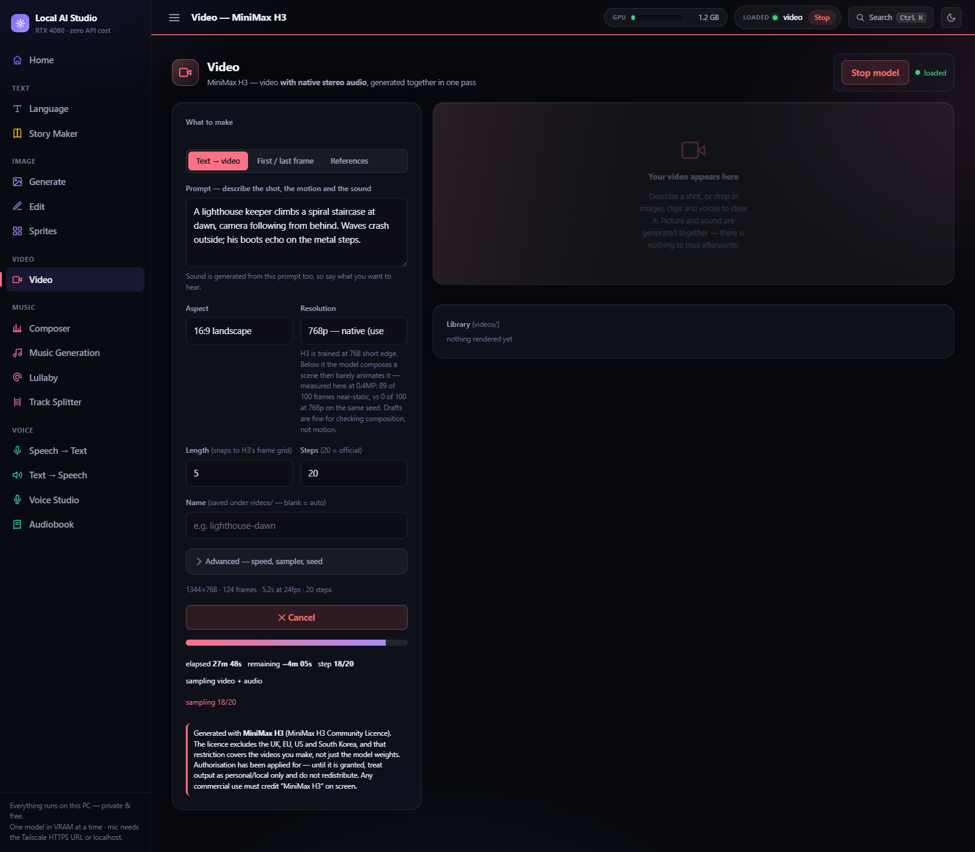
Video — MiniMax H3, mid-render: Text → video mode, 1344×768 (native short edge) · 124 frames · 5.2 s at 24 fps · 20 steps. The progress line is a measured ETA, not a spinner — elapsed, remaining and the current stage come from h3gen.py's own step markers. The licence notice under the controls is shown in-app on every render.
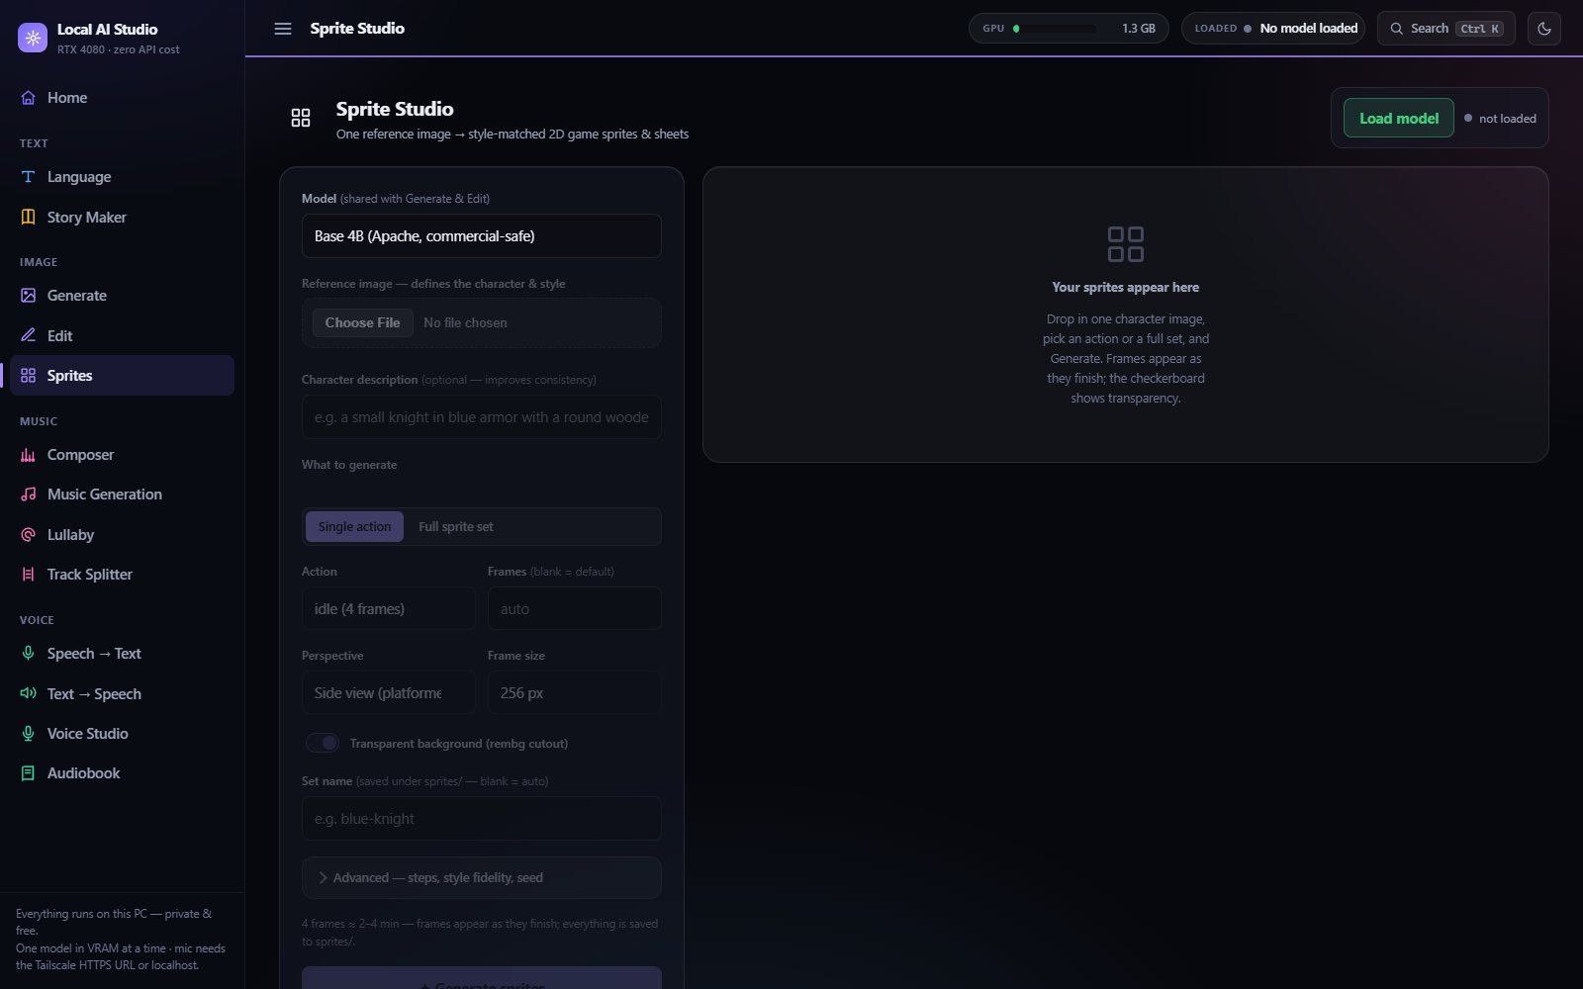
Sprite Studio — single action mode: one reference image, pick a built-in action.
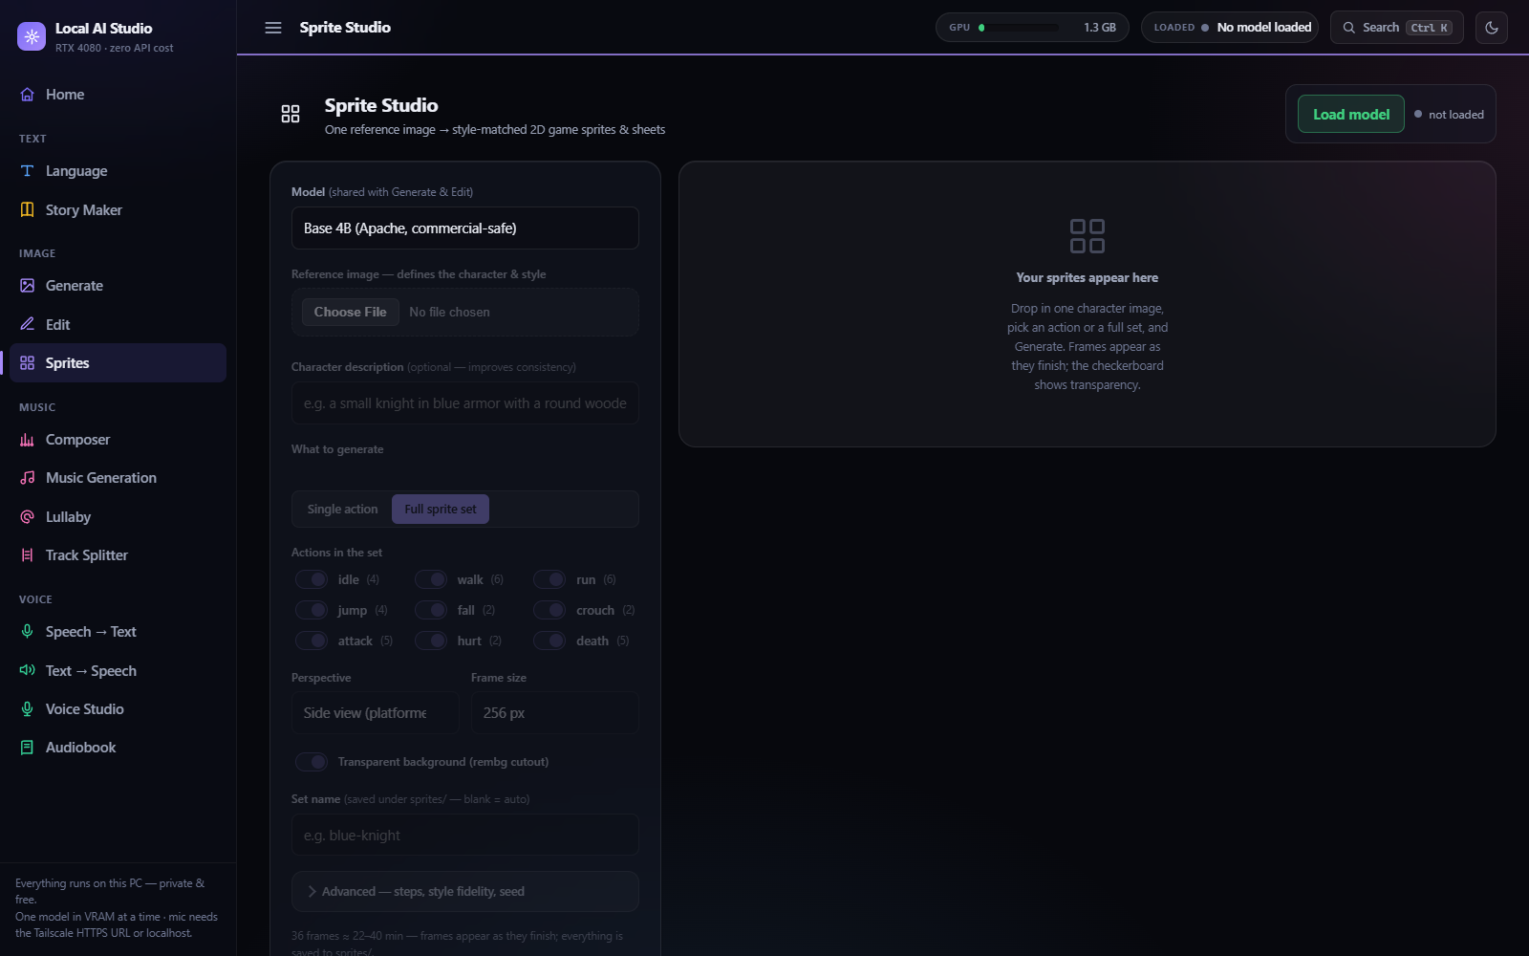
Sprite Studio — full sprite set mode: all 9 built-in actions (idle/walk/run/jump/fall/crouch/attack/hurt/death) selectable in one job.
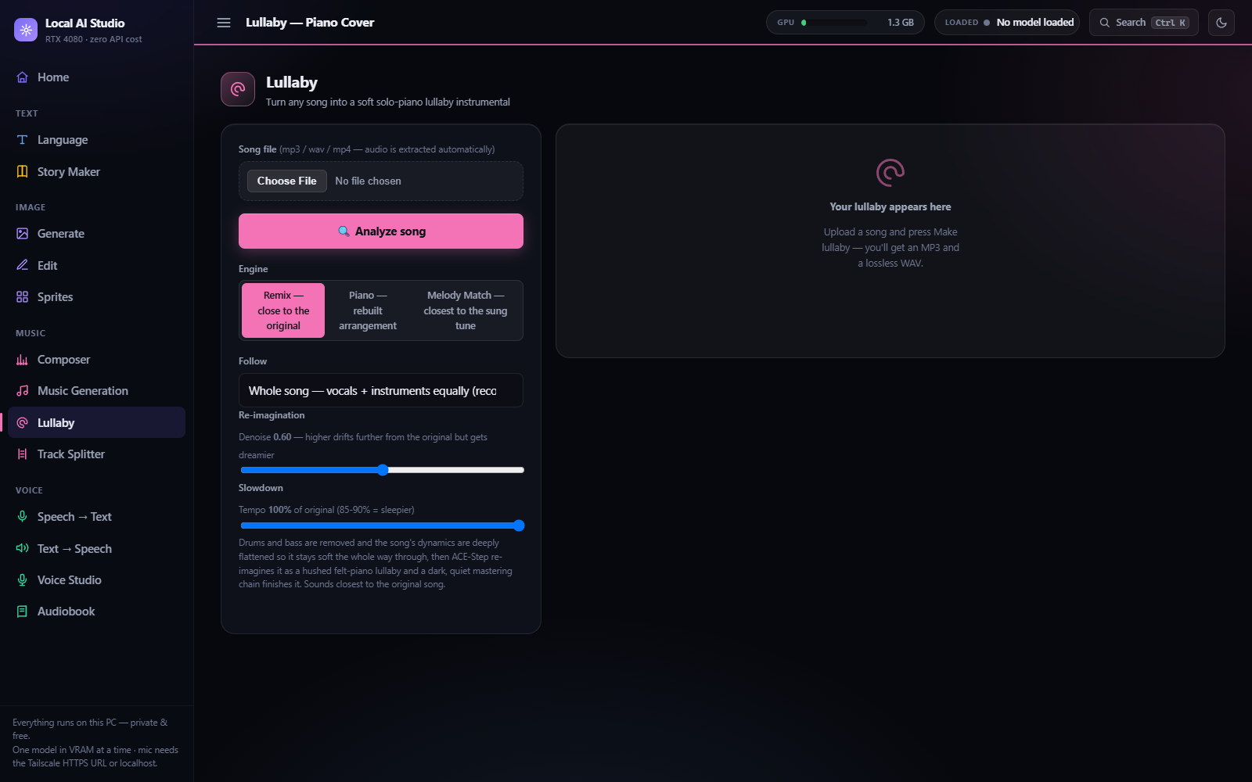
Lullaby — Remix engine (default): closest to the original song.
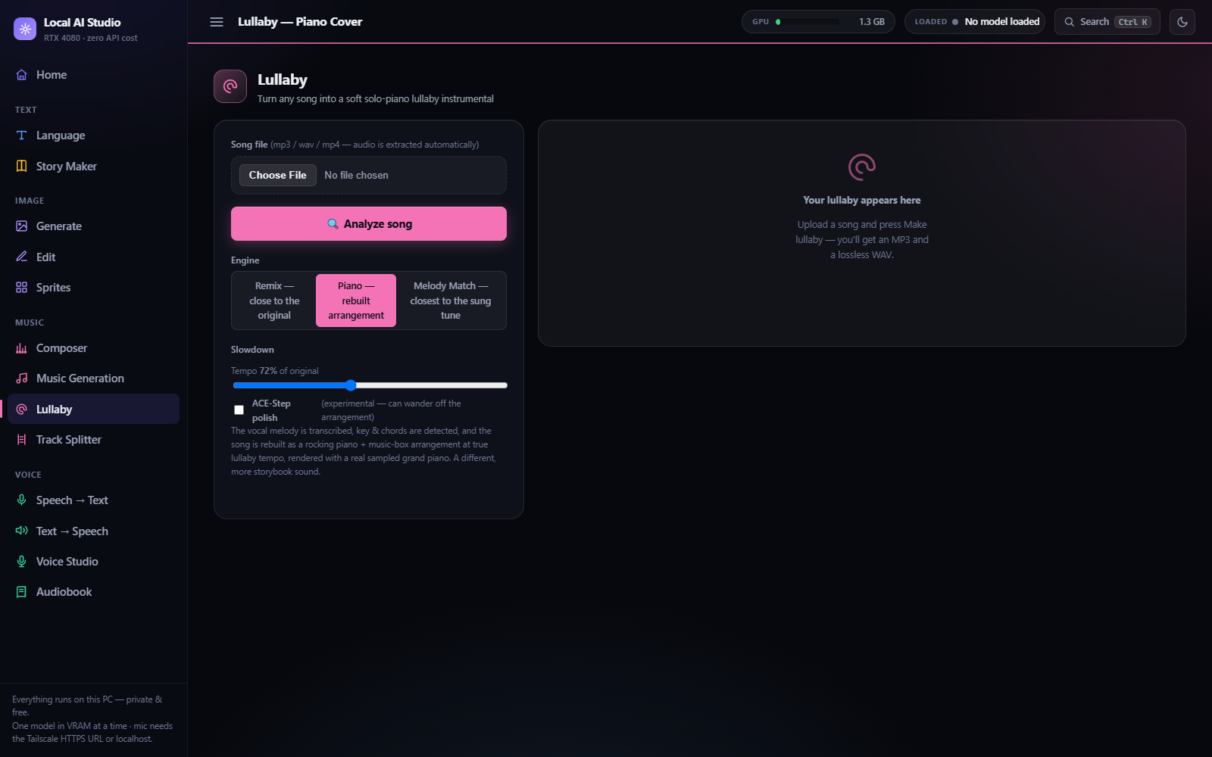
Lullaby — Piano engine: rebuilt piano + music-box arrangement.
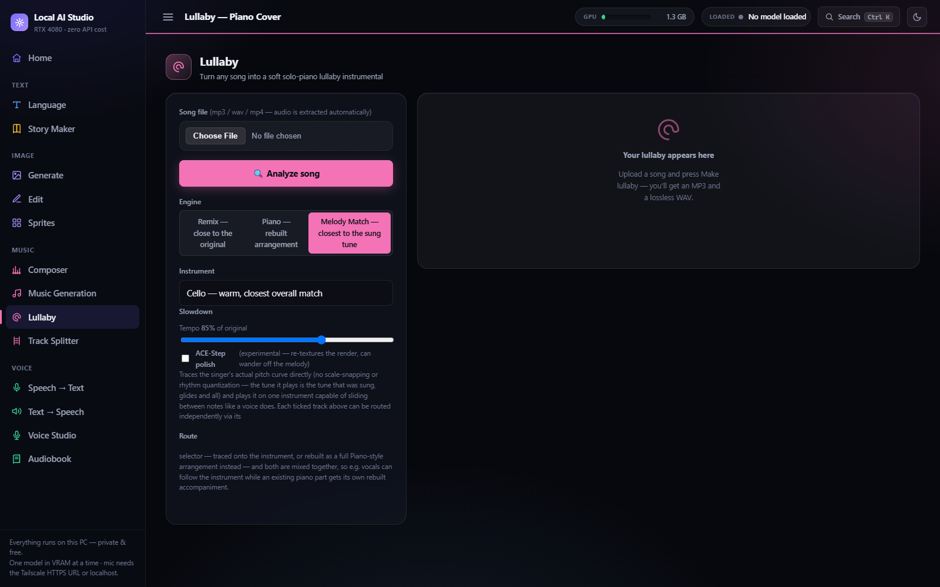
Lullaby — Melody Match engine: instrument choice and per-track routing explained.
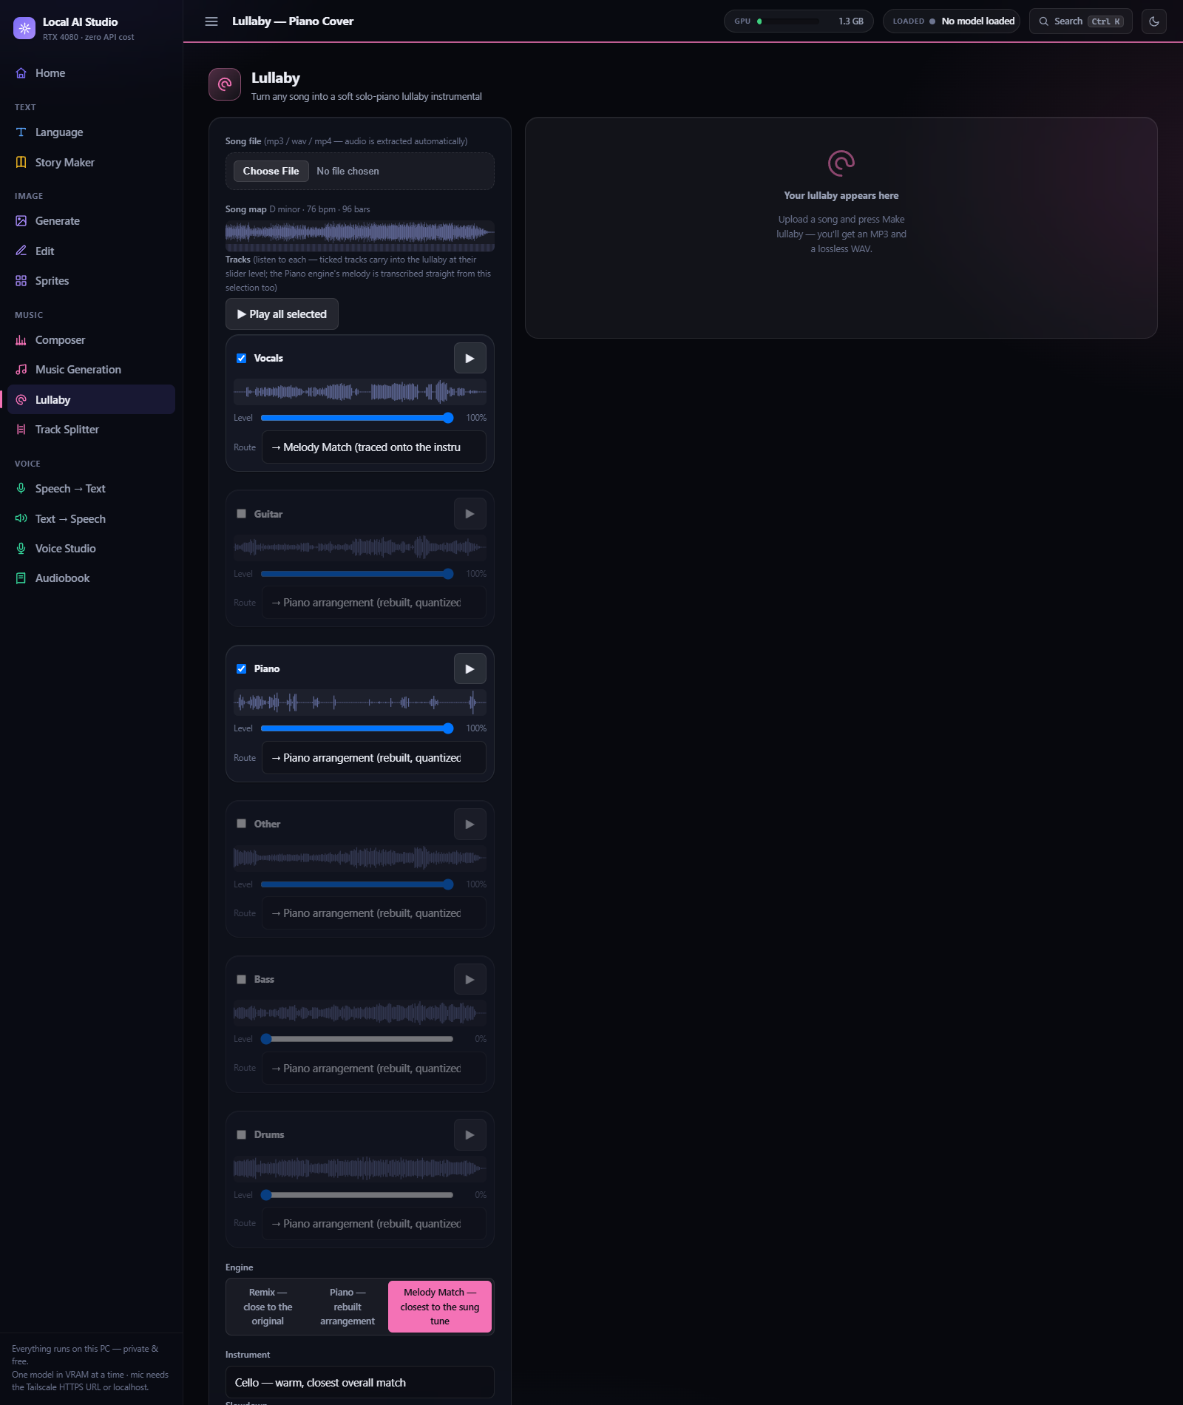
Melody Match with a song analyzed: vocals routed to → Melody Match (traced onto the cello), piano routed to → Piano arrangement (rebuilt, quantized) — both mixed into one render.
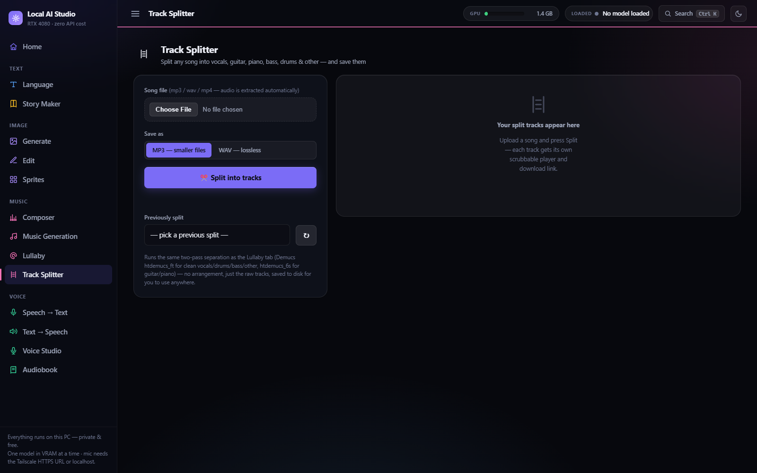
Track Splitter — before splitting a song.
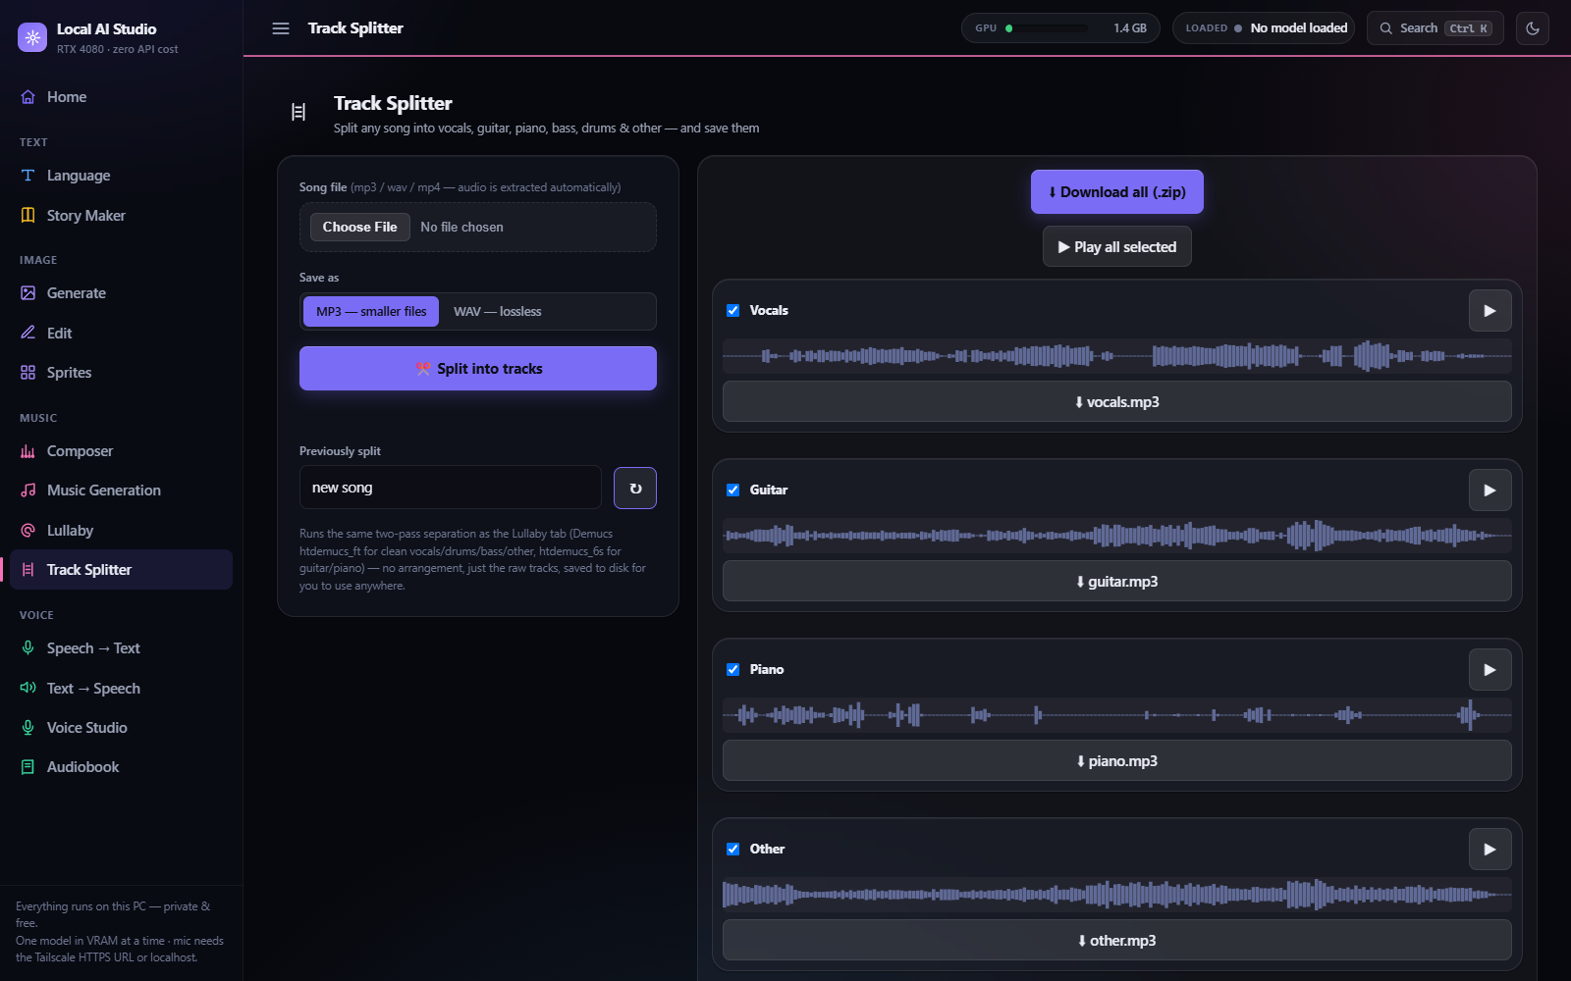
Track Splitter — after splitting: six per-track players, downloads, and Play all selected.
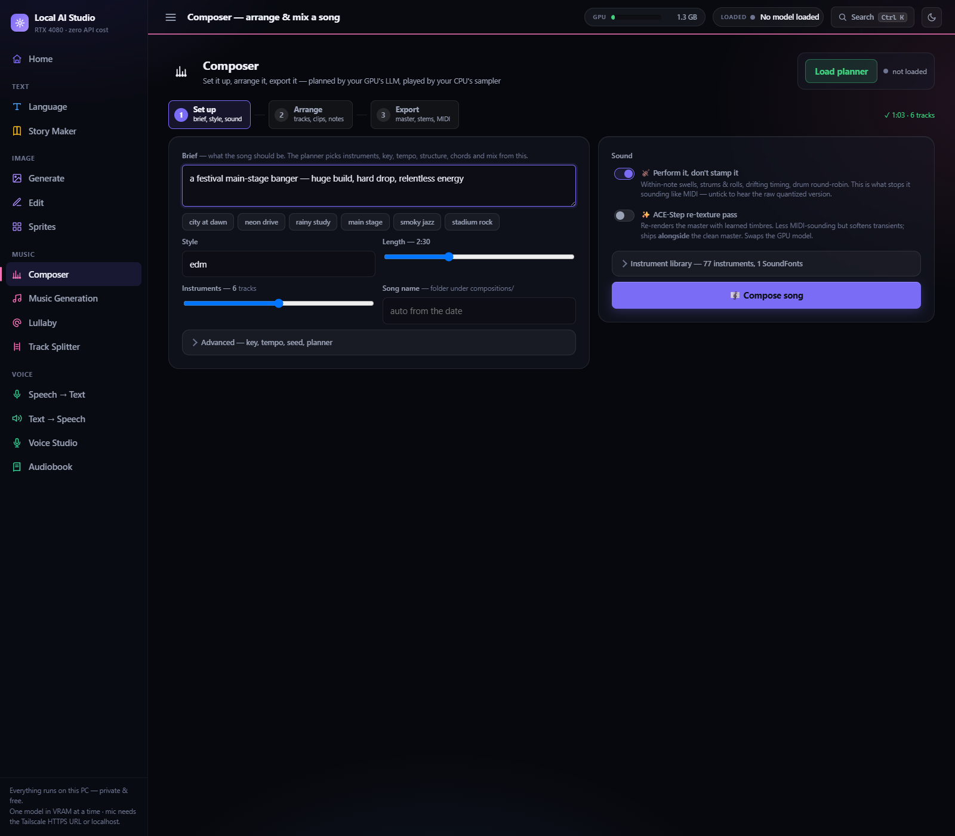
Composer — Step 1 Set up: brief, quick-brief presets, style/length/instrument count, and the Sound options (humanize, ACE-Step re-texture).
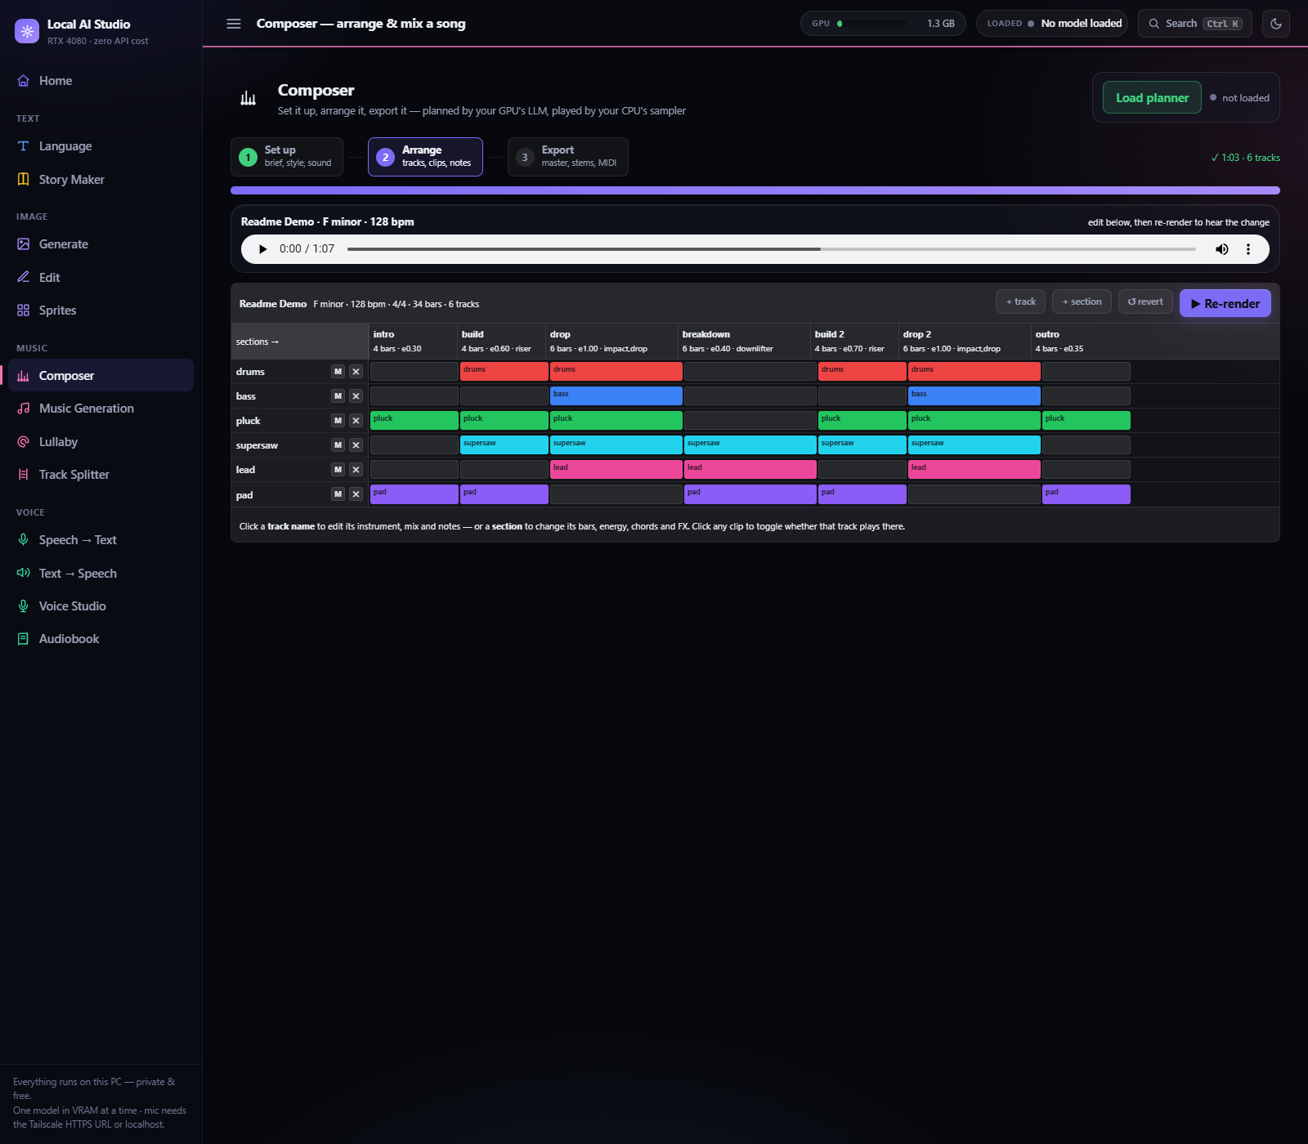
Composer — Step 2 Arrange: a real generated song (EDM, F minor, 128bpm, 6 tracks, 34 bars) — the clip grid shows which track plays in which section, with FX badges (riser/impact/drop) per section.
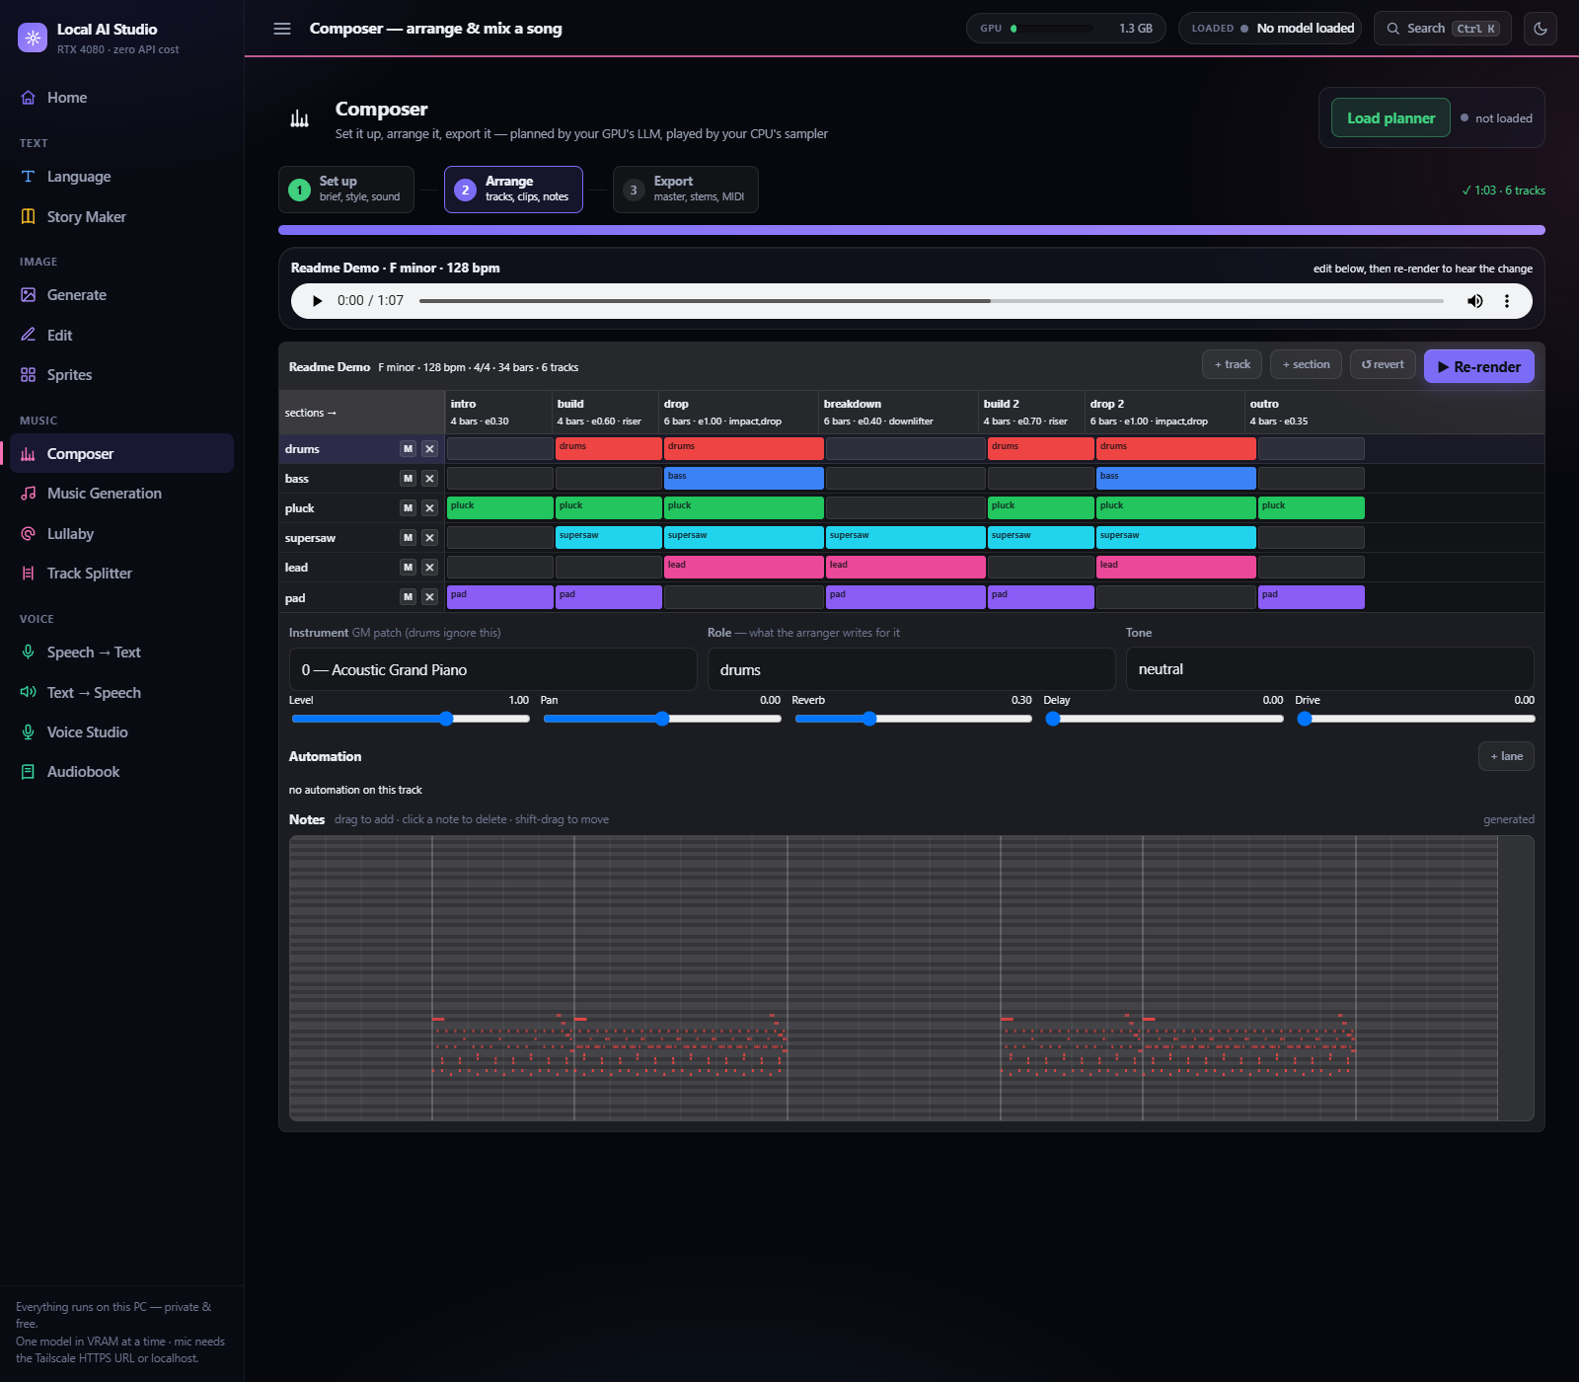
Composer — Step 2 track inspector: instrument/role/tone, level/pan/reverb/delay/drive, automation lanes, and the piano-roll note editor for the selected track.
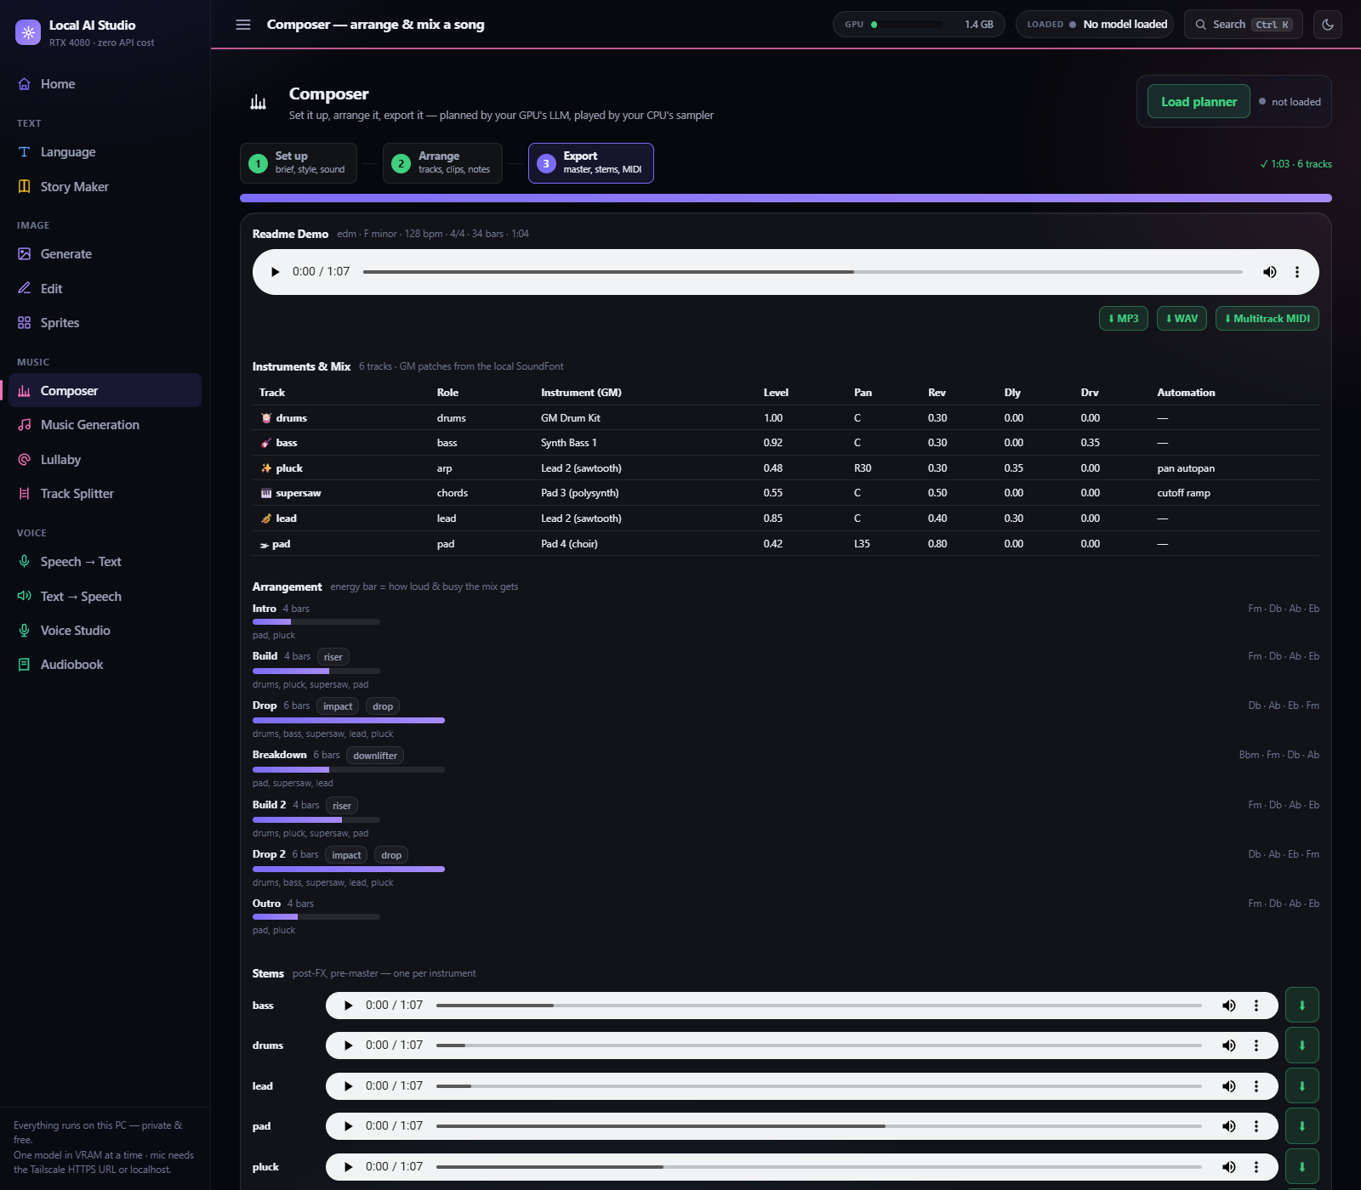
Composer — Step 3 Export: master player + MP3/WAV/MIDI downloads, the full instruments-and-mix table, the arrangement structure with energy bars and chord progressions per section, and per-instrument stem players.

4. The one-model-at-a-time rule
16 GB fits one heavy model. The Manager enforces it: loading any worker first unloads all others (including stopping Ollama residency and freeing ComfyUI VRAM). Violations fail silently — e.g. GPU STT returns an EMPTY transcript with no error if a big model is still resident. Every tab has explicit Load / Stop buttons; controls stay disabled until its model is loaded.
Video is the extreme case and is handled slightly differently: 'load' claims the slot but runs NO warmup pass, because H3's unet is ~21 GB and its text encoder ~15.7 GB — a throwaway 1-step generation would cost minutes and buy nothing. Claiming the slot IS the point: it evicts Ollama, ComfyUI and koboldcpp, which frees the VRAM and, just as importantly, the system RAM that ComfyUI's per-module offload streams the unet from. /api/h3_start refuses outright unless the video slot is held. This is also why 32 GB of system RAM is a requirement rather than a suggestion for that tab.

5. Running and monitoring it
Visual: 'Studio Control Panel.vbs' (tkinter GUI — status lights, per-service start/stop, GPU bar; the .vbs launcher opens it with no console window, unlike the older .cmd which flashes one). CLI: studioctl.ps1 start|stop|status|monitor (starts Ollama → ComfyUI headless from comfyui-src → studio; stop unloads workers first; logs in local-ai-studio\logs). Remote access: 'studioctl start -Remote' publishes the studio at your machine's tailnet HTTPS address — https://<machine-name>.<tailnet-id>.ts.net (run 'tailscale serve status' to see yours) — via Tailscale Serve (tailnet-only).

6. Model & environment inventory
Component | Files / models | Size
Ollama LLMs | gpt-oss:20b, qwen3-vl:8b, optional huihui_ai/gpt-oss-abliterated:20b (Unlocked) | ~14 / 6 / 14 GB
Image (ComfyUI) | flux-2-klein-base-4b-fp8 + qwen_3_4b encoder + flux2-vae (opt. miraclein-9b-fp8 + qwen_3_8b_fp8mixed) | ~12 GB (+17 GB opt.)
Music (ComfyUI) | ACE-Step 1.5 split files: acestep_v1.5_xl_turbo_bf16 (default) + acestep_v1.5_xl_sft_bf16 (diffusion_models), qwen_0.6b_ace15 + qwen_4b_ace15 (text_encoders), ace_1.5_vae (vae). MIT license. The old ace_step_v1_3.5b checkpoint is gone — do not reinstall it. | ~30 GB
Video (ComfyUI) | MiniMax H3: minimax_h3_fl2va_pruned_int8_convrot (text / first-last frame) + minimax_h3_ref2va_pruned_int8_convrot (references) in diffusion_models, qwen3vl_32b_minimax_h3_nvfp4_awq in text_encoders, minimax_h3_video_vae_fp16 + minimax_h3_audio_vae_fp32 in vae. Official pruned int8 — measured better AND faster than the 15.6 GB Q3_K_M GGUF (573 s vs 779 s at 1344×768/20 steps, and Q3 collapsed into abstract geometry). Territory-restricted licence, see §7 | ~63 GB
STT | nvidia/parakeet-tdt-0.6b-v2 (conda nemo-asr) | ~2.3 GB
TTS | hexgrad/Kokoro-82M (conda kokoro); ResembleAI/chatterbox (conda chatterbox); optional Zonos-v0.1 transformer (conda zonos + espeak-ng) | ~0.3 / 3 / 5 GB
Voice Studio | Coqui XTTS-v2 base + dvae.pth + mel_stats.pth (conda xtts); saved voices in local-ai-studio\voices\ | ~2 GB
Story Maker | koboldcpp.exe v1.116.1 + Cydonia-24B-v4.3-IQ4_XS.gguf | ~13.4 GB
ComfyUI runtime | git checkout %USERPROFILE%\comfyui-src (0.30.0) with own venv (torch 2.9.1 cu130) + custom_nodes: VideoHelperSuite, KJNodes (Video tab); optional sageattention / ComfyUI-GGUF | ~8 GB
Lullaby / Track Splitter | lullabykit\: own venv (torch cu129 + Demucs + basic-pitch + FCPE, ~3.5 GB), portable FluidSynth build, FluidR3 GM soundfont (~148 MB) + Salamander Grand Piano soundfont (~1.2 GB extracted) | ~5 GB
Total disk for the required set: ~158 GB (~178 GB with the optional uncensored/Unlocked models). MiniMax H3 alone is ~63 GB of that — skipping the Video tab at install time leaves a fully working studio at ~95 GB.

7. Licensing — MiniMax H3 and the Video tab
Every model in this studio is free to run locally, but two carry restrictions worth stating plainly. XTTS-v2 (Voice Studio) is Coqui CPML: non-commercial, personal/artistic use only. MiniMax H3 (Video) is the unusual one.
H3 ships under the MiniMax H3 Community License Agreement, whose 'Applicable Territory' is worldwide EXCLUDING the European Union, the United Kingdom, the United States and the Republic of Korea. Two things are easy to miss. First, the licence text reaches OUTPUTS as well as weights — it covers use, reproduction, modification, distribution and display of the models 'or any of their Outputs or results' (section V.4) — but in their official licence Q&A MiniMax read this narrowly, telling creators in non-excluded territories that globally distributed content needs no further authorisation, which puts the practical restriction on local deployment of the weights. Second, the one binding obligation on shared output is AUP item 12: clearly disclose that the content is AI-generated. MiniMax have stated that embedded 'MiniMax H3' branding is NOT required and that a credit in the title or description is sufficient. Above $20M annual revenue, commercial use does require prior written authorisation from MiniMax.
Status for this project: individual authorisation for local deployment has been granted by MiniMax under a separate agreement. It is personal to this project's maintainer and does not transfer to anyone who clones or installs the studio. If you are in an Excluded Territory, apply for your own at https://platform.minimax.io/h3-license — individuals may enter 'Personal/None' for company name. Until you hold your own, treat the Video tab as local and personal only. Every other tab is unaffected. The tab repeats this notice in-app on every render, and PHASE 5h of the setup runbook puts it in front of the user and asks before downloading the ~63 GB; declining leaves the rest of the studio fully working. If you redistribute Local AI Studio you must pass this notice on — the recipient's obligations depend on where they are, not where you are.

